EMERGENCY SERVICES FOR CANBERRA
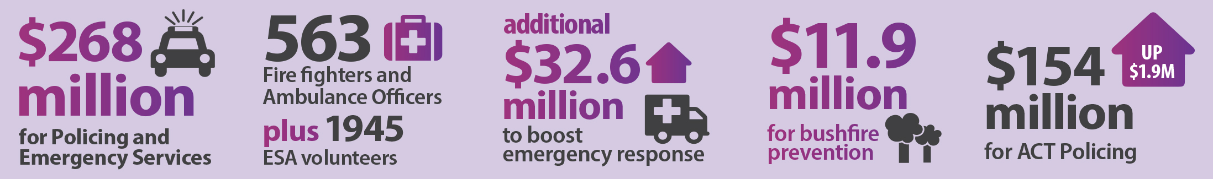
The 2015-16 Budget contains tens of millions of dollars in extra funding to ensure our frontline fire fighters, paramedics and police officers are well equipped to keep Canberrans safe and well.
This year’s emergency services budget includes an extra investment of $41.4 million for the ACT Emergency Services Agency (ESA) and ACT Policing.
This funding is a part of the $268.8 million total funding for policing and emergency services in the ACT for 2015-16.
The budget also provides new funding to help fight and prevent bushfires.

Boosting frontline support
An extra $32.6 million in frontline services includes:
- $15.6 million over four years in extra funding for the ESA to sustain the capability of frontline emergency services;
- $14.7 million over three years to upgrade the Territory Radio Network, which is used by the ESA and other government agencies to communicate, particularly during emergencies;
- $1.3 million in 2015-16 to provide an ambulance station at Greenway, allowing paramedics to use modern facilities in Canberra’s south; and
- $971,000 in 2015-16 to replace the ESA’s Direct Turnout System, which notifies crews of requests for assistance.
Also, a feasibility study will be conducted into potential new sites to replace the existing back-up communications centre at Curtin.

Extra investment in ACT Policing
This budget invests $3.5 million over four years to boost ACT Policing’s frontline operations.
As part of ACT Policing’s 2015-16 Budget of $154.2 million, the Government will provide extra funding to areas including high-tech crime and forensics services, information and communication technology, finance and human resources.

Supporting women in emergency services
This budget invests $221,000 to attract and retain women in emergency services, including:
- $74,000 for design work to upgrade facilities at ESA stations; and
- $147,000 for an ACT Fire and Rescue recruit college to maintain operational capability and encourage female participation.
These initiatives are in line with the Women in Emergency Services Strategy.

Bushfire prevention
This budget invests more than $11.9 million over four years to manage and prevent bushfires, including:
- $9.2 million to implement the Strategic Bushfire Management Plan (version 3) to reduce Canberra’s vulnerability to bushfire; and
- $2.7 million for a fire management strategy in the lower Cotter catchment to protect the water supply.

