BETTER TRANSPORT FOR CANBERRA
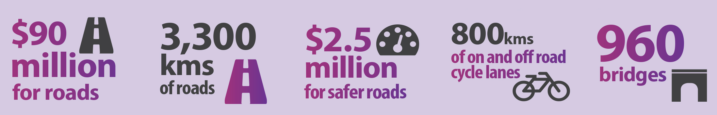
Through the 2015-16 ACT budget, the ACT Government is delivering $152.4 million into public and active transport for Canberra. Combined with the capital contribution to the Capital Metro project, this is one of the biggest investments ever made in the ACT’s public transport network.
This investment will allow people to lead a more active lifestyle as part of their daily travel and provide mass transport options for our city.

Capital Metro
The budget sets out how the ACT Government will pay for this transformative project by making a capital contribution of $375 million after construction is complete and light rail has commenced. This contribution will be funded by the sale of surplus ACT assets and the associated $60 million contribution from the Commonwealth Asset Recycling Initiative.

Community transport
- $496,000 for the continuation of the popular flexible bus service, which started last year, and services for older people, people with a disability and other transport for disadvantaged Canberrans; and
- $264,000 over two years for the continuation of the annual Nightrider bus service.

Active transport – Improved walking and cycling infrastructure
This budget invests $1.7 million to develop more cycle paths and infrastructure. These form part of an overall investment of $23 million in new and ongoing active transport initiatives for Canberra, including:
- $200,000 to design Stage 1 of the Molonglo Cycle Highway from the City to Acacia Inlet, off Lady Denman Drive;
- $1.5 million for the final design and construction of new road crossings on Sullivans Creek cycle path; and
- $50,000 to work with the local arts community to design, produce and install creative bike racks.

This budget invests $1.5 million to improve shared walking and cycling paths, including:
- $600,000 to construct new paths through Bowen Park, connecting to the Kingston Foreshore, and improving the loop ride around Lake Burley Griffin;
- $532,000 to deliver improved walking and cycling connections between the Canberra Hospital and Woden Town Centre;
- $250,000 to design active travel upgrades in and around the Woden Town Centre; and
- $150,000 to design better connections to and from the Kingston Group Centre.
This budget invests $300,000 for feasibility studies into improved walking and cycling path connections for locals visiting their town centres, including:
- $100,000 study for the Belconnen Town Centre;
- $100,000 study for the Tuggeranong Town Centre; and
- $100,000 study for connections between West Belconnen and Belconnen Town Centre.
Age-friendly suburbs
Building on the age-friendly suburbs project started last year, which makes suburbs easier for older Canberrans to get around, this Budget invests further in age-friendly infrastructure.
- $500,000 over two years will fund a feasibility study, detailed design and construction of age-friendly facilities in Kaleen and in the Tuggeranong Valley.
- Works include new footpaths, widening of footpaths, community paths, traffic islands, refuge spots, wheelchair ramps and other best-practice age-friendly infrastructure.
Transport reform
This budget invests $2.3 million to progress the Government’s transport reform agenda and adapt to future transport challenges. Initiatives include:
- Work to improve bus services and ensure the integration of bus and light rail;
- Establishing a collaborative framework across Australian cities on active travel;
- Developing a whole of government peak oil strategy; and
- A targeted road corridor efficiency trial targeting and addressing key constraints to effective traffic flow.

