

2025-26 Capital Works Program
  - Progress Report
Year-to-date performance as at 31 March 2026

Chief Minister, Treasury and Economic Development Directorate

TABLE OF CONTENTS
Introduction 1
Chapter 1 2025-26 capital works Program 2
1.1 2025-26 Program Overview 2
1.2 2025-26 Program Expenditure Year-To-Date MARCH 2026 2
2025-26 Asset Renewal Program 3
2025-26 ICT and P&E Expenditure 5
Chapter 2 Historical expenditure trends 6
Chapter 3 Non-Financial (Milestone) Outcomes 6
Chapter 4 Project PROGRESS 8
4.1 Delivery of Infrastructure for the ACT Community 8
Delivery of Transport Infrastructure 8
Providing Education for All 11
Delivering Health Services 13
Public and Social Housing 14
Environment and Climate 15
Entertainment, Arts and Sports 17
City Services, Recreation and Community Services 18

Appendices
APPENDIX 1: CAPITAL WORKS EXPENDITURE BY MAJOR PROJECT

Introduction
This report details progress made towards delivering the Government’s 2025-26 Capital Works Program and outlines major project achievements for the quarter ending 31 March 2026.
Expenditure details of projects with a current budget greater than or equal to $10 million are at Appendix 1.
The Capital Works Program also includes capital investment in Information and Communication Technology (ICT) and Plant and Equipment (P&E).
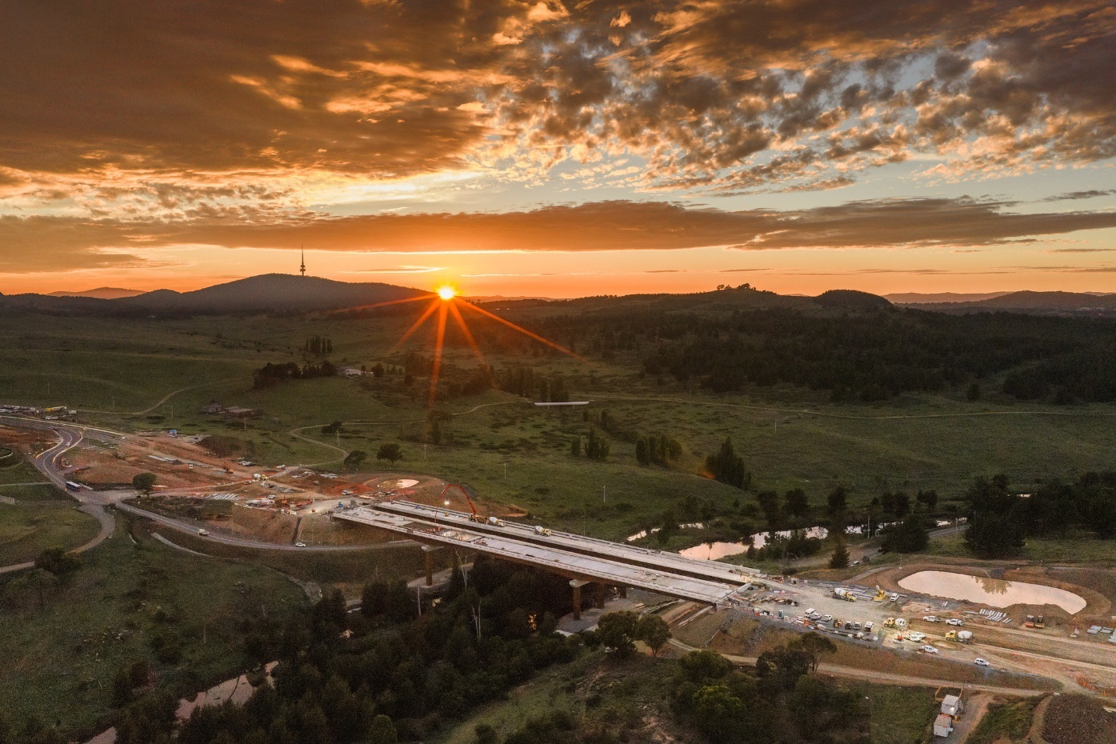
Molonglo River Bridge

2025-26 capital works Program

2025-26 Program Overview
The 2025-26 Budget and Budget Review included several new initiatives, the reprofiling of a range of existing projects and other technical program adjustments, reflecting updated project delivery information.
The available funding in the 2025-26 Capital Works Program is shown in Table 1 below.
Table 1: 2025-26 Capital Works Program Available Funding
 | $ million
2025-26 Budget Review | 1,394
Net estimate of adjustments, savings and rollovers | (14)
Total estimated funds available for expenditure in 2025-26 | 1,380
Declared savings to date | 0
Total Funds Available for Expenditure 2025-26 | 1,380
Capital Delivery Provision | (100)
Forecast Program Expenditure | 1,280

2025-26 Program Expenditure Year-To-Date MARCH 2026
Actual year-to-date (YTD) expenditure as at 31 March 2026 was $750 million, comprising:
- new works expenditure of $30 million; and
- works-in-progress expenditure of $720 million.
YTD March 2026 capital expenditure accounted for 54 per cent of total funds available for expenditure in 2025-26 (59 per cent taking account of the Capital Delivery Provision).
Table 2 below provides a breakdown of YTD capital expenditure incurred by each agency to 31 March 2026 and reflects the administrative arrangements in place from 1 July 2025 under the Administrative Arrangements 2025 (No 1).

Table 2: Capital Works Program Expenditure – YTD 31 March 2026
Agency | 2025-26 Funding Available for Expenditure  ($'000) | 2025-26 YTD March 2026 Expenditure ($'000) | Percentage Spent YTD March 2026
ACT Electoral Commission | 211 | 152 | 72%
Canberra Health Services | 62,509 | 33,376 | 53%
Canberra Institute of Technology | 26,316 | 6,180 | 23%
Chief Minister, Treasury and Economic Development Directorate | 45,757 | 12,446 | 27%
City and Environment Directorate | 247,736 | 102,989 | 42%
City Renewal Authority | 19,491 | 7,962 | 41%
Cultural Facilities Corporation | 7,665 | 2,167 | 28%
Digital Canberra | 33,158 | 7,006 | 21%
Education Directorate | 70,518 | 23,910 | 34%
Health and Community Services Directorate | 18,339 | 3,930 | 21%
Housing ACT | 144,726 | 93,185 | 64%
Infrastructure Canberra | 661,848 | 445,114 | 67%
Justice and Community Safety Directorate | 38,195 | 11,467 | 30%
Office of the Legislative Assembly | 3,118 | 504 | 16%
TOTAL | 1,379,587 | 750,388 | 54%
Forecast Program Expenditure | 1,279,587 | 750,388 | 59%

2025-26 Asset Renewal Program
The Asset Renewal Program provides ACT Government agencies with an annual funding pool for works that extend the useful life or improve the service delivery capacity of existing infrastructure assets. This investment is distinct from routine repairs and maintenance which are funded separately.
YTD March 2026 expenditure for the 2025-26 Asset Renewal Program (both new works and existing projects) was $51 million, or 35 per cent of the funding available of $144 million.

Table 3: 2025-26 Asset Renewal Program Expenditure – YTD 31 March 2026
Agency | 2025-26 Funding Available for Expenditure  ($'000) | 2025-26 YTD March 2026 Expenditure ($'000) | Percentage Spent YTD March 2026
ACT Electoral Commission | 211 | 152 | 72%
Canberra Health Services | 15,560 | 10,367 | 67%
Canberra Institute of Technology | 6,078 | 2,955 | 49%
Chief Minister, Treasury and Economic Development Directorate | 4,881 | 1,035 | 21%
City and Environment Directorate | 62,680 | 19,053 | 30%
Cultural Facilities Corporation | 2,983 | 895 | 30%
Education Directorate | 28,355 | 10,329 | 36%
Health and Community Services Directorate | 1,475 | 375 | 25%
Infrastructure Canberra | 11,880 | 2,384 | 20%
Justice and Community Safety Directorate | 6,448 | 2,633 | 41%
Office of the Legislative Assembly | 3,083 | 470 | 15%
TOTAL | 143,634 | 50,648 | 35%

Significant infrastructure improvements being delivered in the March Quarter 2025-26 through the Asset Renewal Program include:
- School infrastructure inclusion works
- Upgrades to hospital equipment
- Hospital infrastructure and safety upgrades
- Stormwater infrastructure improvements
- Improvements to major venues
- Essential facilities and sportsground upgrades
- Improvements to public spaces and playgrounds

2025-26 ICT and P&E Expenditure
The 2025-26 Capital Works Program includes investments in ICT and P&E projects. Total funding available for these projects in 2025-26 is $156 million. As of 31 March 2026, year-to-date expenditure was $69 million, or 44 per cent of available funding.
Table 4: 2025-26 ICT and P&E Expenditure – YTD 31 March 2026
Agency | 2025-26 Funding Available for Expenditure  ($'000) | 2025-26 YTD March 2026 Expenditure ($'000) | Percentage Spent YTD March 2026
ACT Electoral Commission | 0 | 0 | 0%
Canberra Health Services | 11,323 | 6,449 | 57%
Canberra Institute of Technology | 2,418 | 890 | 37%
Chief Minister, Treasury and Economic Development Directorate | 7,190 | 3,519 | 49%
City and Environment Directorate | 49,051 | 27,524 | 56%
Digital Canberra | 33,158 | 7,006 | 21%
Education Directorate | 13,923 | 8,965 | 64%
Health and Community Services Directorate | 1,648 | 725 | 44%
Housing ACT | 7,200 | 7,200 | 100%
Infrastructure Canberra | 8,586 | 2,687 | 31%
Justice and Community Safety Directorate | 21,338 | 3,793 | 18%
Office of the Legislative Assembly | 35 | 34 | 98%
TOTAL | 155,870 | 68,793 | 44%

Historical expenditure trends
Figure 1 below shows cumulative monthly expenditure as a proportion of annual total funding available for the Capital Works Program for each of the three fiscal years to 2025-26.
Figure 1: Cumulative percentage of program expenditure – YTD March Quarter 2025-26, 2024-25 and 2023-24
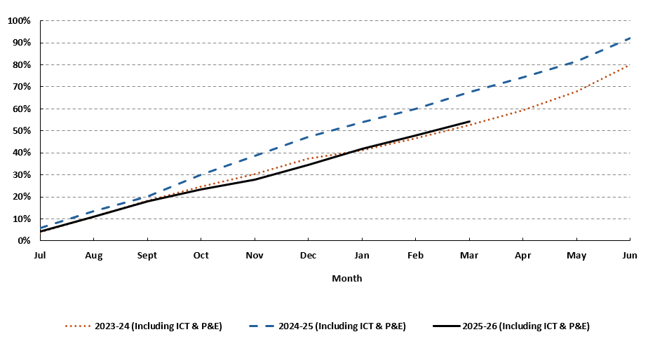

Non-Financial (Milestone) Outcomes
Delivery of the Capital Works Program is also measured against non-financial indicators and reported against key milestones for significant projects with a value greater than or equal to $25 million. This reporting excludes ongoing larger programs of works (for example, Climate action – Continuing the electrification of government assets) that typically comprise smaller projects at varying milestone stages.
Significant projects are made up of Government’s tier 1 projects, generally with a value greater than or equal to $100 million, and tier 2 projects, with a value greater than or equal to $25 million (but less than $100 million) and high-risk projects. As of 31 March 2026, the Capital Works Program included 45 significant projects, accounting for 51 per cent of the 2025-26 funding available for the Capital Works Program.
Table 5 provides a snapshot of the number of significant projects at each key milestone stage at 31 March 2026, integrated with the total corresponding year to date expenditure and current year budget.
Table 5: Milestone Stages of Tier 1 and Tier 2 Projects
Milestone Stage | No. of Projects | % of Projects | 2025-26 Budget ($'000) | YTD Expenditure ($’000)
Feasibility | 3 | 7% | 12,833 | 2,969
Planning/Design/Scope of Works | 9 | 20% | 66,347 | 21,551
Development Application | 6 | 13% | 93,539 | 30,868
Main Works/Construction | 22 | 49% | 509,621 | 435,646
Commissioning/post construction | 5 | 11% | 63,584 | 25,721
TOTAL | 45 | 100% | 745,924 | 516,755

At 31 March 2026, 12 projects were in the stages of feasibility/early planning and design representing 27 per cent of Government’s significant projects. 2025-26 Budget funding for projects at this stage may also include funding for main works where projects advance beyond planning and design during the 2025-26 financial year.
The majority of significant projects (49 per cent) are in the main works or construction phase which collectively have spent 85 per cent of their 2025-26 Budget in the year to date.
In the 2025-26 financial year to date, the following four significant projects were physically completed:
  - Improving Canberra's health infrastructure - Canberra Hospital Expansion;
  - Raising London Circuit;
  - ACT Fire & Rescue Staff and Development and Action Station; and
  - Reducing homelessness by delivering another Common Ground.
These projects remain in a defects liability period until they are financially complete.
Highlights of delivery progress in the March Quarter 2026 for individual capital works projects are provided in Chapter 4 below and further details on individual project progress can be found on the following websites:
- Built for CBR for project updates and information on milestones and progress for current projects and recently completed projects; and
- The Infrastructure Pipeline for more detailed breakdowns of individual project phases and visibility of upcoming opportunities to work on ACT Government-funded projects.

Project PROGRESS

Delivery of Infrastructure for the ACT Community

Delivery of Transport Infrastructure
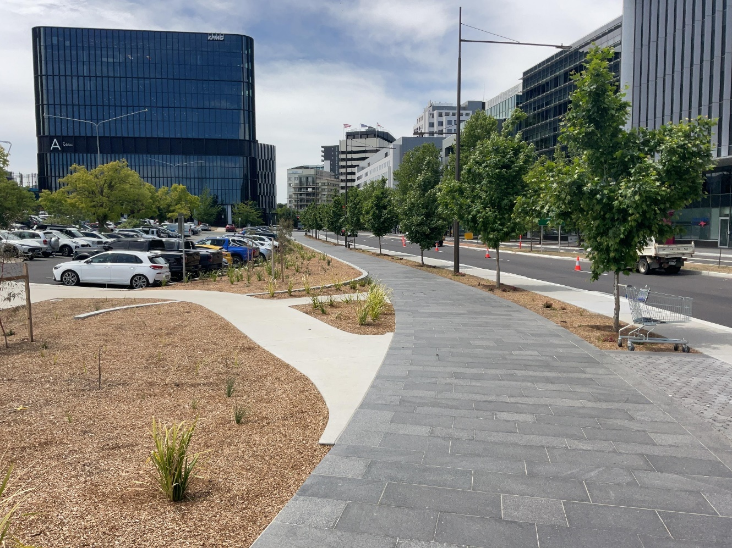Raising London Circuit Completion
Raising London Circuit (RLC) – Preparation is underway for handover to City and Environment Directorate and the National Capital Authority in late 2026.
Delivery of Light Rail Stage 2A (LRS2A) – The Parkes Way bridge major structural elements have been completed, and major construction completion for the project is expected in Quarter 1 2027. London Circuit East is planned to partially open in late 2026. Stakeholders including landowners and business impacted by the project are receiving regular project updates and communications as construction works progress.
Light Rail Procurement, Retrofit and Depot Expansion (LPRDE) – The fifth and final new Light Rail Vehicle (LRV) arrived in Canberra in April 2026. Ten of the 14 existing LRVs have returned to Operational/Revenue Service and three are in various stages of retrofit production and testing. The 14th LRV is expected to commence retrofit installation by the end of April 2026.
Light Rail Stage 2B – The revised, final Environmental Impact Assessment is being completed for submission to the Commonwealth and ACT Governments in June 2026. The final concept design for the allied active travel project, which will be considered as part of the Southern Gateway Framework planning, was also completed.
Molonglo Enabling Works – Project progress includes completion of:
- installation of bridge planks for the Molonglo Valley Interceptor Sewer protection structure;
- the final deck pour for the southbound carriageway;
- all five deck pours for the northbound carriageway;
- concrete pour for the shared user path on the pedestrian bridge and safety barriers on the southbound bridge; and
- installation of high voltage conduits along the eastern and western verges.
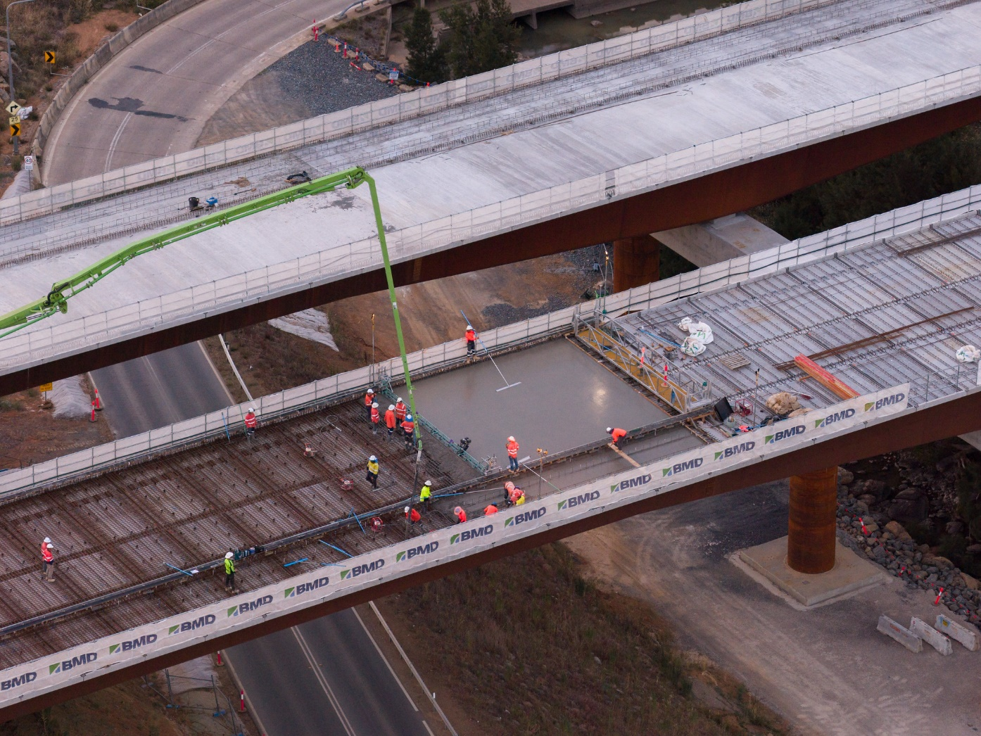 Molonglo River Bridge – Concrete pour
William Hovell Drive Duplication – Both environmental and planning approvals have been received including the Offset Management Plan and the Construction Environmental Management Plan. Construction is scheduled to commence in May 2026.
Athllon Drive Duplication – Enabling utility works were completed in February 2026 and design of the underpass High Voltage (HV) relocation has been finalised. The Development Application (DA) was approved in March 2026 and a works approval received from the National Capital Authority.
Monaro Highway Upgrades and Design – Project progress includes:
- completion of the concrete deck pour on the main flyover bridge over Lanyon Drive and asphalt pavement work north of Lanyon Drive on the southbound carriageway;
- demolition of the existing western half of the Dog Trap Creek Bridge structure and piling for the new structure completed; and
- procurement for the next stage (Package 1C Early Works) is underway which includes construction of a four-way signalised intersection at the existing three-way Sheppard Street and Lanyon Drive intersection.
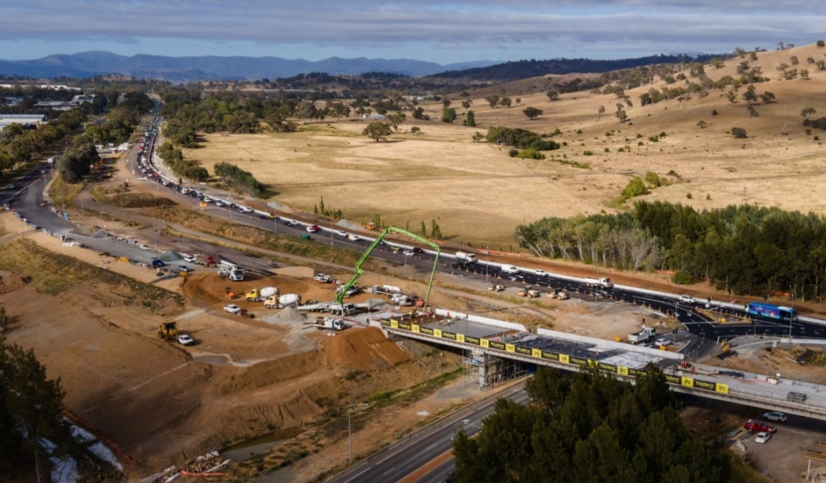
Monaro Highway Upgrades
Canberra Institute of Technology (CIT) Campus Woden Project – Public Transport Interchange – The new transport interchange has been completed.
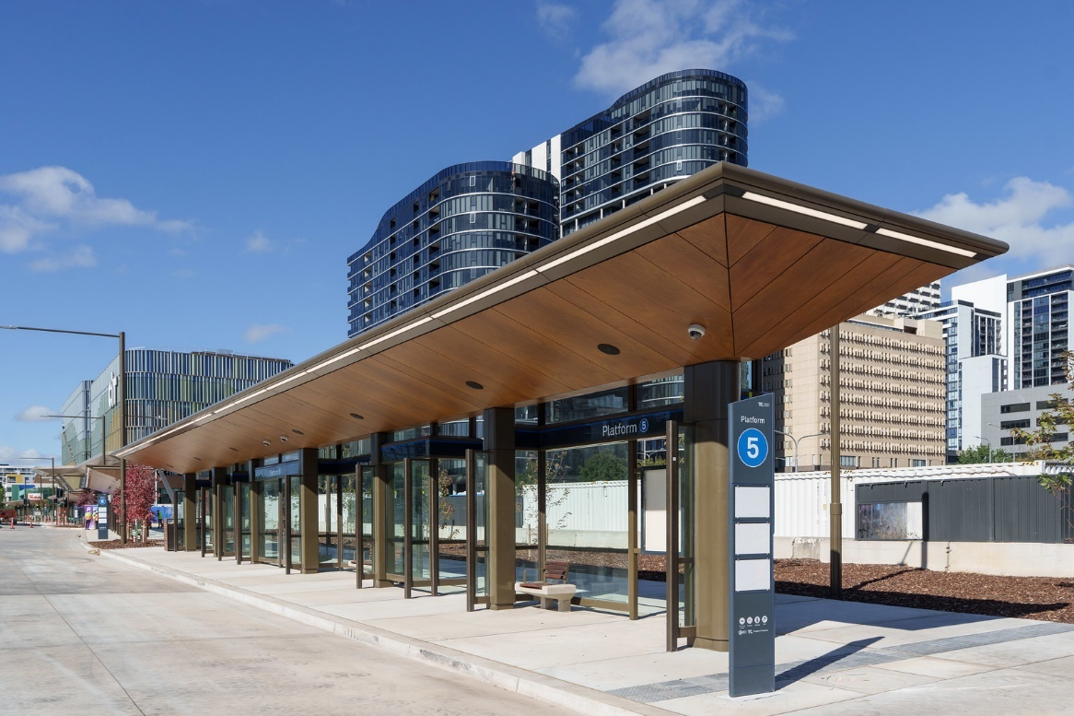
CIT Woden Transport Interchange

Providing Education for All
Canberra Institute of Technology (CIT) Campus Woden Project – CIT Yurauna Bruce commenced operations in January 2026.
Garran Primary School Modernisation – Stage 2 commenced in early December 2025. Demolition of the original school buildings has been completed, and groundworks are underway for construction of the new multi-purpose hall and associated landscaping.
Calwell High School Infrastructure Upgrades – Construction is underway.
Infrastructure Upgrades across Canberra Schools – Black Mountain changeroom modifications have been completed. Cranleigh swipe card access project is scheduled for completion by the end of 2025-26. Procurement is underway for Cranleigh multiple accessible car park.
Refurbishing the Lyneham High School Gym – Procurement is underway with contract award pending.
Fraser Primary School and Melba Copland Secondary School Upgrades – Procurement is underway and submissions for work contracts are being evaluated.
Strathnairn Primary School – Stage 1 of the school opened for the start of the 2026 school year and the Early Childhood Education Centre (ECEC) is complete. Stage 2 works are underway which include earthworks for the playing field, playground and landscaped areas, and work on the gymnasium.
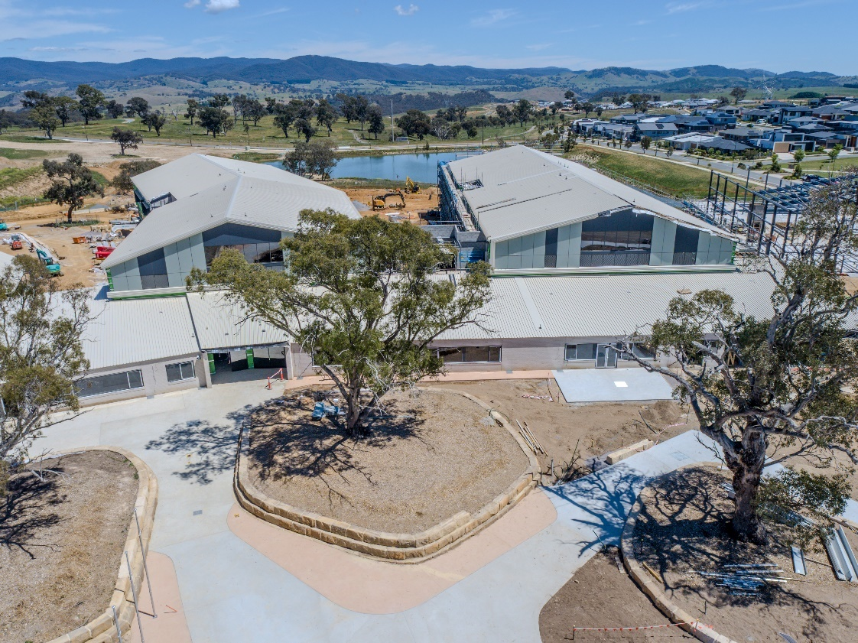
Strathnairn Primary School

Delivering Health Services
Canberra Hospital – Project progress includes:
- construction is progressing to deliver a new palliative care ward, expand and upgrade endoscopy services, and upgrade ACT Pathology’s Laboratory;
- works are continuing on the current phase of the Canberra Hospital Master Plan (CHMP), including the design and fit out of inpatient units, proof of concept and detailed design of clinical services and inpatient buildings, signage and wayfinding, and staging and decanting strategy development; and
- early planning has commenced for the next stage of the implementation of the CHMP focussing on the overall delivery of the pathology and clinical services buildings, and feasibility study for the new mental health precinct.
New Northside Hospital – Project progress includes:
- Schematic Design for the project is progressing. Early works are scheduled to begin in the June Quarter 2026; and
- preparation is underway for the relocation of the Child and Adolescent Mental Health Service (CAMHS) from the North Canberra Hospital Campus to Erindale Business Park as the preferred site.
Upgrading and Enhancing Health Infrastructure at North Canberra Hospital – Works are ongoing to support the continuity of key service delivery throughout the construction of the New Northside Hospital. Investigation is also underway on options to relocate Alcohol and other Drug (AOD) residential treatment facility to replace Arcadia House.
Redeveloping and expanding the services of the Watson Health Precinct – Comprising four buildings: Calm House, Palm Hub, Palm House, and a facility for Catholic Care. Fit-out works have commenced in the first building and the final building’s frames, roof, and walls have been installed.
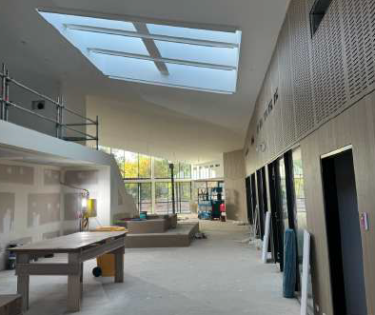
Watson Health Hub - Palm Hub

Improvements at the Ngunnawal Bush Healing Farm – Installation of a new machinery shed for the storage of farm vehicles and infrastructure is underway and is scheduled to be completed by June 2026.
Expanding Health Centres across the ACT – Construction of the Conder Health Centres continues to progress, with pre-sheeting inspections completed. The Independent Commissioning Agent has completed Factory Acceptance testing of the mechanical switchboards.
Delivering a New Palliative Care Ward at the Canberra Hospital – Construction works are 44 percent complete. Hazardous materials have been removed and main construction works are progressing.
Modernising ACT Government Analytical Laboratory (ACTGAL) – Following the completion of the initial upgrade works in November 2025, Stage two of the project will focus on procuring and installing new laboratory workstations.

Public and Social Housing
Growth and Renewal Program – Year-to-date progress includes:
- Completing construction of 94 new dwellings and acquisition of 24 dwellings, six dwellings demolished for redevelopment and the sale of 16 end of use public housing properties; and
- an additional 146 dwellings are currently under construction, in design, development application or in the procurement phase.
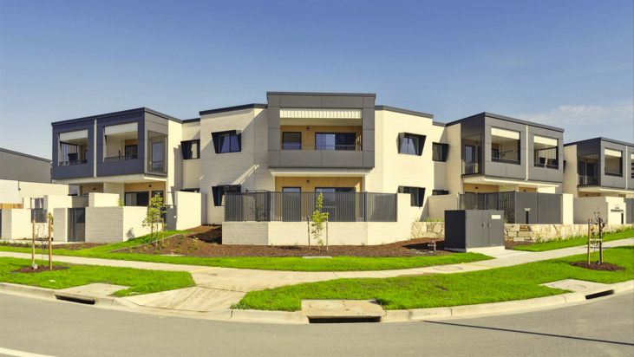
Public Housing Renewal – Denman Prospect
Social Housing Accelerator Program initiative – The ACT Government has committed to deliver between 55-65 dwellings through purchase or construction by June 2028 under the Commonwealth’s Social Housing Accelerator. This includes 17 dwellings delivered in June 2025, and 41 dwellings to be constructed across two sites in the Gungahlin area. The ACT Government is on track to deliver on its commitments under this program by June 2028.
Housing Australia Future Fund (HAFFF) – The ACT Government has committed to deliver 85 dwellings under HAFFF Round 2, with construction commencing by 30 June 2026 and operations by 30 June 2029. There are currently 68 dwellings under construction, in the development application phase, in design or in the procurement phase.

Environment and Climate
Vulnerable Household Energy Support Scheme (VHESS) – Service orders are in place to support delivery of up to $7.423 million in upgrade works between April and June 2026, with activity accelerating in quarter four. To support this increased delivery and manage forecast reprofiling, two additional suppliers were appointed to the VHESS Ceiling Insulation and Electrification Panel through an approach to market process. This has expanded participation by ACT suppliers, increased panel capacity to deliver works in complex public housing properties and positioned the program for accelerated delivery into 2026–27.
As of 31 March 2026, VHESS has delivered ceiling insulation to over 2,990 public housing properties and upgraded gas appliances to electric in more than 1,690 homes.
Electrification of Government Gas Assets (EoGGA) – Project progress includes:
- the EoGGA Program has removed further 13 gas assets this quarter – With 16 removed year-to-date;
- Weetangera Primary School – All gas assets have been removed from site, plant rooms have been refurbished and created to accommodate new electric plant and equipment, new water source heat pump and mechanical equipment have been installed;
- 255 Canberra Ave – Installation of new electric plant and equipment is complete with all gas assets now removed from the building. Commissioning is scheduled for April 2026;
- Gorman Arts Centre – A new electrical point of entry to supply the site is now complete. Electrical cabling has been roughed-in and installation of new ductwork has commenced; and
- Standalone asset replacements – Domestic hot water unit electrification has commenced across various sites and is being delivered by iCBR insourced trades team.

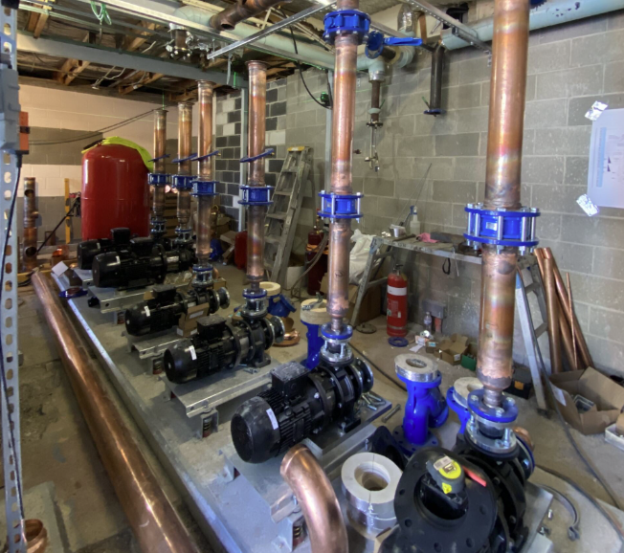
New pumps and pipework at Weetangera Primary School
Delivering the New Recycling Facility (MRF) and Food Organics Facility (FOGO) – Project progress includes:
- significant progress was made on the Final Environmental Impact Statement (EIS) which was lodged with the Territory Planning Authority in March 2026 and substantial work was undertaken to develop the request for proposal documentation for the FOGO Facility;
- a certificate of completion for the demolition of the existing fire damaged MRF was issued to the contractor on completion of the works, with the first milestone payment achieved ahead of schedule on 2 February 2026;
- the public notification period for the Significant Development Application (SDA) for the MRF Facility Works was completed on 10 March 2026; and
- the Contractor continued to progress design documentation toward the Final Sketch Plan (FSP) stage.
Active Travel Investments – Sulwood Drive and Stages 1A, 1B and 1C of the Garden City have been completed with Stage 1D construction tender nearing conclusion.

Entertainment, Arts and Sports
Gorman House Arts Centre Centenary Upgrade – Stage 2 construction is continuing with works progressing across C, F, G and H Blocks, the southern section of E Block, and the waste and storage enclosure. The project is scheduled for completion by September 2026.
Canberra Theatre Redevelopment Project – Project progress includes:
- Main Works commenced on site on 5 January 2026 following contract award in December 2025, with the project successfully transitioned from Early Works into active construction in accordance with the approved delivery strategy, positioning the redevelopment for sustained construction activity in subsequent quarters;
- Early Works continued, including services relocations, widening of Theatre Lane, relocation of the Playhouse Theatre loading dock, installation of project hoardings and establishment of site offices; and
- piling works progressed during the quarter, with completion scheduled for early in the June quarter 2026.
Stromlo Forest Park District Playing Fields – Project progress includes:
- the entity and public consultation period for the Development Application amendment was completed on 6 February 2026;
- significant progress was made on the detailed design documentation, including the preparation and submission of Document Readiness packages for both stages of the project;
- coordination with utility providers continues, including progression of Telstra design works, to advance enabling works planning and reduce future construction risks; and
- On 31 March 2026, a site walkthrough occurred with Minister Berry and key future user groups including Capital Football, Canberra Ultimate, Canberra Region Rugby League, Brumbies Rugby and AFL NSW/ACT to support stakeholder engagement and positive advocacy for the project.
Throsby District Playing Fields – The design consultancy contract was awarded to Stantec in March 2026, with initial site investigations commencing on 17 March 2026.
Canberra Aquatic Centre – The Request for Expressions of Interest has closed with Responses currently under assessment and the reference design is progressing.
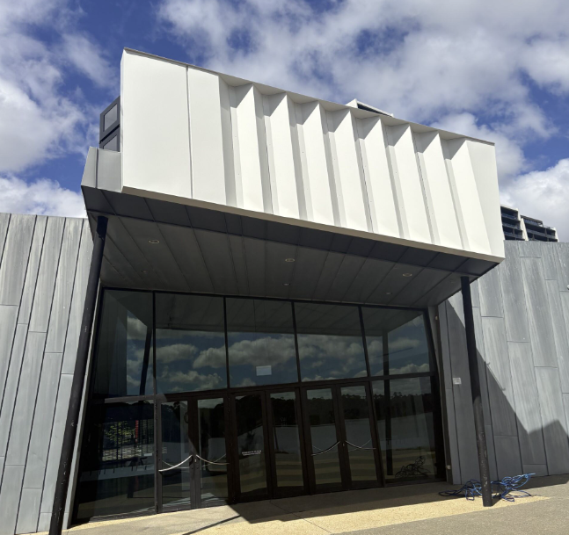
Recently completed Belconnen Arts Centre

City Services, Recreation and Community Services
Per-and Poly-Fluoroalkyl Substances (PFAS) remediation – Project progress includes:
- the completion of remediation and upgrade work for the Kambah Station;
- remediation and upgrade works for Phillip Fire Station are scheduled to begin in mid-2026, with the remediation works tender evaluation report prepared for delegate approval;
- works for Chisholm Fire Station are scheduled to begin in late 2026 and Fyshwick Station to begin in 2027 after site rescheduling; and
- sample soil testing for Rural Fire Services (RFS) sites has been completed with Draft Preliminary Site Investigation (PSI) reports due in May 2026.
Justice Reform – Investing in rehabilitation opportunities for detainees at the Alexander Maconochie Centre (AMC) – ACT Corrective Services staff were relocated to the new building in February. Heating upgrade and detainee art displays within the Building D and Gatehouse were completed in March 2026. A fire services review was also completed in March and the construction procurement for the security office and armoury has closed.
Replacement of ACT Courts Jury and Case Management Systems – Implementation activities for both the new Jury Management System’s (JMS) and the Coroners Case Management System’s (CCMS) have commenced, with the go-live date for the JMS planned to shift from June 2026 to mid-July 2026 to align with operational requirement for go-live in a Court non-sitting period.
Acton Waterfront Park (Ngamawari) – Key pre‑construction activities for Ngamawari have progressed, including completion of the 100 per cent design, submission to the relevant authorities for acceptance, and commencement of site establishment activities. Early works and construction activities are scheduled to commence in April 2026, with the project remaining on tract for completion in early 2028.
Renewing Canberra’s City Precinct – Project progress includes:
- the City Walk section (Stage 2 of Garema Place upgrades) is progressing and remains on track for completion in June 2026, with the final stage to be delivered as part of the Crystalbrook Aurora hotel construction;
- design of City Walk (City Spine Stage 3 - Ainslie Place to Allara Street) is progressing with documentation readiness for Akuna Street to Allara Street (Stage 3b) expected to be completed by mid‑2026, subject to the resolution of geotechnical investigations and stormwater and flood‑modelling considerations. Design for Ainslie Place to Akuna Street (Stage 3a) remains on hold pending further decisions on scope, funding and flood‑modelling outcomes;
- concept master planning and feasibility work is complete for Alinga Street (City Spine Stage 4), with progression to Preliminary Sketch Plan subject to confirmation of a preferred option by the City and Environment Directorate;
- concept masterplans have been completed for Cooyong Street (City Streetscapes) and Dickson Streetscapes Stage 2; and
- Dickson Shops Revitalisation construction commenced in January 2026 and is underway in stages to limit impacts on nearby businesses. The works are being delivered alongside the stormwater network replacement, with completion forecast for June 2027.

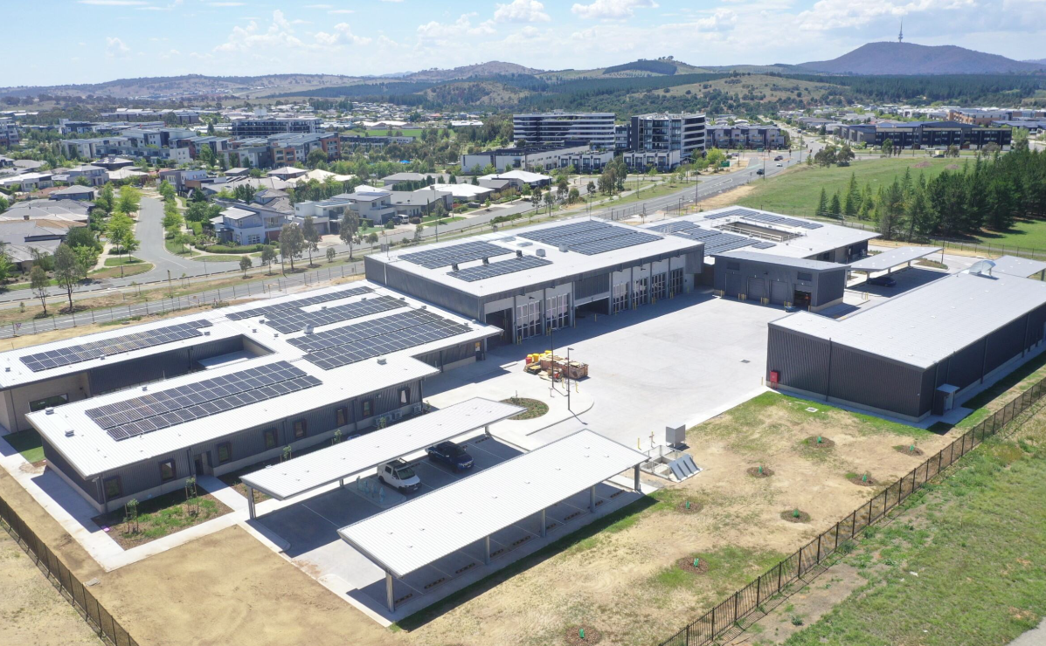
Recently Completed Molonglo Emergency Services Station

Tier 1 and Tier 2 projects that are in early design/feasibility stages with current project budgets less than $10 million (i.e. the majority of project funding has been centrally provisioned subject to completion of these milestone stages) are not included in the Major Projects Report at Appendix 1.
Project funding shortfalls in the current financial year will be internally managed by agencies prior to reprofiling funding from future years.
Projects that are physically complete are not included in the Major Projects Report at Appendix 1.

