Household Spending – February 2024 | 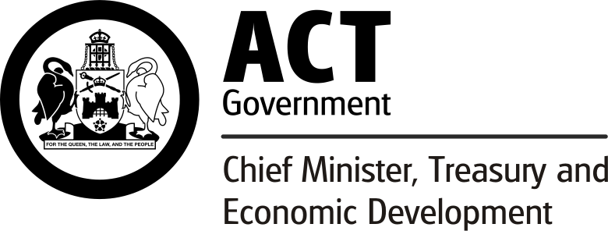
Source: ABS Monthly Household Spending Indicator
Publication Release Date: 04 April 2024 | Next Release Date: 03 May 2024
Household spending in the ACT increased through the year to February 2024.
Household spending in the ACT increased by 7.6 per cent through the year to February 2024 in current price calendar-adjusted terms. The strongest household spending categories were transport (14.1 per cent) followed by clothing and footwear (12.2 per cent) and recreation and culture (9.9 per cent). Through the year, household spending on goods and services increased by 6.4 per cent and 8.5 per cent. Rises were recorded in non-discretionary spending (8.3 per cent) and discretionary spending (6.7 per cent) through the year to February 2024.
Nationally, household spending increased 3.6 per cent through the year to February 2024 in current price calendar-adjusted terms, which was driven by rises in six categories. The largest increases were recorded in transport (12.3 per cent), recreation and culture (5.9 per cent) and hotels, cafes and restaurants (5.8 per cent). Household spending increased for both services (5.1 per cent) and goods (1.9 per cent). Through the year non-discretionary spending increased 6.9 per cent, and discretionary spending fell 0.2 per cent. Among states and territories, the ACT had the second largest rise in household spending (7.6 per cent), following South Australia (7.9 per cent).

Household Spending, ACT and Australia, February 2024
 | Change (%)
 | Monthly | TTY¹
ACT
Food | 0.5 | 8.0
Alcoholic beverage and tobacco² | NA³ | NA
Clothing and footwear | -9.8 | 12.2
Furnishings and household equipment | -8.5 | 6.2
Health | 18.8 | 5.6
Transport | 14.6 | 14.1
Recreation and culture | -1.7 | 9.9
Hotels, cafes and restaurants | -0.5 | 7.9
Miscellaneous goods and services | 15.9 | 1.3
Total | 4.6 | 7.6
Australia
Food | 2.2 | 5.7
Alcoholic beverage and tobacco² | NA | NA
Clothing and footwear | -7.0 | 2.0
Furnishings and household equipment | -3.6 | -0.8
Health | 17.9 | 2.7
Transport | 11.6 | 12.3
Recreation and culture | -1.8 | 5.9
Hotels, cafes and restaurants | -3.7 | 5.8
Miscellaneous goods and services | 12.1 | -5.5
Total | 3.8 | 3.6
¹ Through the year growth is the percentage change from the same period in the previous year.
² The ABS suspended data for the Alcoholic beverages and tobacco category in this release.
³ NA - Not available
Note: Reference period - Jan 2019 = 100.

Monthly Household Spending, February 2024 - ACT and Australia, Current Price, Calendar Adjusted

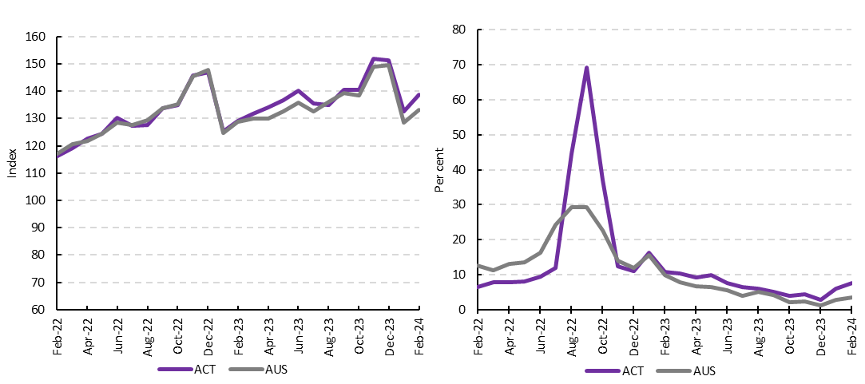

Growth in Household Spending, February 2024, by Jurisdiction

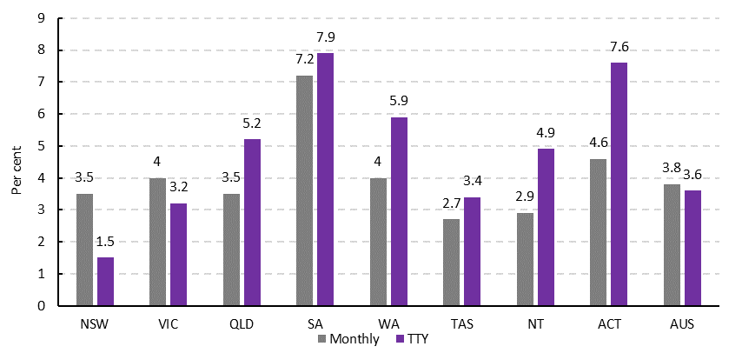
__________________________________________________________________________________________________________________
Definition
This is an experimental monthly household spending indicator using aggregated, de-identified banks transactions data published by the ABS. The indicator provides early insights into household consumption with approximately 68% coverage. The indicator captures the point of expenditure; it is where payment is made for a good or service, not necessarily at the point where ownership changes, or when a service has been delivered, or where the goods and services are consumed. The expenditure of Australian resident households for business purposes is not included within the scope of household spending.

Adjustments
Indicator estimates are produced in current price original and current price calendar adjusted terms by the ABS. Adjustments have been applied by the ABS to allow for length of month and trading day effects present in the month-to-month movements for the series. These are referred to as calendar adjusted estimates. The calendar adjusted series uses trading day adjusted bank transactions data, which differs from the input data used in the original series and includes a length of month adjustment prior to benchmarking. As the indicator time series lengthens, seasonally adjusted estimates will become available.

