ROADS FOR CANBERRA
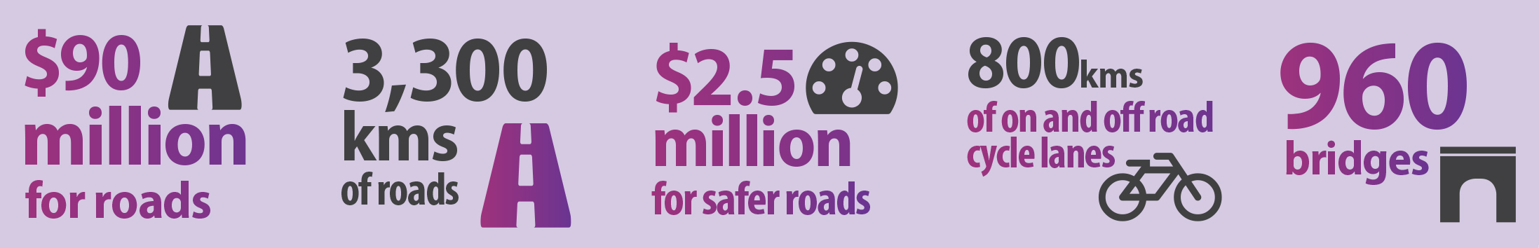
This budget is building better roads for Canberra. This investment is part of the Government’s plan to build an integrated transport network, focusing on roads, public transport and active travel – so we can better connect people to transport hubs, town centres and other communities.

This budget delivers more than $90 million in spending for new roads and road infrastructure – in addition to the ongoing road resealing and maintenance program.

The $90 million in roads will also create jobs – providing work for the local design and construction sector.

Better roads for Tuggeranong
This budget invests $24.6 million over three years for the duplication of Ashley Drive from Erindale Drive to Ellerston Avenue.
The duplication of Ashley Drive will improve Tuggeranong’s road network, as it acts as a major thoroughfare for traffic travelling from the South Tuggeranong suburbs such as Calwell and Gordon to Woden and the City.

Better roads for Gungahlin
This budget invests $62.3 million in road upgrades to cater for the growing Gungahlin region.
- $31.2 million to duplicate Gundaroo Drive between Gungahlin Drive and Mirrabei Drive/Anthony Rolfe Avenue
- $17.1 million for Horse Park Drive. This will fund:
  - Duplication of Horse Park Drive between Anthony Rolfe Avenue and Well Station Drive;
  - Upgrade to the Horse Park Drive and Mapleton Avenue intersection; and
  - Horse Park Drive and Wells Station Drive intersection.
- $14 million to improve roads in the Gungahlin Town Centre, including extensions of The Valley Avenue and Manning Clark Crescent.

Safer roads for Canberra
This budget invests $2.5 million over two years for feasibility and/or design studies for six key intersections and access routes across Canberra. This includes:
- Completing the feasibility study for the duplication of Horse Park Drive between Mulligans Flat Road and the Federal Highway;
- A program of traffic improvements for the regionally significant Pialligo Avenue corridor;
- Traffic signals at the intersections of Belconnen Way and Springvale Drive, and where Hindmarsh Drive intersects with Launceston Street and Eggleston Crescent;
- Intersections of Kuringa Drive and Owen Dixon Drive, and Lance Hill Avenue and Ginninderra Drive; and
- $1.3 million of additional funding over four years to increase mobile speed camera operations by up to 120 hours.

Other Budget initiatives include:
- $700,000 to undertake strengthening works on bridges along the Monaro Highway from Pialligo Avenue to Isabella Drive to ensure a safe and reliable freight route from the Majura Parkway.

