KEEPING CANBERRA HEALTHY AND ACTIVE
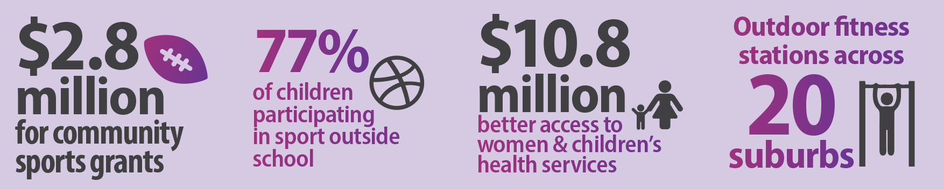
Health will always be the ACT Government’s top priority, and the 2015-16 ACT Budget provides increased and targeted funding to ensure Canberra remains the happiest, healthiest and most active community in the country.
The 2015-16 ACT Budget makes new investments in preventative health and wellbeing initiatives, as well as extra funding for specialist care where people need it most.
Sport and recreation also plays a vital role in keeping Canberrans active and healthy. The ACT Government is continuing to invest in new and ongoing funding for our high quality sport and recreation facilities, programs and services.

Keeping Canberrans healthy
The budget delivers extra funding for more preventative health and wellbeing measures including:
- $1.3 million over two years to continue the Growing Healthy Families Program for Aboriginal and Torres Strait Islander people, which focuses on health, education, parenting skills and broader family support;
- $1.1 million towards preventing chronic diseases through continued funding for the Healthy Future: Preventative Health Program;
- $340,000 over two years to partner with the Heart Foundation to encourage active living across Canberra; and
- $212,000 for the ACT Aboriginal and Torres Strait Islander Tobacco Control Strategy.

Providing specialised care where people need it
Providing care in the community for target groups:
- $31.9 million over four years to boost mental health services and assist in delivering a coordinated, patient-centred approach for people accessing drug and alcohol services;
- $14 million over four years to increase access to cancer outpatient services, establish emergency ambulatory care clinics and programs to treat people outside of a hospital setting;
- $10.8 million over four years for extra beds at QEII Family Centre and for better access to women’s and children’s outpatient services in the community;
- $2.4 million over four years to help patients access palliative care in their home; and
- $800,000 for local organisations who provide drug support and treatment services.

Sport, Recreation & Active Transport
The 2015-16 budget invests in community sport, maintaining facilities and encouraging participation. Funding in this budget, includes:
- $6.6 million over three years for a new sports facility at Melrose High School. The Melrose Football Precinct will have a new FIFA-accredited synthetic football field, a new natural turf grass field, a new sports pavilion, lighting, a car park and multi-use hard courts;
- $4.6 million over two years to upgrade Phillip Oval. The upgrade, in partnership with AFL NSW/ACT and Cricket ACT, will include new community facilities, administration buildings, storage, and lighting. Under the partnership, the sporting codes will inject a further $1.6 million in this project;
- $871,000 in additional funding for mowing and irrigation of ACT sportsgrounds; and
- $400,000 in extra funding in 2015-16 for the Sport and Recreation Grants Program.

The ACT Government is also investing in active transport options around the city, encouraging Canberrans to walk, run and cycle.
This budget invests $1.7 million to develop more cycle paths and infrastructure, including:
- $200,000 to design Stage 1 of the Molonglo Cycle Highway from the City to Acacia Inlet, off Lady Denman Drive;
- $1.5 million for the final design and construction of new road crossings on Sullivans Creek cycle path; and
- $50,000 to work with the local arts community to design, produce and install creative bike racks.

This budget also invests $1.5 million to improve shared walking and cycling paths, including:
- $600,000 to construct new paths through Bowen Park, connecting to the Kingston Foreshore, and improving the loop ride around Lake Burley Griffin;
- $532,000 to deliver improved walking and cycling connections between the Canberra Hospital and Woden Town Centre;
- $250,000 to design active travel upgrades in and around the Woden Town Centre; and
- $150,000 to design better connections to and from the Kingston Group Centre.

This budget invests $300,000 for feasibility studies into improved walking and cycling path connections for locals visiting their town centres, including:
- $100,000 study for the Belconnen Town Centre;
- $100,000 study for the Tuggeranong Town Centre; and
- $100,000 study for connections between West Belconnen and Belconnen Town Centre.

