ACTGov_inline_black.wmf

AAPP 112 - ACT Accounting Policy Paper on

Accounting for

Land Transactions – Transfers Between ACT Government Agencies

Chief Minister, Treasury and Economic Development Directorate

Policy start date: July 2021

1 Introduction 4

1.1 Purpose 4

1.1.1 Agency Responsibilities and Assurance 4

1.1.2 Transition Arrangements 4

1.1.3 Land Governance – Background 4

1.2 Overview Key Land Types and References 4

1.2.1 Accounting Standards and ACT legislation 5

1.2.2 References – ACT Agencies 5

1.2.3 Policy Scope 5

1.2.4 Attachments 6

2 Accounting – Document, Report GGS, Valuation Land 6

2.1 Documentation Requirements for Land Transfers and Related Transactions 6

2.1.1 Land Valuation 7

2.1.2 Accounting classifications - Land Transfers 7

3 Property, Plant and Equipment (AASB 116) 8

3.1 Measurement – Property, Plant and Equipment 8

3.1.1 Transfer Land - Other Agency PP&E Land 8

3.1.2 Administrative Arrangements - Land Transfers 9

3.1.3 Change of Purpose within an Entity 10

4 Non-Current Assets Held for Sale (AASB 5) 10

4.1 Measurement – Assets Held for Sale 10

5 Inventory (AASB 102) 11

5.1 Measurement - Inventory 11

5.1.1 Land Received as Inventory: Transfers and Related Consideration 11

5.1.2 Change of Purpose within an entity 12

5.2 Costs incurred prior to land transfer 12

6 For–profit entities only - Accounting for Government Grants and Disclosure of Government Assistance (AASB 120) 13

7 Application and Examples 14

7.1 Unleased Rural Land (GreenField) 14

7.1.1 Unleased Rural Land (Greenfield) EPSDD to SLA for Development and Sale 14

7.1.2 Unleased Land Transferred to Other Agencies 15

7.2 Urban Land 16

7.3 External Third Party Transfers 17

7.3.1 ACT Agency Transfer to external third parties 17

7.3.2 ACT Agency purchase from External Third-Party 17

7.3.3 ACT Agency disclosures 18

Attachment A: Land Planning and Development Process Frameworks 18

Attachment B: Land MOU Template 27

Glossary 37

# 1 Introduction

## 1.1 Purpose

The purpose of this policy is to provide accounting guidance for ACT Government agencies (Directorates and Territory Authorities) on land transfers between agencies and related transactions. Land, in this policy, has the same meaning as in *The Planning and Development Act 2007* under the ACT Land Framework.

### 1.1.1 Agency Responsibilities and Assurance

ACT Government Agencies are responsible for the management of their land holdings and land transfers and related transactions, and are required to establish transparent, robust governance arrangements to achieve accountability and transparency in accordance with relevant legislation, policies and guidance.

### 1.1.2 Transition Arrangements

Agencies are required to compare their current practices and approaches and take necessary action to align with this policy effective from the 2021-22 reporting year. All contractual arrangements must comply with the Australian Accounting Standards.

### 1.1.3 Land Governance – Background

Under the Constitutional provision, the Commonwealth remains the owner of land in the Territory even after the granting of self-government. *The Australian Capital Territory (Planning and Land Management) Act 1988* (“the Act”) provides that land used by or on behalf of the Commonwealth may be declared National Land and managed by the Commonwealth. The remaining lands of the Territory are Territory Land, and these lands are managed by the ACT Government on behalf of the Commonwealth.

The Commonwealth established the National Capital Authority to reflect its interests and carry out its intentions. The National Capital Plan ensures that the Commonwealth’s national capital interests in the Territory are protected. The National Capital Plan sets out general policies to be implemented throughout the Territory, including:

• policies for land use (including the range and nature of permitted land use); and

• areas that may be suitable for future urban development.

The ACT Legislative Assembly established a Territory Planning Authority who administers a plan (i.e. the Territory Plan) in a manner consistent with the National Capital Plan.

## 1.2 Overview Key Land Types and References

The key types of land in the ACT include:

* Unleased Rural Land (Greenfield) and Land Undeveloped (such as non-financial, non-produced assets), and Urban Renewal Land. These are managed through the Indicative Land Release Program (ILRP), which is used to identify, establish, plan and develop these types of land.
* Urban Renewal and Infill (Brownfield) land planning, land release and development stages.

### 1.2.1 Accounting Standards and ACT legislation

This policy is to be read in conjunction with the applicable legislation, standards, policies and guides including:

**ACT Government References**

*ACT Planning and Development ACT 2007*

*Financial Management Act 1996*

*Legislation Act 2001*

*Public Sector Management Act 1994*

*Annual Reports (Government Agencies) Notice*

Available at: https://www.legislation.act.gov.au

**Australian Accounting Standards**

Australian Accounting Standards incorporate International Financial Reporting Standards issued by the International Accounting Standards Board, with the addition of paragraphs on the applicability of each standard in the Australian environment. Key standards relating to this document include but are not limited to:

*AASB 5 Non-Current Assets Held for Sale and Discontinued Operations*

*AASB 13 Fair Value Measurement*

*AASB 101 Presentation of Financial Statements*

*AASB 102 Inventories*

*AASB 116 Property, Plant and Equipment*

*AASB 120 Accounting for Government Grants and Disclosures of Government Assistance*

*AASB 140 Investment Property*

*AASB 1049 Whole of Government and General Government Sector Financial Reporting;* and

*AASB Interpretation 1038 Contributions by Owners Made to Wholly Owned Public Sector Entities*

### 1.2.2 References – ACT Agencies

There are numerous documents and agencies across the ACT Government that provide guidance and information on land management supporting management decisions and the appropriate accounting classification including:

* Land Planning and Development – Environment, Planning and Sustainable Development Directorate (EPSDD) resources include:
  + - Unleased (Greenfields) and Urban Renewal policy and guides including:
      * Land Release Development Framework (including ILRP); and
      * Performance and Assurance Package
    - Custodianship Map (ACTMapi) and manual;
    - Memorandum of Understanding between EPSDD and the Suburban land Agency (SLA) (Attachment B); and
    - SLA Valuations Procedure [POLICY DOCUMENT – PRECISE SUBJECT MATTER (act.gov.au)](https://suburbanland.act.gov.au/uploads/ckfinder/files/pdf/1_About/Policies/Valuations/Valuations%20Procedure%20(A18048845).pdf)

### 1.2.3 Policy Scope

* This policy **excludes** the following:
  + AASB140 Investment Property;
  + AASB13 Initial recognition of PP&E under this standard as fair value;
  + AASB 116.31 and 34-36 – revaluation of PP&E after initial recognition; and
  + policy surrounding the Land Rent Scheme (excluding normal transfers between agencies).

### 1.2.4 Attachments

* **Attachment A: ACT Land Planning and Development Frameworks**

The ACT Land Planning and Development Framework provides four different steps/processes for land planning and development:

* High Level Land Release and Development Governance Framework map;
* Performance Workflow – Land Framework (13 August 2019);
* Planning and Development Process Stages; and the
* Land Planning and Development Phase Steps
  + The phases are referred to in s7.1.1 Application and example.
* **Attachment B:** **Land Memorandum of Understanding (MoU) and Template**

A MOU template for inter-agency arrangements for ongoing land related endeavours.

Attachments are available at: [Accounting in the ACT Government – Treasury](https://apps.treasury.act.gov.au/accounting).

# 2 land Transfer Documentation and land valuation

The following is an overview guide to accounting for land transfers between ACT Government entities. It includes the documentation required for land valuation and the most appropriate accounting treatments.

## 2.1 Documentation Requirements for Land Transfers and Related Transactions

Notwithstanding other requirements for land transfers and related transactions, the documentation considerations include:

* **Accounting**

For accounting purposes, land transfers and related transactions are required to retain appropriate evidence such as completed documentation of agency agreement between the parties. This includes, but is not restricted to:

* the parties to the transaction, for example acquirer and disposer;
* full description of the land (map and section number to be attached);
* a copy of the lease including lease conditions (if applicable);
* land value and basis of the valuation, evidence attached where appropriate; and
* signed by both parties with the appropriate delegation.
* **ACT Custodianship Map – Notification of Land Transfers**

Custodianship Map information is maintained at agency level, and additionally, EPSDD must be notified of any transfers. EPSDD must be supplied with the executed transfer agreements for the transfer of land between agencies in order to be separately identified in the Custodianship Map. Where the land is not on the ACT Custodianship Map, agencies must update their own land register.

* **Acquisition of Land – Business Case Requirements**

Generally land acquisitions that involve a financial purchase require a cabinet decision with a detailed business case supported by the responsible Minister.

Specific processes are to be followed by the SLA and the City Renewal Authority (CRA) when acquiring land and are contained in the relevant Disallowable Instruments.

The business case is an important mechanism for demonstrating the rationale for each acquisition along with presenting an assessment of its value for money and can provide clarity for the accounting treatment of the transfer. To capture this, the business case must include analysis of:

* financial implications, including valuations considered in accordance with the policies of the agency undertaking the land acquisition;
* the current and future status of the land under the Territory Plan, including any conditions on the Crown lease informed by relevant planning studies;
* the purpose for which the land is being acquired, including how the proposed acquisition meets the objectives, functions and Statement of Intent of the agency undertaking the acquisition, the requirements of the Territory Plan, Statement of Strategic Directions and the Statement of Planning Intent (given under s16 of the *Planning and Development Act* *2007*) and any other relevant Government policies relating to land;
* how the proposed acquisition represents value for money, will assist the Government to maximise community benefits from land development and deliver residential, commercial or industrial development that is in the public interest, and supports development that is environmentally sustainable;
* outcomes of consultation with all relevant stakeholders, including the Under Treasurer and Directors-General of Environment, Planning and Sustainable Development and Transport and City Services; and
* a risk assessment.

(reference: Disallowable Instruments DI2017-261 and DI2017-262 *City Renewal Authority and Suburban Land Agency (Suburban land Agency Land Acquisition) Direction 2017)*.

These requirements should be read in conjunction with the Budget Process Rules and the Finance and Budget Group (FABG) Budget Initiatives Full Business Case Development memo that is issued annually. This memo contains the relevant business case template and is available here: <https://actgovernment.sharepoint.com/sites/intranet-ACTPSCFO/SitePages/Budget%20Officers.aspx>

### 2.1.1 Land Valuation

Land valuation should be applied under:

* the relevant accounting standards, for example Fair Value approach AASB 13 including a description of the valuation methodology for Property Plant and Equipment AASB 116; and
* any applicable agency internal valuation procedures.

### 2.1.2 Accounting classifications – Land Transfers

The following sections provide an overview and guide to land transactions and their relationship to accounting standard classification and related items. Accounting standards classifications considered for Land transfers are:

* ***Section 3.*** Property Plant and Equipment (PP&E) (AASB 116);
* ***Section 4***. Non-Current Assets Held for Sale and Discontinued Operations (AASB 5); and
* ***Section 5***. Inventories (AASB 102);

# 3 Property, Plant and Equipment (AASB 116)

## Initial and subsequent recognition of Property Plant and Equipment (PP&E) will be dealt with in a separate WhoG policy.

AASB 116 provides for tangible items that are held for use in the production or supply of goods or services, for rental to others, or for administrative purposes, and are expected to be used during more than one period (AASB 116.6).

The measurement at recognition of an item of PP&E that qualifies for recognition as an asset shall be measured at its cost (AASB 116.15). For not-for-profit entities this is at fair value (AASB 116, Aus15.1) where *consideration for the asset is significantly less than fair value* to enable to further its objectives. This means that if the asset is received at a cost that is below fair value, the asset needs to be recognised **at fair value**, not the cost paid by the agency. Fair Value is defined as the price that would be received to sell an asset or be paid to transfer a liability in an orderly transaction between market participants at the measurement date (AASB 116.6, also see AASB 13: Fair Value Measurement).

For ACT Government agencies, the valuation of PP&E land and buildings is assumed to be fair value on transfer as long as the transfer is immediate (within the current financial year). The transferor value can be assumed to be fair value by the transferee and a further valuation will not be required UNLESS there is a change of purpose for the land (see 4.1.3). This does not apply for transfers under an administrative arrangement equity transfer where purpose has already been determined (see 4.1.4).

**Land Held in PP&E when there is an Undetermined Future use**

* If a for-profit entity has not determined that it will use the land as owner-occupied property or for short-term sale in the ordinary course of business, the land is regarded as held for capital appreciation (AASB 140.8 (b)) and it would be treated as investment property.
* Not-for-profit entities are to recognise the asset under AASB 116 (see section 3 above) (AASB140.9 AUS9.1). For example, land held for which the use is not yet determined, such as greenfield land.

## 3.1 Measurement – Property, Plant and Equipment

Below is the land measurement under PP&E for:

* transfer to another agency as Property, Plant and Equipment;
* Administrative Arrangements - land transfers; and
* change of purpose reclassification for land with an entity.

### 3.1.1 Transfer Land – Other Agency PP&E Land

The process below DOES NOT include transfers between EPSDD and SLA for the purposes of land development – see Section 7.

Accounting for transferring land as PP&E for supplier (transferor) and receiving agency (transferee).

* **Fair Value of Transferor**

Assets are to be transferred at fair value (AASB13.27-30) which is determined based on all feasible alternative uses for the asset. In the public sector, restrictions imposed by government and listed in the lease clause substantially eliminate alternative uses. With this characteristic of public sector assets, a market participant would not be considered when pricing the asset. These restrictions mean that alternative uses are not available and considered in valuing those affected land assets, for example land under specialised infrastructure.

For the transferor, it is not necessary to revalue the land prior to transfer – the carrying amount is considered to be the fair value of the land. If the Transferor is aware that the asset is not currently held at fair value, a valuation should be obtained, and the asset should then be transferred at the new fair value.

* **Transferee – Land has same Purpose as that of Transferor**

Where the transferee will use the land for the same purpose (see meaning below) as the transferor, the land will continue to be held at the transferred amount. This purpose is the requirement of the transferor to value land at its highest and best use (AASB 13 – see above) and assumes that the value is based on continuing restrictions over the use of the land.

*Same purpose* – does not mean that the land will be used in exactly the same way, for example land and buildings designated for ‘community use’ are able to be used for a number of different purposes, including a childcare centre, a community activity centre, a community theatre, a cultural or health facility, an educational establishment or a hospital.

### 3.1.2 Administrative Arrangements – Land Transfers

Transferring Assets as Equity under an Administrative Arrangements:

Administrative Arrangements (AA) transfers are accounted for under AASB 1004: Contributions and Interpretation 1038 in the application of non-reciprocal transfers of land between government entities. The transfers are equity transfers as the land will be associated with the function that is transferring and the Administrative Arrangement is accepted as the designation of the owners.

The value of the land should be that of the transferor value to be consistent with the accounting standard (Int 1038 s38), and to make the transfer equal in each agency.

If an inter-government entity AA transfer is designated as equity (AASB 1038.2), which is for no contribution and not in the ordinary course of business, then it is a contribution by owners and an equity transfer (receiving entity journals *DR Asset CR Equity, providing agency journals will be determined by current accounting treatment e.g. as inventory or PPE)*. There is also a possibility that the revaluation reserve may also need to be transferred as part of the transfer (Interpretation 1038.31) which is at the discretion of the owners. As a revaluation reserve is generally attached to a class of assets it may be difficult to determine the value associated with one item and transfer the appropriate amount.

Transferring Assets as Equity – not associated with an AA:

Where a function is not being transferred but “owners” have decided that the land will be transferred and requires the transfer to meet the following conditions:

* there must be a formal designation of the transfer of land as being a contribution by owner/distributions to owner (Interpretation (Int) 1038 s13); and
* approval by “owners” i.e., Cabinet or the Portfolio Minister(s) concerned:
* the approval should clearly state that the transfer is a capital distribution; and
* the approval was made prior to the transfer.

A designation can take the form of a minute of a decision by the Government, correspondence to the transferee, legislation, administrative orders and allocation statements, directions or bulletins issued by or on behalf of relevant Ministers each of which specifies that the transfer (or a class of such transfers) is to be added to the transferee’s contributed equity (Interpretation 1038 s31).

Transferring Assets as Income (Revenue and Expense)

If the inter-government transfer is designated as Income then under Int 1038.*12* Redesignation of Transfers, you cannot re-designate as Equity as it has been designated as Income (Journals *DR Asset CR Gains or Revenue*).

Contributed asset gains that are recorded by an agency will match the expense recorded by the Transferor (generally SLA and CRA in this example). These examples include the transfer of assets significantly below fair value where they are transferred to another agency for ongoing management under the transferee’s broader purpose.

### 3.1.3 Change of Purpose within an Entity

Transfers within an entity from PP&E to Inventory (AASB 102) should be recognised at the asset’s carrying amount at the time it becomes available for sale (116.68A). Therefore, the initial recognition as inventory will be the carrying amount of the land measured under PP&E (noting this should be fair value (AASB 116.Aus15.1) for NFP agencies) at the time of the change of purpose to Inventory.

# 4 Non-Current Assets Held for Sale (AASB 5)

Where a non-current asset is under consideration for disposal AASB 5 Non-current Assets Held for Sale and Discontinued Operations may be appropriate.

**Assets Held for Sale are:**

* assets that are available for immediate sale in their present condition, and their sale is highly probable, within the next 12 months (AASB 5.6-8); and
* are not depreciated and are recognised as current assets (AASB 5.25).

**Classifying an Asset as Held for Sale (AASB 5) would be incorrect if:**

* the asset is not saleable in its current state;
* the asset is not being actively marketed;
* it is not highly probable the asset will be disposed of in the next 12 months because for example:
  + The asking price is unrealistically high and not highly probable a buyer will be found; or
  + There simply is not a market for that asset/business in the current economic cycle.
* the asset is to be abandoned rather than sold (AASB 5.13); and
* the asset(s) or disposal group is to be used and then closed down.

**Difference between Asset Held for Sale and Inventory**

Assets which are held for sale but are not traded in the normal course of business cannot be classified as inventory e.g. Housing ACT holding community housing.

## 4.1 Measurement – Assets Held for Sale

Measuring and valuation of non-current assets held for sale occurring from a change of purpose are an exception to the fair value measurement principle used in most acquisition accounting because they are measured at the lower of the carrying amount and fair value less costs to sell (AASB 5.15).

Below are the steps for disclosing the measurement, initial recognition, and disclosure for PP&E change of purpose to non-current asset held for sale (AASB 5):

1. before transfer to “held for sale”, remeasure the asset e.g. if the asset is land under AASB 116 PP&E and currently valued at fair value than revalue the land as at the date of transfer;
2. transfer to current assets (held for sale) then valuation is at the LOWER OF:

a. the value arrived at in step 1; and

b. the “fair value less costs to sell”.

Note: that the revaluation amount (in step 1, if applied) will usually be fair value. “Fair

value less costs to sell” is usually a lower amount. Any difference is taken to the Statement of Profit or Loss and Other Comprehensive Income;

1. the “fair value less costs to sell” is constantly reviewed, and the asset is kept at a value equal to the lower of that value or its original carrying value prior to recognition in current assets; and
2. depreciation is not charged as long as the asset is carried within current assets, because any reduction in value should be captured by the revised “fair value less costs to sell”.

# 5 Inventory (AASB 102)

AASB 102 Inventories are assets (e.g. land) that are:

* held for sale in the ordinary course of business;
* in the process of production, construction or development for such sale;
* in the form of materials or supplies to be consumed in the production process, or in the rendering of services (AASB 102.6); or
* inventory can include land and other property held for resale (AASB 102.8). For example, land/property acquired exclusively with a view to subsequent disposal in the near future or for development and resale.

## 5.1 Measurement – Inventory

Inventories are measured at the ‘lower of cost or net realisable value’ (AASB 102.9) where:

* ‘Cost of inventories’ (AASB 102.10) being the aggregate of:
* purchase costs (e.g. for raw materials and finished goods);
* conversion costs; and
* other costs incurred to bring the inventories to their present location and condition.
* ‘Net realisable value’ is the estimated selling price in the ordinary course of business, less the estimated costs of completion and the estimated costs necessary to make the sale (AASB 102.6).
* Any write down associated with the inventory to net realisable value and all losses of inventories should be recognised as an expense in the period of the write down or that loss occurs (AASB 102.34).

### 5.1.1 Land Received as Inventory: Transfers and Related Consideration

Currently in the ACT Government, the only entities that would receive land inventory are SLA and CRA. The land held by SLA and CRA is predominantly for the purpose of resale and classified as inventory. This land may be received from other ACT Government entities. If the transfer is to a for‑profit entity AASB 102 paragraphs 8-10 outlines the measurement and cost requirements.

Land Received for no Consideration (For-profit entities):

Journal entries for these transfers would be:

*Dr Inventory*

*Cr Gains arising from contribution of Assets with a subsequent write down of the asset*

*Dr Inventory Losses*

*Cr Inventory to derecognise the asset to cost of nil*

Land Received for Consideration (For-profit entities):

Journal entries for these transfers would be:

*Dr Inventory*

*Cr Cash/Payables*

### 5.1.2 Change of Purpose within an entity

* **Transfers within an Entity from Inventory to PP&E (AASB 116).**

This applies in cases where the land purchased or received by way of transfer will not be developed in the foreseeable future. An indication of intention to develop land is:

* + whether the land is included in the Indicative Land Release Program (ILRP);
  + agreement by the Cabinet or relevant Ministers; or
  + a successful market sounding exercise that the land will be transferred in the future.

Where land under inventory is reclassified to PP&E, it will be valued and recognised in PP&E at fair value.

Agencies should undertake regular (recommended annually) review to ensure there has been no evidence of a change of intention.

* **Reclassification back from PP&E to Inventory at a Later Time**

If there is a change at a later date to develop the land as inventory, the subsequent transfer back to inventory should be at the fair value at the date of change in use. Inventory should be recognised at the asset carrying amount at the time it becomes available for sale (AASB 116.68A). Therefore, the initial recognition as inventory will be the carrying amount of the land measured under PP&E at the time of change of purpose to Inventory, a revaluation may be required.

Assessment is made to determine any write-down in inventory carrying value and fair value transferred to either gain or loss on revenue.

### 5.2 Costs Incurred Prior to Land Transfer

This section relates to ACT Government agencies, **whose main purpose is the development and sale of land**, that commence development on land that has not yet been transferred. If there is agreement by the Cabinet or relevant Ministers, a successful market sounding exercise or inclusion in the ILRP, that the land will be transferred in the future, the costs associated with that land development can be capitalised as inventory until the land is subsequently sold.

There must be reasonable certainty that the land will be transferred, and the receiving entity will receive future economic benefit from the land in order to be recognised as an asset. If there is no agreement for the future transfer, all development costs must be expensed. Under the inventory standard AASB 102, costs associated with the planning and site investigations conducted by EPSDD after the land has been transferred to SLA must be expensed by EPSDD.

Any costs associated with planning and site investigation on brownfield sites belonging to other agencies must also be expensed by EPSDD as they will not hold the land as an asset at any stage. The sites are subsequently transferred from the other agency to SLA for future development.

Journals where agreement exists:

**Costs associated with development costs prior to land transfer**

Receiver

*Dr Inventory*

*Cr Cash*

**On transfer – AS AN EXPENSE TRANSFER**

*Dr Inventory*

*Cr Cost of Sales*

*Dr Cash / Receivables*

*Cr Revenue*

**On transfer – AS A DESIGNATED EQUITY TRANSFER**

Disposer

*Dr Equity*

*Cr Land Asset (PP&E)*

Receiver

*Dr Land Asset (PP&E)*

*Cr Equity*

Receiver

*Dr Inventory*

*Cr Land Asset (PP&E)*

**On sale to external party**

Disposer

*Dr Cost of Goods Sold*

*Cr Revenue*

*Cr Inventory*

# 6 For–profit entities only – Accounting for Government Grants and Disclosure of Government Assistance (AASB 120)

* **Land Received with Obligations**

Grants for non-depreciable assets with obligations to be fulfilled are recognised in the profit and loss over the period/s that bear the cost of meeting the obligations e.g. a grant of land may be conditional upon the erection of a building on the site, therefore recognising the grant in profit and loss over the life of the building (AASB 120.18).

* **Non-Monetary Government Grants**

Where there is a government grant in the form of a transfer of a non-monetary asset (AASB 120.23) such as land or other resources for the use of the entity. The usual accounting treatment is:

* for both the grant and asset (land) to be valued at fair value under AASB 13; or
* alternatively record both asset (land) and grant at nominal amount (e.g. transfer value of nil) (AASB 102 for for-profit entities).
* **Presentation of Grants Related to Assets**

Grants related to assets including non-monetary grants at fair value are recognised as either:

* + - deferred income – recognise in profit or loss on systematic basis over the useful life of the asset; or
    - deduct grant in arriving at the carrying amount of the asset – the grant is recognised in profit or loss over the life of a depreciable asset as a reduced depreciation expense.

# 7 Application and Examples

The following are some examples of accounting application for various land transfers and related transactions.

## 7.1 Unleased Rural Land (Greenfield)

The Unleased Rural Land (Greenfield) is distributed through the Indicative Land Release Program (ILRP) developed by EPSDD.

### 7.1.1 Unleased Rural Land (Greenfield) EPSDD to SLA for Development and Sale

The following outlines the process and the accounting treatment of unleased rural land (Greenfield) from EPSDD to SLA for development and sale to third party/s.

**Table: Process EPSDD Transfer Unleased Rural Land to SLA for Development/Sale**

| **Process** | **Transferor (Supplier)** | | **Transferee (Receiver)** | |
| --- | --- | --- | --- | --- |
| **EPSDD**  **Journals** | **Policy ref.** | **SLA**  **Journals** | **Policy**  **ref.** |
| **EPSDD Land held as PP&E Pre-Transfer agreement with SLA** | PP&E | 3 |  |  |
| **At commencement of agreement  \*Phase 2 (i.e. due diligence phase)**   * The agreed sale price to SLA is the fair value of the land at Phase 2 in accordance with AASB 13. This should be explicit in the sales agreement. |  |  |  |  |
| * EPSDD transfer the land from PP&E to Inventory. At the date of transfer to inventory the deemed cost/value in inventory is fair value PP&E as determined at Phase 2. | Dr Inventory  Cr PP&E | 3.1.3 |  |
| **Land transferred to SLA at \*Phase 5**  Transfer value is the carrying amount of the inventory which is at agreed value Phase 2. | Dr Receivables  Cr Revenue from Contracts  Dr Cost of sales  Cr Inventory | 5 | Dr Inventory  Cr Payables  Value is at initial agreed value Phase 2 | 5 |
| **EPSDD Subsequent costs incurred to get the land ready for sale**  Costs are added to the inventory carrying amount, however as per the principles of AASB 102, they would be immediately expensed to ensure that the land is not being carried at higher than its recoverable amount, which is Phase 2 the agreed value. | Dr Inventory  Cr Cash/Payables  Dr Inventory – Net Realisable Value (NRV) Expense  Cr Inventory |  |  |  |
| **EPSDD Land which fails Government support or due diligence is transferred back to PP&E** at the same value at which it was transferred to inventory. | Dr PP&E  Cr Inventory |  |  |  |
| **SLA costs to bring the land to saleable condition** |  |  | Dr Inventory  Cr Cash/Payables |  |
| **SLA Sale of land to third party/s** |  |  | Dr Cost of Sales  Cr Inventory  Dr Cash/Receivable  Cr Revenue | 7.3 |
| **EPSDD distribution to TBA** | Dr Cost of Sales  Cr Land Sale Revenue  Dr Capital Distribution to TBA  Cr Transfer to Govt Expense |  |  |  |

\*Phases refer to: **Attachment A:** **Land Planning and Development Frameworks**

* **The** **Land Planning and Development – Phases:**

The phases provide the details of the processes for land planning and development.

* Phase 2 – Project Due-Diligence and Planning Intentions
* Phase 5 – Prepare Formal Transfer of Project to SLA

At the time of developing this policy the terminology “Phase” was correct. Over time this terminology may change but the nature of the work being undertaken in each “Phase” and application of the principles of this policy do not.

For the *Capital distribution to TBA* outlined in the table above there must be a formal designation of the transfer of dividend as being a contribution by owner/distributions to owner (Interpretation (Int) 1038 s13). Rather than a new or separate designation on every transfer an overarching designation has been completed by the Treasurer and is available to each agency for inclusion in audit papers.

### 7.1.2 Unleased Land Transferred to Other Agencies

* Unleased Land can be transferred at no cost/book value/fair value to other agencies for consideration or no consideration, examples may include:
* Education – land transferred for school sites to the Education Directorate.
* Housing ACT – for social housing.
* TCCS – for Undeveloped, Unleased or Vacant Land (includes roads, vergers, footpaths, lane ways, stormwater, reserves – e.g. playgrounds, neighbourhoods and environmental offsets).
* Effective from the 2022-23 reporting year, land transferred from SLA to other agencies will be based on consideration at **fair value** in line with the Cabinet decision during the 2022-23 Budget processto increase transparency of government policy decision making.
* **SLA Transfers Inventory to Other ACT Agencies (INCOME)**

SLA or CRA transfers unleased land development with consideration paid to SLA/CRA as part of the development plan to an agency. The transaction journals required are:

SLA/CRA (Transferor)

*Dr Cash*

*Cr Revenue (Proceeds of Sale)*

*Dr Expenses (Cost of Land Sold)*

*Cr Inventory*

Receiving Agency (Transferee)

*Dr Asset*

*Cr Cash*

**No Consideration Paid:**

SLA/CRA (Transferor)

*Dr Expenses (Cost of Land Sold – Asset Transfer to Another Entity)*

*Cr Inventory (if not already written off in a prior period)*

Receiving Agency

*Dr Asset – PP&E*

*Cr Gains from Contributed Assets e.g. transfers to TCCS for open urban space.*

* **EPSDD Transfer PP&E to Other Agency for Administrative Purposes (EQUITY)**

If EPSDD has unleased land that is to be transferred to agencies for no or nominal cost for administrative purposes as a contribution by owners (AASB 1004 - see above section 3.1.1),and is for non-commercial purposes the transfer journals would be:

EPSDD (transferor)

*Dr Equity*

*Cr PP&E*

Receiver (transferee) e.g. Housing ACT

*Dr PP&E*

*Cr Equity*

## 7.2 Urban Land

Urban land includes:

* Urban In-Fill (e.g. open space land repurposed to blocks of land for sale);
* Undeveloped, Unleased or Vacant Land (see example under 7.1.2 TCCS); and
* Urban Renewal (Brownfield) land.

The Urban Land types have varying purposes and therefore individual requirements. An Urban In-Fill land may have a development project that may enter the process of development at different stages and requires unique process considerations. Given the specific nature of the various types of Urban Land transfers there is no specific model, and the following are limited examples.

* **TCCS Transfers PP&E Land held to CRA**

TCCS holds Undeveloped, Unleased or Vacant Land which it transfers at PP&E value to CRA (PTE) who receives the land as a transfer. CRA then reclassifies the inventory in line with their purpose to sell the land. The transaction journals would be:

TCCS

*Dr Expense (Asset transferred to another entity)*

*Cr PP&E*

CRA

*Dr Inventory*

*Cr Gains Arising from Contribution of Assets*

Subsequently as the transfer occurred at zero cost, the inventory will be written down:

CRA

*Cr Inventory*

*Dr Write Off Expense*

* **Urban Renewal (Brownfield) land**

Repurposing of Undeveloped / Unleased / Vacant Land by EPSDD, for example, Parks and Conservation land (PP&E) to be transferred to SLA or as a direct sale to developer for development and sale. The transaction journals would be:

EPSDD supplier (transferor):

*Dr Inventory*

*Cr PP&E and then*

*Dr Cost of Sales*

*Cr Inventory*

Example SLA receiver (transferee):

*Dr Inventory*

*Cr Gains Arising from Contribution of Assets*

* **Equity Transfers Inventory land to other agency**

Where there is a designated equity transfer under AASB 1004, agreement from the owners must be obtained prior to the transfer as set out in 3.1.2 above. CRA/ SLA holds Undeveloped / Unleased / Vacant Land which it transfers at inventory value to TCCS who receives the land as a transfer – CRA should change the purpose of the land from inventory to PP&E as outlined in 5.1.2.

## 7.3 External Third Party Transfers

The following are examples of ACT agencies land related transactions with external third parties not under s7.1 Unleased or s7.2 Urban:

* Transferring at no/nominal cost or selling to external third party; and
* Purchasing from external third party.

### 7.3.1 ACT Agency Transfers to External Third Parties

The following are examples of land related transfers to external third parties.

* **For Nominal/ No Cost**

For example, an agency has transferred the site to external third-party for nominal cost.

* Agency land is transferred to CRA than transferred to the external party for nominal cost. External advice KPMG 2019 recommended CRA should treat land from the agency as PP&E as momentarily held before transferred to the external party for nominal value, therefore CRA do not hold in ordinary course of business.
* **Land Held Under PP&E and Sold under AASB 5 Assets Held for Sale**

For example, Housing ACT sell social housing to external third party.

* Land and buildings were treated as PP&E (AASB 116 PP&E) as they are used within concept of administrative purposes and not traded in the normal course of business. See Section 3 PP&E.
* A change of purpose for the land and buildings making them available for sale under AASB 5 *Non-current Assets Held for Sale* (see Section 4) where:
* Immediate sale in their present condition, and their sale is highly probable, within the next 12 months they are transferred and sold.

### 7.3.2 ACT Agency Purchases from External Third-Party

The purchase of land from an external third party can be for no/nominal cost or commercial price.

* Where the purchase is for no cost, a valuation is completed and then held as Capital Works in Progress (CWIP), PP&E or inventory depending on the purpose.
* **External Purchase over Time**

For example, Housing ACT making an external purchase for social housing which can take some time to complete.

* until transaction is complete, Housing puts the costs to CWIP; and
* when complete, transfer from CWIP to PP&E.

### 7.3.3 ACT Agency Disclosures

For example agency disclosures relating to land transfers please refer to the ACT Government Model Financial Statements at [Accounting in the ACT Government - Treasury](https://www.treasury.act.gov.au/accounting)

# Attachment A: Land Planning and Development Process Frameworks

The following are four processes on land planning and development that are used in Unleased (Greenfields) and Leased Rural and Urban Renewal and Infill (Brownfields):

* High Level Land Release and Development Governance Framework;
* Performance Workflow – Land Framework (13 Aug 2019);
* Planning and Development Process Stages; and
* Land Planning and Development Phases (Referred to in Section 7 Application and Examples)

## High Level Land Release Development Governance Framework

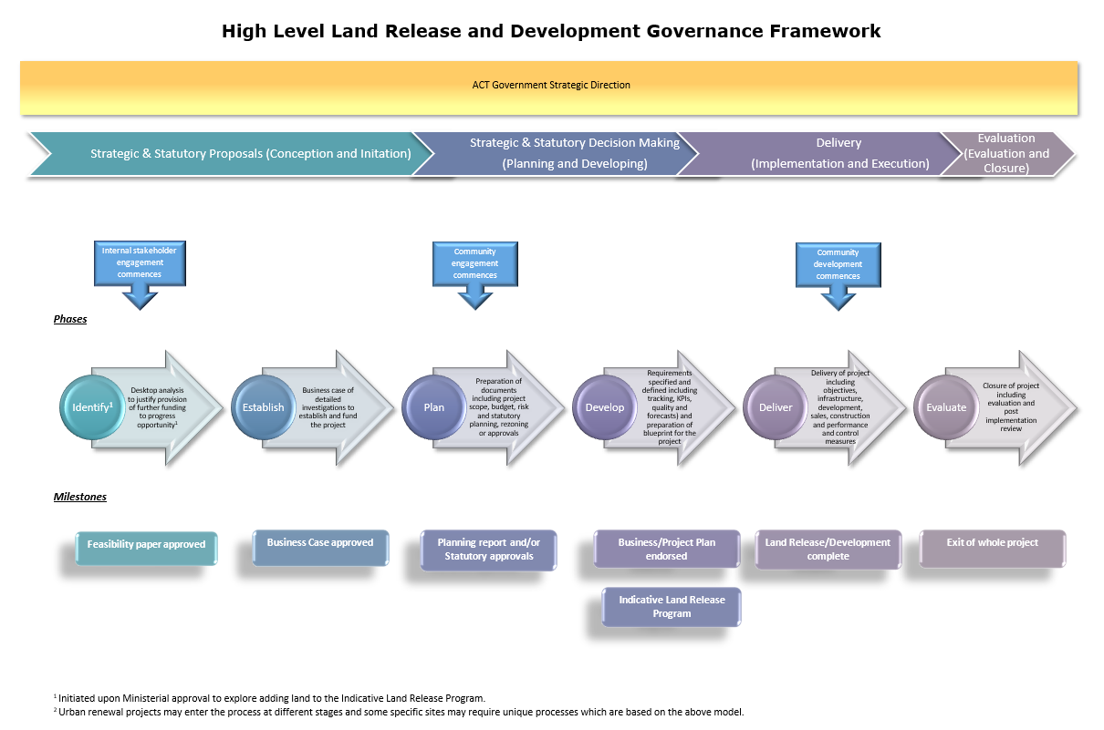

## Performance Workflow Land Framework

**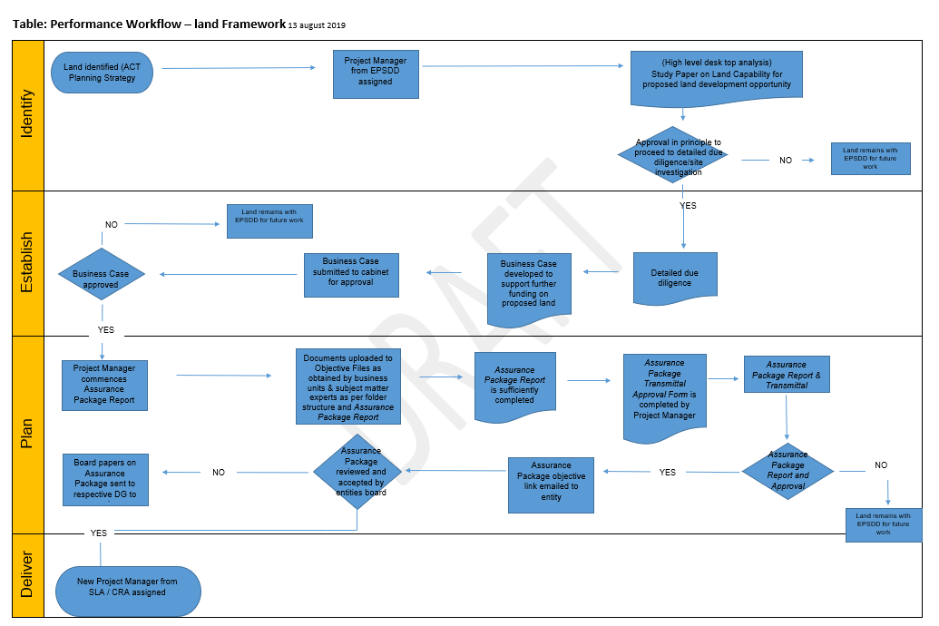**

**ACT Land Planning and Development Process Frameworks (June 2021)**

## Planning & Development Process Stages

The following are the land planning and development process stages for the respective processes.

* 1. **Urban and Infill**

The Urban Renewal and Infill (Brown) land planning, land release and development stages vary with each project.

* 1. **Unleased (Greenfields) and Leased Rural**

The unleased (Greenfields) and leased rural land planning, land release and development stages are detailed below Table 1 consists of the 7 Phases steps which are detailed in section 3.

**Table: Unleased (Greenfields) and Leased Rural Planning, Land Release and Development Stages**

NCP Land Use Zone Ready

NCP – DCP

NCP Guidelines

**ACT Planning Strategy**

&

**Transport for Canberra**

**Years**

25

10

5

4

1

**SLA or Englobo**

**Land Development**

Continual Update of Land Supply Pipeline

**EPSDD**

**Planning, Infrastructure and Design**

**Phases 1-7**

**Assessments & Studies**

Contamination

Heritage

Environmental

Bushfire Risk

Trees

Land Surveys

Geotechnical

Infrastructure & Services

Traffic

WSUD

Market

Community Needs

Preliminary Design

EPBC Requirements

EIS

**Strategic Advice**

Planning Investigations and Studies

Management of Major Infrastructure Works requirements

**Territory Plan (Statutory)**

Structure Plan

Concept Plan

Development codes

General codes

Precinct Code

Other Codes

**Variation to the Territory Plan**

to introduce new structure or concept plan or to change existing statutory requirements

Indicative Land Release Program and Major Infrastructure Works Program

**Years**

0

1

2

4

6

**Land Release - Phase 7**

Private sector – Deed of Agreement

Public Sector Land Development

(if applicable)

**Estate Development Plan** (subdivision) Development Application

Subdivision Construction

Dwelling Development Application and/or Building Certifier – Any block specific requirements such as higher construction standards applied

**Built Form**

Dwelling Construction

## Land Planning and Development – Phase Steps

The land planning and development phase steps provides details of processes.

**PHASE 1 – PLANNING CHECK**

**Phase 1A – Planning Strategy Consistency**

|  |  |  |  |
| --- | --- | --- | --- |
| Inputs:   * No budget funding required. * Development proposal or land acquisition opportunity – private or government. | Activities:   * Review proposal against the ACT Planning Strategy, Transport Canberra and the ACT Climate Change Strategy, The Territory and National Capital Plans and other available data. | Outputs:   * Advise D-G/Treasury/Cabinet of consistency or inconsistency of the proposal against ACT Government policies and seek agreement to proceed to Phase 1B if supported. | Example Projects: |

**Phase 1B – Desktop Analysis**

|  |  |  |  |
| --- | --- | --- | --- |
| Inputs:   * D-G/Cabinet agreement to commence preliminary desktop analysis of the proposal. * No budget funding required. | Activities:   * Engage with Treasury and prepare draft ‘Big picture business plan’ (BPBP) (district level) if required. * Prepare project specific gateway flowchart and propose timing. * Undertake high level desktop analysis including environment, traffic, infrastructure, contamination, heritage, trees, commercial, retail, density, community facilities and schools, playing fields and other planning matters. * Determine draft infrastructure capacities and preliminary costs to service the proposal. * Determine draft social infrastructure requirements and preliminary costings. * Obtain preliminary financial advice from directorates and agencies to use in the preparation of the BPBP. * Confirm tenure. * Determine potential draft future land release opportunities. | Outputs:   * Draft BPBP for Treasury/ Cabinet agreement to fund activities at the appropriate time in Phase 2 or later if required. * Determine budget funding requirements and if outside present funding agreements, prepare business cases as appropriate. * Advise D-G/Treasury/Cabinet on outcomes of analysis and seek agreement to proceed to Phase 2. | Example Projects:  Kowen, CSIRO Ginninderra  Or other government or private projects or submissions if supported. |

**PHASE 2 – PRELIMINARY PLANNING AND SITE INVESTIGATIONS**

**Project Due-Diligence and Planning Intentions**

|  |  |  |  |
| --- | --- | --- | --- |
| Inputs:   * BPBP funding from Treasury if required to complete due diligence and prepare other required documentation. | Activities:   * Undertake all detailed due diligence and strategic planning investigations including environment, heritage, contamination (including UXO), social and community needs and retail. This is to include expectations for schools, district level playing fields, major trails, retail and commercial facilities and roads and other infrastructure. * Undertake preliminary traffic and infrastructure investigations (including hydraulic and power) to determine capacity, servicing and upgrade requirements and costs including network costs. * Complete technical investigations including indicative development plan, cut and fill analysis, dwelling block density, dwelling block yields, and estimated estate development costs and statutory plans as required (includes concept plans/precinct codes and any other documentation to achieve an agreed planning outcome). * Prepare Territory Plan variation planning report and background documents including draft structure and statutory plans. * Prepare EPBC and ACT environmental approval documentation if required (EIS or S211 EIS exemption), other documents and applications based on draft structure plan and process for approvals. * Identification of possible timing for land release. * Engage with the SLA. * Undertake community consultation if appropriate. | Outputs:   * Draft Planning report to support rezoning including any draft structure plans and other statutory plans. * Draft documentation to support EPBC Act and ACT environmental approval processes to support a planning report if required. * Brief SLA Board. * Heritage, EPA and other approvals relating to studies undertaken to date. * Confirmation of land release timing. * BPBP review for Treasury/ Cabinet agreement to fund project specific activities in Phase 3 if required. * Advise Treasury/Cabinet on the outcomes of analysis and seek agreement to proceed to Phase 3. | Example Projects:  Eastern Broadacre  Symonston, Majura West and Fyshwick (EPBC and S211 and any statutory documentation) |

**PHASE 3 – DETAILED PLANNING, SITE INVESTIGATIONS & TRANSMITTAL TO SLA**

**Phase 3A – Statutory Rezoning and Approvals**

|  |  |  |  |
| --- | --- | --- | --- |
| Inputs:   * Revised specific BPBP funding from Treasury. * Completed planning and supporting reports. | Activities:   * Prepare and process Territory Plan variation and rezoning documentation (Planning Policy) and other statutory planning processes to deliver agreed planning outcomes and seek agreement. * Encourage the National Capital Authority to prepare and process National Capital Plan amendment documentation (if required) to coincide with Territory Plan variation. * Prepare major infrastructure expectations and delivery model(s) to coincide and integrate with estate development and design in accordance with timing in BPBP. Estate and major infrastructure provisions and delivery outcomes must be integrated design. * Engage with the SLA. * Determine ILRP timing for possible land release. | Outputs:   * Statutory rezoning for Territory Plan/ National Capital Plan approval. * Support to integration of major infrastructure provision with preliminary estate development and design and timing. * Endorsed planning requirements and controls in statutory planning documents. * EPBC Act approval. * ACT EIS (including infrastructure) approval(s). * Endorsed statutory and other plans, if required. * Brief SLA Board. * Identification of any further investigations or approvals required to be undertaken by the SLA. * Project identified on ILRP. * Agreement from Treasury/ Cabinet for specific BPBP funding for activities in Phase 3B if any are required. | Example Projects:  Kenny FUA and Molonglo Group Centre (statutory documentation). |

**Phase 3B – Planning and Infrastructure Adequacy Check**

|  |  |  |  |
| --- | --- | --- | --- |
| Inputs:   * Project BPBP and agreed funding from Treasury/Cabinet | Activities:   * Review previous planning to confirm that the outcomes are still relevant. * Review and confirm relevance of previous statutory approvals and conditions. * Engage with the SLA. | Outputs:   * Ensure all necessary (re)statutory approvals are in place or expected to be in place. * Funding for integrated major infrastructure design and construction and estate planning business cases approved. * Brief SLA Board. | Example Projects:  Kenny and Molonglo Group Centre |

**Phase 3C – Formal Transfer of Project to Suburban Land Agency**

|  |  |  |  |
| --- | --- | --- | --- |
| Inputs:   * No budget funding required. * Statutory rezoning and relevant environmental approvals. * Endorsed statutory plans, if required. * Revised BPBP if required. | Activities:   * prepare Transmittal package for land and project transfer to SLA including all statutory requirements as well as expected transfer values, yields and outputs and payments to Government, Director-General instrument and instructions to the SLA Board, timing, costs to transfer and SLA obligations. Includes integrated major infrastructure directions and delivery outcomes with estate planning. * Confirm need for Indicative Design Development Plan (IDDP) response by the SLA or an englobo developer. * Confirm land release timing. * Obtain land valuation. * Identification of any outstanding investigations or requirements for further investigations. * Engage with the SLA. | Outputs:   * Formal transmittal of project to SLA with all supporting information including targeted dwelling numbers and identification of any further investigations or statutory approvals required and requiring an IDDP submission by the SLA or an englobo developer. * Brief Treasury/Cabinet on transmittal occurrence and advise further submissions assessing performance on regular basis. * Confirmation of major integrated infrastructure works to service project/estate. * Integrated infrastructure works and estate construction funding business cases supported if required. * Brief SLA Board. | Example Projects: |

**Phase 3D – Suburban Land Agency Project Response**

|  |  |  |  |
| --- | --- | --- | --- |
| Inputs:   * Transmittal from the Directorate. * No budget funding required. | Activities:   * Pre-development testing and endorsement of options * SLA prepares Indicative Design Development Plan (IDDP). * SLA to prepare integrated major infrastructure provisions and estate delivery models to support land release in conjunction with EPSDD. * SLA or an englobo developer submits the IDDP and supporting documentation to EPSDD for endorsement and demonstrates that estate planning has been sufficiently resolved and addresses the requirements of EPSDD’s transmittal advice. | Outputs:   * Endorsement of the IDDP by EPSDD to proceed to detail infrastructure, estate and subdivision planning. * Endorsement by the EPSDD of the integrated major infrastructure and estate delivery methods. * Brief SLA Board. | Example Projects: |

**SLA PROJECT IMPLEMENTATION AND DELIVERY PROCESS**

**Suburban Land Agency Detailed Design and Land Response**

|  |  |  |  |
| --- | --- | --- | --- |
| Inputs:   * EPSDD endorsement of the IDDP. * EPSDD endorsement of the integrated major infrastructure and estate delivery methods. | Activities:   * SLA to prepare integrated major infrastructure provisions and estate delivery models. * SLA or an englobo developer to prepare detail subdivision design, Estate Development Plan, DA or preparation of deed of agreement for englobo release. * SLA or englobo developer to prepare estate development plan process and seek EPSDD endorsement. * SLA or an englobo developer to ensure consistency with Transmittal package and other approvals or need to seek re-approval from EPSDD. * SLA or an englobo developer to review previous statutory approvals to ensure currency and if required, seek re-approval. | Outputs:   * Endorsement of the detailed subdivision design, an Estate Development Plan and DA approvals. * Compliance with a deed of agreement in the case of an englobo land release. SLA or an englobo developer to gain Detailed Design and Construction approvals. * SLA or an englobo developer to ensure land release in accordance with the Land Release Program to the required dwelling block yields set out in EPSDD’s statutory documentation. | Example Projects:  Taylor, Jacka |

# Attachment B: Land MOU Template

**Memorandum of Understanding**

Between

**[name]**

[address]

And

**[NAME]**

[address]

[Date]

**RE: UNLEASED TERRITORY LAND TRANSFERS TO THE SUBURBAN LAND AGENCY FROM THE ENVIRONMENT PLANNING AND SUSTAINABLE DEVELOPMENT DIRECTORATE**

**Content**

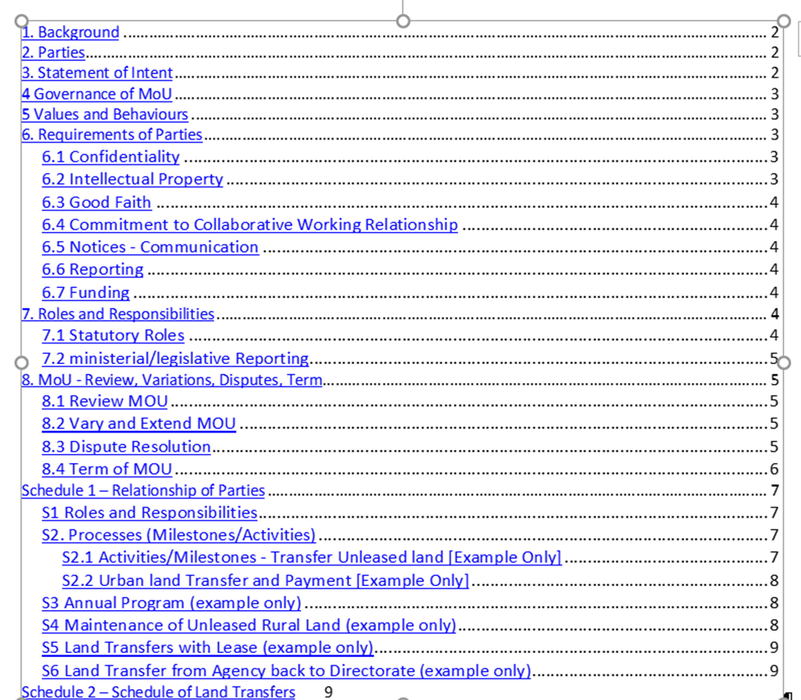

**1. Background**

The [party (name) e.g. Directorate is responsible for strategic and statutory planning in relation to Territory land. The Directorate’s function focuses on the governance of the administrative aspects of rural land including acting as custodian of unleased rural Territory land.]

The [party (name) e.g. Agency is responsible for delivering the ACT Government’s suburban development program, including urban renewal in established town centres and suburbs. This comprises land releases for residential, commercial, industrial, mixed use and community purposes.]

The parties have a shared commitment to the [e.g. delivery to the public of Territory land that has been identified for development. The Directorate transfers rural and urban Territory land to the Agency for this purpose.]

The parties are giving effect to their shared commitment by entering into this Memorandum of Understanding (MoU).

**2. Parties**

The parties to this Memorandum of Understanding (MoU) are:

1. [agency name], represented by the [position e.g. Deputy Director General], and
2. [agency name], represented by the [position e.g. Commissioner].

The contact officers for the MoU are:

1. [agency name]: [position and area e.g. Executive Branch Manager, Reporting], and
2. [agency name]: [position and area e.g. Chief Financial Officer].

**3. Statement of Intent**

This MoU sets out the understanding between the parties. The main intent of this MoU is to provide for an efficient, reliable, integrated, flexible and responsive framework in which the parties may manage the [e.g. transfer of rural and urban Territory land to the Agency from the Directorate for the purposes of development and/or delivery of the land for sale to the public].

The parties to this MoU share certain responsibilities in the provision of services to the community, and the performance of various statutory functions.

The parties intend that this MoU constitutes an enduring shared commitment to support the Government and its Ministers in the provision of services to the community.

This MoU is intended to be supplemented by Schedules (which may take the form of guidelines, governance documentation or specific arrangements) as required. Schedules may be reviewed, revised, or added to as required, by consent of the parties without a review of this entire MoU.

This MoU does not create any legal obligations between the parties.

**4 Governance of MoU**

Each party will make all reasonable efforts, within its business constraints, to give effect to the intent of this MoU.

This MoU and its Schedule(s) comprise the entire arrangement between the parties in relation to the subject matter of this MoU and it supersedes any priori representations, negotiations, writings or memoranda and agreements.

This MoU operates under requirements of Whole of Government ACT Land Policy and/or guidelines.

Land in this MoU excludes land held by other agencies on behalf of the Territory.

**5 Values and Behaviours**

All personnel, whether employees, consultants or contractors will provide services in the name of the respective parties in a manner that is consistent with the ACTPS values of respect, integrity, collaboration, and innovation enshrined in the Public Service Management Standards.

**6. Requirements of Parties**

This section covers the party’s requirements to confidentiality of information, intellectual property, good faith, dispute resolution and communication notices to parties.

**6.1 Confidentiality**

* Except as provided in this MOU, or under ACT Government law and policies, the parties commit not to disclose confidential information to any person without the prior consent of the party that provided the information, except to the extent that the confidential Information is:
* Required/ authorised to be disclosed by law;
* Disclosed to the ACT Government solicitors, auditors, insurers or advisers;
* Generally available to the public; or
* In the possession of a party without restriction in relation to disclosure.
* Each party will take all reasonable measures to:
* protect confidential information against loss, unauthorised access, use, modification; disclosure or other misuse in accordance with reasonable procedures for that purposes; and
* only provide authorised personnel with access to the confidential information.
* The confidential information includes that:
* which is or relates to documents, submissions, consultations, policies, strategies, practices and procedures of any party to this Agreement which are by their nature confidential;
* is notified (whether in writing or not) by one party to the other as being confidential; or
* is personal information.
* Confidential information does not include information that:
* is or becomes public knowledge other than by breach of Agreement;
* is required by law to be disclosed; or
* has been notified in writing to one party to another as not being confidential.

**6.2 Intellectual Property**

Ownership of any intellectual property rights in any contract material created by either party vests in the Territory.

Intellectual property means all statutory and other proprietary rights in respect of inventions, innovations, patents, utility models, designs, circuit layouts, mask rights, copyrights (including future copyrights), confidential information, trade secrets, know-how, trademarks and all other rights in respect of intellectual property as defined in Article 2 of the Convention establishing the World Intellectual Property Organisation of July 1967.

**6.3 Good Faith**

The parties acknowledge and commit that, in exercising any right, requirement or function, or in giving any approval or consent, or in deciding whether or not to agree to any proposed course of action set out in the MoU, each party will:

1. act reasonably and in good faith towards the other in relation to carrying out their activities under this MoU, and in law, and
2. provide all assistance reasonably required to enable each party to promptly carry out the activities under this MoU.

**6.4 Commitment to Collaborative Working Relationship**

The parties acknowledge that they will work collaboratively together towards fulfilling, and in accordance with the relevant laws, policies and requirements outlined and required for this MOU.

**6.5 Notices - Communication**

Any notice, or other communication, required to be given or sent to either party under the MoU must be in writing and given to, and acknowledged by, the relevant representative (the representatives means, in relation to each party, the representatives whose names and contact details are specified in Item 1 Schedule 1, or as notified in writing from time to time by one party to the other).

**6.6 Reporting**

The parties commit to report on an exception basis items relating to critical incidents and major issues as they may arise.

Communications will be conducted on an open and ongoing basis to support collaborative working relationship.

**6.7 Funding**

Unless otherwise stated in this MOU, or otherwise decided by the Parties, anything a Party does under this MOU agreement will be done at the Party’s cost without expectation of cost sharing or fiscal reimbursement from the other party.

**7. Roles and Responsibilities**

Specific roles and responsibilities are outlined at Schedule [1and 2].

**7.1 Statutory Roles**

Nothing in the MoU limits the independent role, function or decision-making authority of a statutory office holder.

**7.2 ministerial/legislative Reporting**

The parties commit that any ministerial briefings, regulations and/or responses to scrutiny relevant to this MoU are to be prepared by the lead party, being the [party e.g., that created the instrument under scrutiny]. Both parties commit to provide assistance to each other as required.

**8. MoU - Review, Variations, Disputes, Term**

This MoU sets out the understanding between the parties on the term of and the management of the MoU.

**8.1 Review MOU**

The parties commit to the review of this MoU regularly [insert timeframe e.g. annually or at least once every Xyrs or event trigger if required] after its execution or sooner as necessitated by changes or by the mutual consent of the parties.

**8.2 Vary and Extend MOU**

This MoU may be varied or extended only by the written consent of the parties prior to the expiration of this MoU.

**8.3 Dispute Resolution**

The parties recognise that the relationship between the parties is one of mutual respect and collaboration and a genuine partnership. Accordingly, both parties commit to working together to reach a position of consensus on matters of mutual interest whenever possible.

If a dispute (meaning a difference that cannot readily be resolved between the parties in relation to financial management, delivery or performance) arises in relation to this MoU, the parties commit to resolve the dispute by negotiations, including by referring the dispute to people who have authority to intervene and direct some form of resolution.

As a general principle, dispute resolution should in the first instance involve a meeting between the parties at the lowest appropriate level to clarify the issue and reach a prompt resolution through discussion. If no resolution can be achieved at this level, the matter should be referred by the following steps:

1. First by the individuals in dispute to their line manager/s for resolution
2. If a matter cannot be resolved at manager level, it should be escalated to the relevant Executive Branch Manager (EBM) or equivalent/appropriate level for resolution, and
3. If a matter remains unresolved or cannot be agreed at EBM or equivalent/appropriate level with a reasonable period, the matter will be referred to the representatives of the agencies (Section 2) to settle a final position on the matter.

**8.4 Term of MOU**

This MoU commences on the Commencement Date [date] or the date that this MoU is signed by the last party, whichever is later, and continues unless and until either:

1. the parties determine in writing that all actions outlined in this MoU are no longer required; or
2. the operations of one of the parties is discontinued or changed substantially in relation to its core functions; or
3. by any other mutual consent; or

d) either party providing 30 days written notice to the other party advising that they wish the MoU to cease. This MoU will then cease after the 30th day following this notice.

………………………………………. ……………………………………….

Signature of Signature of

Name: Name:

Position: Position:

Agency: Agency:

Date: Date:

**Schedule 1 – Relationship of Parties**

The following are the delineation for the roles and responsibilities of the respective parties to this MOU.

**S1 Roles and Responsibilities**

1. [name]

In support of this MoU, [name] will:

* 1. [List responsibilities]

1. [name]

In support of this MoU, [name] will:

* 1. [List responsibilities]

**S1.1 Scope**

1. The MoU outlines the key land development activities relevant to the transfer of Territory land between party and the party. The MoU does not contain a comprehensive list of activities undertaken at each stage of the development process.
2. This process applies to all Territory land transferred from party. Land acquired by the party from third parties are not within the scope of this MoU.

**S2. Processes (Milestones/Activities)**

[Outline the processes (and/or milestones/activities) and requirements in the transfer of land]

**S2.1 Activities/Milestones - Transfer Unleased land [Example Only]**

The planning and development process as set out in the below Transfer Process Steps outlines the milestones in the unleased Territory land transfer between the Directorate and the Agency.

**Transfer Process Steps:**

**T1**

At the completion of “Phase 3 – Statutory Rezoning and Approvals” (see schedule 2) and prior to the commencement of “Phase 4 – Review Planning and Major Infrastructure Provision”, the Directorate will transfer custodianship to the Agency. This is a precursor for the Directorate to obtain valuation to determine the nominal value of the land.

**T2**

The Directorate obtains valuation of the land in its current condition for the permitted use at the time just prior to the commencement of the due diligence process. Valuations will be determined on a GST exclusive basis.

**T3**

On completion of valuation the Directorate prepares the transmittal package for provision to the Agency to transfer custodianship of the land to the Agency.

**T4**

The Directorate will retain due diligence (Due Diligence means, the activities related to land investigations, land capability, environmental assessments, ecological assessments, lease checks, Territory Plan controls etc. to ensure a site is ‘de-risked’ to the extent practicable prior to approval for development and/or sale.) activities and land management of the site until the completion of “Phase 4 – Review Planning and Major Infrastructure Provision”.

**T5**

* The Agency prepares the Estate Development Plan (EDP) or equivalent development approval for the site and lodges the approval request with the approving authority, the Directorate.
* The Directorate issues a Notice of Decision approving the EDP to the Agency.

**T6**

* The accounting treatment of the land transfer is as follows. Once the Schedule of Land Transfer is approved by both parties, the Agency raises a liability in its accounts for the acquisition for the amount owing based on the valuation.
* The Directorate raises a corresponding receivable in its Territorial accounts.
* The Agency pays the Directorate upon settlement of the individual blocks. Assets are to be transferred at fair value based on the ‘highest and best use’ (ACT Land Transaction Policy) of the transferor.

**S2.2 Urban land Transfer and Payment [Example Only]**

The activities/milestones in the urban infill unleased Territory land transfer payment process steps outlined below are:

**Payment Process Steps:**

**P1**

The Agency receives a notification from the Directorate that a transmittal package is being prepared. This is a precursor for the Agency to obtain valuation to determine the nominal value of the land.

**P2**

Post valuation, the Directorate raises a Schedule of Land Transfer request (see Schedule 2).

**P3**

The Directorate undertakes the due diligence process for the site.

**P4**

If required, the Agency prepares the Estate Development Plan (EDP) or equivalent development approval for the site and lodges the approval request with the approving authority, the Directorate.

**P5**

If required, the Directorate issues a Notice of Decision approving the EDP to the Agency.

**S3 Annual Program (example only)**

Linking to the Governments ILRP and agreement by the government an annual program of proposed transfers and payments will be provided to the Directorate as part of the annual budget process and updated at each budget review. This program will set out the expected timing of the transfer of land and the timing of the payment for the land.

**S4 Maintenance of Unleased Rural Land (example only)**

Unleased land will be maintained by the Directorate post transfer and prior to release for sale to the public unless funding arrangements for maintaining land provide otherwise.

Funding arrangement means the funding that is specified in annual ACT Budget Papers and approved as part of an Appropriation Act for the period identified.

**S5 Land Transfers with Lease (example only)**

Land that is transferred to the Agency by the Directorate that is under a lease, will have that lease transferred to the Agency.

**S6 Land Transfer from Agency back to Directorate (example only)**

Where an environmental offset has been identified during the due diligence process, the Agency will be required to transfer the land to the Directorate at nominal value.

**Schedule 2 – Schedule of Land Transfers**

Serial Number /202X

**SCHEDULE Of LAND TRANSFER**

|  |  |
| --- | --- |
| Transferring Agency | Name |
| Acquiring Agency | Name |
| Date of Transfer |  |

**THE FOLLOWING LAND/ASSETS HAS BEEN TRANSFERRED:**

|  |  |
| --- | --- |
| **Description** | **Land Value** |
| Include a full description of the land as described in a map (map and section number to be attached). | Basis of the market valuation to be detailed and valuers report to be attached. |

|  |  |  |  |  |
| --- | --- | --- | --- | --- |
| **Asset Identifier** | **Capital Value** | **Useful Life** | **Current Insured Value** | **Date** |
| Land |  |  |  |  |
| Land Improvements |  |  |  |  |
| Buildings |  |  |  |  |
| Accumulated Depreciation |  |  |  |  |
| Leasehold Improvements |  |  |  |  |
| Accumulated Depreciation |  |  |  |  |
| Property Plant and Equipment |  |  |  |  |
| Other (specify) |  |  |  |  |

|  |  |  |
| --- | --- | --- |
| **Financial Details** | **Previous Year**  **$’000** | **Current Year**  **$’000** |
| Total full year revenue (non-GPO) |  |  |
| Total full year expenses - comprising |  |  |
| Utilities |  |  |
| Repairs & maintenance |  |  |
| Other works & expenses |  |  |
| Total full year capital funding |  |  |

|  |  |  |
| --- | --- | --- |
| **Signatures** | **Transferring Agency** | **Receiving Agency** |
| Signature |  |  |
| Name |  |  |
| Position |  |  |
| Date |  |  |

**Glossary**

* **Carrying amount** is the amount at which an asset is recognised after deducting any accumulated depreciation and accumulated impairment losses (AASB 116). Carrying amount is used interchangeably with book value.
* **Cost** is the amount of cash or cash equivalents paid or the fair value of the other consideration given to acquire an asset at the time of its acquisition or construction or, where applicable, the amount attributed to that asset when initially recognised in accordance with the specific requirements of other Australian Accounting Standards, e.g. AASB 2 Share-based Payment (AASB 116).
* **Fair value** is the price that would be received to sell an asset or paid to transfer a liability in an orderly transaction between market participants at the measurement date (AASB 13).
* **Inventories** are assets: (a) held for sale in the ordinary course of business; (b) in the process of production for such sale; or (c) in the form of materials or supplies to be consumed in the production process or in the rendering of services. (AASB 102)
* **Net realisable value** is the estimated selling price in the ordinary course of business less the estimated costs of completion and the estimated costs necessary to make the sale (AASB 102)

|  |  |  |  |
| --- | --- | --- | --- |
| Version | Date | Author | Revision notes |
| 1.0 | 1 May 2022 | Financial Reporting and Framework Branch | First release |

ACTGov_inline_black.wmf

Chief Minister, Treasury and Economic Development Directorate

May 2022