Cover Page

Law Courts of the   
Australian Capital Territory

Contract Summary

June 2016

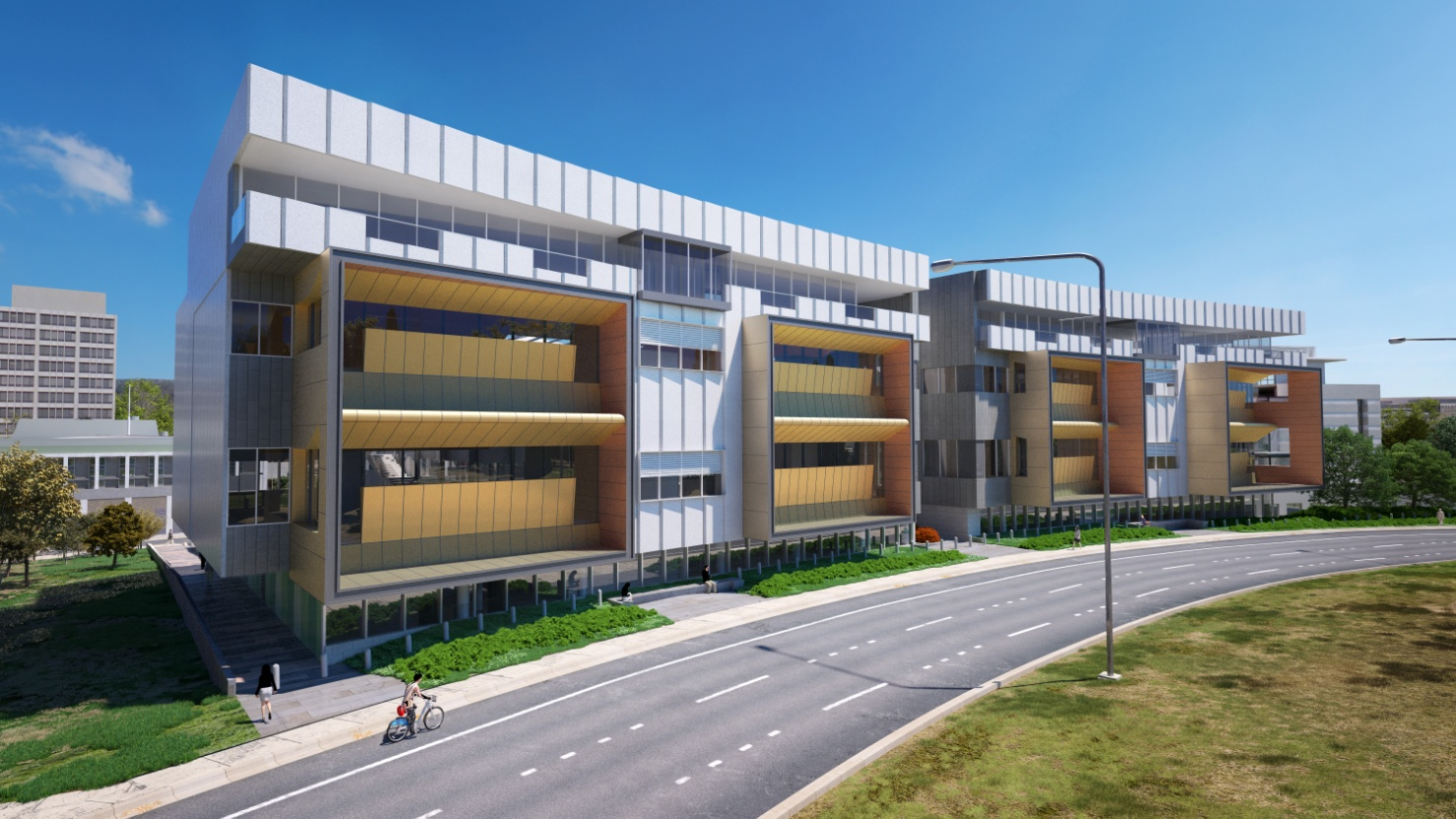



Foreword

This Project Summary provides information about the contractual nature of the ACT Law Courts Project (Project) as at the point of Financial Close.

The first part of this summary provides a broad overview of the Project, including the rationale for undertaking it as a Public Private Partnership (PPP), a summary of the tender process, the value-for-money calculation for the Project and the Project timetable. The second part focuses in more detail on the key commercial features of the Project, including the main parties and their general obligations, the broad allocation of risk between the public and private sectors and the treatment of various key Project issues.

The ACT government is committed to providing better services by expanding and improving the Territory’s public infrastructure and service delivery and, where appropriate, using private sector expertise to design, finance, build, operate and maintain infrastructure projects. To achieve this objective the ACT government has set out in *The Partnerships Framework – Guidelines for Public Private Partnerships* to provide a transparent framework for the development and delivery of PPP projects. The Partnerships Framework adheres to the *National Public Private Partnerships Guidelines* and links with existing government policy on capital procurement and funding. Further information on the framework is available at <http://apps.treasury.act.gov.au/partnerships-framework>.

This summary should not be relied on as a complete description of the rights and obligations of the parties in respect of the Project which are governed by the ACT Law Courts Project Agreement and associated Project documentation. The Project Agreement is available online at [www.procurement.act.gov.au/contracts](http://www.procurement.act.gov.au/contracts).

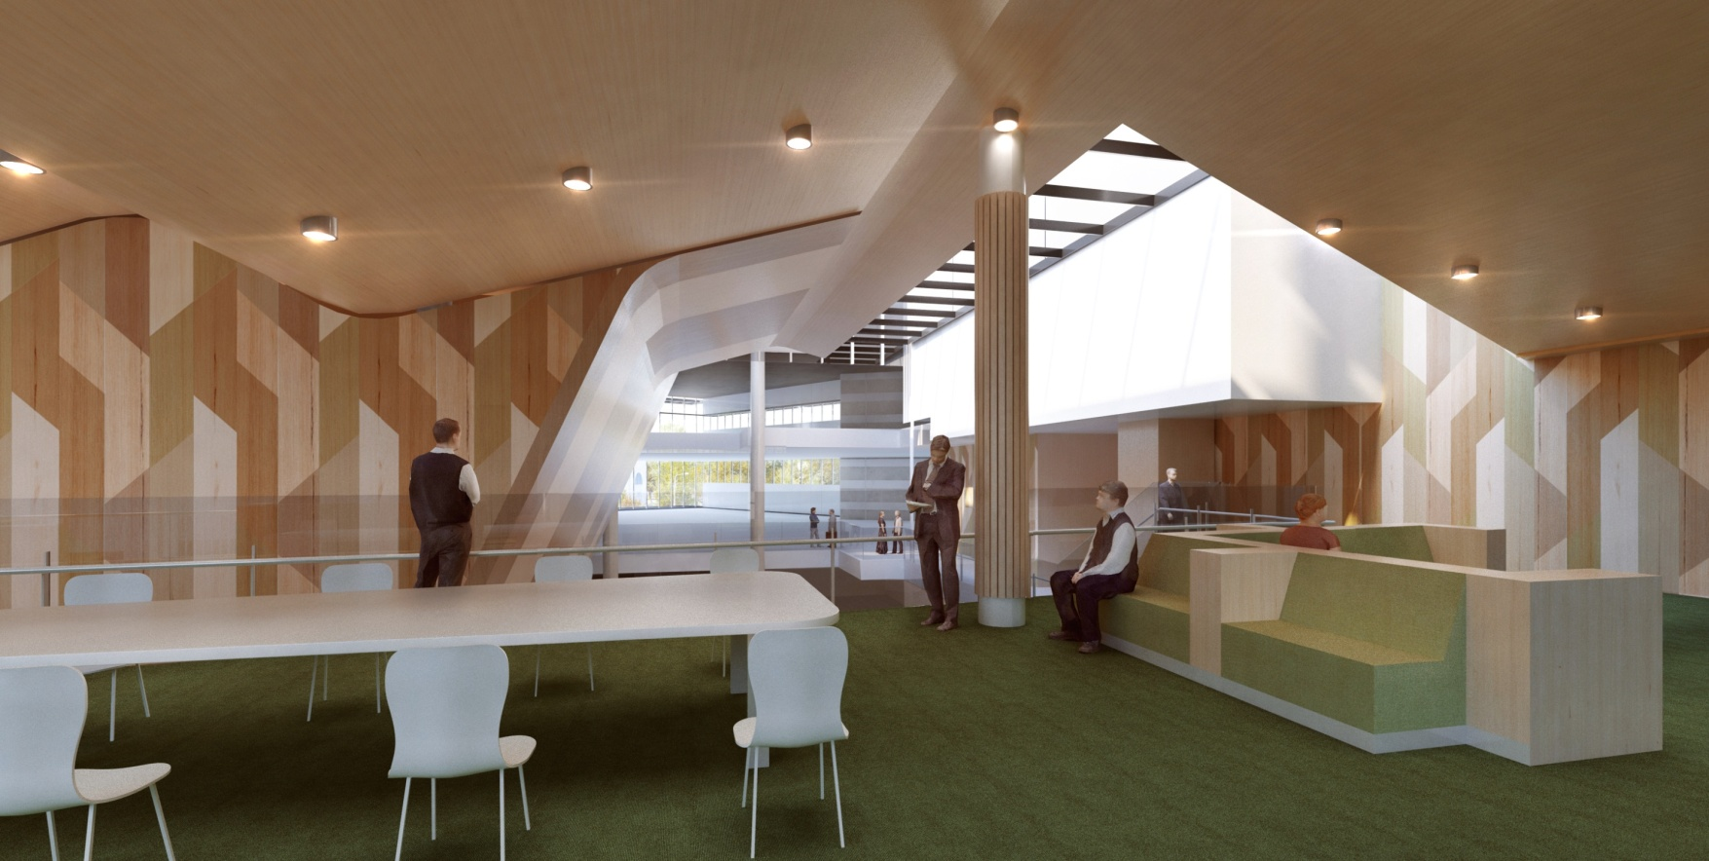

Contents

1.0 Project Overview 1

1.1 The ACT Law Courts Project 1

1.2 ACT Partnerships Framework 8

1.3 Tender Process 9

1.4 Value for Money 11

1.5 Project Milestones 16

2.0 Commercial Features 17

2.1 Project Documents 17

2.2 Parties to the Project Agreement and Documents 17

2.3 Risk Transfer 18

2.4 General Obligations of Juris Partnership 21

2.5 General Obligations of the Territory 23

2.6 Payment Mechanism and Abatement Regime 23

2.7 Default, Termination and Step-In Regimes 26

2.8 Finance 27

2.9 Fitness for Purpose 28

2.10 Territory Rights at Expiry of Contract 28

2.11 Current Version 28

Appendix A – Glossary 29

Appendix B – Useful references 31

Appendix C – Key contact details 32

Appendix D – RFP Evaluation Criteria 33

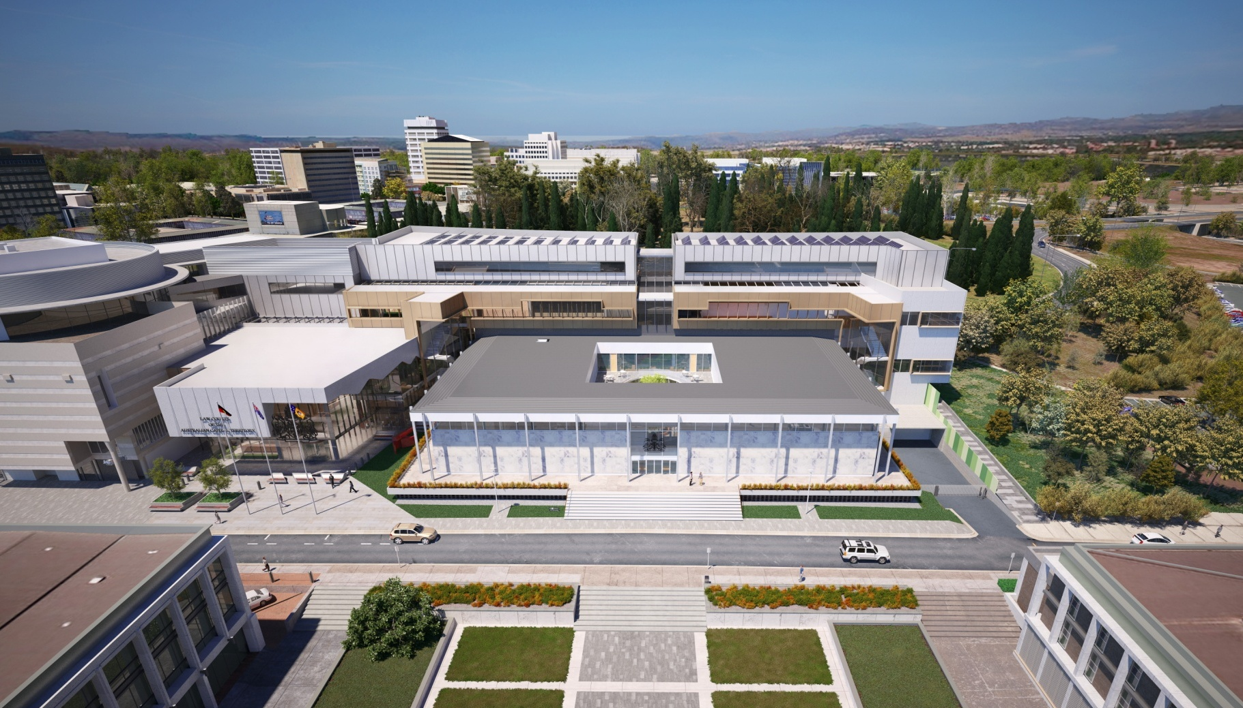



© Copyright Government of the Australian Capital Territory. This publication is copyright. No part may be reproduced by any process except in accordance with the provisions of the Copyright Act 1968.

This document is to be attributed as the ACT Law Courts Contract Summary.

Edition 1 - June 2016

# Project Overview

## The ACT Law Courts Project

### Overview

On 14 December 2015 the government of the Australian Capital Territory (Territory) entered into an Agreement with Juris Partnership for the design, construction and financing of a major redevelopment to the existing courts precinct including the provision of a range of facilities management and support services for the combined Courts Facility over a 25-year period.

The Project represents an investment of $160 million (capital expenditure) in the courts precinct and will provide the Territory with a contemporary and fit-for-purpose facility that is capable of meeting the needs of the judicial community for the foreseeable future. In addition, enhanced justice support, custodial and remote witness facilities will ensure that judicial processes are able to comply with changing legislation and maintain the safety and dignity of all participants.

The Project is the first social infrastructure Public Private Partnership (PPP) project to be undertaken by the Territory. The PPP procurement approach was selected to ensure that competitively driven innovation in design, delivery and whole-of-life considerations were captured in delivering an optimum outcome for this complex Project.

1. Figure : View of New Facility from Vernon Circle

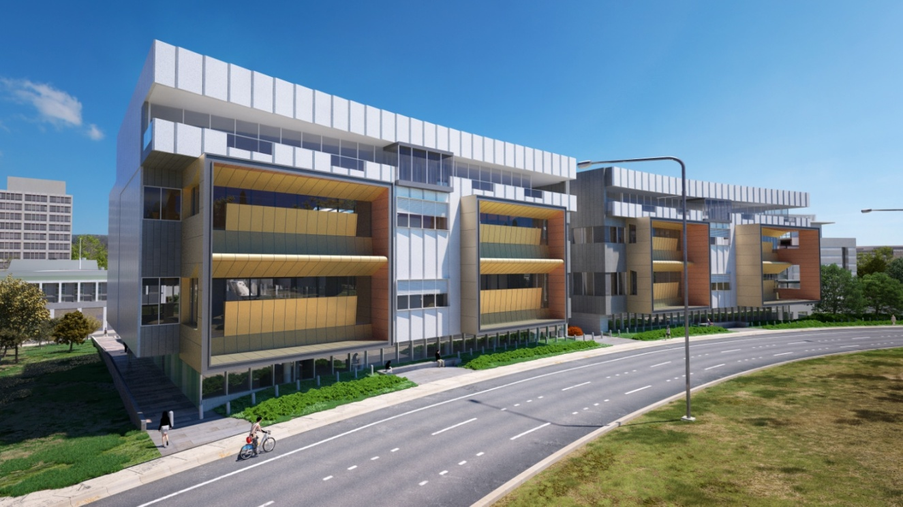

### The Consortium

The major members of the Juris Partnership consortium include Laing O’Rourke Australia Construction Pty Ltd (builder and equity investor), Macquarie Corporate Holdings Pty Limited (equity investor and financial adviser) and Programmed Facility Management Pty Ltd (facilities manager). These consortium members all have national and international experience in delivering social infrastructure PPPs.

### The new facilities

The project will create a combined Law Courts facility for the Australian Capital Territory (ACT) which will maximise operational efficiencies whilst still respecting the separate jurisdictions of the Supreme Court and the Magistrates’ Court.

New-build facilities for the Supreme Court will be constructed to replace the out-of-date accommodation currently located in the 50-year old heritage listed building located adjacent to the Magistrates’ Court building.

The new Supreme Court will be located within a four-storey building to be constructed along Vernon Circle (see Figure 1) and will also occupy parts of the existing Supreme Court building following its reconfiguration.

A new public entrance and registry area will be built in the open space between the two existing buildings to connect the Supreme Court and Magistrates’ Court and provide access to common facilities for members of the public and the legal community (see Figure 2). The existing Supreme Court building will be fully refurbished to accommodate judicial and other functions and will be fully integrated into the completed facility in a way that respects and retains its unique heritage value.

1. Figure : New combined court entrance



The new Supreme Court will include eight courtrooms – five of which will be jury courtrooms – and has been designed to accommodate a total of ten courtrooms (including eight jury courtrooms) in the future.

The Magistrates’ Court will continue to operate with eleven courtrooms, all of which will be upgraded to provide modern audio-visual and remote witness capabilities and improved acoustic performance. In addition, the Magistrates’ Court will gain one new hearing room.

The ACT Law Courts project will also deliver a new and expanded custodial facility, dedicated vulnerable witness suite, new mediation suite, dedicated parole board hearing room, a combined and centralised registry area, new jury facilities and accommodation for a range of judicial and community support functions.

### The Project site

The Project will be delivered on the site on which the Supreme Court Building and the Magistrates’ Court Building are currently located as shown in Figure 3. A key feature of the site is the precinct around Knowles Place containing the existing Supreme Court, Reserve Bank and the City Police Station. The centre-line of this precinct, that bisects the Supreme Court building, is aligned with University Avenue and is one of the prominent axes in the original Griffin Plan for Canberra.

1. Figure : Project Site (existing)

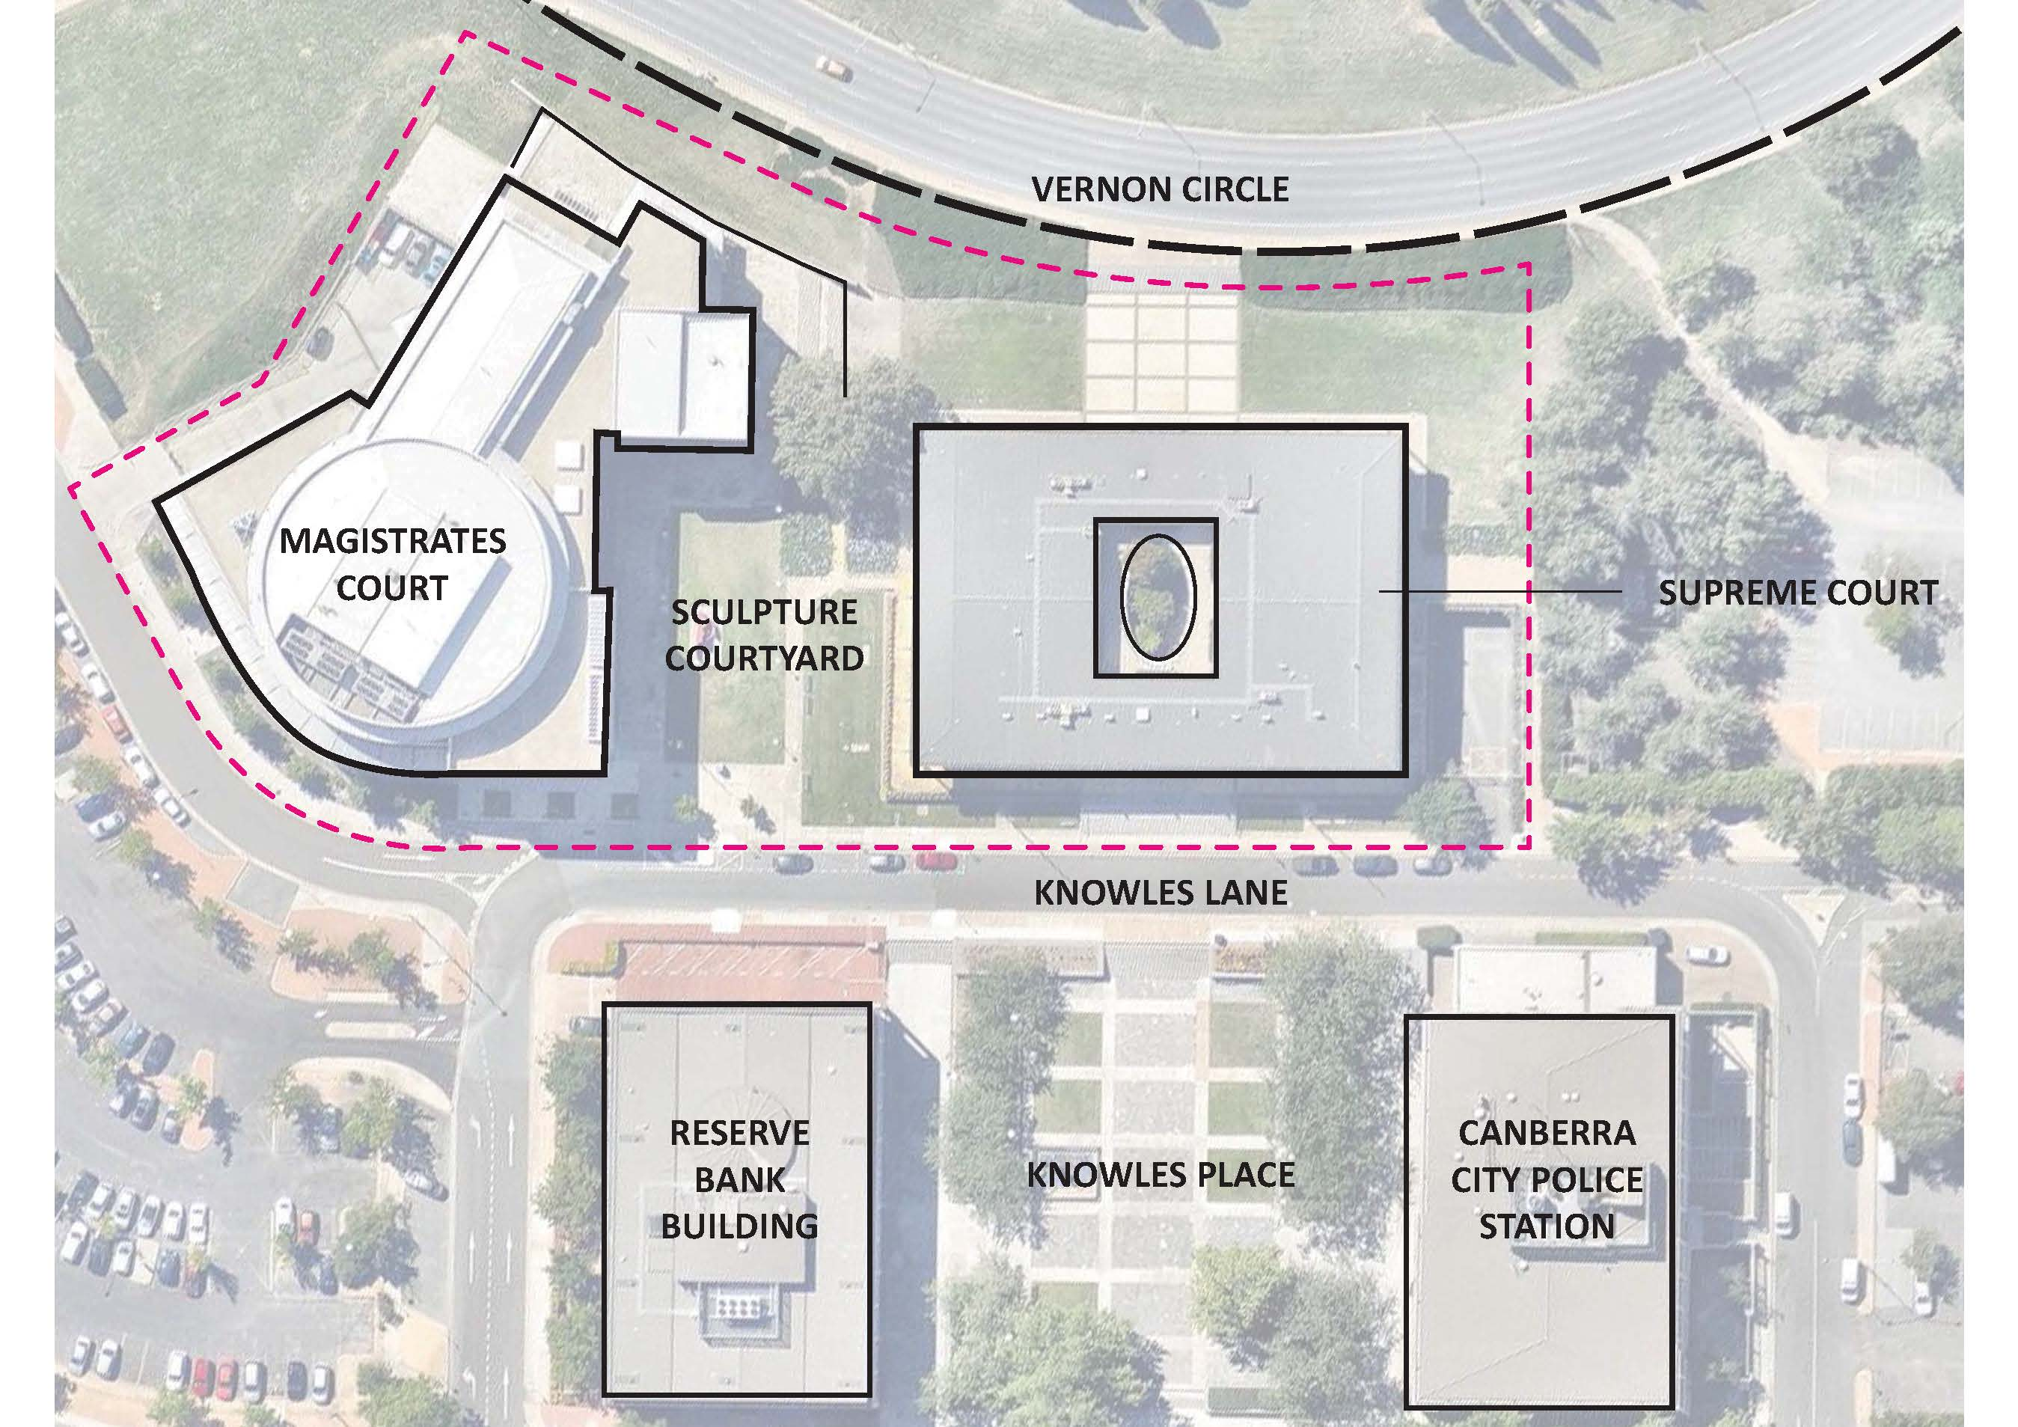

City planning and heritage considerations for the redevelopment are of paramount importance and throughout the planning and procurement stages the Territory has, and continues to, consult extensively with the National Capital Authority, the Heritage Council, the Government Architect and other interested parties.

In particular, planning for the redevelopment has placed high levels of importance on the following matters:

* retention of the internal geometry of the Supreme Court building
* responding to the University Avenue axis through transparency and building form
* retaining the marble clad façade and other significant heritage elements of the Supreme Court building
* maintaining the visual relationship between the three buildings around Knowles Place.

Despite the constrained nature of the site, development and expansion opportunities exist between the two buildings and to the Vernon Circle side of the Supreme Court building.

Figure 4 indicates the positioning of the new structures on the site plan to expand and integrate both of the existing court buildings.

Figure : Project Site and building demarcations

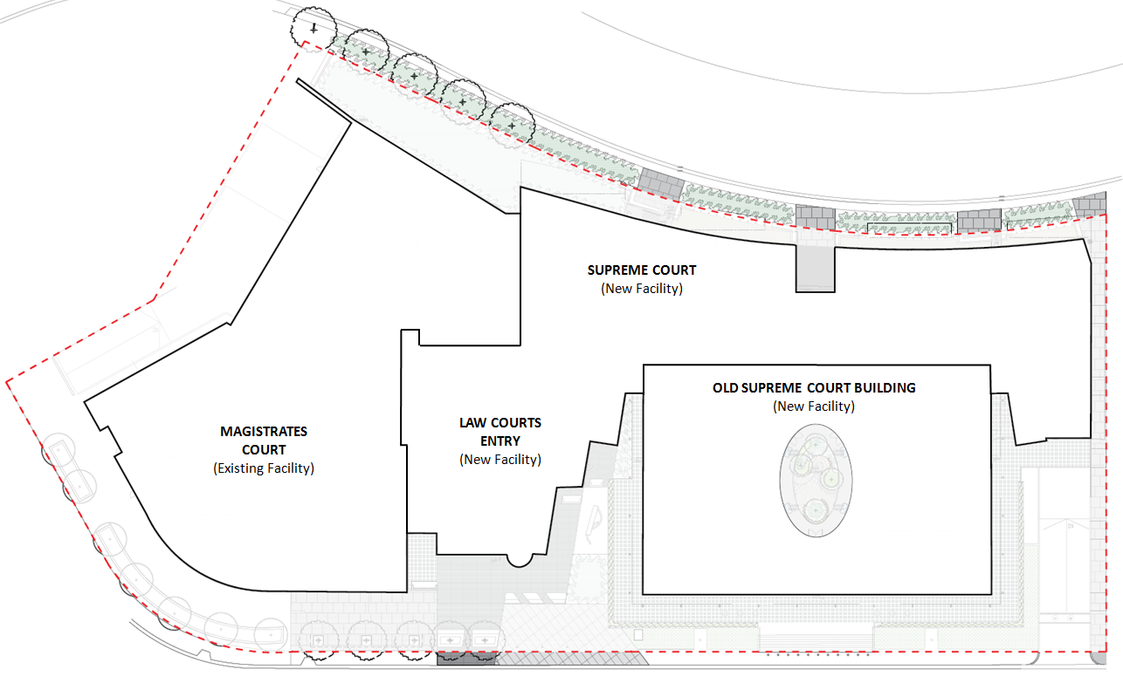

### Integration requirements

The Project will also deliver full integration between the existing Magistrates’ Court building, the new facility to be constructed, and the existing Supreme Court building that will be retained and fully refurbished. For the purposes of delineating certain areas of risk and responsibility, the Project Agreement sets out different terminology for various parts of the Courts Facility. These designations are indicated in Figure 4 and described below.

* New Facility – the newly constructed parts of the Courts Facility together with the fully refurbished Supreme Court building.
* Existing Facility – the Magistrate’s Court building, comprising of areas that remain substantially unchanged following the completion of the D&C Phase and Reconditioned Areas.
* Reconditioned Areas – those parts of the Magistrates’ Court building that will be substantially reconfigured and refurbished to deliver the integrated design solution.

For the Existing Facility, certain risks pertaining to pre-existing building conditions are not transferred to Juris Partnership. However, the refurbishment of the Supreme Court building is treated as if it were a new-build aspect of the Project and Juris Partnership takes the risks associated with the existing condition and the building’s structure.

In addition to the works required to connect the New Facility with the Existing Facility, the Project will deliver full integration of building services, courtroom technology systems, communications and security across the whole of the Courts Facility. The Territory’s existing network will also be reconfigured to provide a coherent installation across the whole of the site.

### Staging of the works

In order that the Supreme Court can continue to operate during the construction of the new building, the works are broken into two distinct stages. These stages are indicated in Figure 5.

1. Figure : Project staging

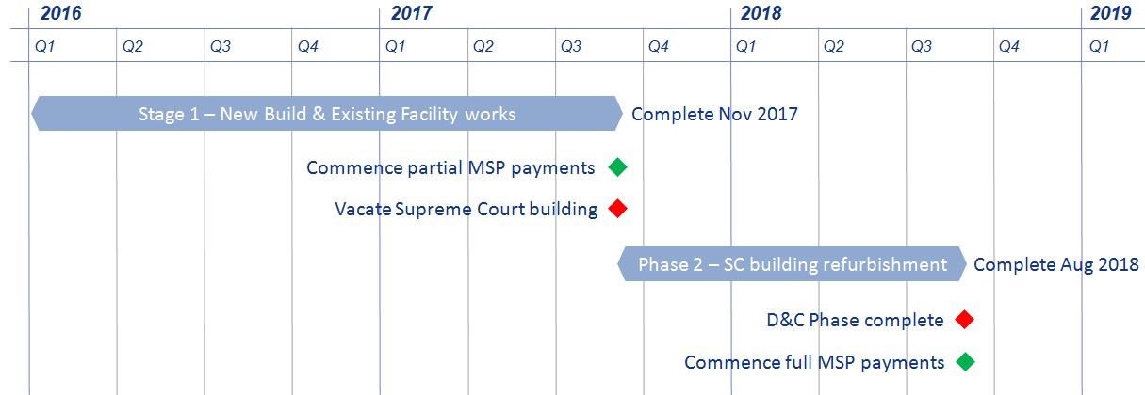

### Project objectives

The Project’s primary objective is to provide the Australian Capital Territory with judicial facilities that have the capacity and contemporary technologies to meet the needs of the justice community for the next period of Canberra’s growth.

A focus on integrating the currently separated Magistrate’s Court and Supreme Court buildings, together with honouring the heritage of the site, respecting jurisdictional identities, and providing for the safety and dignity of all participants in the judicial process, will ensure that the new Courts Facility will provide an outstanding environment for the legal community.

The following sections provide more detail on the key design objectives for the Project.

#### Functional integration

* The design of the New Facility will combine seamlessly with the Magistrates’ Court to create an integrated Courts Facility that is efficient, functional, and will deliver whole-of-life operational efficiencies for the Territory.
* The Courts Facility will respect the individual jurisdictional identities of the Supreme Court and Magistrates’ Court.
* The experience of the public court users (legal profession, litigants, witnesses, etc.) in attending the Courts Facility will be of a functionally integrated, single facility.
* Operational efficiencies will be achieved through integration of the Court Facility and the provision of Services across the Court Facility; and
* Through connections, shared spaces and design continuity ensure that collegiality and strong working relationships are facilitated across court jurisdictions.

#### General court design requirements

* Provide an efficient, contemporary and safe environment for all users of the Courts Facility, including the judiciary, magistracy, staff, legal profession, litigants, witnesses, defendants and persons in custody.
* The Courts Facility will:
  + be welcoming to the public without an institutional feel;
  + be accessible for all users;
  + provide for the effective security of participants in the operations of the courts both within courtrooms and within other areas of the building;
  + make use of the latest technology to support ‘e-courts’, remote witnesses, remote defendants, in-court presentation of evidence and exhibits and security;
  + deliver intuitive and effective way-finding through interior design and the use of artworks as well as through signage;
  + maximise opportunities for natural light and external views and incorporate other design strategies to provide a calming environment to reduce anxiety in areas where stress and the potential for conflict may occur;
  + acknowledge the history of the site and the traditional owners of the land; and
  + not compromise the dignity of defendants, including persons in custody.

#### Future proofing

* The Courts Facility will be sufficiently flexible to accommodate future growth – both in regard to physical expansion and for changes in technology and court processes.
* The New Facility must incorporate the necessary infrastructure and provide an appropriate ‘chassis’ to accommodate the future growth through the provision of additional criminal courtrooms.

#### Urban, civic and heritage design

* The design will deliver a solution, internally and externally, that befits an important civic building in a prominent location that is recognised as an exceptional example of civic and heritage conservation design.
* The New Facility design will respond appropriately to the wider context of the urban planning requirements for Canberra.
* The design of the Courts Facility will:
  + be reflective of a Territory identity, strongly relate to the Site and acknowledge the Griffin Plan and legal precinct;
  + respect the location of the building and its orientation with the axis of University Avenue and its significance to the municipal axis within the Griffin Plan and proximity to City Hill;
  + add significantly to the public realm of the City Hill and create a precinct with a strong sense of identity;
  + through its architecture and interior design, establish a symbolism appropriate to the dignity and function of a law court;
  + take maximum advantage of the views to City Hill, Black Mountain and the Brindabella Ranges;
  + convey a sense of strength, stability and independence;
  + complement and respect the heritage value of the location and the existing Supreme Court.

#### Sustainability

* The New Facility will adopt a best practice approach to Environmentally Sustainable Design outcomes and achieve a minimum 5-star rating under the Green Buildings Council of Australia’s public buildings, as-built tool.
* Through integration with the New Facility, the energy performance of the Existing Facility will, where practicable and affordable, be improved to maximise the whole-of-life efficiency of the full Courts Facility.

## ACT Partnerships Framework

#### Background

The Project is being delivered as a PPP in accordance with the Territory’s *The Partnerships Framework*. *The Partnerships Framework* model seeks to achieve better value for money by capturing the expertise and efficiencies of the private sector in designing, financing, building and maintaining infrastructure projects and providing services on a whole-of-life basis where appropriate.

*The Partnerships Framework* sets out ACT specific policy requirements, but otherwise PPP projects in the Territory are delivered with regard to the National PPP Policy and Guidelines (National PPP Guidance) that apply across all State, Territory and Commonwealth arrangements.

Details of the National PPP Guidance and *The Partnerships Framework* are available at: <https://infrastructure.gov.au/infrastructure/ngpd/> and <http://apps.treasury.act.gov.au/partnerships-framework> respectively.

#### Procurement Assessment

In 2013 and early 2014, during the business case development phase, the Territory considered a range of procurement models and identified several delivery methods for detailed assessment, such as:

* unbundled construction based models that separate the procurement of the design and construction of the new facility from its ongoing maintenance and other services
* construction based models that include an element of facility maintenance typically of hard facilities management but with no soft facilities management
* a PPP procurement model that includes hard facilities management, soft facilities management and selected judicial support services.

A range of key procurement drivers were considered in evaluating each of the above-mentioned models that included ensuring the achievement of:

* timely delivery of the Project
* optimal whole-of-life costs and value for money
* optimal risk allocation
* an efficient and appropriate facility design (including safe and secure)
* certainty of costs over the life of the asset
* service and maintenance standards over the life of the asset
* flexibility in operations over the life of the asset
* innovation in asset and service delivery
* a competitive outcome.

After a detailed assessment of the various delivery models, a PPP procurement model was identified as the preferred option. This was assessed as the preferred procurement model primarily on the basis that:

* the risk transfer possible under a PPP approach would allow the Territory to retain minimal risk on the complex design and construction challenge of the Project as a brown-field development
* PPP delivery is the only delivery method that transfers maintenance and facilities management risk, site risk, asset capability risk and interface risk to the private sector in an integrated contract
* PPP delivery provides optimal whole-of-life costs as the private sector is responsible for long-term maintenance and facilities management in addition to design and construction, which should drive an optimal whole-of-life outcome
* there was evidence of sufficient market depth to allow the Territory to achieve a competitive outcome through this model.

The procurement assessment was supported by the business case undertaken for the Project.

## Tender Process

The Territory conducted a competitive tender process to identify the private sector party to deliver the Project. The tender process was implemented in accordance with *The Partnerships Framework* to ensure that the Territory received the best value-for-money outcome.

The tender process involved a call for registrations of capability from the market (through the issue of the Invitation for Expressions of Interest (IEOI) document); receipt of EOI submissions; issue of a Request for Proposal (RFP) to short-listed respondents; submission of Proposals; and an evaluation and clarification phase followed by the appointment of a Preferred Respondent and finalisation of contractual documentation for execution.

1. Table : Key procurement milestones

| Date | Tender Stage |
| --- | --- |
| 10 July 2014 | Invitation for EOI issued |
| 15 August 2014 | EOI proposals submitted |
| 07 October 2014 | Shortlist of respondents selected |
| 19 December 2014 | RFP issued |
| 29 May 2015 | RFP proposals received |
| 23 October 2015 | Preferred Respondent announced |
| 14 December 2015 | Contract Close |
| 17 December 2015 | Financial Close |

A formal project governance structure was put in place to oversee the tender process including the evaluation of the detailed RFP Proposals. The governance structure is represented diagrammatically in Figure 6.

1. Figure : Project evaluation structure

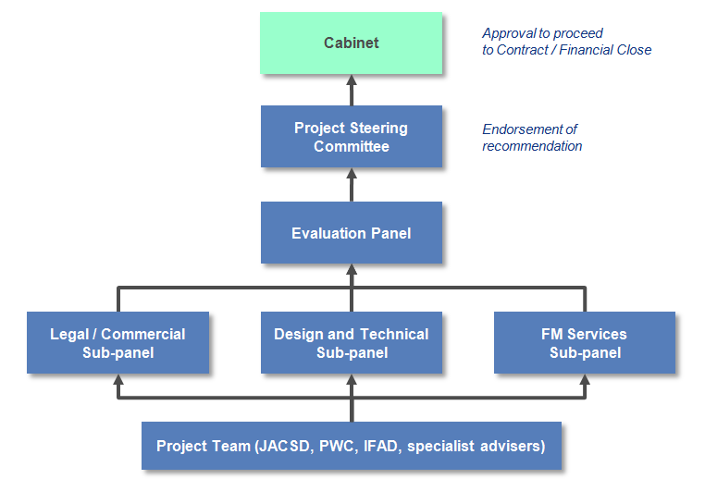

EOIs were received from six interested consortia and two were selected to proceed to the RFP stage. RFPs were received from the two shortlisted bidders on 29 May 2015.

The RFP evaluations (including the impact of the clarification process) were conducted by an Evaluation Panel which was supported by three discipline-based evaluation sub-panels: Legal/Commercial, Design and Technical and Facility Management Services. Evaluation Panel and sub-panel membership was selected based on stakeholder representation (including the Judiciary, Treasury, Procurement and Capital Works and the Justice and Community Safety Directorate) and requirements for appropriate and relevant skills and experience. The sub-panels were supported by Law Courts and Tribunal staff, specialist advisers and other government agencies as required. The key selection criteria used in the assessment of proposals are presented in Appendix D.

As part of the extensive RFP evaluation process, both bidders were asked to respond to clarifications about how their Proposals might address a number of issues highlighted during the evaluation process. At the completion of the evaluation and clarification process, Juris Partnership’s solution was considered to represent best value-for-money.

Accordingly, the Territory appointed Juris Partnership as Preferred Respondent and proceeded to negotiate the final form Project documents and executed the Project Agreement and ancillary contracts that govern the Project.

The major strengths of the Juris Partnership proposal are:

* an outstanding functional and architectural design solution that responded well to the critical heritage and urban design requirements
* a technologically superior and future-proofed approach to providing managed courtroom audio-visual solutions throughout the Courts Facility
* an effective response to the sustainability and energy efficiency requirements, including the provision of a 110kw solar photovoltaic array
* a design for the New Facility that provided two additional areas that can be converted in future to additional jury courtrooms
* a highly competitive, risk-adjusted whole-of-life cost
* a strong funding and commercial solution
* an effective service delivery strategy and model that efficiently met the Territory’s operational requirements and demonstrated clear understanding of the operating environment
* an appropriate allocation of project risk between parties.

The tender process was undertaken within a robust probity framework and was endorsed by the Project’s probity adviser based on the following probity objectives:

* fairness and impartiality
* use of a competitive process
* consistency and transparency
* security and confidentiality
* identification and resolution of conflicts of interest
* compliance with Government policies as they apply to tendering.

## Value for Money

*The Partnerships Framework* seeks to objectively identify and implement the most efficient form of infrastructure delivery. Under this approach, the analysis of value for money focuses on the benefits and risks associated with each delivery option. This involves a detailed examination of Territory managed delivery options and comparison of these with each proposal received from the private sector. The analysis considers quantifiable elements (i.e. items that can be quantified in monetary terms) as well as qualitative considerations.

#### Public Sector Comparator

The development of a Public Sector Comparator (PSC) is a standard process for PPPs and represents an estimate of the hypothetical, risk-adjusted, whole-of-life cost of the Project if delivered by the Territory. The PSC is developed in accordance with the proposed output specification and risk allocation included in the RFP and is based on the most likely and efficient form of conventional (i.e. non-PPP) delivery by the Territory.

The PSC is expressed in terms of the net present cost to the Territory, calculated using a discounted cash flow analysis and takes full account of the costs and assumed risks that would otherwise be encountered using the alternative style of procurement. The PSC includes amounts to cover both the design and construction costs and the maintenance and facilities management costs during the 25-year Services Phase of the Project.

The PSC is made up of a number of elements as indicated in Table 2.

1. Table 2: Public Sector Comparator

| Components of the PSC | Net Present Cost ($m) |
| --- | --- |
| Capital costs | 132.04 |
| Facilities management (Services) costs | 69.95 |
| Lifecycle replacement | 60.12 |
| Risk-adjusted PSC (disclosed to the shortlisted bidders) | 261.61 |
| Additional transferred risks | 4.65 |
| Competitive neutrality | - |
| PSC (excluding retained risk) | 266.26 |

Note: the assumptions used to formulate the PSC include:

* 1. All values are expressed in net present values as at 30 June 2015 and discounted at a nominal discount rate of 5.50% per annum in accordance with the National PPP Guidance applying under *The Partnerships Framework*.
  2. The fully risk-adjusted PSC of $266.26 comprises the raw PSC at $239.0 million plus the assessed value of transferred risk at $27.26 million. The risk-adjusted PSC disclosed to bidders during the RFP was $261.61 million which included $22.61 million for transferred risk. The amount of risk included in the disclosed PSC represented the mid-point of the probability assessment rather than the highest certainty level for assessed risks.
  3. The transferred risk totalling $27.26 million refers only to those capital, lifecycle and facility management risks transferred to the private sector under *The Partnerships Framework* arrangements (i.e. those risks that the Territory would otherwise assume) and excludes the Territory’s estimate of its retained risks.

The competitive neutrality adjustment removes any net competitive advantages that accrue to a government business by virtue of its public ownership. No allowance was made in the PSC for competitive neutrality.

The net present cost of the total payments including service payments to be paid to Juris Partnership is compared with the PSC. If it is lower than the PSC, it is an indication that at face value, the proposal represents quantitative value for money.

#### Payment to Juris Partnership

The Territory will pay for the Project through a Monthly Service Payment (MSP) arrangement. The MSP includes payments for the provision and availability of the Courts Facilities (i.e. servicing the debt and equity investments made during the D&C Phase), the provision of the Services and the other running costs of Juris Partnership (management, insurances, etc.).

Payment of the MSP commences on a partial basis (approximately 65% of the full MSP) on completion of Stage 1 and steps up to the full payment on completion of Stage 2.

At Financial Close, the MSP is calculated and projected over the full term of the contract based on the fixed pricing of Juris Partnership along with assumptions for certain costs and adjustment mechanisms that remain at the Territory’s risk. These assumptions include:

* application of Consumer Price Index (CPI) at an annual rate of 2.5% which applies to most of the operational costs of Juris Partnership (but not to debt and equity repayments)
* the cost of insurances for the Courts Facility during the Services Phase
* the amount of demand for certain Services (e.g. transcription) where demand is variable and driven by the Territory in the delivery of the judicial functions

In addition, the projected MSP does not take account of the following:

* the occurrence of any Territory retained capital risk events that are financed through future MSP payments
* the future impact on the Services costs (including periodic lifecycle costs) from any D&C Phase modification
* repricing of the reviewable services (cleaning, transcription, security, etc.) at five-yearly intervals during the contract term
* other circumstances where the Territory retains all or part of the risk (e.g. certain changes in law or policy)
* any adjustments to the MSP as a result of abetments for failures in service delivery

On the basis of the Juris Partnership proposal, and the matters noted above, the projected nominal (indexed) MSP payments that payable during the contract term are shown in Table 3 below.

1. Table : Estimated annual MSP

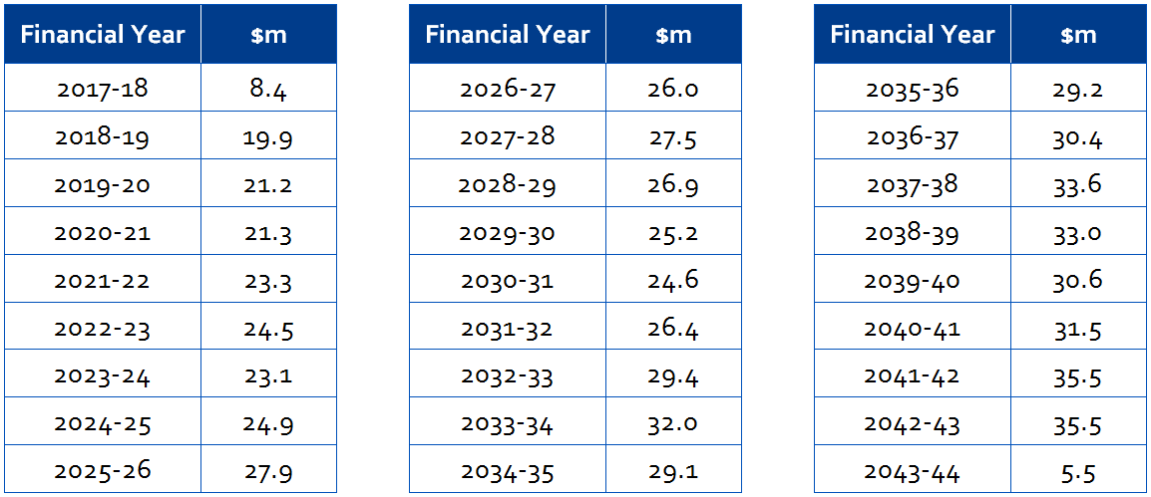

The amounts set out in Table 3 are also represented the graph below. The light blue bars in the graph indicate the amount of the MSP attributable to periodic lifecycle maintenance and refurbishment expenditure which varies from year to year.

1. Figure : Estimated annual MSP

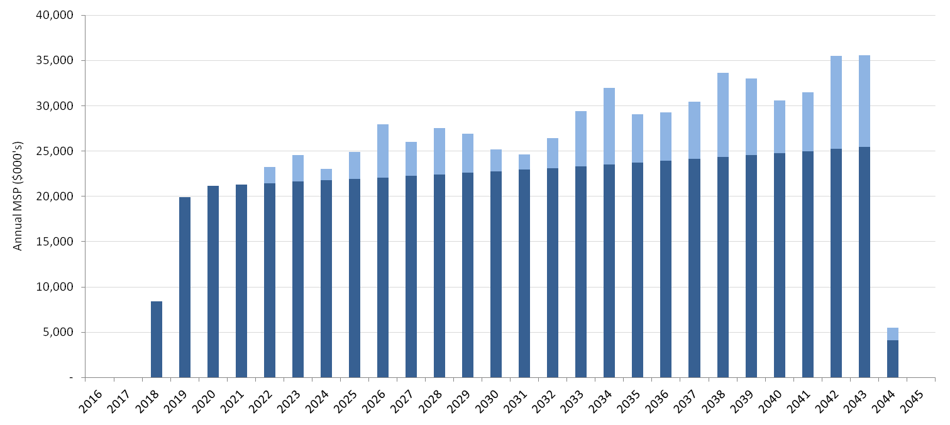

In relation to the amounts in Table 3, and the graph above, the following should be noted:

* financial year 2017-18 only represents a partial year for stage 1 MSP only
* financial year 2018-19 is a partial year for stage 2 payments (i.e. full MSP)
* financial year 2043-44 only represents a partial year.

When discounted at 7.3% [1] to a base date of 30 June 2015, the NPC of the Juris Partnership proposal is $250.4 million.

#### Quantitative value-for-money comparison

As noted above, value-for-money is established through comparison of the NPC of the successful proposal with the Territory’s PSC.

It should be noted that the original PSC did not include provision for a number of additional requirements that were subsequently added to the scope of the RFP after the PSC was established. The scope additions included:

* replacement of failing security, audio-visual and video conferencing equipment as Priority Works
* full court technology, acoustic and lighting upgrades to 10 existing Magistrates’ courtrooms
* comprehensive backlog maintenance and building standards work to the existing Magistrates’ Court
* mandatory achievement of a 5-star rating with the Green Buildings Council of Australia for the New Facility
* the addition of a second persons-in-custody lift to the Magistrates’ Court
* the addition of 3 extra remote witness rooms to the on-site vulnerable witness suite.

This represents additional value from the expanded scope of $11.5 million in NPC terms.

As indicated in Table 4 below, the Juris Partnership proposal delivered a value-for-money outcome that was assessed at $27.4 million (or 9.9%) on the basis of comparison against the base PSC as adjusted to account for the additional scope value. Against the base PSC the assessed value-for-money outcome was $15.9 million (or 6.0%).

1. Table 4: Quantitative value-for-money comparison between public sector delivery and private sector delivery

|  | NPC of Public Sector Delivery ($m) | NPC of Juris Partnership’s Proposal ($m) | Value-for-Money ($m) | Value-for-Money (%) |
| --- | --- | --- | --- | --- |
| Base VFM analysis | 266.3 | 250.4 | 15.9 | 6.0% |
| Adjusted VFM analysis | 277.8 | 250.4 | 27.4 | 9.9% |

This quantitative analysis does not recognise a range of other significant value-for-money benefits provided by the Juris Partnership proposal that were not included in the PSC. Juris Partnership’s proposal incorporated qualitative value for money benefits and design enhancements that go beyond the scope of the Territory’s reference project used to determine the PSC.

These benefits include:

* two additional jury courtroom areas within the New Facility chassis (one left as a shell area and the other used for the library) that will provide for future expansion requirements
* a fully managed video-conferencing and audio visual service for remote witness evidence (including recording, storage and retrieval service) and for the presentation of evidence and exhibits in court
* underwritten revenue (which reduces the MSP) from the on-site café for the 25-year Services Phase with mandatory obligations to operate the service
* solar water heating and photovoltaic arrays sized to meet the Courts Facility’s base-load demand.

## Project Milestones

As indicated in Table 5 below, the construction phase for the Courts Facility will be complete by September 2018. Stage 1 completion at the end of 2017 will deliver all of the new-build facilities, including six new Supreme Court courtrooms. On completion of Stage 2 the remaining two Supreme Court courtrooms, the new custody area, the mediation suite and all other remaining functional areas will be delivered.

1. Table : Key Project milestones

| Milestones | Date |
| --- | --- |
| Contractual Close | 14 December 2015 |
| Financial Close | 17 December 2015 |
| Commencement of construction | 18 December 2015 |
| Completion of Stage 1 | 24 November 2017 |
| Completion of Stage 2 | 28 August 2018 |
| End of Project Term | August 2043 |

# Commercial Features

Part Two of this document outlines the contractual relationships between the parties involved in the Project, including the allocation of risk and the obligations of both Juris Partnership and the Territory. A brief description of the Juris Partnership arrangements is also provided. Capitalised terms used in this Part Two are defined in the Project Agreement unless otherwise noted.

## Project Documents

On 14 December 2015 the Under Treasurer, on behalf of the Territory, executed the Project Agreement and other associated Project Documents with Juris Partnership and other related parties to design, construct and finance the Project and provide ongoing maintenance and soft facilities management services over a 25-year term.

In accordance with Government policy, the executed Project Agreement and associated documents are publicly disclosed and available via [www.procurement.act.gov.au/contracts](http://www.procurement.act.gov.au/contracts).

## Parties to the Project Agreement and Documents

The relevant parties under the contractual arrangements are:

* **The Territory:** The Territory is a signatory to the Project Agreement and other ancillary Territory Project Documents. The Under Treasurer is the person empowered to execute these contracts on behalf of the Territory.
* **Juris Partnership:** Juris Partnership MCHPL Project Co Pty Ltd in its personal capacity and as trustee for Juris Partnership MCHPL Project Trust and Juris Partnership LOR Project Co Pty Ltd in its personal capacity and as trustee for Juris Partnership LOR Project Trust are the organisations that have been contracted to deliver the Project as Juris Partnership. Juris Partnership is the main contracting entity with the Territory. Juris Partnership, in turn, has entered into a range of contractual relationships with its consortium partners to deliver elements of the Project. Notwithstanding this, Juris Partnership will be the organisation ultimately responsible for the delivery of the Project and will, among other things, provide overarching management for the duration of the Project.
* **Equity Providers:** Macquarie Corporate Holdings Pty Ltd (Macquarie) and Laing O’Rourke Corporation Limited (Laing O’Rourke) have jointly committed to provide the total equity commitment by Juris Partnership.
* **Financiers:** Macquarie Corporate Holdings Pty Ltd and Sumitomo Mitsui Banking Corporation (SMBC) are the senior lenders providing the total debt commitment by Juris Partnership. The senior debt is drawn progressively from Financial Close during the D&C Phase.
* **D&C Subcontractor:** Juris Partnership has engaged Laing O’Rourke Australia Construction Pty Limited (LORAC) to undertake the design and construction for the Courts Facility.
* **Services Subcontractor:** Juris Partnership has engaged Programmed Facility Management Pty Ltd (PFM) to deliver hard and soft facilities management services.

#### Project contractual relationships

The relationship between the Territory, Juris Partnership and other related parties is detailed in the Project Agreement and associated contracts. The structure and principal agreements required for the delivery of the Project are outlined in Figure 7 below.

1. Figure 8: Contractual relationships under the Project Agreement

Contractual relationships under the Project Agreement

1. Note: The relevant Parent Guarantors are also parties to the D&C Direct Deed and Services Subcontractor Direct Deed

## Risk Transfer

The risk allocation in the Project Agreement is consistent with *The Partnerships Framework* under which the Territory seeks to achieve best value for money by allocating risks to the party best able to manage them. This process results in various risks being:

* retained by the Territory
* transferred to the private sector, and/or
* shared between the parties.

The Project Agreement and associated documents establish the obligations of each party in managing these risks.

Table 5 provides a high-level outline of the risk allocation for the Project. Where a risk is allocated to both parties, the parties may not share that allocation equally. All risks are dealt with in detail in the Project Agreement and associated Project Documents.

1. Table 6: Project risk allocation

| Risk Category | Description | Territory | Project Co |
| --- | --- | --- | --- |
| Planning Risk |  |  |  |
| Obtaining appropriate planning approvals | Risk of obtaining planning and other building approvals |  | 🗸 |
| Site Risks |  |  |  |
| Contamination for which Project Co is responsible | Cost relating to the management and removal of known contamination in the Site and removal of contamination caused by the Project Co |  | 🗸 |
| Contamination for which Territory responsible | Cost relating to management and removal of contamination caused by the Territory, that migrates onto Site post contract, or that the Territory requires remediated to higher standard than legally required | 🗸 |  |
| Artefacts, heritage claim | Risk that the Site has archaeological and cultural heritage value (above or below ground) | 🗸 |  |
| Native Title  Construction and Commissioning Risks | Risk that the Site is the subject of a Native Title claim Design | 🗸 |  |
|  |  |  |  |
| Design risk | The risk that the design development activities cannot be completed on time and/or to budget and the design does not allow the delivery of the Services to the Services Specification |  | 🗸 |
| Construction risk | The risk that construction activities cannot be completed on time and/or to budget |  | 🗸 |
| Defects risk | The risk that defects are identified following completion of construction |  | 🗸 |
| Equipment | Responsibility for the selection, procurement and maintenance of equipment |  | 🗸 |
| Fit for purpose (commissioning) | Risk that the New Facility and Reconditioned Areas are not constructed so as to be fit for purpose or do not comply with contractual obligations |  | 🗸 |
| Modification | If the Territory elects to make a significant variation to the New Facility or the Services to be provided by Juris Partnership | 🗸 |  |
| Commissioning and Completion | Risk that the New Facility cannot be commissioned in accordance with the agreed commissioning criteria |  | 🗸 |
| Energy performance | The risk that the Courts Facility will require greater consumption of energy than predicted in pre-construction modelling |  | 🗸 |
| Operational Risks |  |  |  |
| Fit for purpose (operating) | Risk that the New Facility is not able to deliver the Services and/or is not fit for purpose at the required levels |  | 🗸 |
| Operational costs (non-reviewable services and facilities management) | Risk that operational costs exceed Juris Partnership’s budgeted cost over the operating phase of the Project |  | 🗸 |
| Operational costs (reviewable services) | Risk that operational costs exceed budgeted cost over the operating phase of the Project | 🗸 | 🗸 |
| Lifecycle costs | Risks associated with the replacement and refurbishment of the Courts Facility over the operating phase of the Project |  | 🗸 |
| Utility price risk | Risk of change in the price of the utilities | 🗸 |  |
| Utility volume risk  Change in Law or Policy Risks | The volume of energy demand | 🗸 | 🗸 |
|  |  |  |  |
| Changes in Law (General) | Risk that a change in legislation / regulations which applies generally will impact on the design or construction of the New Facility or provision of the Services | 🗸 | 🗸 |
| Changes in Law (Project Specific) | Risk that a change in legislation / regulations which expressly and exclusively applies to the Project, or a Territory policy or quality standard, will impact on the design or construction of the New Facility or provision of the Services | 🗸 |  |
| Tax risk | Risk of changes in income tax, GST or the introduction of a tax affecting companies generally |  | 🗸 |
| Force Majeure |  |  |  |
| Force Majeure | Risk that specified unforeseen events will impact on the design or construction of the New Facility or on the provision of the Services | 🗸 | 🗸 |
| Finance Risk |  |  |  |
| Funding risk | Risk of providing funds to meet design and construction costs |  | 🗸 |
| Base interest rate risk after Financial Close | Risk of movements in base interest rates after Financial Close |  | 🗸 |
| Operating insurance premium risk | Risk of inability to obtain insurance or material increases in insurance premiums for industrial special risks / consequential loss cover other than where caused by Juris Partnership | 🗸 |  |
| Residual condition | Risk that on expiry of the contract term the condition of the Courts Facility is less than that required by the Project Agreement |  | 🗸 |

## General Obligations of Juris Partnership

Juris Partnership has contracted with the Territory to finance, design and construct the New Facility and Reconditioned Areas and provide related facilities management services to the Courts Facility over a 25-year term. The Project Agreement details the Territory’s minimum design requirements (Output Specification) which Juris Partnership must meet in delivering the New Facility and Reconditioned Areas and the minimum service performance requirements (Services Specification) Juris Partnership must achieve throughout the 25-year Services Phase. The full array of Juris Partnership’s obligations is contained in the Project Agreement and ancillary contracts.

Table 7 further summarises the obligations of Juris Partnership over the course of the Project.

1. Table 7: Summary of key Juris Partnership obligations

| Project Element | Description |
| --- | --- |
| Design, construction and commissioning | Juris Partnership is responsible for the design, construction and commissioning of the New Facility and Reconditioned Areas to ensure that it is fit for its intended use as a courts facility. Juris Partnership must also comply with Territory’s industry participation policy and requirements. |
| Furniture, Fittings and Equipment (FF&E) | Procurement, installation, commissioning and maintenance of all FF&E (other than those items to be procured and maintained by the Territory). A detailed indicative list of required FF&E is appended to the Project Agreement. Juris Partnership takes the risk that the FF&E provided is adequate and otherwise fit for its intended purpose. The Territory has some flexibility to comment on the final type and quantity of all FF&E. |
| Interim Services | Interim Services are provided during the D&C Phase prior to Stage 1 Completion and consist of:   * + - providing a help desk function;     - planned preventative maintenance and defect rectification services to the existing Magistrate’s and Supreme Court buildings; and     - management of existing services contracts including security, cleaning, recording and transcription services, pest control and waste management and disposal services. |
| Services | Juris Partnership is responsible for the delivery of a range of facility management services (Services) in the Courts Facility in accordance with the Services Specification commencing at Commercial Acceptance of Stage 1 and for a period of 25 years from Commercial Acceptance of Stage 2B. These services include:   * + - building management (reactive/planned as well as lifecycle replacement)     - help desk     - utilities management     - recording and transcription services     - cleaning     - security (excluding custodial)     - waste management and disposal     - grounds maintenance   Juris Partnership is responsible for whole-of-life risk associated with the Courts Facility as well as all scheduled and unscheduled maintenance. |
| Insurances | Juris Partnership is required to take out a range of insurances in relation to the Courts Facility during both the design and construction and operating phases of the Project. |
| Transition | Management, coordination and execution of activities (excluding core judicial functions) to progressively relocate operations from existing areas to new or refurbished locations in the New Facility and Reconditioned Areas. |
| Finance | Procurement of debt and equity to fund the delivery of the Project. |
| Handback | Undertake all necessary tasks to ensure that the Courts Facility and Site are returned to the Territory in accordance with the end of term requirements set out in the Project Agreement. |
| Commercial Development | Juris Partnership is required to design, construct, finance and operate an on-site café. |

## General Obligations of the Territory

#### Delivery of judicial functions

The ongoing delivery of all judicial and custodial functions will be undertaken by the Territory.

#### Other Project Agreement obligations

Under the Project Agreement, the Territory’s obligations include the following:

* the Territory must (subject always to the Territory’s access requirements for delivery of its core functions) provide Juris Partnership with the necessary access to allow it to perform its obligations
* to pay the MSP to Juris Partnership during the Services Phase subject to the abatement regime that may apply if Services are not delivered to the required standard (see Section 2.6 (Payment Mechanism and Abatement Regime) for more detail)
* the Territory may review and comment on design documentation and other material that will be submitted by Juris Partnership in accordance with the Project Agreement
* the Territory must pay for any utilities usage costs during the Services Phase.

## Payment Mechanism and Abatement Regime

Juris Partnership is required to provide the Services as specified in the Services Specification from Commercial Acceptance of Stage 1 (i.e. when the New Facility (excluding the part occupying the existing Supreme Court Building) and Reconditioned Areas are complete and commissioned). Failure to do so exposes Juris Partnership to abatement in accordance with the abatement regime set out in the Project Agreement.

Payment for delivery of the Services is made by the Territory over the 25-year Services Phase in the form of the MSP, which is paid monthly in arrears. The formula for calculating the MSP is detailed in the Project Agreement. The MSP comprises payments made to Juris Partnership by the Territory for the capital cost of delivering the New Facility and Reconditioned Areas including financing costs and the cost of delivering the Services.

#### Abatement regime

Any failure by Juris Partnership to provide the Services or to have areas of the Courts Facility available in accordance with the Services Specification may constitute a ‘Service Failure’ and potentially result in a reduction of the MSP (in accordance with a pre-determined formula specified in the Project Agreement).

The Project Agreement categorises each service failure as either a:

* Failure Event – a Service Failure that affects one or more specific areas of the Courts Facility. Where certain defined events prevent or materially impacts the use of a relevant area for its intended function it is deemed to be an ‘Availability Failure’; otherwise it is considered to be an ‘Incident Failure; or
* Quality Failure – certain other Service Failures defined in the Service Specifications (not generally referrable to a specific area in the Courts Facility) which occur as a consequence of a failure to satisfy the Service Requirements.

A Failure Event is categorised depending on the severity of its potential consequences, taking into account the significance of the area affected and how important it is that the area be made available, for example, non-availability of a court room attracts a larger reduction than a general meeting room. This in turn determines the response and rectification time that applies. The abatement regime also recognises smaller failures that do not render a space unusable, but nevertheless impact on the ability to provide the required Services.

Each Quality Failure event is categorised based on the nature, severity and level of priority. Each category specifies an appropriate response time and rectification time which Juris Partnership must adhere to (outlined in the Services Specification). Failure by Juris Partnership to respond to and rectify any Quality Failure may result in abatement.

#### Interim Services

The Interim Services are paid for separately by way of a fixed monthly Interim Services Fee and reimbursement for certain defect rectification on a cost plus margin basis above a pre-set threshold (below which Juris Partnership bears the cost).

There is no abatement for performance of the Interim Services however, if Juris Partnership fails to perform, the Territory may elect to direct a Modification to remove all or part of the Interim Services.

#### Changes in costs incurred by Juris Partnership (including Modifications and Changes in Law)

The Territory has flexibility to make changes to the Courts Facility over the Term of the Project Agreement. The Territory may, at its sole discretion, request Juris Partnership to implement modifications (to the Works / Courts Facility, Services or the FF&E it is required to procure) provided the Territory compensates Juris Partnership in accordance with the pre-determined regime in the Project Agreement. This includes an ability to remove Works or Services from the Project scope. Under the modifications regime, Juris Partnership must provide an estimate of the cost impact of any modification proposed by the Territory in a manner which complies with the requirements of the Project Agreement. All costs must be provided on an open book basis.

The Territory may pay for the modification either by way of a lump sum, milestone payments, or an adjustment to the MSP (where the modification is financed by Juris Partnership). To provide greater transparency and certainty around modification costs, the Project Agreement specifies a range of pre-agreed margins and other on-costs Juris Partnership can claim in such circumstances.

A regime has also been established that will enable the Territory to request Juris Partnership to perform additional minor works without the need to invoke the modifications regime.

In addition to Territory-initiated modifications, the Territory must pay for cost increases arising from certain changes in law and policy to the extent set out in the Project Agreement.

Subject to certain conditions, Juris Partnership may be entitled to performance relief under the Project Agreement and to payment by the Territory of certain additional costs and expenses incurred by it as a result of the following events:

* breach by the Territory of any Project Documents
* remediation of contamination for which the Territory is responsible under the Project Agreement
* industrial action which directly affects the Project and which Juris Partnership can demonstrate is a direct result of an act or omission of the Territory or a Territory-related party at the Site other than any act or omission which is authorised or permitted
* suspension of the D&C Activities or the delivery of the Services required by law or the Territory because of a native title claim or the discovery of artefacts that is not caused by an act or omission of Juris Partnership
* certain unknown and unforeseeable Site conditions
* during the D&C Phase, any act or omission of the Territory or relevant Territory-related parties other than any act or omission which is authorised or permitted under the Project Agreement
* during the Services Phase, a fraudulent, malicious, unlawful or reckless act or omission by the Territory or relevant Territory-related parties in respect of the Project
* during the Services Phase, damage to the Courts Facility or unreasonable interference with the Services directly caused by a third party contractor of the Territory.

## Default, Termination and Step-In Regimes

#### Default

A default by Juris Partnership under the contractual arrangements will entitle the Territory to various remedies. Where a default has occurred, the Territory will in most circumstances be required to give Juris Partnership an opportunity to remedy the default. If the default is not remedied by Juris Partnership within the required remedy period, it will escalate to a Major Default.

The Project Agreement also elevates a number of events to immediately be classified within the Major Default category (such as when there are persistent breaches or repeated Service Failures).

In respect of Major Defaults, Juris Partnership will be given the opportunity to agree a remedy program (if the default is capable of remedy). Where Juris Partnership fails to remedy the Major Default within the required remedy period or to comply with an agreed remedy program, this will generally, subject to the rights of the Financiers to remedy the default, give rise to the Territory’s right to terminate the Project Agreement.

Certain events of default give rise to a Territory termination right immediately upon their occurrence, subject to the rights of the Financiers to remedy the default, (e.g. insolvency of Juris Partnership or Juris Partnership abandons the Project. These events are called Default Termination Events.

#### Step-In

In addition to triggering termination rights (or potential termination rights), events of Major Default and Default Termination Events may trigger additional Territory rights and remedies including:

* the right to step-in to remedy the situation (i.e. the right to assume control and management of the Project, the Works or the Services)
* the right to require Juris Partnership to replace a subcontractor that caused the Major Default or Default Termination Event at an agreed point within the applicable remedy period.

Step-in rights for the Territory, as specified in the Project Agreement, can be triggered for example when:

* a Major Default or a Default Termination Event has occurred and has not been remedied
* there is an Emergency.

The default related step-in right is subject to the rights of Juris Partnership and the Financiers to remedy the default. During any step-in associated with a default, the MSP will be adjusted to the extent that the Services are not being provided in accordance with the Project Agreement.

#### Termination

Where the Project Agreement is terminated before the natural expiry of the Services Phase, Juris Partnership may be entitled to a termination payment. The Project Agreement can be terminated as a result of the following:

* Default Termination Event
* a Force Majeure Termination Event (including an uninsurable event)
* Territory for Convenience

The basis for the calculation of the termination payment will be determined by the reason for the termination as summarised in Table 8.

1. Table 8: Termination options

| Event | Trigger | Termination Payments |
| --- | --- | --- |
| Default Termination Event | The Territory may terminate the Project Agreement if certain events of default have occurred and not been remediated in accordance with the Project Agreement | The Project’s fair market value determined by tendering or an independent valuer, at the Territory's election, except in certain circumstances, for example, an independent valuer must be used in certain circumstances including where there is no liquid market. |
| Termination for Convenience | The Territory may at any time, for reasons of its own choosing, unilaterally elect to terminate the Project Agreement for convenience | The outstanding debt as at termination date plus the fair market value of the equity as assessed by the independent expert together with other reasonable costs. |
| Termination for Force Majeure | The occurrence of a Force Majeure Termination Event (including an uninsurable event for which the Territory does not act as the insurer of last resort) | The outstanding debt as at the termination date plus other agreed costs. |

The compensation calculations are consistent with the National PPP Guidance and established market precedent and are set out in the Schedule 10 to the Project Agreement.

## Finance

Juris Partnership is responsible for the provision of debt and equity finance for the Project. Its funding structure comprises senior debt drawn progressively from Financial Close and equity committed at Financial Close by way of equity letters of credit, with the equity funding drawn down as a lump sum during construction.

The debt is for an initial period of three and a half years from Financial Close. It is assumed that debt will then be refinanced at regular intervals over the remainder of the Project term. The Territory will not share in any refinancing losses but will be entitled to 50 per cent of the benefit of any refinancing gain, after allowing Juris Partnership to recoup any prior refinancing losses.

Juris Partnership has retained the risk in relation to any market disruption events under the Project’s financing with its debt providers.

## Fitness for Purpose

The Project Agreement contains a fitness for purpose test for the New Facility and Reconditioned Areas consistent with the National PPP Guidance. The Existing Facility is required to be fit for performance of the Services and to meet the standard of the Existing Facility set out in the Services Specification and, where applicable, the Output Specification.

## Territory Rights at Expiry of Contract

The Project Agreement requires Juris Partnership to hand back the New Facility and commercial developments to the Territory at the expiry of the Term for nil consideration and in a condition that meets the requirements of the Project Agreement. The Territory will then resume full control of the Courts Facility and commercial developments.

To ensure that the assets are in sound working order, the Courts Facility will be independently inspected on an annual basis in the years leading to the expiry of the Term to ensure that all lifecycle and maintenance works have been completed and that the Courts Facility will meet the relevant handback condition. The handback condition is described in the Project Agreement.

If Juris Partnership fails to maintain the Courts Facility to the standard required to satisfy the handback requirements, the Territory will be entitled to withhold a portion of the MSP to cover the expense of any shortfall.

## Current Version

This document may be updated from time to time. Please check with the contacts listed at Appendix C for the current edition.

– Glossary

Terms used in this Project Summary have the meaning given to them in the Project Agreement unless otherwise defined in this Glossary or elsewhere in this document.

| Term | Meaning |
| --- | --- |
| ACT | Australian Capital Territory |
| CMTEDD | Chief Minster, Treasury and Economic Development Directorate |
| Contract Close | The date on which the State and Project Co entered into the Project Agreement. This occurred on 14 December 2015 |
| Courts Facility | The Existing Facility (including the Reconditioned Areas) and the New Facility |
| D&C Phase | The period from Financial Close to the completion of all construction works required under the Project Agreement |
| Existing Facility | The Magistrates’ Court building |
| FF&E | Furniture, fittings and equipment |
| Financial Close | The date on which Project Co satisfied all of the conditions that had to be met before its financiers made funds available to it. This occurred on 17 December 2015 |
| IEOI and EOI | Invitation for Expressions of Interest and Expression of Interest |
| JACSD | Justice and Community Safety Directorate |
| Laing O’Rourke | Laing O’Rourke Corporation Limited |
| LORAC | Laing O’Rourke Australia Construction Pty Limited |
| Macquarie | Macquarie Corporate Holdings Pty Ltd |
| MSP | The Monthly Service Payment payable by the Territory to Juris Partnership from completion of the each Stage of the Works |
| New Facility | The newly constructed parts of the Courts Facility together with the fully refurbished Supreme Court building |
| NPC | Net present cost |
| PPP | Public-Private Partnership |
| Preferred Respondent | A Respondent who has been selected, following the RFP Phase, as preferred to proceed to the Negotiation and Completion Phase |
| Project | The ACT Law Courts PPP Project |
| Project Agreement | The ACT Law Courts PPP Project agreement entered  into between Juris Partnership and the Territory dated 14 December 2015 |
| Project Co | The Juris Partnership represented by its partners and trustees, the counterparty to the Project Agreement and the main contracting entity with the State |
| Proposal | The proposal submitted by Respondents in response to the RFP |
| PSC | The Public Sector Comparator for the Project, being the risk-adjusted cost of the most likely efficient form of public sector service delivery that could be employed to satisfy all elements of the output specification. |
| Reconditioned Areas | Those parts of the Magistrates’ Court building that will be substantially reconfigured and refurbished to deliver the integrated design solution |
| Respondent | A person, legal entity or body corporate invited to submit a proposal |
| RFP | Request for Proposal |
| Services Phase | The period from completion of Stage 1 to the expiry of the Project Agreement |
| SMBC | Sumitomo Mitsui Banking Corporation |
| Territory | The body politic established by section 7 of the Australian Capital Territory (Self-Government) Act 1988 (Cth) |

– Useful references

Project documentation, including the Project Agreement, is available at: [www.procurement.act.gov.au/contracts](http://www.procurement.act.gov.au/contracts).

ACT Government Treasury policy guidance and Project information is available at: <http://apps.treasury.act.gov.au/partnerships-framework>.

The Justice and Community Safety Directorate: [www.justice.act.gov.au](http://www.justice.act.gov.au)

The Project website: <http://actlawcourtsproject.com.au>

– Key contact details

Justice and Community Safety Directorate

Website: [www.justice.act.gov.au](http://www.justice.act.gov.au)

Executive Director, Capital Works & Infrastructure  
Justice and Community Safety Directorate  
Level 7, 12 Moore Street,   
Canberra ACT 2601

Phone (02) 6205 3505

Chief Minister, Treasury and Economic Development Directorate (CMTEDD)

Website: [www.treasury.act.gov.au](http://www.treasury.act.gov.au)

Executive Director, Infrastructure Finance and Advisory  
Chief Minister, Treasury and Economic Development Directorate  
Nara Centre, 1 Constitution Avenue  
Canberra ACT 2601

Phone: (02) 6207 5650

– RFP Evaluation Criteria

The Territory evaluated each Proposal against the following Evaluation Criteria.

#### Criterion A - Commercial

The Territory evaluated the following criteria:

* Commercial Solution - the commercial solution including the intra-consortium commercial relationships and the level and appropriateness of any financial support
* Commercial Departures - the nature and extent of the proposed departures from the draft Contractual Documents.

#### Criterion B - Financial

The Territory evaluated the following criteria:

* Funding Structure – the appropriateness, competitiveness and flexibility of the funding structure
* Certainty of Funding - the certainty and robustness of funding
* Financial Assumptions - the robustness of the financial assumptions.

#### Criterion C – Commercial Opportunities

The Territory evaluated the appropriateness and value-for-money of the proposed Commercial Opportunities.

#### Criterion D - Risk Adjusted Cost

The Territory evaluated the whole-of-life, risk-adjusted cost of the Proposals by taking into account the financial and risk consequences of the each proposal.

#### Criterion E – Master Plan and Architectural Design

The Territory evaluated the following criteria:

* Site Plan - the appropriateness of the site plan for the Courts Facility
* Architectural Form – the external architectural form of the proposed design of the New Facility
* Landscape – the appropriateness of the quality and layout of the landscaping solution

#### Criterion F – Functional and Operational Design

The Territory evaluated the following criteria:

* Functionality and Operational Efficiency – the functionality and operational efficiency of the proposed design
* Interior Design – the appropriateness and quality of the proposed interior design
* Engineering services – the appropriateness and quality of the engineering and building infrastructure services
* Flexibility and expansion capability – the flexibility and expansion capability of the proposed design
* Environmentally Sustainable Development – how and the extent to which the Respondent has met the ESD requirements
* Commercial Opportunities – the design aspects proposed for any Commercial Opportunities
* Design Departures – the extent to which the Proposals depart from the requirements of the Output Specification.

#### Criterion G - Equipment

The Territory evaluated the process for Equipment selection and the appropriateness and quality of the selected furniture, fixtures, fittings and other Equipment.

#### Criterion H - Project Management

The Territory evaluated the following criteria:

* Project Co management – the resourcing, staffing structure, experience and approach of Project Co
* Design Development Process – the Respondent’s approach to the Design Development Process, including the coordination and management of user groups and the design team
* Master Works Program – the Respondent’s proposed timelines and program
* Impact on Business Continuity – the proposed methodologies and approaches to complying with the business interruption requirements and minimising any impact on the ongoing operation of the existing Supreme Court and Magistrates’ Court.
* Construction Management - the proposed methodologies and approaches to delivering the New Facility and Reconditioned Areas.
* Completion - the appropriateness of the Respondent’s proposed Completion methodology.
* Work Health and Safety – the Respondent’s approach to complying with the Territory’s policies and achieving high standards of workplace safety.

#### Criterion I - Services

The Territory evaluated the following criteria:

* Operational Readiness and Ramp up - the robustness of the Respondent’s proposed mobilisation plan for the implementation for the Services
* General Service Management – the proposed performance monitoring program, reporting and management structure proposed to manage the delivery of the required Services.
* General Services - the Respondent’s understanding of the Territory’s requirements for specific sections of the General Services Specification and the appropriateness of the Respondent’s proposed systems, process and resources to comply with the General Service Requirements.
* Service-Specific Solutions - the service-specific solutions including proposed system, processes, flexibility and certainty of quality of Services delivery

#### Criterion J – Commitment to the Territory’s Local Industry Participation Policy (LIPP)

The Territory evaluated the Respondent’s LIPP commitments as detailed in the submitted plan.

#### Criterion K – Approach to Priority Works

The Territory evaluated the Respondent’s design, delivery and commercial approach to delivering the Priority Works.



1. The discount rate was established in accordance with the methodology set out in Volume 5 of the National Public Private Partnership Guidelines.