OPPORTUNITIES FOR ALL CANBERRANS
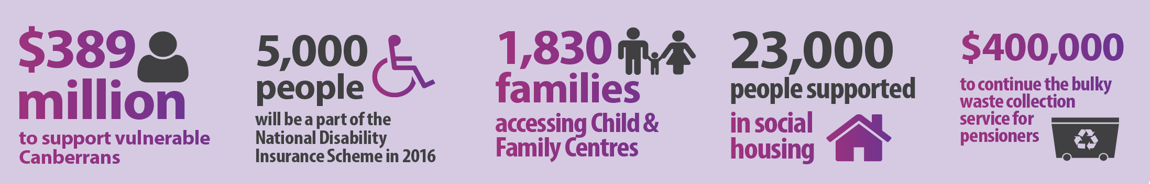
Social inclusion is a cornerstone of this Government’s values and policies – and the ACT Government is committed to ensuring opportunities can be shared by all Canberrans.
The funding in this budget for Canberra is a clear statement of our values – we are investing in major reforms to ensure the support providing to vulnerable Canberrans with the right services at the right time.
We are continuing to support and enhance the programs that our community relies upon. We are also investing in new initiatives to help Canberra’s most vulnerable and disadvantaged.

Support for vulnerable Canberrans
The ACT Budget funds more than $389 million in 2015-16 recurrent funding for people who need a helping hand.
Our community has been built upon the principle that everyone should have the opportunity to achieve their ambitions, regardless of their background or circumstances.
The ACT Government will invest $107 million in recurrent funding for disability and therapy services, which includes our ongoing support for the NDIS. The Government also funds $83.4 million for Child and Youth Protection Services through the Community Services Directorate.
This year’s budget also includes $160 million for housing and homelessness support.

Young people
- $40 million to implement A Step Up for Our Kids¸ the ACT Government’s strategy to support children and young people in care.
- $1.4 million to build a new respite property for young people aged 13-18 in partnership with the Ricky Stuart Foundation.
- $5.3 million to improve support for vulnerable children and young people through a new information and record keeping system.
- $391,000 to support the work of the Children and Young People Death Review Committee.
- $2.5 million for the Bendora Throughcare Care unit to support young people leaving detention.

Right service right time
- $1.2 million to continue transforming service delivery under the Better Services initiative that is already making access to services easier for people.
- $1.7 million to support disability services transitioning to the NDIS through funding for the appropriate level of indexation.
- $1 million to support the Community Sector Reform Program that is cutting red tape and improving business processes in the community sector.
- $3.0 million for homelessness services, match funded by the Commonwealth under the National Partnership Agreement on Homelessness.

Seniors
- $495,000 to continue the successful flexible transport bus service for the aged and people with a disability in Woden, Weston, Belconnen and Tuggeranong.
- $400,000 to continue the bulky waste collection service for pensioners and concession card holders to remove large bulky items from their home.

Domestic violence
New action to counter domestic violence in this year’s budget builds on long standing and ongoing support for the sector. These include:
- $250,000 in additional funding to expand the capacity of three key domestic and sexual violence services to handle the current spike in demand for crisis assistance;
- $615,000 in funding for ACT public schools to provide social and emotional learning programs. This will help children learn about the importance of respectful relationships, and give them easy and accessible ways to get support;
- The establishment of an ACT domestic violence data framework, funding women’s safety grants and supporting the Domestic Violence Prevention Council with $300,000 from the confiscated Assets Trust Fund announced in March; and
- Contribute to the national campaign to raise awareness about violence against women and children.

Public Housing renewal for Canberra
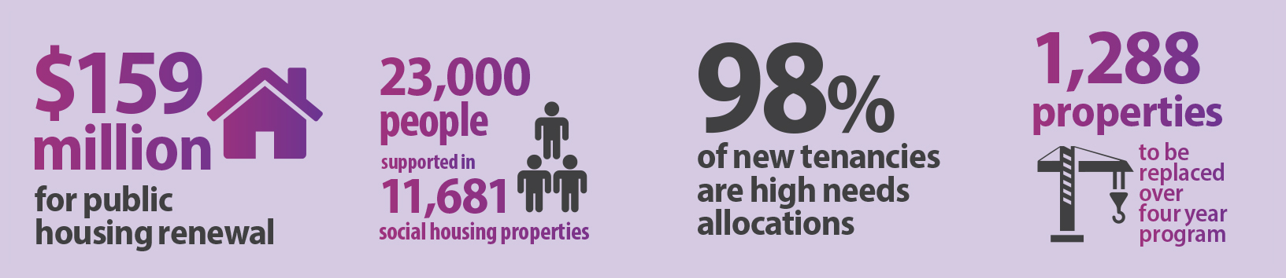
The 2015-16 ACT Budget will invest more than $159 million in public housing that better meets tenants’ needs, now and into the future.
As part of the public housing renewal program, the ACT Government is building and acquiring new homes across Canberra to improve the overall quality of the public housing portfolio. This investment will also break down concentrations of disadvantage and support the renewal of Canberra’s urban areas.

Major sites to be replaced
The Budget allocates $159.2 million in recurrent and capital expenditure over the next two years to secure replacement housing for 352 public housing properties along the Northbourne Avenue corridor ( Karuah and Owen Flats) and at other major sites (Allawah Court and the Red Hill Housing Precinct) under the public housing renewal program.
This is the first stage of a four- year program that will provide 1,288 modern and efficient replacement public housing dwellings.

Support for tenants
In determining where the new public housing can be located, the ACT Government takes into consideration access to shops, services and transport including bus routes. Eligible tenants from across Canberra will be considered for places in this new accommodation, and it will not be limited to tenants relocating from Northbourne Avenue or multi-unit properties.
The public housing renewal program will require many public housing tenants to move to a different home. The ACT Government will work with these tenants and community service providers to ensure all tenants have the support they need during the process of moving house and establishing themselves in new communities. No current public housing tenant will become homeless as a result of the program.
The relocation of tenants is expected to commence in late 2016 depending on tenants’ individual needs and circumstances.

