IMPROVING CANBERRA’S JUSTICE SYSTEM
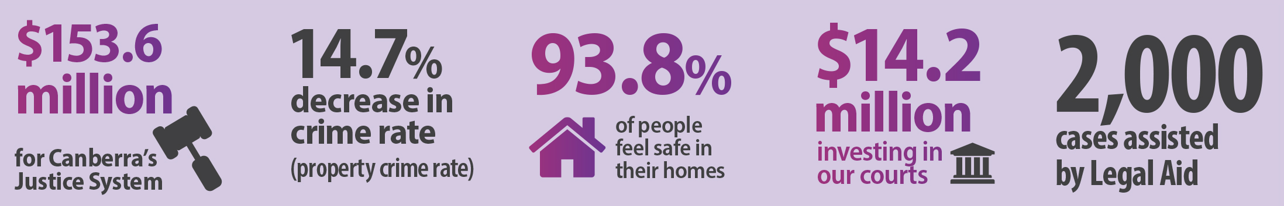
The Territory budget recognises the importance of access to justice and provides funding to vulnerable Canberrans and victims of crime.
The ACT Government is providing an additional $34 million over the budget cycle to improve Canberra’s justice system.
Significant investment has been made to the ACT Courts, including new funding for a fifth ACT Supreme Court judge.
In total, $154.9 million in annual funding is provided for the justice system in the 2015-16 Budget.

Greater assistance for Canberrans in need
This budget invests more than $3.1 million for vulnerable people in the community and victims of crime. This includes:
- $1.6 million over four years to form an administratively based Victims of Crime Financial Assistance scheme;
- $366,000 for two years for the High Density Housing program which aims to prevent or reduce crime and facilitate access to justice, health, education and employment for residents living in high density housing;
- $358,000 for an additional two years for the Street Law early intervention outreach service. The service provides legal assistance to people who are homeless or at risk of becoming homeless; and
- $867,000 for Legal Aid Commission over two years to provide essential legal services to the community.

More resources for ACT courts and legal services
This budget invests $20.7 million in ACT courts. This includes:
- $14.2 million over three years to progress the redevelopment of the ACT Supreme and Magistrates courts, including the construction of facilities to enable the courts to operate during construction;
- $3.1 million over three years to appoint a fifth ACT Supreme Court judge in 2016-17 to address the increase in matters before the court;
- $241,000 in 2015-16 for temporary judicial resourcing to reduce the backlog of matters; and
- $3.2 million recurrent funding over four years for four additional staff at the ACT Government Solicitor.

Expanding restorative justice
This budget invests $2.1 million over four years to allow adult offenders to participate in the restorative justice processes as an alternative to imprisonment.
This investment in phase two of the Government’s restorative justice program and follows on from the ten year anniversary of restorative justice in the ACT.

Strengthening correctional capability
This budget invests $8.2 million in ACT Corrective Services. This includes:
- $3.2 million over three years to enhance capacity of community corrections; and
- $4.9 million over four years to implement a new information management system to improve offender and detainee management and reporting.

