BETTER HEALTH SERVICES FOR CANBERRA
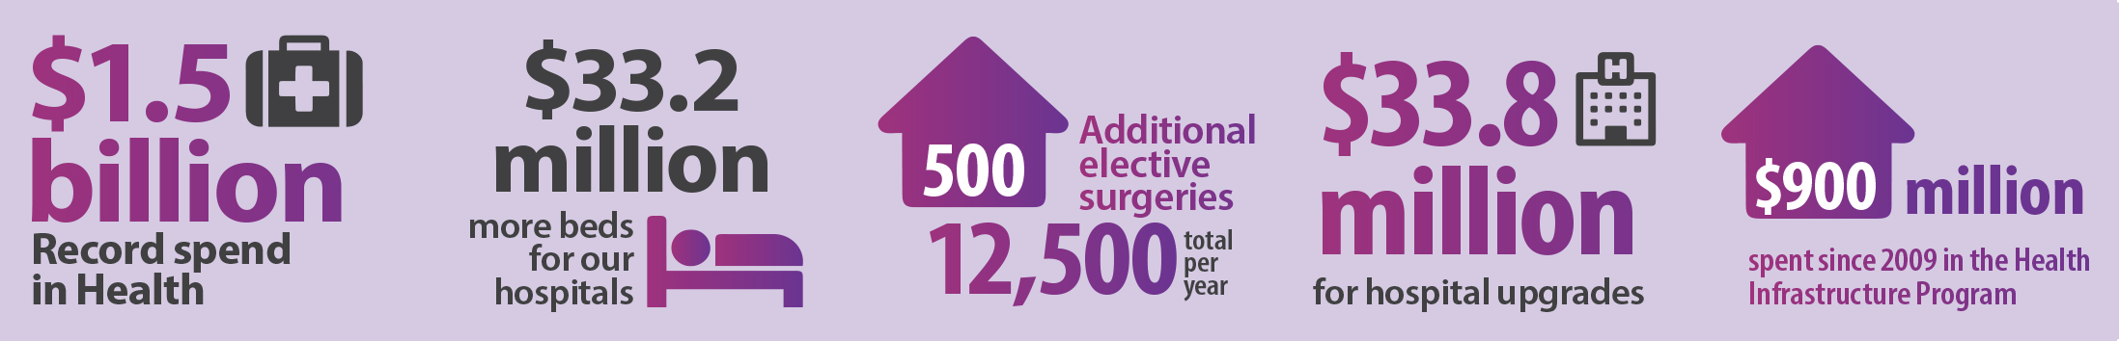
The health of Canberrans will always be the ACT Government’s top priority, and the 2015-16 ACT Budget invests further in our health system.
This budget invests more than $161 million in new health funding over four years to deliver better support, better services, better equipment, better facilities and more beds right across Canberra.
The ACT’s overall health budget is $1.5 billion – the biggest it has ever been and nearly one-third of the total ACT Budget
We are also building a new sub-acute hospital for Canberra: the ACT’s third public hospital at the University of Canberra will be a purpose-built facility offering rehabilitation and mental health care services.

More services for Canberra
This budget invests $40.6 million in extra funding for more beds and services:
- $40.6 million over four years for more acute hospital services:
  - $5.7 million for emergency specialists
  - $23 million for new general hospital beds at the Canberra Hospital (TCH) and Calvary Hospital;
  - $10.2 million for two new intensive care beds at TCH; and
  - $1.4 million for hospital in the home, to help people recover from illness in their own home.
This budget invests $15 million ($14.8m) for more surgeries and operations:
- $14.8 million over two years to provide an extra 500 elective surgeries (taking the total to 12,500 a year); and
- An additional 500 endoscopy cases.

Better facilities: Health Infrastructure Program
This budget invests $33 million for new equipment and infrastructure:
- $17.3 million to build a new Central Sterilising Services Facility at Canberra Hospital;
- $2.5 million redevelopment at Canberra Hospital to enable another eight new beds; and
- A grant to help fund 400 extra parking spaces at the University of Canberra Public Hospital (UCPH);
Total investment to date in the Health Infrastructure Program (HIP) is now more than $900 million (excluding UCPH) since 2009. The HIP also includes the TCH Emergency Department upgrade, the Secure Mental Health Unit, the Ngunnawal Bush Healing Farm and other upgrades at Canberra Hospital.

Building the University of Canberra Hospital
The UCPH will be the first facility of its kind in the ACT. Construction will start in early 2016. It will:
- Provide a new and innovative model specifically for rehabilitation and mental health care;
- Be a teaching hospital to continue the integration of clinical and teaching environments; and
- Provide research opportunities to benefit not only this facility and our community, but the broader healthcare sector as well.

Upgrading Calvary Hospital
This Budget invests $12.4 million for Calvary Hospital:
- $5.6 million for a refurbishment and new equipment for the operating theatre;
- $3.1 million development at Calvary Hospital to enable 12 new acute beds; and
- $3.7 million for new imaging services including a new CT scanner.
In addition, a new five-storey car park providing 704 spaces, an overall increase of 515 spaces for the Calvary Hospital campus, is currently under construction.

