
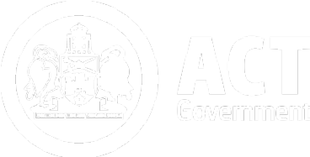

2025-26 Capital Works Program
  - Progress Report
Year-to-date performance as at 30 June 2026

Chief Minister, Treasury and Economic Development Directorate

TABLE OF CONTENTS
Introduction 1
Chapter 1 2025-26 capital works Program 2
1.1 2025-26 Program Overview 2
1.2 2025-26 Program Expenditure Year-To-Date June 2026 2
2025-26 Asset Renewal Program 3
2025-26 ICT and P&E Expenditure 5
Chapter 2 Historical expenditure trends 6
Chapter 3 Non-Financial (Milestone) Outcomes 6
Chapter 4 Project PROGRESS 8
4.1 Delivery of Infrastructure for the ACT Community 8
Delivery of Transport Infrastructure 8
Providing Education for All 10
Delivering Health Services 11
Public and Social Housing 13
Environment and Climate 13
Entertainment, Arts and Sports 14
City Services, Recreation and Community Services 15

Appendices
APPENDIX 1: CAPITAL WORKS EXPENDITURE BY MAJOR PROJECT

Introduction
This report details progress made towards delivering the Government’s 2025-26 Capital Works Program and outlines major project achievements for the quarter ending 30 June 2026.
Expenditure details of projects with a current budget greater than or equal to $10 million are at Appendix 1.
The Capital Works Program also includes capital investment in Information and Communication Technology (ICT) and Plant and Equipment (P&E).

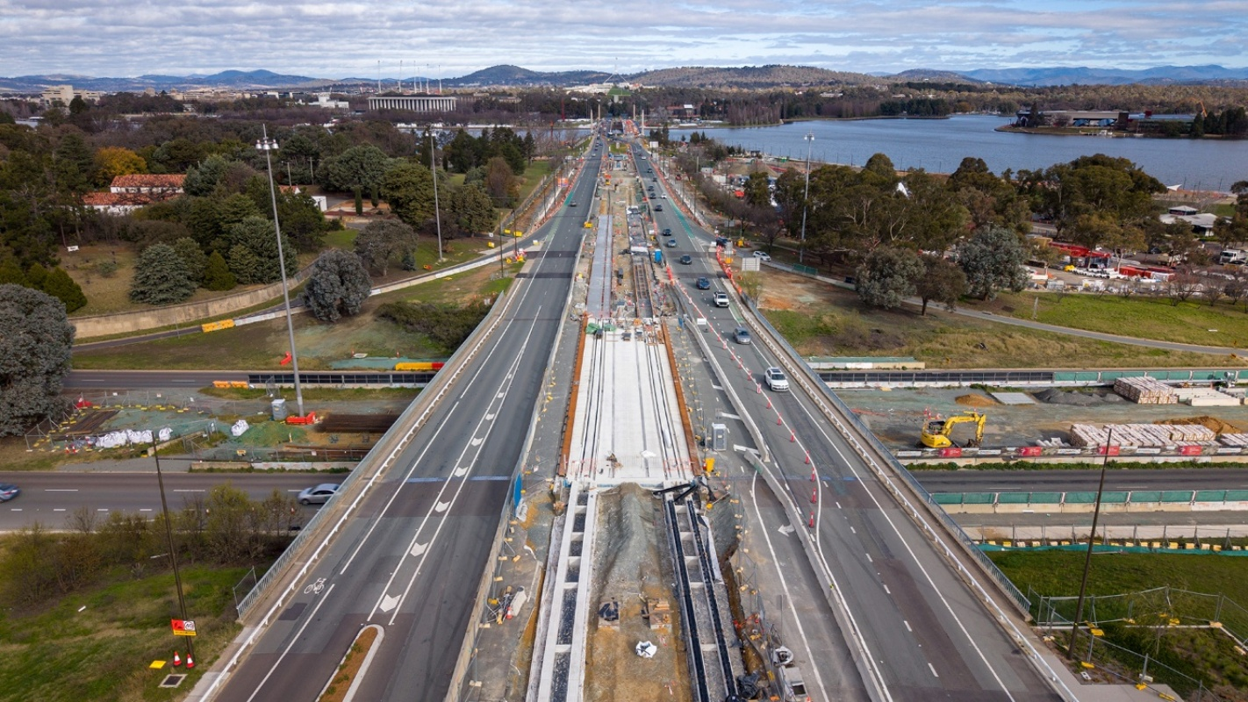
Commonwealth Avenue Light Rail Bridge over Parkes Way

2025-26 capital works Program

2025-26 Program Overview
The 2025-26 Budget and Budget Review included several new initiatives, the reprofiling of a range of existing projects and other technical program adjustments, reflecting updated project delivery information.
The available funding in the 2025-26 Capital Works Program is shown in Table 1 below.
Table 1: 2025-26 Capital Works Program Available Funding
 | $ million
2025-26 Budget Review | 1,394
Net estimate of adjustments, savings and rollovers | (15)
Total estimated funds available for expenditure in 2025-26 | 1,379
Declared savings to date | 0
Total Funds Available for Expenditure 2025-26 | 1,379
Capital Delivery Provision | (100)
Forecast 2025-26 Program Expenditure | 1,279

2025-26 Program Expenditure Year-To-Date JUNE 2026
Actual year-to-date (YTD) expenditure as at 30 June 2026 was $1,080 million, comprising:
- new works expenditure of $52 million; and
- works-in-progress expenditure of $1,028 million.
YTD June 2026 capital expenditure accounted for 78 per cent of total funds available for expenditure in 2025-26 (84 per cent after taking account of the Capital Delivery Provision).
Table 2 below provides a breakdown of YTD capital expenditure incurred by each agency to 30 June 2026 and reflects the administrative arrangements in place from 1 July 2025 under the Administrative Arrangements 2025 (No 1).

Table 2: Capital Works Program Expenditure – YTD 30 June 2026
Agency | 2025-26 Funding Available for Expenditure  ($'000) | 2025-26 YTD June 2026 Expenditure ($'000) | Percentage Spent YTD June 2026
ACT Electoral Commission | 211 | 152 | 72%
Canberra Health Services | 62,509 | 51,092 | 82%
Canberra Institute of Technology | 26,314 | 7,962 | 30%
Chief Minister, Treasury and Economic Development Directorate | 45,750 | 21,172 | 46%
City and Environment Directorate | 247,735 | 136,653 | 55%
City Renewal Authority | 19,477 | 13,907 | 71%
Cultural Facilities Corporation | 7,665 | 3,621 | 47%
Digital Canberra | 33,159 | 20,409 | 62%
Education Directorate | 69,562 | 33,702 | 48%
Health and Community Services Directorate | 18,028 | 6,882 | 38%
Housing ACT | 144,726 | 159,932 | 111%
Infrastructure Canberra | 662,846 | 603,163 | 91%
Justice and Community Safety Directorate | 38,193 | 19,842 | 52%
Office of the Legislative Assembly | 3,118 | 1,744 | 56%
TOTAL | 1,379,293 | 1,080,234 | 78%
Forecast Program Expenditure | 1,279,293 | 1,080,234 | 84%

2025-26 Asset Renewal Program
The Asset Renewal Program provides ACT Government agencies with an annual funding pool for works that extend the useful life or improve the service delivery capacity of existing infrastructure assets. This investment is distinct from routine repairs and maintenance which are funded separately.
YTD June 2026 expenditure for the 2025-26 Asset Renewal Program (both new works and existing projects) was $74 million, or 52 per cent of the funding available of $144 million.

Table 3: 2025-26 Asset Renewal Program Expenditure – YTD 30 June 2026
Agency | 2025-26 Funding Available for Expenditure  ($'000) | 2025-26 YTD June 2026 Expenditure ($'000) | Percentage Spent YTD June 2026
ACT Electoral Commission | 211 | 152 | 72%
Canberra Health Services | 15,560 | 14,063 | 90%
Canberra Institute of Technology | 6,078 | 3,281 | 54%
Chief Minister, Treasury and Economic Development Directorate | 4,881 | 1,950 | 40%
City and Environment Directorate | 62,679 | 27,320 | 44%
Cultural Facilities Corporation | 2,983 | 1,890 | 63%
Education Directorate | 28,355 | 14,111 | 50%
Health and Community Services Directorate | 1,475 | 687 | 47%
Infrastructure Canberra | 11,880 | 5,422 | 46%
Justice and Community Safety Directorate | 6,447 | 3,510 | 54%
Office of the Legislative Assembly | 3,083 | 1,709 | 55%
TOTAL | 143,632 | 74,095 | 52%

Significant infrastructure improvements being delivered in the June Quarter 2025-26 through the Asset Renewal Program include:
- School infrastructure inclusion works
- Upgrades to hospital equipment
- Hospital infrastructure and safety upgrades
- Stormwater infrastructure improvements
- Improvements to major venues
- Essential facilities and sportsground upgrades
- Improvements to public spaces and playgrounds

2025-26 ICT and P&E Expenditure
The 2025-26 Capital Works Program includes investments in ICT and P&E projects. Total funding available for these projects in 2025-26 is $156 million. As of 30 June 2026, year-to-date expenditure was $103 million, or 66 per cent of available funding.
Table 4: 2025-26 ICT and P&E Expenditure – YTD 30 June 2026
Agency | 2025-26 Funding Available for Expenditure  ($'000) | 2025-26 YTD June 2026 Expenditure ($'000) | Percentage Spent YTD June 2026
Canberra Health Services | 11,323 | 8,196 | 72%
Canberra Institute of Technology | 2,416 | 1,481 | 61%
Chief Minister, Treasury and Economic Development Directorate | 7,190 | 5,400 | 75%
City and Environment Directorate | 49,051 | 32,485 | 66%
Digital Canberra | 33,159 | 20,409 | 62%
Education Directorate | 13,923 | 13,228 | 95%
Health and Community Services Directorate | 1,685 | 939 | 56%
Housing ACT | 7,200 | 7,200 | 100%
Infrastructure Canberra | 8,586 | 3,757 | 44%
Justice and Community Safety Directorate | 21,338 | 10,319 | 48%
Office of the Legislative Assembly | 35 | 35 | 100%
TOTAL | 155,906 | 103,449 | 66%

Historical expenditure trends
Figure 1 below shows cumulative monthly expenditure as a proportion of annual total funding available for the Capital Works Program for each of the three fiscal years to 2025-26.
Figure 1: Cumulative percentage of program expenditure – YTD June Quarter 2025-26, 2024-25 and 2023-24

Non-Financial (Milestone) Outcomes
Delivery of the Capital Works Program is also measured against non-financial indicators and reported against key milestones for significant projects with a value greater than or equal to $25 million. This reporting excludes ongoing larger programs of works (for example, Climate action – Continuing the electrification of government assets) that typically comprise smaller projects at varying milestone stages.
Significant projects are made up of Government’s tier 1 projects, generally with a value greater than or equal to $100 million, and tier 2 projects, with a value greater than or equal to $25 million (but less than $100 million) and high-risk projects. As of 30 June 2026, the Capital Works Program included 46 significant projects, accounting for 54 per cent of the 2025-26 funding available for the Capital Works Program.
Table 5 provides a snapshot of the number of significant projects at each key milestone stage at 30 June 2026, integrated with the total corresponding year to date expenditure and current year budget. Table 5: Milestone Stages of Tier 1 and Tier 2 Projects
Milestone Stage | No. of Projects | % of Projects | 2025-26 Budget Review ($'000) | YTD Expenditure ($’000)
Feasibility | 4 | 9% | 12,051 | 6,813
Planning/Design/Scope of Works | 9 | 20% | 52,425 | 21,196
Development Application | 5 | 11% | 97,371 | 49,030
Main Works/Construction | 24 | 52% | 503,974 | 589,246
Commissioning/post construction | 4 | 9% | 72,765 | 58,349
TOTAL | 46 | 100% | 738,586 | 724,634

At 30 June 2026, nine projects were in early planning and design, representing 20 per cent of the Government’s significant projects. 2025-26 Budget funding for projects at this stage may also include funding for main works where projects advance beyond planning and design during the 2025-26 financial year.
52 per cent of significant projects are in the main works or construction phase which collectively have spent 117 per cent of their 2025-26 Budget Review allocation in the year to date.
In the 2025-26 financial year to date, the following six significant projects were physically completed:
  - Improving Canberra's health infrastructure - Canberra Hospital Expansion;
  - Better community infrastructure – Gungahlin Community Centre – design and construction;
  - Raising London Circuit;
  - ACT Fire & Rescue Staff and Development and Acton Station;
  - Well-prepared emergency services - Molonglo Station and Casey Station; and
  - Better transport infrastructure - New light rail vehicles and depot expansion.
These projects remain in a defects liability period until they are financially complete.
Highlights of delivery progress in the June 2026 Quarter for individual capital works projects are provided in Chapter 4 below and further details on individual project progress can be found on the following websites:
- Built for CBR for project updates and information on milestones and progress for current projects and recently completed projects; and
- The Infrastructure Pipeline for more detailed breakdowns of individual project phases and visibility of upcoming opportunities to work on ACT Government-funded projects.

Project PROGRESS

Delivery of Infrastructure for the ACT Community

Delivery of Transport Infrastructure
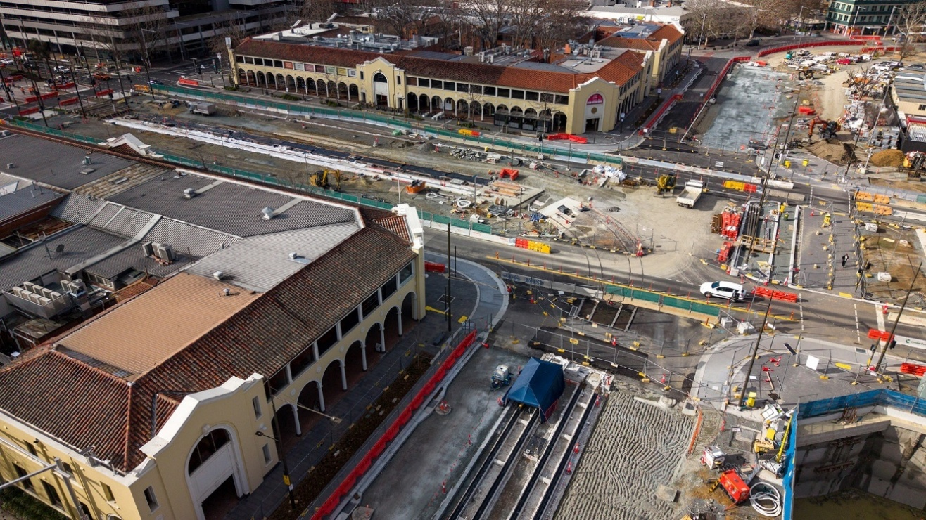Light Rail Stage 2A London Circuit West under construction
Delivery of Light Rail Stage 2A (LRS2A) – Significant progress has been made on Light Rail Stage 2A, with construction remaining on track for completion in early 2027. Project progress includes:
- the installation of roof canopies at City South, Edinburgh Avenue and Commonwealth Park stops;
- completion of track slab works throughout the Raising London Circuit area and across London Circuit and Commonwealth Avenue;
- progression of major utility relocation, drainage, rail installation, paving and landscaping works; and
- continued planning for the reinstatement of parking, including accessible parking at the Theatre Lane Car Park.
Light Rail Procurement, Retrofit and Depot Expansion (LPRDE) – The retrofit programme was completed in June 2026 with the fifth and final new light rail vehicle entering operational service and all 14 retrofitted light rail vehicles returned to service.
Building Light Rail to Woden (Light Rail Stage 2B) – The final Environmental Impact Assessment incorporating the State Circle East alignment has been finalised and submitted to the Commonwealth and ACT Government for assessment. Targeted engagement continued with Commonwealth agencies and other key stakeholders regarding project design and environmental outcomes.

Monaro Highway Upgrades and Design – Project progress includes:
- completion of concrete parapets (barriers) on the bridge over Lanyon Drive, stone pitching on the barriers adjacent to the bridge and the abutments for the second half of the bridge over Dog Trap Creek;
- commencement of widening works on Lanyon Drive and excavation of the Dog Trap Creek channel under both main bridges; and
- progression of the approval process for the Striped Legless Lizard Offset Management Plan for the Kenny offset site.
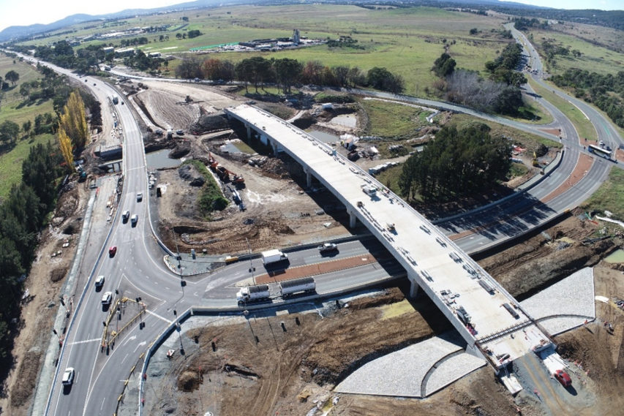Monaro Highway Upgrades
Molonglo Enabling Works – Project progress includes completion of:
- civil works for the Whitlam high voltage feeder;
- installation of parapets and safety railings on the southbound Molonglo River Bridge structure;
- construction of two indented bus bays; and
- installation of advance traffic signal detectors for the Sculthorpe Avenue intersection.
William Hovell Drive Duplication – Construction commenced in April 2026 following completion of environmental approvals and a Welcome to Country and Smoking Ceremony. The project entered active construction during the quarter, supported by a community communications campaign and ongoing collaboration with stakeholders.
Athllon Drive Duplication – The Project Proposal Report was submitted to the Commonwealth Government on 25 June 2026. The Request for Tender for the Southern Section Main Works was released to market on 30 June 2026 and will remain open until 27 August 2026.
Major road rehabilitation – Project progress includes:
- rehabilitation completed for Kuringa Drive, Sulwood Drive Eastern and Western section, Lithgow Street and Sawmill Circuit; and
- procurement tender processes are underway for Pialligo Avenue, Gungahlin Drive, Barrier Street, and Overall Avenue in Casey.

Providing Education for All
Strathnairn Primary School – Stage 2 works continued during the June quarter following the opening of Stage 1 for the 2026 school year. Progress included Level 1 fit out works, gymnasium construction and completion of key external works.
Whitlam Primary School and Early Childhood Education Centre – Construction is continuing with the installation of the main building structure completed.
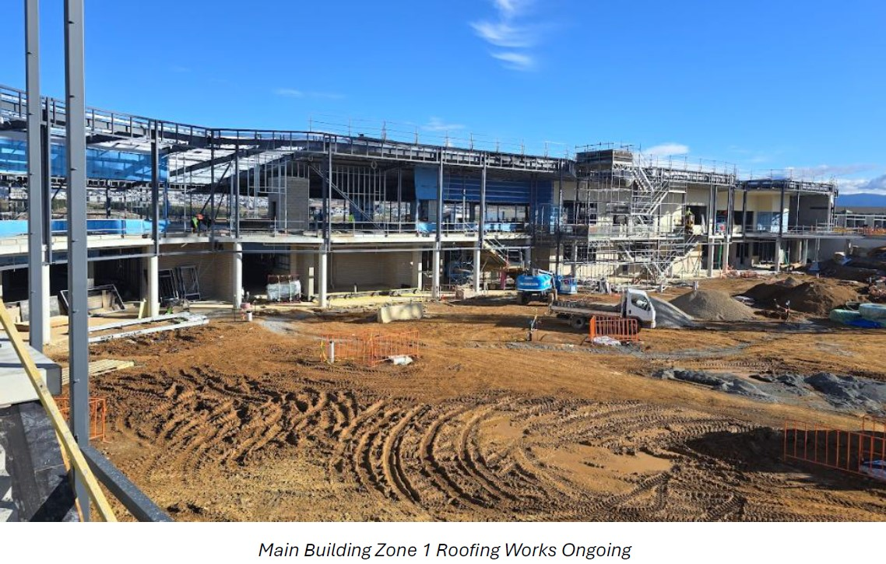Whitlam Primary School and Early Childhood Education Centre Main Building Zone 1 under construction
Garran Primary School Modernisation – Stage 2 construction is continuing including steel and roofing works, car parking construction and landscaping activities.
Infrastructure Upgrades across Canberra Schools – Stage 2 works at Calwell High School were completed, including internal glazing improvements to offices and classrooms. The Cranleigh swipe card access project is expected to be completed by the end of July 2026.
Refurbishing the Lyneham High School Gym – Final contract negotiations with the preferred head contractor have recommenced following the Government’s decision to proceed with current refurbishment.

Delivering Health Services
Canberra Hospital – Project progress includes:
- continuing works on the current phase of the Canberra Hospital Master Plan (CHMP). The signage and wayfinding project has been completed;
- continuing early planning for the next stage of the implementation of the CHMP, focussing on the overall delivery of the pathology and clinical services buildings, and feasibility study for the new mental health precinct; and
- construction works are 65 per cent complete on the new palliative care ward, with wall framing, services rough-in and the majority of sheeting completed.
New Northside Hospital – Early Works Construction commenced in May 2026 and schematic design activities continued during the quarter.
Upgrading and Enhancing Health Infrastructure at North Canberra Hospital – Works are ongoing to support the continuity of key service delivery throughout the construction of the New Northside Hospital and to relocate Alcohol and other Drug (AOD) residential treatment facility to replace Arcadia House.
Redeveloping and expanding the services of the Watson Health Precinct – Construction progressed to approximately 90 per cent completion across the four-building precinct with the commencement of both electrification and building commissioning activities.
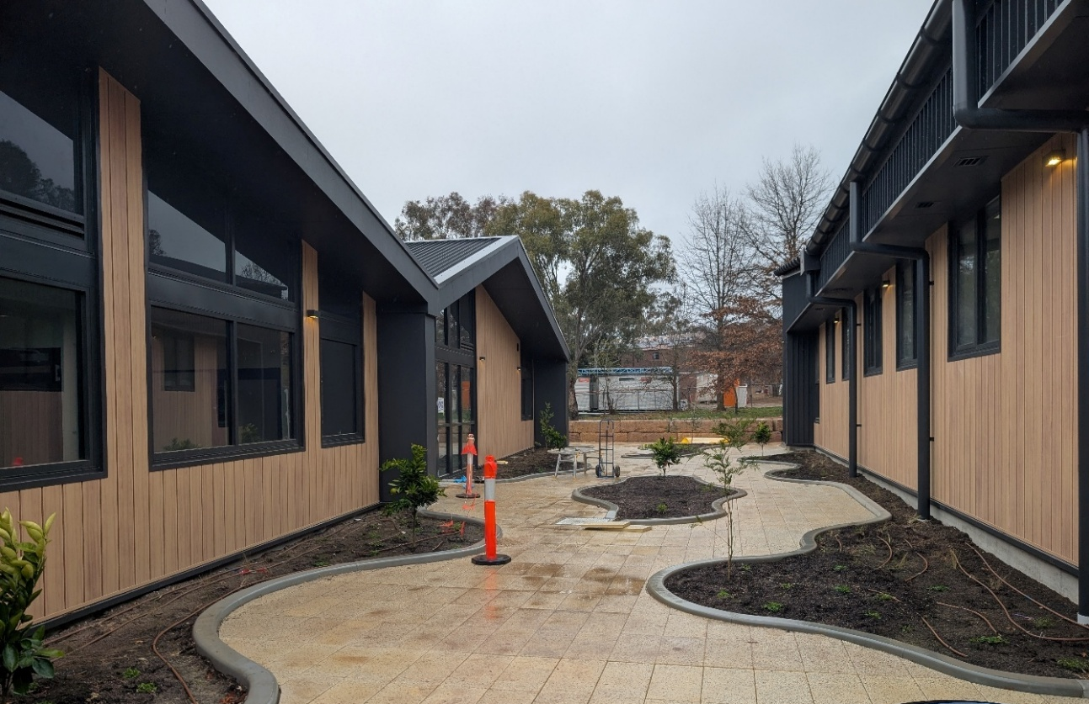 Watson Health precinct under construction
Improvements at the Ngunnawal Bush Healing Farm – A new machinery shed for the storage of farm vehicles is due to be completed by July 2026.
Expanding Health Centres across the ACT – Project progress includes:
- continuation of the South Tuggeranong Health Centre construction with utility connections completed and commissioning planning underway; and
- continuation of the concept design activities for the Inner South Health Centre and approval of the concept design for the North Gungahlin Health Centre incorporating a community space.
Modernising ACT Government Analytical Laboratory (ACTGAL) – Following the completion of Stage 1 works in June 2026, a contractor has been engaged for Stage two of the project to upgrade laboratory workstations.

Public and Social Housing
Growth and Renewal Program – Year-to-date progress includes:
- completing construction of 128 new dwellings and acquisition of 49 dwellings, six dwellings demolished for redevelopment and the sale of 26 end of use public housing properties; and
- an additional 112 dwellings are currently under construction, in design, development application or in the procurement phase.
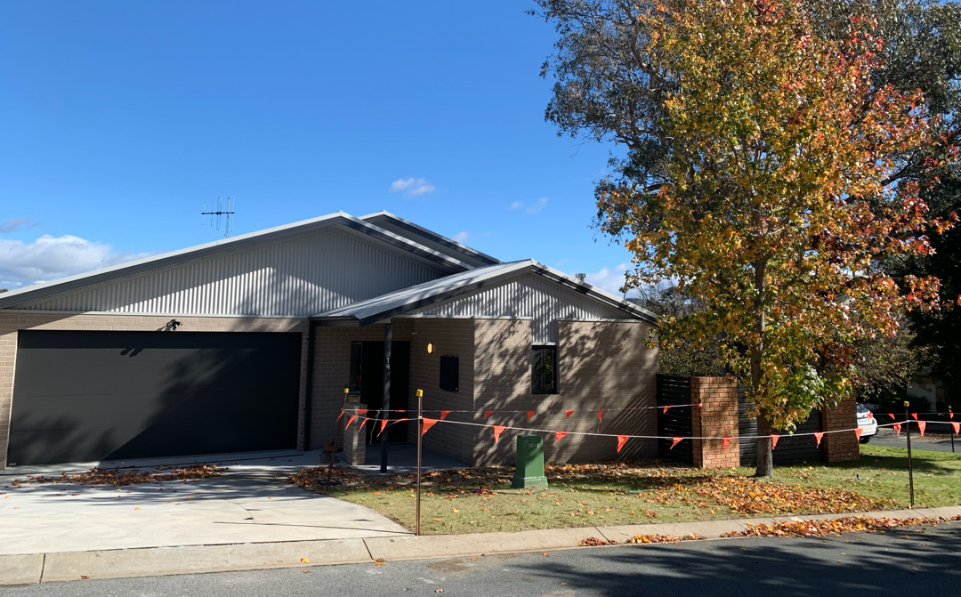 Ngunnawal three bedroom house
Social Housing Accelerator Program initiative – The Government is on track to deliver between 55-65 dwellings through purchase or construction by June 2028 under the Commonwealth’s Social Housing Accelerator. This includes 17 dwellings delivered in June 2025, and 41 dwellings planned across two sites in Gungahlin.
Housing Australia Future Fund (HAFFF) – The ACT Government is working in partnership with the Commonwealth to deliver 85 new public housing dwellings by 30 June 2029 under the second round of HAFFF. There are currently 68 dwellings under construction, in the development application phase, in design or in the procurement phase.

Environment and Climate
Vulnerable Household Energy Support Scheme (VHESS) – The objectives of the VHESS are to reduce energy hardship for vulnerable and low-income households and support the introduction of minimum energy performance standards for rental properties. As of 30 June 2025, VHESS has delivered ceiling insulation to over 3,040 public housing properties and upgraded gas appliances to electric in more than 2000 homes.
Electrification of Government Gas Assets (EoGGA) – The program exceeded its annual target by removing 26 gas-powered assets from Government sites during 2025-26. In the June 2026 quarter, gas-powered asset removals were completed at Tuggeranong Homestead, Gorman House, Hall Community Precinct, Albert Hall, North Ainslie Primary School, and Weetangera Primary School.
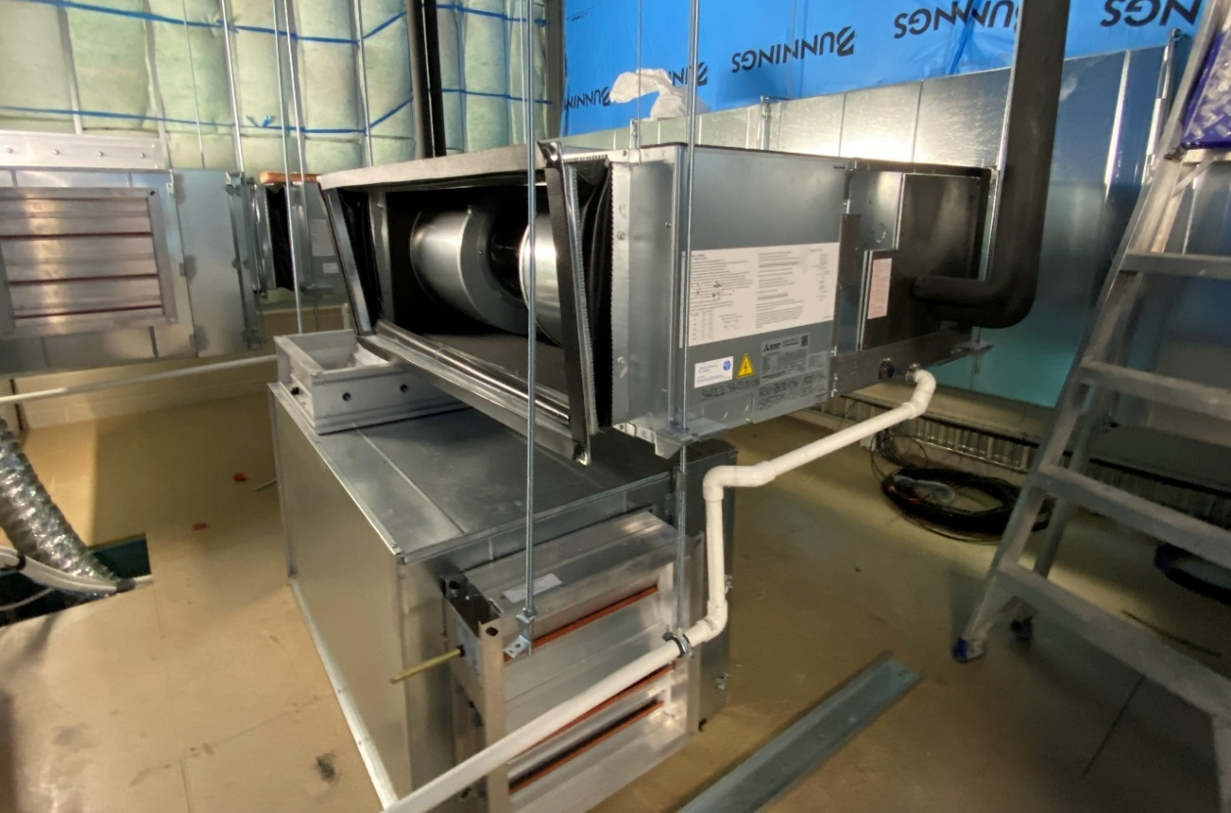
New Equipment at Weetangera Primary School
Materials Recovery Facility (MRF) and Food Organics Facility (FOGO) – Project progress includes:
- MRF: Recycling Road upgrade works, including site establishment, service locating and preparatory construction activities commenced in June 2026. Final Sketch Plan is being prepared and the design of glass washing solution on site is progressing; and
- FOGO: The Environmental Impact Statement process was completed in June 2026 and the Request for Proposal documentation is expected to support release to market in Quarter 3 2026.
Active Travel Investments –Stage 1D construction commenced in June 2026, following engagement of the construction contractor.

Entertainment, Arts and Sports
Canberra Aquatic Centre – The procurement process is entering the Request for Tender phase. The reference design and options have been largely completed.
Stromlo Forest Park District Playing Fields – The design process is underway for a staged delivery approach for the project. Coordination with stakeholders is continuing to support progression of the development application process.
Throsby District Playing Fields –site investigations were completed in the June quarter enabling progression to the next phase of planning and design.
Gorman House Arts Centre Centenary Upgrade – Stage 2 construction is continuing and the project is scheduled for completion by August 2027.
Canberra Theatre Redevelopment Project – The project successfully transitioned from Early Works to Main Works construction. Bulk excavation and piling activities were completed and overall design development reached approximately 90 per cent completion.
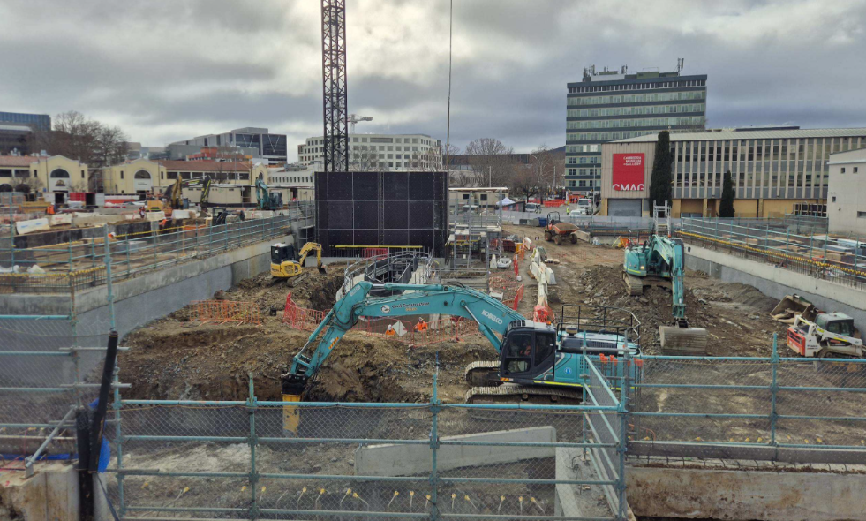
Canberra Theatre Redevelopment under construction

City Services, Recreation and Community Services
Per-and Poly-Fluoroalkyl Substances (PFAS) remediation – Rural Fire Service and Data Gap Investigation assessments have been completed and the project is on track for completion in June 2027.
Justice Reform – Investing in rehabilitation opportunities for detainees at the Alexander Maconochie Centre (AMC) – Construction of the new Security Office is underway and will be completed in October 2026. Further upgrades of the Centre including the Detainee Programs room, Detainee Education Building and Building D are expected to be delivered in 2026-27.
Replacement of ACT Courts Jury and Case Management Systems – Implementation of both the new Jury Management System’s (JMS) and the Coroners Case Management System’s (CCMS) is progressing well, with the go-live date for the JMS planned for August 2026.
Well-prepared emergency services – ACT Ambulance Service modernisation – Procurement processes are underway to upgrade the ESA Communication Centre and progressively modernise the ambulance fleet.
Acton Waterfront Park (Ngamawari) – Construction activities have commenced and key enabling works completed. The Park is expected to open in January 2028.
Gungahlin Community Centre - design and construction – The Centre and Youth Hub were completed in May 2026 and officially opened in July 2026.
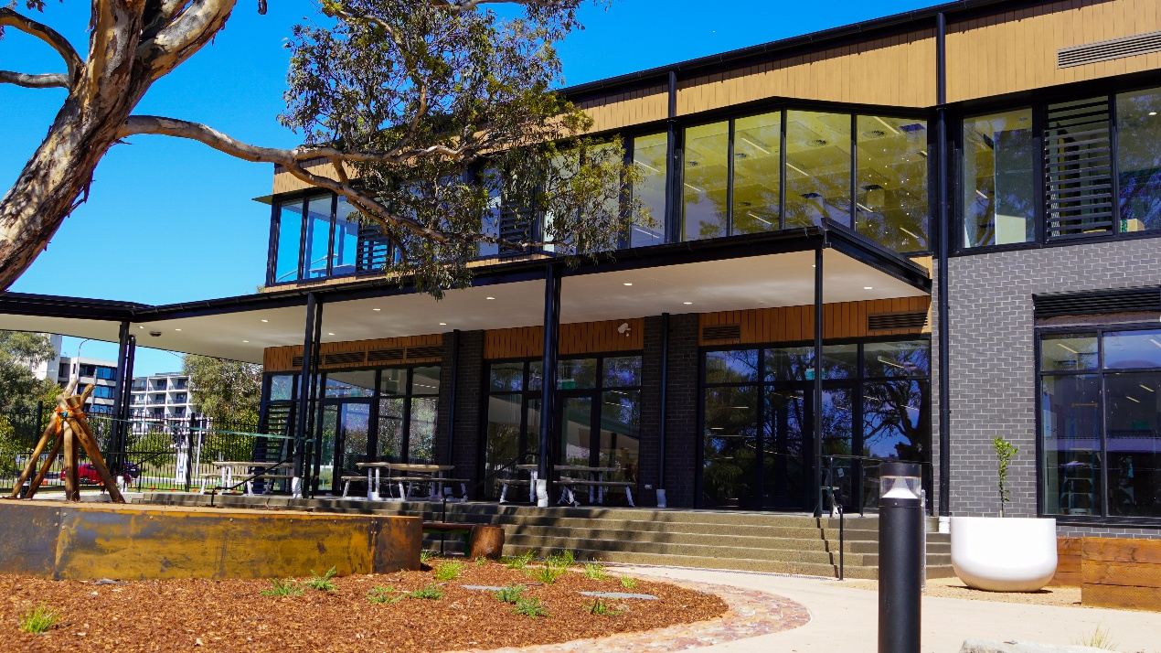
Gungahlin Community Centre
Renewing Canberra’s City Precinct – Project progress includes:
- design works for City Spine Stage 3 (Ainslie Place to Allara Street) and City Spine Stage 4 Alinga Street) are progressing;
- City Hill master planning is underway with the Concept Master Plan scheduled for completion by mid-2027; and
- Dickson Shops Revitalisation construction is progressing in stages to limit impacts on nearby businesses. Project completion is forecast for June 2027.
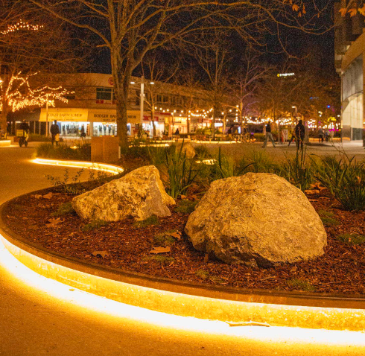
Winter in the City 2026

Tier 1 and tier 2 projects that are in early design/feasibility stages with current project budgets less than $25 million (i.e. the majority of project funding has been centrally provisioned subject to completion of these milestone stages) are included in the milestone reporting but not included in the Major Projects Report at Appendix 1 if their total project budget is less than $10 million.
Project funding shortfalls in the current financial year are internally managed by agencies prior to reprofiling funding from future years.
Projects that are physically complete are not included in the Major Projects Report at Appendix 1.

