ACT Government logo

ACT Population Projections

2022 to 2060

ACT Population Projections

2022 to 2060

Chief Minister, Treasury and Economic Development Directorate

Chief Minister’s, Treasury and Economic Development Directorate

**Contents**

Executive Summary 3

Introduction 4

Main results 5

Methodology 13

Assumptions 14

Fertility 14

Mortality 14

Overseas migration 15

Interstate migration 15

Limitations and Uncertainty 17

Appendix A – Quality framework for the population projections 19

# Executive Summary

Population projections are an important component for many aspects of planning, research and policy development and advice. This paper, a product of the ACT Public Service (ACTPS), presents updated population projections for the Australian Capital Territory to June 2060. The ACT Government last released forty-year projections in 2019, with projections prepared in collaboration with the Australian Bureau of Statistics (ABS). Building on this work, the ACT Treasury has prepared these projections in collaboration with the School of Demography at the Australian National University based on official data sources and modelling until October 2022. The projections incorporate data from Census 2021, which showed a 5 per cent upgrade to the ACT population in comparison to Estimated Resident Population (ERP) derived from the 2016 Census (known as rebasing).

Population in the ACT is projected to grow to approximately 784,000 persons by June 2060. Much of the growth is expected to come from net migration, consisting of net overseas migration and net interstate migration, further supported by the natural increase (births minus deaths) in the population. The projected population for June 2058 is around 63,000 persons higher than the previous projections published in 2019. This change reflects data from Census 2021 that shows net migration into the ACT to be significantly higher than the ABS previously estimated – strong net migration is expected to persist over the projection period.

The median age in the ACT is expected to only rise from 35 years in 2021 to 37 years in 2060. Migration tends to put downward pressure on median wage, as most migrants tend to enter in their mid-20s.

The pattern of population growth varies across ACT suburbs based on the date that a district or suburb was first released, subsequent development activity, and finally ageing. As a result, districts and suburbs have distinct lifecycles, growing quickly as land is released and new families move in, then ageing over time.

At the small area geography level, the Molonglo Valley (Molonglo) district (approximated by the ABS Statistical Area 3 (SA3)) is expected to grow the fastest over the 40‑year period compared to the other districts. However, within the timeframe of the projections, Belconnen is projected to remain the largest district. At the suburb level (approximated by Statistical Area 2 (SA2)), Kambah and Ngunnawal are expected to remain the largest suburbs over the period projected at the SA2 level (June 2022 to June 2026).

The updated projections incorporate a new set of assumptions, which take account of the impact of   
COVID-19 for international migrant cohorts. The population projections are based on assumptions needed to produce 40‑year district and suburb level population projections. Therefore, the population projections contained in this document are indicative and should not be interpreted as precise predictions.

Treasury has created upside and downside scenarios from the baseline set of population projections to provide further information. The assumptions in the baseline projections are varied for these scenarios. However, no changes have been assumed to current policy positions in areas that can impact the growth of the Territory. ACT population is expected to range between 759,000 and 817,000 persons by June 2060 under alternative upside and downside scenarios.

Going forward, Treasury intends to update the estimates annually or as required, in comparison to the previous frequency of once in two years. ACTPS will plan the release of updated reports accordingly.

# Introduction

This report presents the ACT Government’s population projections by single year of age, by sex (male/female) and by small geographic areas. The base year is the estimated resident population as at 30 June 2021. Projections over the period June 2022 to June 2026 are presented up to the Statistical Area 2 (SA2) level by single year age and sex. Projections over the period June 2022 to June 2060 are presented up to the Statistical Area 3 (SA3) level by single year age and sex. Both SA2 and SA3 geographies are in accordance with Australian Statistical Geography Standard (ASGS) 2016.

The purpose of this report is to provide updated population projections for the ACT over the medium term for planning, research and policy purposes. This update to the population projections incorporates the initial estimated impact of Census 2021 and COVID-19 on population growth. Due to the pandemic, there is greater uncertainty around these projections relative to previous years. Reflecting this, the projections also include for the first time, upside and downside scenarios for the ACT population.

The onset of COVID-19 since early 2020 has been a major shock to population growth in Australia, including the ACT. Closed borders disrupted international migration, which previously contributed 40 to 50 per cent of ACT’s population growth. The COVID‑19 disruption to population flows reduced migrant inflows while outflows were less affected. The impact of migrant behaviour in response to COVID-19 on the modelling assumptions add to the uncertainty of the projections.

ACT Treasury has prepared the assumptions underpinning these population projections in consultation with ACT government directorates. The School of Demography at the Australian National University has provided technical expertise which has assisted in developing these assumptions, as well as the ACT Treasury’s cohort component model used to produce the projections. The data underpinning these forecasts were sourced from Australian Bureau of Statistics (ABS) through special data requests.

The *Main Results* section outlines the broad results of the population projection model. The *Assumptions* and *Methodology* sectionsoutline how the model was constructed. *Limitations and Uncertainty* surrounding these population projections are discussed, highlighting the impacts of the availability of final intercensal discrepancy from Census 2021 from the ABS. Upside and downside scenarios for the projections are also shown for the medium term.

# Main results

The ACT population is expected to increase from 453,558[1] persons in June 2021 to 784,043 persons in June 2060, an increase of over 330,000 persons. This translates to an average annual growth rate of around 1.4 per cent over the 39-year period. Net migration is expected to be the main contributor to population growth over this period.

Figure 1 shows the historical and projected ACT population levels to June 2060. The ACT population has grown by over 136,000 people since 2000. It is expected to grow by over 330,000 persons to 2060. Growth rates are expected to increase over the short-term until 2030, offsetting the impacts of the COVID‑19 pandemic on long term population growth.

Unless otherwise mentioned, all references to stock of population in the figures in this report denote population as at 30 June of the year concerned.

Figure 1: Historical and projected population and population growth in the ACT, June 2000 to June 2060

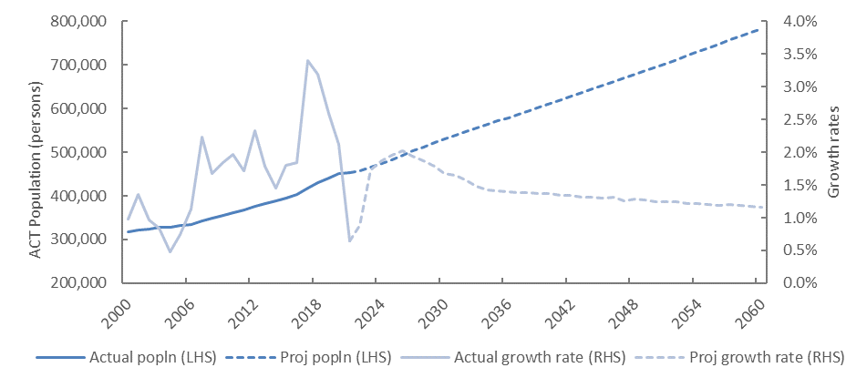

Figure 2 provides a comparison between the current and previously published population projections. It shows that the ACT is expected to reach the milestone population of half a million two years earlier than previously projected. Overall, despite the shock from COVID-19 and associated international travel restrictions, the current population projections indicate an increase in the ACT’s population of 63,000 by June 2058, in comparison to the projections released in 2019.

Figure 2: Comparison of current population projections with 2019 projections, June 2018 to June 2058

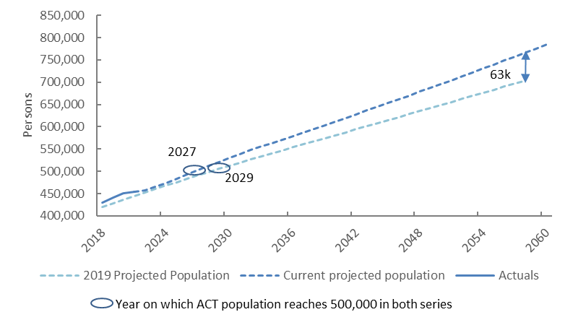

A key difference between the two population projections reports comes from the change in the average growth rate of the ACT population because of the rebasing exercise that the ABS conducted during the release of Census 2021. Figure 3 shows that the average population growth for the ACT over the 15-year period between September 2006 and September 2021 increased from 1.7 per cent prior to Census 2021 to 2.0 per cent post Census 2021. The ABS underestimated the ACT population by around 22,000 persons in its Estimated Resident Population (ERP) prior to the 2021 Census.

Figure 3: Comparison of 15-year average ACT population growth rates pre- and post-2021 Census

This chart shows the change in 15-year average growth rate of ACT population pre- and post-Cenus 2021. The average growth rate of ACT population between September 2006 and September 2021 increased from 1.7% to 2.1% as result of the rebasing exercise carried out post Census 2021.


There are three broad components to population growth, natural increase, net overseas migration and net interstate migration. Prior to the outbreak of COVID-19, net overseas migration accounted for around half of the annual growth in ACT’s population between 2009-10 and 2018-19. However, net overseas migration was severely affected by international border closures due to COVID-19 and was negative in 2020-21.   
Net overseas migration is assumed to bounce back through to 2025-26 before settling to longer term trends from 2031-32.

The intercensal discrepancy in the ABS estimated residential population data is yet to distributed by the ABS between the three broad population components. While the ABS notes the increase in the ACT population from rebasing was mainly due to net migration, updated estimates for net overseas and net interstate migration for the intercensal period will not be released until June 2023. In the interim, Figure 4 shows the historical and projected net flows for natural increase (NI) and net migration, which combines: net overseas migration, net interstate migration and the intercensal discrepancy. After recovering from the impacts of border closures, net migration is expected to return its underlying trend growth over the forecast horizon and remain a key contributor to the ACT’s population growth.

Figure 4: Population growth by component: historical and projections, 1987-88 to 2059-60

This chart shows the actual and projected components of ACT population growth, namely natural increase and net migration. The ACT's natural increase is expected to vary from 3000 to 3200 persons between 2030 and 2060. Projected net migration is expected to increase to around 6,000 persons in the later part of this decade, then reduce for a few years before increasing back to about 6,000 persons around 2060.


The estimated age structure of the ACT population is an important element of the population projections since it informs service planning. All ages contribute positively to ACT population growth between June 2021 and June 2060. Figure 5 shows a comparison of the age structure from ages 0 to 100+ years in the ACT between June 2021 and June 2060 disaggregated by sex.

Figure 5 shows that there is a similar age structure by sex. In June 2021, the single year age with the highest population for both males and females was age 28. By June 2060, the single year age with the highest population is expected to be age 29 for both males and females.

Figure 5: Age structure in the ACT, June 2021 vs. June 2060

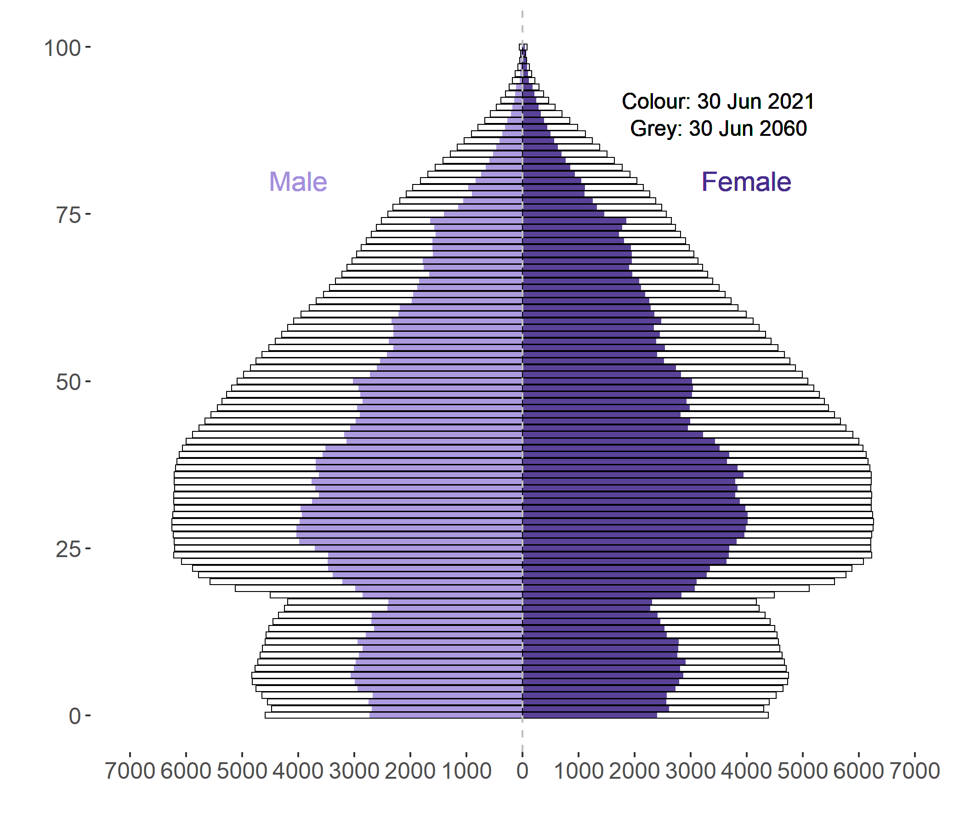

The population projections show a moderate aging of the ACT population, with migration continuing to play an important contribution to the age structure of the ACT population. The 65+ years age group across both sexes is expected to increase from 13.3 per cent of the population in June 2021 to 14.6 per cent in June 2060. In contrast, the 0 to 14 years age group is expected to reduce from 18.5 per cent of the population in June 2021 to 17.6 per cent of the population in June 2060. Importantly, the key age group for labour force participation, 15-64 years, is expected to decrease marginally as a share of the population between June 2021 and June 2060 (figure 6).

Figure 6: Proportion of various age groups in ACT population, June 2021 and June 2060

This chart compares the proportions of 0-14, 15-64 and 65+ years age groups between 2020 and 2060. While the 0-14 and 15-64 years age groups are projected to reduce by less than a percentage point between 2020 and 2060, the 65+ years age group is expected to increase by 1.3 percentage points over the same period.


The median age in the ACT is expected to increase from 35 years at June 2021 to only 37 years at June 2060 (Figure 7). The median age for females was higher than males in 2021. However, they are expected to gradually converge over the next 39 years, with median age for females reaching 37.3 years and that of males 36.8 years.

Figure 7: ACT median age; females, males and persons, June 1980 to June 2060

This chart shows the median ages of the ACT population as well as by sex (males/female). While the median age of females was greater than males in 2021, they are expected to converge by 2060.


Population growth across ACT districts reflects the relative stages of growth relating to the initial release of developments in each district relative to offsetting factors like urban infill and ageing over the projection period to June 2060. Table 1 shows the change in population at the ACT district level (approximated by the ABS ASGS 2016 structure SA3) between 2021 and 2060.

Table 1: Population change in ACT SA3s between June 2021 and June 2060

| SA3 | Population in June 2021 | Population share in June 2021 (%) | Population in June 2060 | Population share in June 2060 (%) | Change in population | Average rate of growth |
| --- | --- | --- | --- | --- | --- | --- |
| Belconnen | 105,872 | 23% | 175,826 | 22% | 69,954 | 1.3% |
| Canberra East | 1,932 | 0% | 2,232 | 0% | 300 | 0.4% |
| Gungahlin | 87,843 | 19% | 148,799 | 19% | 60,956 | 1.4% |
| Molonglo | 11,382 | 3% | 86,148 | 11% | 74,766 | 5.3% |
| North Canberra | 61,372 | 14% | 140,999 | 18% | 79,627 | 2.2% |
| South Canberra | 31,591 | 7% | 58,342 | 7% | 26,751 | 1.6% |
| Tuggeranong | 89,245 | 20% | 88,914 | 11% | -331 | 0.0% |
| Urriarra – Namadgi | 621 | 0% | 469 | 0% | -152 | -0.7% |
| Weston Creek | 24,522 | 5% | 25,671 | 3% | 1,149 | 0.1% |
| Woden Valley | 39,178 | 9% | 56,643 | 7% | 17,465 | 0.9% |
| ACT | 453,558 | 100% | 784,043 | 100% | 330,485 | 1.4% |

With the new developments of Denman Prospect and Whitlam, Molonglo SA3 is expected to show the most significant population growth over the 40-year period between June 2020 and June 2060, growing at an average rate of 5.3 per cent, followed by infill driven developments in North Canberra. Belconnen is however, expected to remain the largest SA3 in terms of population over this period. Overall, population growth in Molonglo, North Canberra, Gungahlin and Belconnen SA3s are expected to contribute the most to ACT population growth over the 39-year period. Established and relatively aged districts in 2020 like Tuggeranong and Weston Creek are either projected to shrink or grow marginally in population by 2060. The rate of growth in the population for Woden Valley increases from around 2040.

At the SA2 level, Kambah in Tuggeranong SA3 and Ngunnawal in Gungahlin SA3 are expected to remain the suburbs with the two largest populations in the ACT over the entire period 2022 to 2026. However, the two suburbs have contrasting population growth profiles. Kambah’s population is projected to decline from an estimated 15,702 persons at June 2021 to 14,761 persons at June 2026, while Ngunnawal’s population is projected to increase from 11,012 persons at June 2021 to 11,885 persons at June 2026.

West Belconnen, Taylor, Denman Prospect, Moncrieff and Civic SA2s are expected to show the fastest population growth over the period from June 2021 to June 2026. By June 2026, four suburbs from the Gungahlin district are expected to be among the top ten ACT suburbs by population, with Belconnen and Bruce from the Belconnen district, Kambah and Gordon from the Tuggeranong district, and Kingston and Civic suburbs completing the top ten.

Figure 8 shows line charts demonstrating changes to population levels projected for each ACT district while figure 9 compares population pyramids for each district between 2021 and 2060.

Figure 8: Population (actual and projections) by district, June 2000 to June 2060

This panel chart shows how population is expected to vary between 2001 and 2060 for the largest ACT districts Belconnen, Gungahlin, Molonglo, North Canberra, South Canberra, Tuggeranong, Weston Creek and Woden Valley.


Figure 9: Population distribution by age and sex, by district, June 2021 vs. June 2060

This chart shows the population pyramids for the largest ACT districts Belconnen, Gungahlin, Molonglo, North Caberra, South Canberra, Tuggeranong, Weston Creek and Woden Valley between 2021 and 2060.


# Methodology

The ACT 2022 population projections are produced using a cohort component population projection model. This model provides a robust basis for producing population projections at a granular level. It also allows the flexibility for projections to be updated in a timely manner and extended to include specific scenarios. It can also evaluate different assumptions about future demographic behaviours across key components: including births, deaths, interstate/internal migration, and overseas migration.

The cohort component population projection model used here is based on the standard demographic accounting equation of population change:

$$P_{i}\left(t+1\right)=P_{i}\left(t\right)+B_{i}\left(t,t+1\right)-D_{i}\left(t,t+1\right)+M_{i}\left(t,t+1\right)-O_{i}\left(t,t+1\right)+I_{i}\left(t,t+1\right)-E_{i}\left(t,t+1\right)$$

where the population of a suburb ($P_{i}$) at time t+1 is equal to the population at time t plus the number of births ($B_{i}$), in-migrants ($M_{i}$), and immigrants ($I_{i}$) minus the number of deaths ($D_{i}$), out-migrants ($O_{i}$) and emigrants ($E_{i}$) that occurred in the intervening period t to t+1.

As part of the demographic change, migration represents one of the major components and consists of two separate flows: arrivals and departures. Arrivals comprises in-migration (interstate/within ACT migration) and immigration (overseas), and departures consists of out-migration (interstate/ within ACT migration) and emigration (overseas). The distinction between interstate/within ACT migration and overseas migration is important because they are two mutually exclusive populations, with different probabilities to migrate. In addition, there is the possibility that they will not move in the same direction of population change, which is also considered when estimating population growth.

The basic population characteristics of the cohort component population projection model are age (single year age groups), sex (male, female) and suburbs (approximated by Statistical Areas Level 2). The model uses survivorship ratios obtained from lifetables constructed from age-specific mortality rates. Cohort survivorship is natural feature of populations as they age over time. For example, it is used in the prediction of the number of females aged 10 years that would remain in the population and their likelihood of giving birth in the future. This aspect of the model allows the projection to maintain internal validity.

All inputs and outputs of the population projection model are disaggregated by age, sex and district or suburb. This includes the inputs for the demographic components of change. The detailed migration flow information, as opposed to the previous net migration inputs, are useful to both increasing accuracy and assessing implications of both interstate/internal and overseas migration.

# Assumptions

The ACT 2022 population projections adopt a range of assumptions on fertility, mortality, overseas migration and interstate migration. These assumptions are made based on the historical trend of demographic behaviours of ACT’s population as well as the existing policy settings, including decisions on city planning.

## Fertility

Total fertility rates in the ACT are expected to decline from 1.6 in 2019-20 to around 1.5 by the end of June 2030, before stabilising at this level for the rest of the projection period (figure 10). This means an average woman in the ACT is expected to give birth to 1.5 children over her life in the medium term.

Figure 10: ACT total fertility rate, historical and assumed, 2014-2015 to 2059-2060

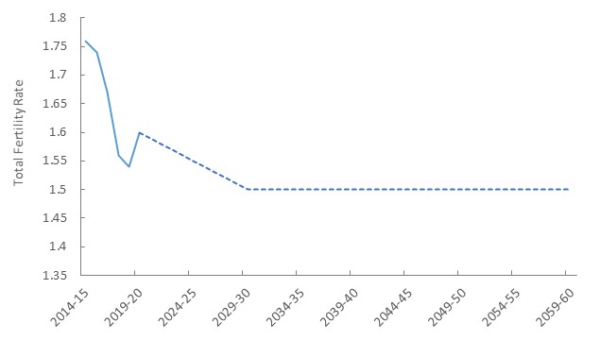

## Mortality

Mortality rates are expected to improve over the 40-year period, consistent with the assumptions published for the ACT by the ABS as part of its 2017 population projections[2]. Life expectancy at birth is assumed to increase from 81.8 to 83.7 years for males and from 85.4 to 86.3 years over the 40-year period ending 30 June 2060 (figure 11).

Figure 11: Life expectancy at birth, by sex, June 2020 to June 2060

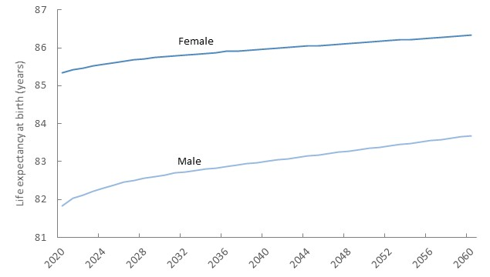

## Overseas migration

COVID-19 impacted both emigration and immigration in 2020-21 and are assumed to take around two years to recover to their pre-pandemic levels. Immigration is assumed to be more severely impacted relative to emigration, in line with recent data.

ACT’s immigration is assumed to recover quickly and grow steadily once it returns to the pre-pandemic levels. Emigration rates for ACT suburbs are assumed to trend towards the ACT average by the end of June 2030 before stabilising over the rest of the projection period.

## Interstate migration

Historically, interstate migration in the ACT oscillates between net outflows and net inflows year on year. In the aggregate, the ACT has seen a positive contribution to its population from interstate migration. While state border closures from COVID-19 impacted the levels of both in-migration and out-migration, net migration is expected to remain positive for the ACT over the projection horizon. Preliminary Census 2021 results for internal migration, while not the same as net interstate migration used in ERP, indicates that the ACT is one of only three jurisdictions to have had a net inflow from other states and territories over the five year period since Census 2016.

Over the past 20 years, the median age of interstate in-migration has been rising faster relative to that of interstate out-migration (figure 12), as relatively more people of the mature working class (aged 45 to 59 years) moved into the ACT. This trend is expected to continue over the next 40 years.

Figure 12: Median age, interstate in-migration vs interstate out-migration, 2000-01 to 2019-20

This chart shows historical data on median age of in-migrants to, and out-migrants from, the ACT between 2000-01 and 2019-20. While the median age for out-migrants has been higher than that for in-migrants at least since 2000, the difference has narrowed since 2015-16.


# Limitations and Uncertainty

The population projections contained in this report are the result of data availability and data updates at the time of publication, and certain assumptions about future trends in fertility, mortality and migration. Social and economic factors, and policy decisions by the Australian and ACT governments influence these assumptions.

#### Limitations

The ABS will produce the final intercensal discrepancy for Census 2021 in June 2023. Updated net overseas migration and net interstate migration figures for the ACT for the period September quarter 2017 to June quarter 2021 are expected to be available then. For the current set of projections, given lack of further information, Treasury has assumed that net migration has contributed the additional population attributed to intercensal discrepancy in each quarter. This will be updated once actual data is available from the ABS in June 2023 and may affect population distributions to SA3s and SA2s.

In general, as more data from Census 2021 is released, some of the assumptions considered in the current set of projections may also have to be revisited. Treasury will consult with the ABS in early 2023 and accordingly plan another update to the current set of population projections in late 2023 or early 2024.

#### Uncertainty

Given the importance of migration to ACT population growth, whether assumptions around behaviours of migrating cohorts, both internationally and interstate, are realised can have a significant impact on the accuracy of these population projections.

Similarly, given the significant contributions from natural increase to ACT population growth, whether assumptions around fertility materialise are also expected to have a strong impact on the accuracy of these projections.

In summary, considering the factors referred above, the population projections contained in this document should not be interpreted as precise predictions of demographic future, but instead provide an indication of population change and its possible implications for the Territory.

#### Scenarios

ACT Treasury has endeavoured to model the uncertainty surrounding the baseline population projections through upside and downside scenarios.

The upside scenario assumes that the opening of international borders leads to a higher number of returning skilled migrants, international students and tourists, including working holiday makers, than that of the baseline scenario. This would lead to an increase in the ACT population through higher net overseas migration. In addition, a high level of job vacancies is expected to continue in the upside scenario, attracting skilled migrants to the ACT from both overseas and interstate.

Further, higher total fertility rates, net overseas migration and net interstate migration are expected to be sustained in the medium term due to better economic and labour market outcomes in the upside scenario.

As a result, ACT population is expected to reach 817,000 by June 2060 in the upside scenario, around 33,000 more people compared to the baseline scenario. The population growth rate is expected to stabilise at around 1.3 per cent, compared to the 1.2 per cent in the baseline scenario.

The downside scenario assumes lower net migration levels in comparison to the baseline scenario. As a result, ACT’s population is expected to only reach 759,000 by June 2060, around 25,000 fewer people compared to the baseline scenario. The population growth rate is expected to stabilise at around   
1 per cent, compared to the 1.2 per cent in the baseline scenario.

The shaded areas in figure 13 below show population levels and growth rates corresponding to the upside and downside scenarios, relative to the baseline.

Figure 13: ACT population levels and growth rates in the upside and downside scenarios, June 2010 to June 2060

This two-panel chart shows the ACT population levels and growth rates for the baseline scenario as well as the range for both population levels and growth rates derived from the upside and downside scenarios. The upper panel shows the population levels while the lower panel shows the growth rates.


1. Quality framework for the population projections

The Council on Federal Financial Relations (CFFR), consisting of the Commonwealth Treasurer and all state/territory Treasurers, have agreed to a set of quality principles. The expectation is that these principles will ensure consistency across population projections produced by each jurisdiction and the Centre for Population (CPop). The five principles that have been agreed upon are[3]:

* Relevance - Population projections should clearly outline their purpose and intended uses.
* Timeliness – Projection users should be able to make decisions based on the most up to date data and trends.
* Accuracy - Population projections should be accompanied by detailed explanatory notes communicating the accuracy and uncertainty of methodologies employed. Scenario analysis should be conducted to show dependence of projection outcomes on assumptions.
* Interpretability - Interpretability refers to the presentation of data, and availability of accompanying information to maximise comprehension and usefulness to end users. Interpretability is important as it enables the information to be understood and used appropriately.
* Accessibility - Accessibility refers to how easily users can access population projections and explanatory information.

The key actions that the Heads of Treasuries have agreed upon regarding the above quality principles provide guidance on the outputs and deliverables the ACT has produced as a part of this population project. The table below presents each principle, the agreed actions and how the current set of ACT population projections are consistent with the agreed actions.

| Principle | Agreed Actions | Is the ACT conformant? |
| --- | --- | --- |
| Relevance | To improve relevance, jurisdictions should produce population projections to a common:   1. base population: the reference year of the latest final rebased Estimated Resident Population (e.g., data as at June 2021 following the 2021 Census); 2. geography: a minimum of state or territory, and a small area geographic level (LGA or SA3); 3. reference period: A minimum of 20 years; and 4. age and sex split: a minimum of 5 year age groups by sex at the state and territory level.   In addition, projections should be accompanied by a description of relevant assumptions made for the state and territory level and a summary of assumptions and/or explanatory information about the assumption approach for lower geographies. | Yes.   1. Base population used is 30 June 2021 Estimated Resident Population based on the ABS’ *Regional Population by age and sex* released on 30 August 2022. 2. The population projections are at the SA3 and SA2 levels. 3. Reference period is 39 years (until 30 June 2060) for SA3 data. 4. All SA3 and SA2 populations have been disaggregated into single year age and sex.   Refer assumptions section for details on assumptions considered for the current set of population projections. |
| Timeliness | **To improve timeliness, jurisdictions should produce and release projections:**   1. at a minimum frequency standard of once per Census cycle; 2. within two years of the release of preliminary rebased ERP; and 3. according to a published release schedule.   Consistent with the above, jurisdictions are free to determine the timing of their projection releases, and the content of their release schedules, so long as the timing and schedules are transparent to the public. | **Yes.**   1. This is the first ACT release of population projections at a small area geographic level post Census 2021. 2. The timing of the next release will be determined after liaising with the ABS on availability of further data, |
| Accuracy | **To improve accuracy of projections and their analysis, jurisdictions should produce projections:**   1. with accompanying explanation of the uncertainty associated with projection methodology and assumptions; and 2. with scenario analysis, using different assumptions (such as high or low migration, fertility, and mortality). | **Yes.**   1. & (b) Refer section on *Limitations and Uncertainty* in this publication. |
| Interpretability | **To improve interpretability, jurisdictions should provide accompanying documentation with releases that:**   1. address these quality principles in the release; and 2. are made available in Excel and / or CSV formats. | **Yes.**   1. This section addresses the quality principles. 2. Population at the SA3 and SA2 geography levels are available in Excel format on the ACT Treasury website. |
| Accessibility | To improve accessibility, jurisdictions should:   1. make projections publicly available in an easy to find location; and 2. provide access to underlying data and projection components for the state and territory level, and lower geographies where possible. | Yes.   1. The population projections are available on the ACT Treasury website. 2. Projection components have also been provided for the ACT on the ACT Treasury website. However, underlying data has been sourced through special requests and cannot be shared publicly. |

1. This figure is from the ABS *Regional Population by age and sex, 2021* publication released on 30 August 2022.
2. Refer <https://www.abs.gov.au/statistics/people/population/population-projections-australia/latest-release>
3. Refer Commonwealth Treasury Centre for Population’s media release on the principles: <https://population.gov.au/media/media-working-with-states-territories-local-gvt.html>