NATION LEADING SCHOOLS FOR CANBERRA
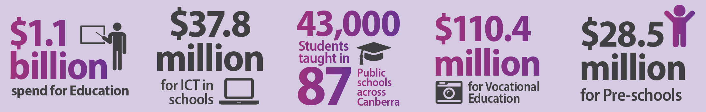
Canberrans can be proud of our nation leading education system. The ACT’s education system teaches over 70,000 students across both government and non-government schools.
The 2015-16 Territory budget provides a record amount of funding to ensure our education system continues to deliver for students and teachers. This year’s ACT education budget is the biggest ever, delivering over $1.1 billion this financial year.
This budget delivers over $160 million for better classrooms and state-of-the-art, innovative facilities. We’re also providing new funding to help support students with disability.
This budget renews our CIT campuses to be better than ever, including a new $10.7 million CIT campus in Tuggeranong and upgrading Bruce and Reid campuses.

Modern schools for our children
This budget invests more than $160 million for modern classrooms and schools right across Canberra including:
- $18.4 million to modernise Belconnen High School, including extensive refurbishment and upgrading of existing facilities;
- $30.3 million for the North Gungahlin Primary to Year 6 school, scheduled to open in January 2019;
- $3.6 million to replace the roofs at Melrose High School and Mt Stromlo High School;
- $6.5 million for a specialist learning centre at Caroline Chisholm School, to provide science, technology, engineering and maths programs to students across Tuggeranong;
- $37.8 million to replace and upgrade computers and expand wireless capability across primary schools whilst maintaining critical, centrally provided ICT support services; and
- $1 million for feasibility studies for a Year 7-10 school in North Gungahlin and a Primary to Year 10 school in Molonglo.

Helping kids learn
This budget boosts programs and resources to deliver even better outcomes:
- $3.9 million in funding to help students with disability, including extra resources to increase participation in education, and for transport of students with disability to ACT public schools;
- $615,000 for the training of teachers and support staff about domestic violence, and the development of an online resource centre to connect families to support services.

Support for teachers
Funding to support the best educators in the country:
- $1.3 million for the next stage of online services for professional learning, teaching standards and professional practice through the ACT Teacher Quality Institute; and
- Almost $700,000 for teacher resources to assist in the delivery of the Australian Curriculum.

Vocational Education
This budget invests $13.3 million in CIT facilities:
- A new $10.7 million Canberra Institute of Technology training centre in Tuggeranong will update CIT’s course offerings and facilities for students in Canberra’s south; and
- A further $2.6 million will upgrade existing CIT campuses at Reid and Bruce.

