Icon Water

Industry Panel public hearing
6 February 2015 John Knox
Managing Director

1

Response to the draft decision

- We support the draft findings in favour of each of our contentions with the 2013 ICRC decision
Biennial reviews removed
Cost of capital based on benchmark firm
Calculation of depreciation revised
- We support the well- accepted regulatory techniques adopted by the Panel
- We seek reconsideration of some decision elements, particularly:
  - demand risk, and
  - cost of capital

2

Icon Water’s presentation today

Our plans for the next four years (Amanda Lewry - General Manager, Asset Management)
- Draft decisions for which we are seeking reconsideration (Sam Sachse - General Manager, Finance)

Icon Water
Our plan for the next four years

Amanda Lewry

General Manager, Asset Management

4

The infrastructure supporting your

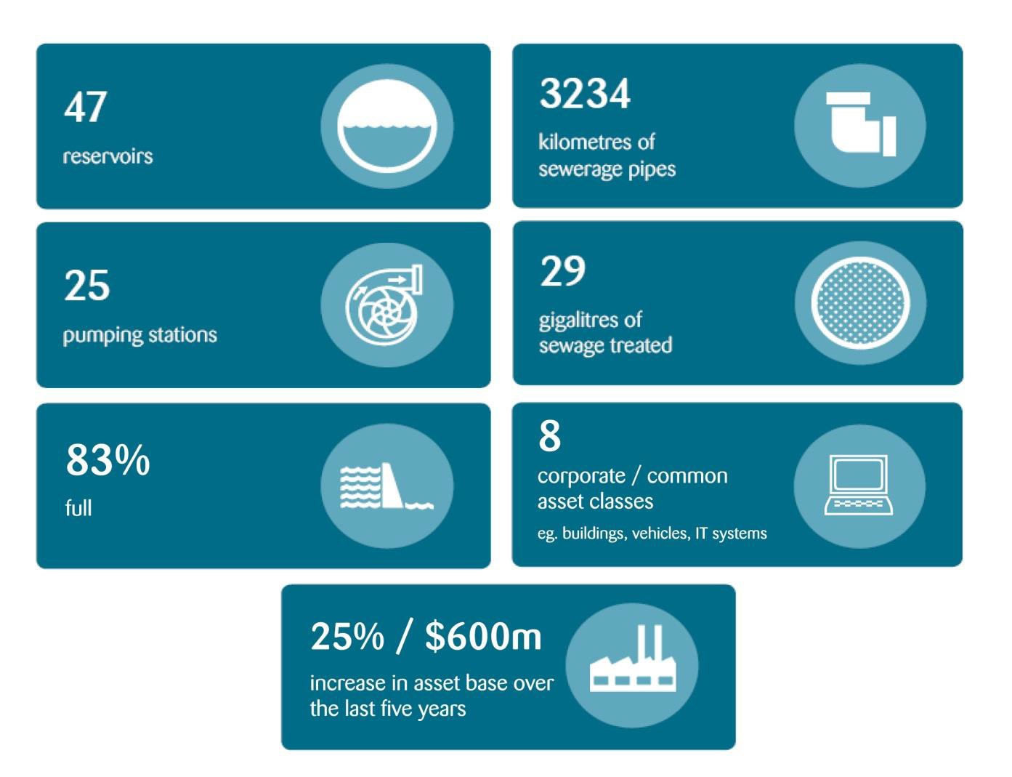
service

Capital projects to support
continued services in a growing Canberra

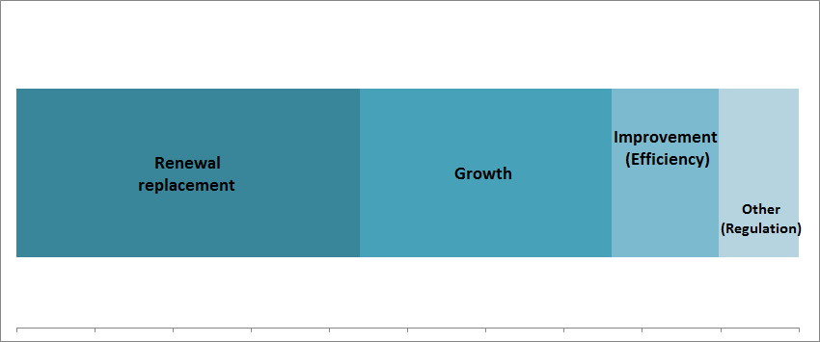
Five years to 30 June 2018
44%
32%
14%
10%

Supporting the continued provision
of existing services

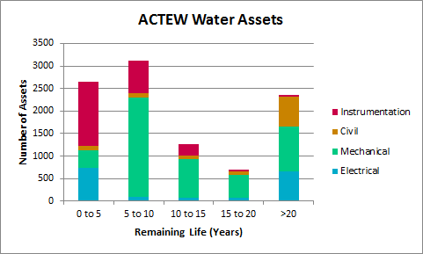Water Network Risk Profile by Asset Class
Sewerage Network Risk Profile by Asset Class

Non-potable

Water Reservoirs

Treated Water Pumping
Water Transfer Mains
Stromlo Water Treatment Plant
Googong Water Treatment Plant
Raw Water Pumping
Dam Offtake and hydro

Remote treatment
Fyshwick LMWQCC Electrical
LMWQCC Site Services Risk Profile
LMWQCC treatment Risk Profile
Odour Control Sewerage Pump
Stations

0% 50% 100%
0% 50% 100%

Renewal Program

7

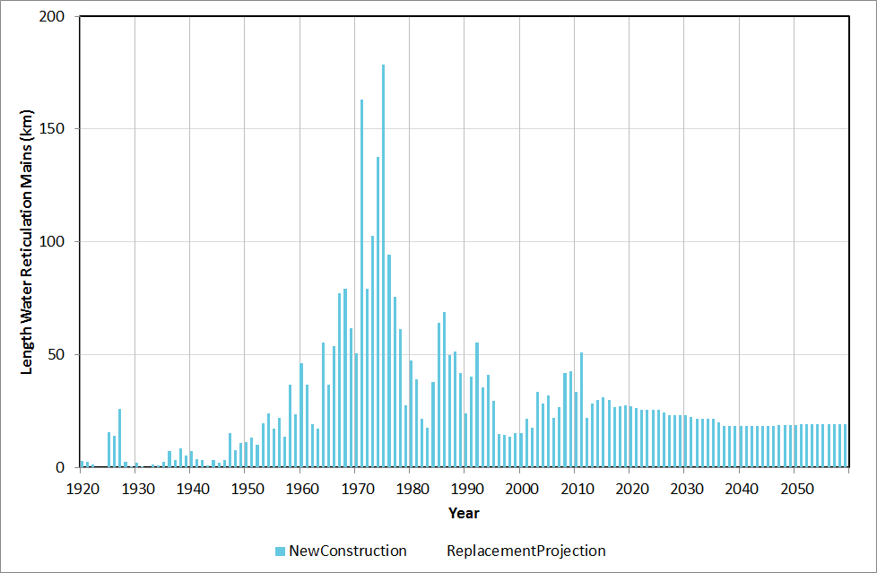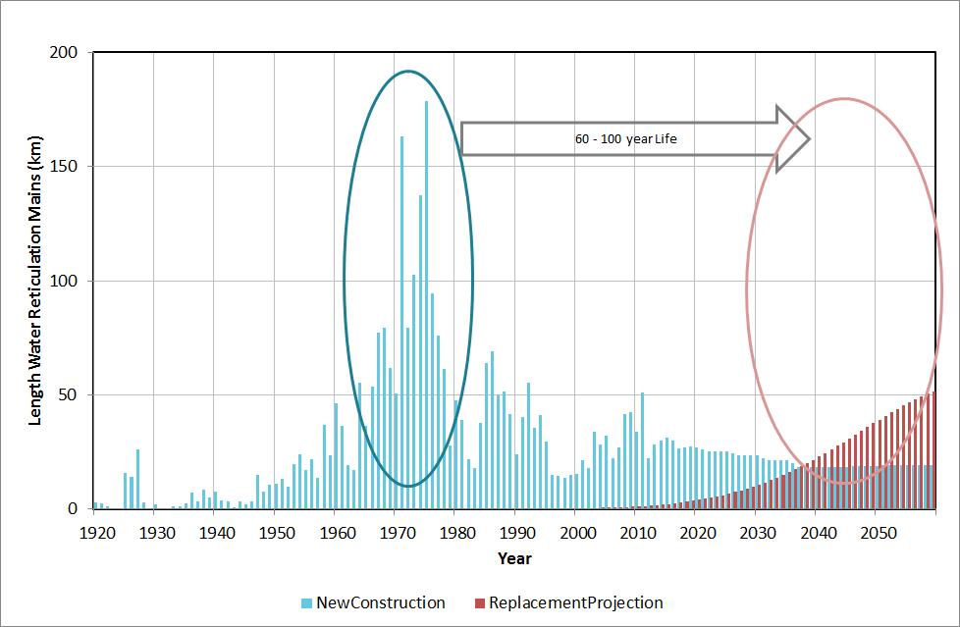Capital projects – Renewal of the mains

Good condition sewer pipe Poor condition sewer pipe

8

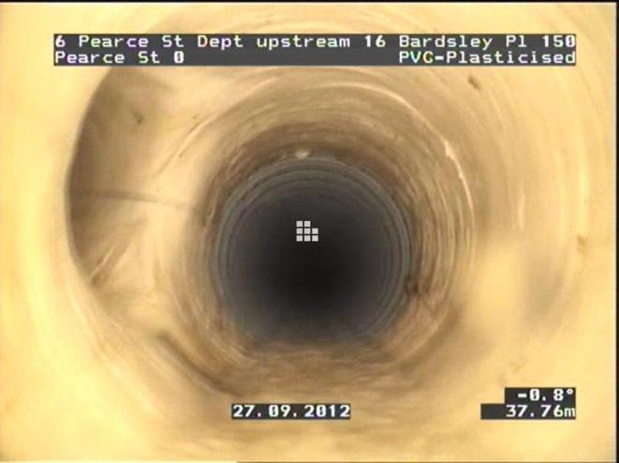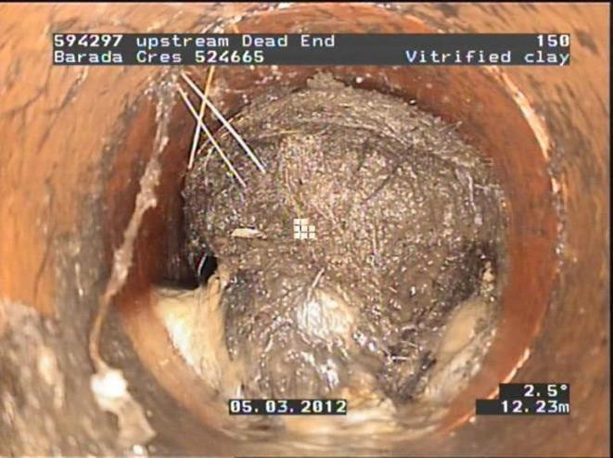Capital projects – Renewal of the mains

Good condition sewer pipe Poor condition sewer pipe

8

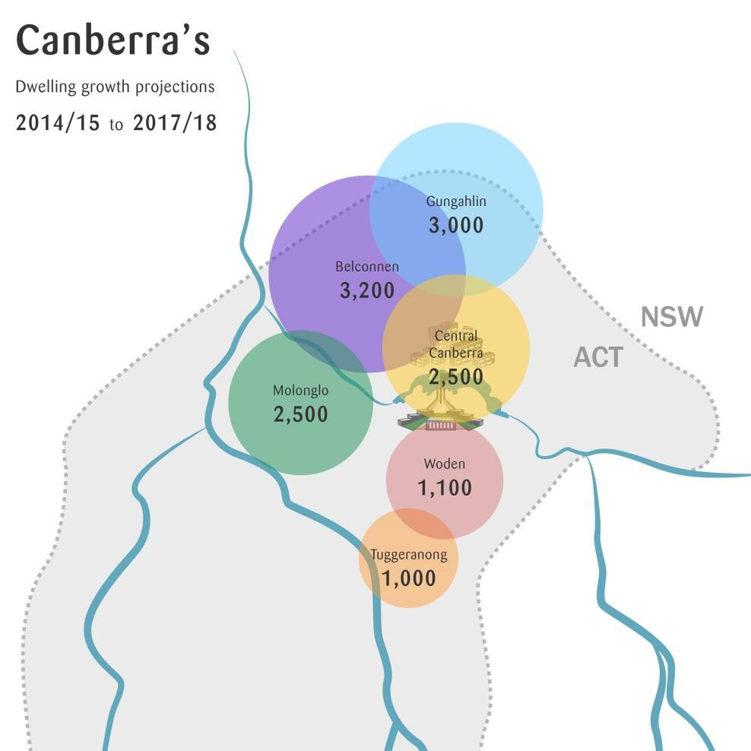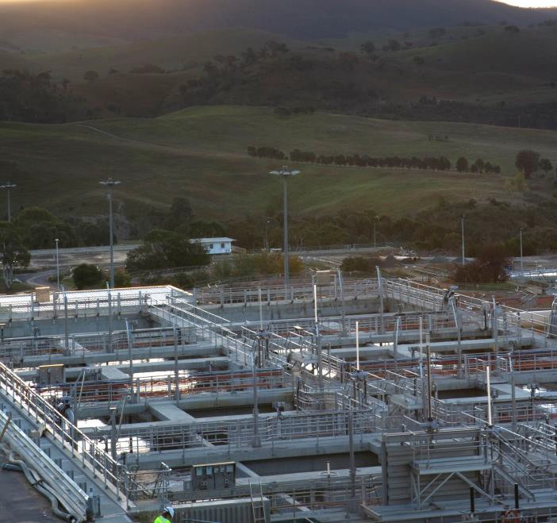Supporting and enabling growth in
the ACT

All growth in ACT supported by LMWQCC Volumes of water have not increased but sewer loading has increased

Figures from LDA Indicative Land Release Program
2014 - 2018

10% growth

9

180,000

Operating costs
Actual operating costs ($'000 12-13 prices)

10
160,000
WAC and UNFT
Sewer
Water

140,000

120,000

100,000
$'000 12-13 Prices

80,000

60,000

40,000

20,000

-
2013-14 Actual 2014-15 Forecast 2015-16 Forecast 2016-17 Forecast 2017-18 Forecast

Costs are not predicted to increase in real terms despite ageing network and a 25% increase in asset base

Icon Water

Areas in which we are seeking
reconsideration Sam Sachse
General Manager, Finance

11

Icon Water is seeking
reconsideration of

Demand risk
  - Water sales forecasts
  - The deadband for the demand volatility
adjustment mechanism
- Cost of capital parameters
  - Equity beta
  - Gamma

Demand risk
- Risk that revenue will fall significantly short of efficient costs:
  - Water volumes are uncertain and sensitive to weather outcomes
  - Revenue highly sensitive to water volumes
  - Relatively high water sales forecasts (in our view)
  - No adjustment for sales variance within ±7%

60,000

55,000

50,000

Water volumes forecast

Net evaporation Water sales

45,000
ML / mm x 38

40,000
Icon Water estimate/forecast
Panel draft forecast

35,000

30,000

25,000

20,000

15,000

Financial year ending 30 June

Adopting Icon Water’s forecast would increase a typical residential bill by around $1 per week
Severe water
restrictions
2004 2005 2006 2007 2008 2009 2010 2011 2012 2013 2014 2015 2016 2017 2018

Deadband
Icon Water proposal Panel draft decision

60

40

20

0
$m $2014-15

-20

-40
- Icon Water proposes the revenue at risk be reduced to 3% of forecast sales (from 7%)
- This benefits customers by
  - reducing the scope for Icon Water to earn more revenue than is necessary, and
  - Allowing Icon Water to fund productivity improvement initiatives

Water volumes
15
-60

-80

Cost of capital

Decision  component | Panel draft  decision | Icon Water  proposal
Equity beta | 0.7 | 0.9
Gamma | 0.5 | 0.25
Nominal vanilla WACC | 7.20% | 7.78%
- We seek an appropriate rate of return that provides incentive for efficient investment
- The WACC decisions for NSW utilities in 2013 were above 7.20%
- Impact on the annual bill for a typical residential customer would be $2 per week

16

Icon Water’s proposed price path

1600
Panel draft decision Icon Water proposal
CPI increase on 2012-13 base

1400
Indicative annual residential bill ($ nominal)

1200

1000

800

600

400

200

ICRC determination

The proposed increase on the 2012-13 (pre-ICRC determination) base is in line with CPI, despite the large investments that have secured water supply for the long term

0
2012-13 2013-14 2014-15 2015-16 2016-17 2017-18

17

2.0%

Water bill as a proportion of
household income

1.5%

1.0%

0.5%

0.0%

200kL bill as a % of average household income
The average annual combined water bill has remained below 1% of
average household income since 1994-95.

18

Icon Water’s proposed price path

 | 2015-16 | 2016-17 | 2017-18
Icon Water proposal
Water | CPI + 10.8% | CPI + 0% | CPI + 0%
Sewerage | CPI + 11.7% | CPI + 0% | CPI + 0%
Panel draft decision
Water | CPI – 7.5% | CPI – 2.4% | CPI – 2.4%
Sewerage | CPI + 2.4% | CPI + 0% | CPI + 0%

Under Icon Water’s proposal to bring prices back approximately in line with 2012-13 prices, a typical residential customer would pay around $3 more each week.

2000

Icon Water’s proposed prices

1800
are within the range of other
major water utilities
Bill for 200kL residential customer ($ per annum)

1600

1400

1200

1000

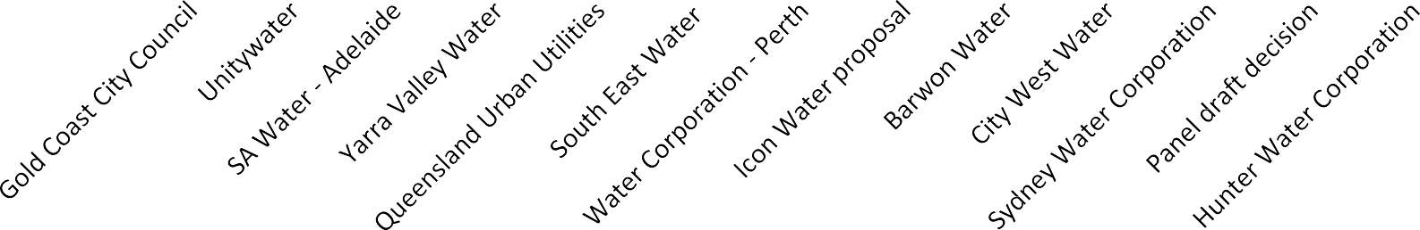800

2015/16 2017/18  Icon Water 2015/16  Icon Water 2017/18

Icon Water

Industry Panel public hearing 6 February 2015

Thank you

Disclaimer
This document has been prepared by Icon Water for the Industry Panel Review public hearing held on 6 February 2015. Icon Water has made every attempt to ensure the accuracy and reliability of the information in it, however any prospective reader must make their own enquiries to satisfy themselves regarding the information provided. Icon Water does not provide any warranties and does not accept any
responsibility or liability for the accuracy, content, completeness, legality, or reliability of the information 21
within.

