The mean price of ACT’s residential dwellings increased in the December quarter 2023
The total value of residential dwellings in the ACT increased by 1.2 per cent to $187.3 billion in the December quarter 2023. The number of residential dwellings rose by 1,300 to 197,500 this quarter. The mean price of residential dwellings increased by 0.6 per cent to $948,500 this quarter, to be 1.5 per cent lower through the year to the December quarter 2023.
Nationally, the total value of residential dwellings increased by 1.9 per cent to $10,397.1 billion in the December quarter 2023. The mean price of residential dwellings increased by 1.5 per cent to $933,800 this quarter. Across Australia, NSW recorded the highest mean price of residential dwellings ($1,184,500), followed by the ACT ($948,500) and Victoria ($895,000). The lowest mean price is in the Northern Territory ($489,200).

ABS Total Value of Dwellings – December Quarter 2023
 | Dec Qtr  2022 | Sep Qtr  2023 | Dec Qtr  2023 | Change (%)
 |  |  |  | Quarterly | TTY
ACT
Mean price ($'000) | 962.8 | 943.3 | 948.5 | 0.6 | -1.5
Number ('000) | 193.1 | 196.2 | 197.5 | 0.7 | 2.3
Total Value ($b) | 185.9 | 185.0 | 187.3 | 1.2 | 0.8
Australia
Mean price ($'000) | 891.0 | 920.4 | 933.8 | 1.5 | 4.8
Number ('000) | 10,969.0 | 11,082.1 | 11,134.6 | 0.5 | 1.5
Total Value ($b) | 9,773.3 | 10,200.3 | 10,397.1 | 1.9 | 6.4

Residential Property Market – December Quarter 2023
Capital cities |  | Established House |  |  |  | Attached Dwelling
 |  | Median Price of Transfers ($'000) | Change (%) |  |  | Median Price of Transfers ($'000) | Change (%)
 |  |  | Quarterly | TTY |  |  | Quarterly | TTY
Sydney |  | 1,360.0 | -2.2 | 4.3 |  | 780.0 | -1.3 | 2.0
Melbourne |  | 840.0 | 0.0 | -4.0 |  | 615.0 | -0.2 | 0.0
Brisbane |  | 830.0 | 3.8 | 10.7 |  | 545.0 | 4.4 | 13.5
Adelaide |  | 760.0 | 5.5 | 12.6 |  | 556.0 | 6.9 | 15.8
Perth |  | 665.0 | 7.3 | 14.7 |  | 445.0 | 6.0 | 11.3
Hobart |  | 701.1 | 1.2 | -4.2 |  | 526.0 | -4.2 | -6.5
Darwin |  | 585.0 | -3.7 | -0.8 |  | 380.0 | 1.1 | -0.7
Canberra |  | 980.0 | -0.3 | -2.0 |  | 610.0 | -0.2 | 1.7

Chart 1: Dwelling stock, Canberra and Australia
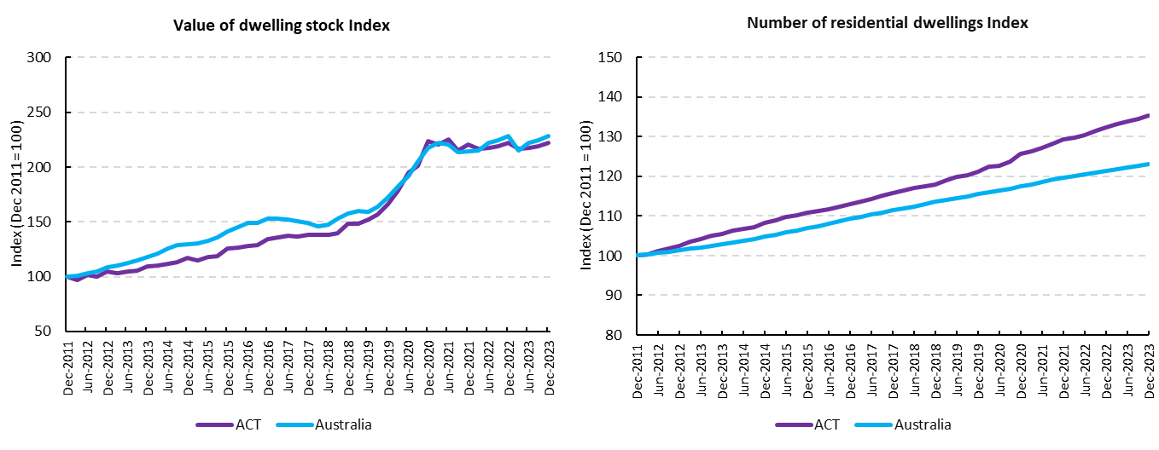
Source: ABS Release: Total Value of Dwellings.

Chart 2: Mean price of residential dwellings, December Quarter 2023
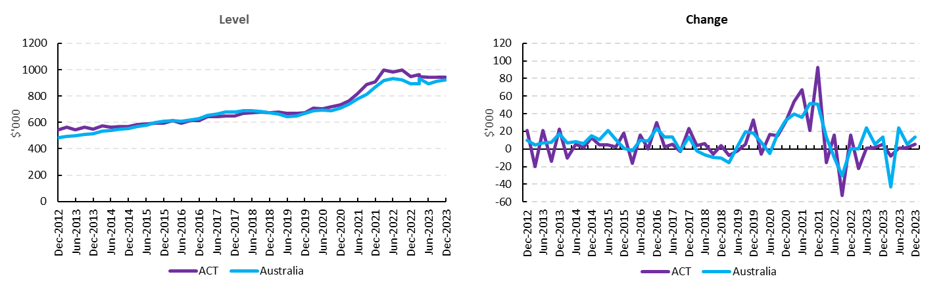
Source: ABS Release: Total Value of Dwellings.

Chart 3: Mean dwelling price and median price of transfers, Capital City, December Quarter 2023
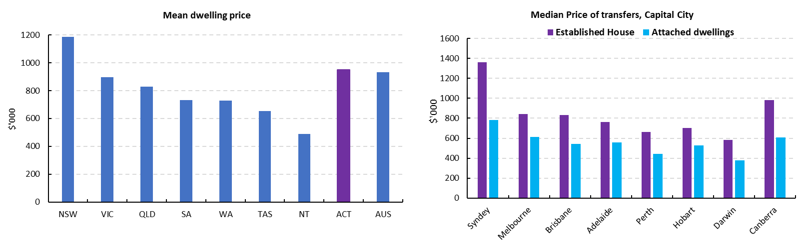
Source: ABS Release: Total Value of Dwellings.

The unstratified median price (for established houses and attached dwellings) of dwelling transfers over the reference period is the price at the mid-point of all properties sold in the period. This means that half of all properties (in the same region and of the same dwelling type) that were sold in the period did so at a price below the median, and the other half had a price above the median. In contrast, the mean price of residential dwellings represents the average dwelling price in the reference period regardless of dwelling type. The mean prices are calculated across the whole of state and for all dwelling types, whereas the medians are calculated for individual dwelling types and for the capital city and rest of state separately.

