# Economic Outlook

2.1 Economic Overview 17

2.2 ACT Economic Outlook 19

2.3 Australian Economic Outlook 39

2.4 International Economic Outlook 41

## Economic Overview

The last 18 months have resulted in the largest disruptions to economic activity and people movement across Australia and the world in the post-war period.

Since the initial outbreak of COVID-19 in March 2020, the ACT economy has been resilient, with GSP growing by 2.4 per cent in 2019-20 and expected to grow by around 3 per cent in 2020-21.

This outcome is for the economy as a whole, however, and some sectors of the economy have not fared as well and have required support from the Government. Strong public sector spending has bolstered growth, both directly in responding to the public health impacts of the pandemic and through the provision of support to households and businesses while private sector activity has progressively recovered.

Despite the impact of the current Delta outbreak and lockdown restrictions overall economic growth is still estimated to be 2½ per cent in 2021-22, only slightly lower than anticipated at the time of the 2020-21 Budget. However, the timing and composition of that activity has changed markedly.

Economic activity is expected to decline significantly in the September quarter 2021, with household consumption contracting sharply and disruptions to the construction sector and delays in some investment projects also weighing on activity.

Many of the ACT’s 30,000 businesses have also been significantly affected by the lockdown restrictions, with nearly a third of them applying for COVID-19 Business Support Grants. The impacts on business are also flowing through to households, with 63,000 Canberrans receiving support from the Commonwealth’s Pandemic Disaster Leave Payment. The contraction in private sector activity will again be partly offset by stronger public consumption, both through this support to businesses and households and in the public health response and broader community supports.

**While this is a significant setback to growth, it is expected to be temporary, with growth in the December quarter as restrictions ease, and the recovery gathering significant momentum into 2022.**

The recovery will be underpinned by the household and business support being provided by the ACT and Commonwealth Governments. As restrictions are eased, household consumption is expected to rebound strongly in 2022 supported by the current high savings rate and increasing consumer confidence.

The easing of restrictions is also expected to see business confidence increase and, along with it, business investment, which will sustain growth in the second half of 2022 and beyond. Private sector investment has also been relatively resilient in the ACT with many businesses taking advantage of Commonwealth Government policy incentives.

There is a significant pipeline of public investment that will support activity and jobs through the recovery and into the future.

In addition to changes in economic activity, labour market conditions have also been influenced by border closures, both domestic and international, and the responses of employers to pandemic conditions.

Headline employment and unemployment outcomes have broadly followed the path of economic activity, with subdued employment growth of ½ per cent in 2019-20 and a rapid rebound in the first half of 2020-21. However, although economic growth strengthened in the second half of 2020-21, employment growth was more muted as it was constrained by slower population growth as a result of the closure of international and national borders.

Some variation in economic activity has been absorbed by changes in hours worked and underemployment, rather than employment and unemployment. Hours worked have fallen significantly and underemployment has risen following the recent lockdown, despite increases in employment and a fall in unemployment in August 2021. The ABS Weekly Payroll Jobs and Wages release indicates that employee jobs have also fallen sharply, by 7.1 per cent, in the two weeks after the lockdown commenced on 12 August 2021. Part of this decline is expected to flow into employment and unemployment; however, the decline also captures people who remain employed but do not receive any pay during the period.

Closed international borders reducing the entry of students and skilled migrants and domestic travel restrictions constraining cross border movements have also significantly affected the labour market, resulting in the emergence of labour shortages for both skilled and unskilled jobs. This has been reflected in an increase in job vacancies compared to the number of unemployed people, indicating that some businesses are finding it difficult to find workers with the skills they need. The likely earlier than previously expected opening of international borders and greater freedom of movement domestically as vaccination thresholds are reached will be an important part of addressing this issue which will be key to the recovery of the economy.

As the economy recovers and borders reopen, employment is expected to rebound growing at ½ per cent in 2021-22 and then 1 per cent in 2022-23 before stabilising at 1¼ per cent.

There remains considerable uncertainty about the evolution of the pandemic and the implications of having the virus circulating in the community even at very high vaccination rates. If hospital capacity becomes stretched, further lockdowns or more stringent public health and social measures may be required which could delay the recovery of economic activity and employment. Even the possibility of lockdowns may weigh on confidence and affect the expected rebound. Very high vaccination rates also create opportunities for international and domestic movement, which could see population growing more strongly than anticipated and bolster growth and employment.

Despite this uncertainty the ACT is well positioned to rebound and take advantage of opportunities if they present themselves, as well as to respond to any emerging downside risks.

## ACT Economic Outlook

The ACT economy weathered the first year of the COVID-19 pandemic reasonably well and performed more strongly in 2020-21 than was expected at the time of the 2020‑21 Budget. Gross State Product (GSP) is anticipated to have grown by 3 per cent, much higher than the 2 per cent growth we forecast. This follows growth of 2.4 per cent in 2019-20.

Nonetheless, the effects of COVID-19, have been disproportionate across different sectors of the economy with some suffering significant negative impacts and requiring extensive support from the Government.

The lockdown put in place in the ACT on 12 August 2021 in response to the outbreak of the COVID-19 Delta variant will see economic growth contract in the September quarter 2021, although the impact is likely to be less pronounced in the ACT than in the national economy.

**Negative impacts are expected to be temporary. On the back of two years of growth, and having avoided the recession that was experienced nationally, the ACT economy is expected to rebound strongly as restrictions are eased. This will be driven by our high rate of vaccination, which we anticipate will ease pressure on hospitalisations and support progressive easing of health restrictions.**

There remains significant uncertainty about the future evolution of the pandemic and significant upside and downside risks to the economic outlook. For this reason, the updated economic forecasts for the ACT in Table 2.2.1 reflect a baseline scenario based on the assumptions outlined in Box 2.2.1. This approach is consistent with that taken in the 2020‑21 Budget and August 2020 Economic and Fiscal Update. Alternative upside and downside scenarios are outlined later in this chapter to demonstrate the level of uncertainty and risk to the baseline forecasts.

Although the strong vaccination rates are likely to see an earlier reopening of borders than was assumed in the 2020-21 Budget, with students returning from early 2022, it is still expected to take some time for population growth to return to its pre-pandemic rate. As a result, the projections beyond 2021-22 incorporate the impact of lower-than-average population growth on the economic parameters, rather than the normal technical assumption of a return to long-run growth.

### Assumptions

**Box 2.2.1: Key assumptions**

The emergence of the Delta strain of the virus with higher transmissibility means significant risks and uncertainties remain in the evolution of the pandemic and the pace of economic recovery. The ongoing risks of further outbreaks, along with the possible reimposition of restrictions, continue to have implications for the ACT’s economic outlook.

As the public health situation allows, the Government will progressively ease restrictions, starting from 1 October 2021, before easing again on 15 October 2021, when licensed venues are expected to be able to open with density restrictions. Further easing is planned from 29 October 2021 where all retail would be permitted to open with density restrictions. Further information on the ACT’s COVID-19 pathway forward is available on the COVID-19 website: https://www.covid19.act.gov.au/__data/assets/pdf_file/0007/1861621/ACTs-Pathway-Forward-270921.pdf.

The key assumptions that underpin the economic forecasts are set out below. Outcomes could be substantially different to the baseline estimates, depending on the extent to which the following assumptions hold:

* COVID-19 vaccines are rolled out reaching 80 per cent coverage across Australia by the end of 2021 and they are effective in minimising the health impacts of COVID-19;
* there are no additional large-scale outbreaks of COVID-19 in Australia or the ACT over the forecast period and localised outbreaks are quickly contained;
* restrictions begin easing from 1 October 2021 in the ACT and will be lifted progressively on 15 October 2021 and 29 October 2021. The next phase of easing of restrictions will be considered by end of November/early December;
* state and territory borders will begin to open in 2022;
* international border restrictions will be gradually lifted when the rate of double-dose vaccination Australia-wide has reached 80 per cent or above, consistent with the National Plan to Transition Australia’s National COVID-19 response. At the current pace of vaccination, this is expected to commence by end of December 2021;
* the ACT and national economies continue to respond well to the fiscal and monetary policy stimulus measures. There is a smooth transition from public support to private sector consumption and investment as stimulus measures are withdrawn over the course of 2022; and
* net overseas migration flows are consistent with current estimates.

Table 2.2.1 Economic parameters, 2021-22 Budget, baseline forecasts, percentage change

|  |  |  |  |  |  |  |
| --- | --- | --- | --- | --- | --- | --- |
|  | 2019-20 Actual | 2020-21 Estimate | 2021-22  Budget | 2022-23 Forecast | 2023-24 Projection | 2024-25 Projection |
| ACT |  |  |  |  |  |  |
| Gross State Product1 | 2.4 | 3 (2) | 2½ (2¾) | 3¼ (2¾) | 3 (3) | 3 |
| State Final Demand1,2 | 3.3 | 3.8 (3¼) | 2 (2¼) | 3 (2) | 2¼ (2¼) | 2½ |
| Employment3,4 | 0.5 | 1.8 (4) | ½ (½) | 1 (1) | 1¼ (1¼) | 1¼ |
| Wage Price Index3,4,5 | 2.0 | 1.7 (1½) | 1¾ (1¾) | 2 (1¾) | 2¼ (2) | 2½ |
| Consumer Price Index3,4 | -0.6 | 4.8 (3) | 1¾ (1¼) | 1¾ (1½) | 2 (1¾) | 2¼ |
| Population3 | 1.2 | ¼ (¼) | ¼ (¼) | 1 (¾) | 1 (1) | 1 |
| **Australia** |  |  |  |  |  |  |
| Gross Domestic Product1,2,6 |  | 1¼ (¾) | **4¼ (3½)** | 2½ (2½) | 2¼ (2¾) | 2½ |

**Sources:** ABS Australian National Accounts: National Income, Expenditure and Product; Australian National Accounts: State

Account; Labour Force, Australia; Wage Price Index, Australia; Consumer Price Index, Australia; National, State and

Territory Populations; CMTEDD estimates; 2020-21 MYEFO; and 2021-22 Commonwealth Budget.

**Notes:** Forecasts and projections are rounded to a ¼ of a percentage point. Numbers in brackets are the estimates published in the 2020-21 Budget.

1. Real values.
2. Year average basis (average of the current financial year relative to the previous financial year).
3. Through the year growth (current quarter relative to the same quarter in previous year).
4. Actuals for 2020-21.
5. Total hourly rates of pay, excluding bonuses.
6. 2021-22 Commonwealth Budget forecasts, comparisons in brackets are to 2020-21 MYEFO forecasts.

### Gross State Product

GSP is estimated to grow by 3 per cent in 2020-21, 1 percentage point higher than was expected at time of the 2020-21 Budget.

Economic activity in the ACT recovered quickly as health restrictions were eased in July 2020. State Final Demand (SFD) grew by 6.1 per cent over the year to the June quarter 2021, reflecting a strong recovery in activity, more than offsetting the 2.7 per cent decline in SFD in the June quarter 2020 from the initial COVID-19 lockdown in March 2020.

Retail turnover in the ACT increased by 0.6 per cent in the June quarter 2021 to be 10.7 per cent higher over the year, in real terms, well above historical average growth.

**The strong recovery in 2021‑22 was driven by a rebound in household consumption, led by spending on hospitality and retail trade, and a solid pick up in dwelling investment and alterations and additions.**

A solid improvement in private investment was also a key driver of the higher‑than‑expected GSP outcome in 2020‑21. In the June quarter 2021, private investment increased by 2.4 per cent, driven by an increase in machinery and equipment investment, led by purchases of vehicles and computer equipment, as well as an increase in total non-dwelling construction reflecting increased investment in new buildings.

Public final demand is also expected to continue to contribute to the ACT’s GSP growth in 2020‑21, reflecting a ramp-up in government spending to contain the spread of the virus, provide support for businesses and individuals affected by COVID-19 restrictions and boost frontline services in response to the pandemic.

#### Forecast for 2021-22

While the ACT economy is forecast to grow by 2½ per cent in 2021-22, only ¼ of a percentage point lower than expected at the time of the 2020-21 Budget, the timing and composition of this growth differs significantly from previous expectations. Private sector activity is now expected to be more muted in the first half of 2021-22, with growth instead being supported by an increase in public sector activity in response to the Delta outbreak and the impacts of the lockdown. Private sector activity is then expected to recover in the second half of 2021‑22, reducing the need for the more immediate household and business supports.

Household consumption is now expected to contract sharply in the September quarter 2021 following the ACT lockdown. Retail turnover, which accounts for over a third of household consumption, fell by 19.9 per cent in August 2021, greater than the fall in April 2020 (14.7 per cent). Retail turnover is now at its lowest level since April 2020.

Experience of previous lockdowns in 2020 supports expectations that household consumption will recover strongly as health restrictions are eased and consumer confidence returns. Further, household saving is likely to have increased during this lockdown, providing scope for savings to be drawn down as the economy opens up.

**The level of public sector support for businesses and individuals affected by COVID-19 lockdowns suggests household income will remain relatively resilient in the ACT.**

Public consumption is expected to make a stronger contribution to GSP growth in 2021-22 than previously expected, reflecting a high level of government activity and expenditure on the COVID-19 related health response and support for households and businesses. The support provided by the ACT Government is outlined in further detail in Chapter 3. This has been complemented by income support for households provided by the Commonwealth and its joint funding of some business support programs.

There could be some near-term upside risks associated with public consumption, as the Commonwealth Government has increased its spending in the ACT to administer the fiscal supports for individuals and businesses across eastern Australia.

Public investment is expected to increase from 2021-22, as the ACT Government continues to invest in Canberra’s infrastructure and services, with major investments such as Light Rail Stage 2, the expansion of the Canberra Hospital and the new Woden CIT campus driving growth in public infrastructure. This will also support the recovery of economic activity and jobs.

The gradual easing of health restrictions, particularly the opening of retail trade from 29 October 2021, will contribute to household consumption recovering from the December quarter. Low interest rates, the reopening of interstate and international borders, and the summer holiday season, will support a strong return of household consumption over the first half of 2022.

Although consumer confidence, which is a key driver of household consumption, has declined from the recent peak in April 2021, it remains well above the lows that were experienced in the previous lockdown. (Figure 2.2.1). In part, this reflects lower levels of uncertainty around the impact of COVID‑19 on jobs and activity.

Further, while household consumption in 2021-22 will not be as strong as was previously anticipated due to the ACT’s 12 August lockdown, overall, household consumption is forecast to recover and remain an important driver for the ACT’s GSP growth in 2021‑22 (Figures 2.2.1 and 2.2.2).

Figure 2.2.1: Consumer confidence, Australia

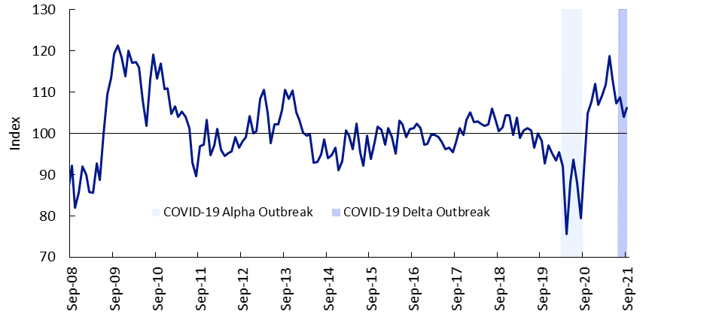

**Source:** Westpac-Melbourne Institute Consumer Sentiment, September 2021.

Figure 2.2.2: Contribution to GSP growth, ACT

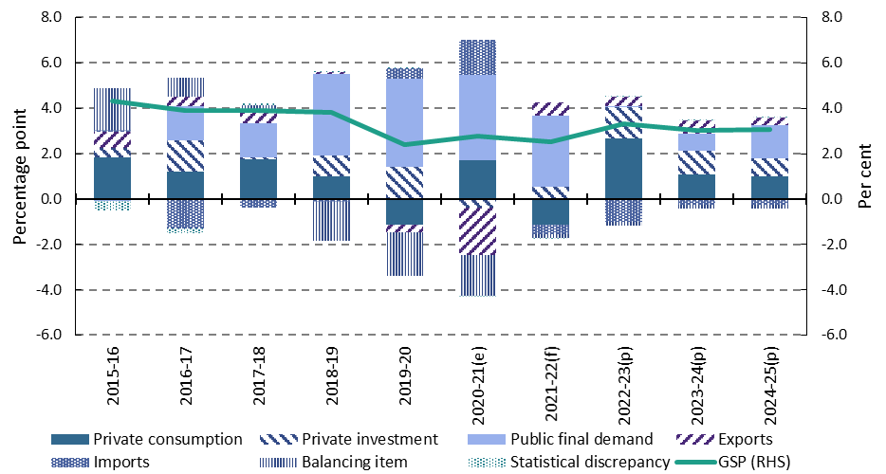

**Sources:** ABS National Accounts: National Income Expenditure and Product; and CMTEDD estimates.

However, any necessary departure from the currently expected transition through the *ACT’s Pathway Forward Framework* as a result of developments in the COVID-19 pandemic may affect consumer confidence and household consumption as outlined in the economic risks section. There are some upside risks, related to the speed with which confidence recovers and the effect of high vaccination rates on hospitalisations due to the virus, both of which will affect how households draw down savings in the near term.

The continued recovery in business investment in 2021-22 that was expected at the time of the 2020-21 Budgetis now expected to be delayed. The recent lockdowns across the country have increased uncertainty and eroded business confidence (Figure 2.2.3). This is likely to see businesses delay investment decisions until conditions improve and there is evidence of a sustained increase in demand.

Figure 2.2.3: Business confidence, Australia

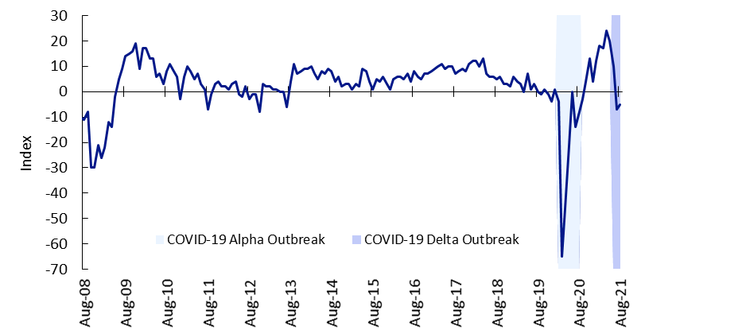

**Sources:** NAB Business Sentiment, August 2021.

Business investment is expected to remain around current levels in 2021-22, before improving solidly from mid-2022 on the back of an improvement in demand as restrictions are eased. The expected opening of international borders from late 2021 will also see a surge in consumer and business confidence that will support a sustained improvement in demand and investment.

Dwelling investment is expected to continue to grow strongly in 2021-22, with the leading indicators of activity in the sector remaining elevated. Investor finance activity in the ACT is at a record high. Approvals for detached houses were above long run averages in the March and June quarters of 2021, while dwelling commencements also increased strongly for both detached houses and other residential dwellings in the March quarter 2021. In addition, the ACT Government’s conveyance duty concessions, and the completion of projects under the Commonwealth Government’s HomeBuilder Program, combined with record low interest rates, will continue to support strong activity going forward.

Net exports are expected to contribute to GSP growth in 2021-22 as exports of services, in particular education, are expected to increase in 2022 as international border restrictions ease.

#### Forecast for 2022-23 to 2024-25

From 2022-23, GSP growth is expected to continue being supported by household consumption, private investment and public consumption. In addition, as international borders reopen, our tourism and international education sectors are expected to become key drivers of growth again, supporting an expansion in the contribution from exports (Figure 2.2.2), although this will be partially offset by imports as ACT residents are likely to return to overseas travel.

**Figure 2.2.4: Gross State Product, ACT**

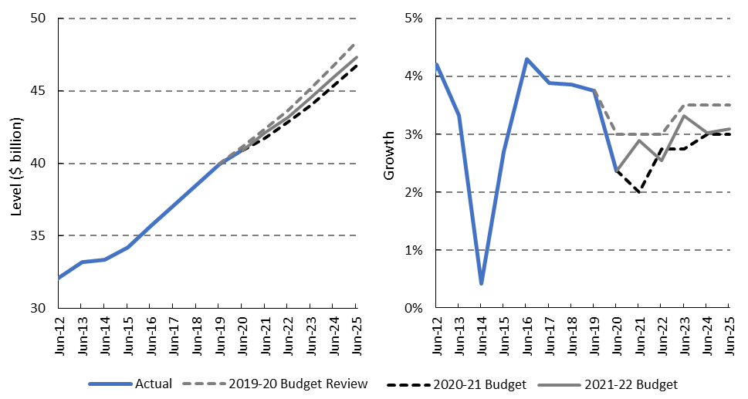

**Sources:** ABS Australian National Accounts: State Accounts; and CMTEDD estimates.

GSP growth is expected to accelerate to 3¼ per cent in 2022-23, before stabilising at around 3 per cent in 2023‑24 and 2024-25. The rate of growth in 2023-24 is the same as that forecast in the 2020‑21 Budget, reflecting growth returning to its pre-Delta pace, and as students and migrants return sooner than previously anticipated. As a result of the stronger than expected GSP growth in 2020‑21, the level of GSP is forecast to be above the 2020‑21 Budget estimates over the budget and forward estimates period, though it remains lower than anticipated at the time of the 2019-20 Budget Review prior to the pandemic (Figure 2.2.4).

### Labour Market

After a strong recovery from COVID-19 restrictions in the second half of 2020, the ACT labour market lost some momentum in the first half of 2021. This is in part due to the effect of successive restrictions in other jurisdictions on the visitor economy in the ACT. In addition, Australia’s international border closure reduced student entry and limited migration, which saw the emergence of skills shortages in some sectors in the first half of 2021. Employment growth over the year to the June quarter 2021 slowed to 1.8 per cent, down from the peak of 4.0 per cent over the year to the December quarter 2020.

This softening of the labour market as measured by the ABS Labour Force Survey has continued into 2021-22, noting that the statistical surveys available are not well suited to measure the current environment of rapid disruption.

While the ACT’s unemployment rate fell to 3.5 per cent in August 2021, from 4.3 per cent in July 2021, employment fell by 0.2 per cent and the participation rate fell by 0.7 percentage points in the month. Part time employment fell sharply, partly offset by an increase in full time employment. Below the headline number of jobs, hours worked in the ACT also fell by 2.5 per cent in the month and the underemployment rate increased reflecting the softening of the labour market. The volatility of the ABS Labour Force survey for the ACT is the subject of ongoing discussions with the ABS.

The current Delta outbreaks and the associated lockdowns over the east coast have intensified the impact of the pandemic on the labour market across Australia, including the ACT.

More recent weekly payroll jobs data, published by the ABS based on the Australian Tax Office’s single touch payroll system, which supplements the traditional labour force survey, has captured this impact.

Over the fortnight to 28 August 2021, payroll jobs fell across Australia except in Queensland and South Australia, with the largest fall recorded in the ACT (down 7.1 per cent), followed by Victoria (down 2.8 per cent) and New South Wales (down 1.6 per cent). This significant fall in the number of payroll jobs in the ACT reflects the impact of the lockdown in response to the Delta outbreak implemented from 12 August 2021. As a result, the number of payroll jobs in the ACT in the week ending 28 August 2021 has fallen to around 5.0 per cent below the pre‑pandemic level (Figure 2.2.5). This will not necessarily fully flow through into the unemployment rate as it captures people who remain employed but do not receive any pay during the period.

Figure .5: Total payroll jobs, ACT and Australia

This chart illustrates the number of payroll jobs in the ACT and Australia from the week ending 14 March 2020 to 28 August 2021 as an index. The week ending 14 March 2020 is the reference week and is equal to 100. The chart shows significant falls in March 2020 and January 2021, which broadly tracks the national experience. Over the fortnight to 28 August 2021, payroll jobs fell across Australia and even more sharply in the ACT, with the number of payroll jobs in the ACT in the week ending 28 August 2021 declining to be below the pre pandemic level reflecting the impact of lockdowns on the ACT labour market. The latest fall in August is a departure from the national experience.

**Source:** ABS Weekly Payroll Jobs and Wages in Australia, Interim.

Employment is expected to contract sharply in the September quarter 2021, particularly for businesses most exposed to COVID-19 restrictions including those servicing the ACT’s domestic tourism market.

Overall employment growth is expected to be ½ per cent in 2021-22, the same growth rate as expected at the time of the 2020‑21 Budget but coming off weaker than previously expected growth in 2020-21.

**The ACT’s unemployment rate is expected to increase in the September quarter, partially offset by declines in participation. However, this loss in employment is forecast to be fully recovered by the June quarter 2022, following the easing of restrictions, along with a decline in the unemployment rate and an increase in the participation rate.**

Over the forward estimates period, employment growth is expected to resume the trajectory envisaged in the 2020‑21 Budget, growing by around 1 per cent in 2022‑23 before stabilising at around 1¼ per cent in 2023-24 and 2024-25. This reflects expectations of the vaccination rates in Australia and the ACT, consistent with the *National Plan to Transition Australia’s National COVID‑19 Response* and the *ACT’s Pathway Forward Framework*, reducing the need for lockdowns and enabling the reopening of Australian international borders. This recovery in employment growth will also be supported by the underlying strength in ACT economic conditions and associated high job vacancies (additional details are presented in Box 2.2.2).

**Box 2.2.2: Unemployment and job vacancies**

Prior to the Delta outbreaks, job vacancies across Australia, including in the ACT, reached a record high in May 2021 and remain elevated at around 8,000 vacancies in the ACT and 333,700 vacancies nationally in August. This reflects efforts by employers to fill a large number of jobs lost during the pandemic and new hiring in parts of the economy experiencing strong demand. The *Vacancy Report* in August 2021 released by the National Skills Commission shows that labour demand is higher than it was in February 2020 across nearly all main occupations.

Despite the 8,000 job vacancies in August 2021, there were an average of 9,800 people unemployed in the ACT in the June quarter 2021. The rise in unemployment from a low of around 7,200 prior to the pandemic in the March quarter 2020 indicates a possible mismatch between the skills underpinning labour demand and those supplied by jobseekers.

The negative relationship between the vacancy rate and the unemployment rate indicates employers may be finding it increasingly difficult to match workers with the specific skills that they need, perhaps because the skills are also in high demand broadly in the ACT, and potentially in other job markets in Australia.

A number of factors could be driving this, including a reduction in skilled migrant inflows, reduced inflows from other jurisdictions with workers less likely to travel reflecting uncertainties associated with the pandemic, health concerns around some jobs, childcare responsibilities may have changed, and lockdowns could also be impacting the willingness of people who find themselves between jobs or frictionally unemployed to re‑join the labour market and search for work. Some people may also be choosing not to enter or re-enter the labour market to look for work. Skills mismatches will likely improve as vaccination targets are achieved and restrictions are progressively eased, along with the reopening Australia’s international borders.

### Housing Market

The ACT’s property market remains buoyant. The market gathered momentum in 2020-21 on the back of historically low interest rates and stimulus programs. The housing stimulus programs in the ACT include the Home Buyer Concession Scheme, conveyance duty concessions for owner occupiers purchasing land and off‑the‑plan apartments and a Lease Variation Charge Remission, which were supported by the Commonwealth’s HomeBuilder program.

Demand in the market remains very strong. While the current lockdown may reduce auction clearance rates in the short term, strong pent-up demand is likely to see activity rebound strongly as restrictions ease. This is likely to put upward pressure on property prices in the ACT, though growth rates should moderate.

The total value of new housing loans taken by owner-occupiers and investors has increased by 80.2 per cent over the year to July 2021, driven by loans to purchase new and existing dwellings, as well as for the construction of new dwellings (Figure 2.2.6). There has been a strong increase in new housing loans by investors over the year to July 2021. This indicates a rebound in investor demand for housing in the ACT from the decline in early 2020.

Figure 2.2.6: Value of new housing finance commitments (excluding refinancing), original data,   
12 month moving total, ACT

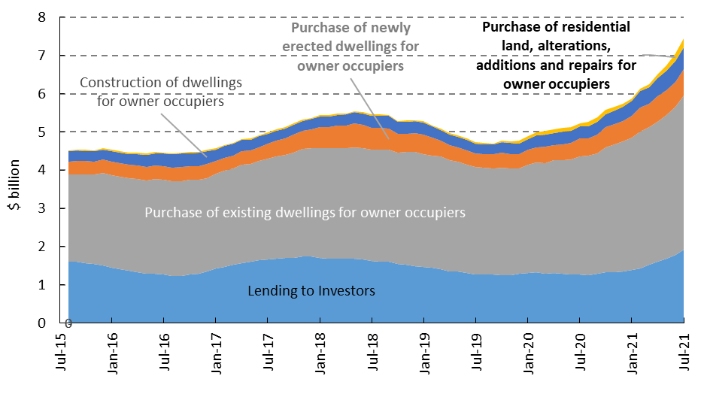

**Source:** ABS Lending Indicators, Australia.

Building activity in the ACT remains resilient, with leading indicators suggesting a reasonable dwelling investment pipeline for detached and semi-detached houses (Figure 2.2.7). Dwelling commencements for new houses rose 52.5 per cent from 259 to 395 over the year to the March quarter 2021 and residential building approvals for detached houses rose 23.6 per cent from 89 to 110 over the year to August 2021.

There were 5,073 residential building approvals in 2020-21, with a total value of around $1.5 billion. This level of activity is broadly in line with the average number of approvals over the past 5 years.

Easing of restrictions, supported by low interest rates and ACT Government stimulus programs, are expected to result in continued strength in the ACT’s housing market over the forward estimates period.

Figure 2.2.7: Value and number of residential building approvals (12 month moving total) and commencements (4 quarters moving total), Original Data, ACT

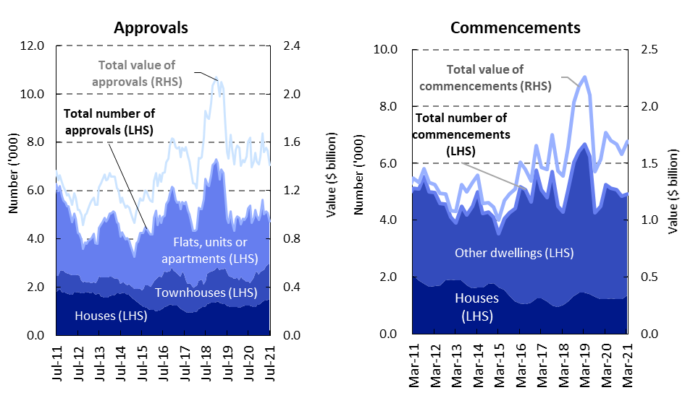

**Sources:** ABS Building Approvals, Australia and Building Activity, Australia.

### Population

Population growth, one of the key drivers of economic and employment growth, and demand in the housing market, has been significantly affected by the COVID-19 pandemic and the associated public health restrictions.

The drivers of population growth include natural increase (births less deaths), international migration and interstate migration. The COVID-19 pandemic has impacted each of these drivers of population growth differently. Importantly, national border restrictions have significantly lowered international migration estimates for the ACT.

The ACT’s population is expected to grow by ¼ per cent over 2020-21 and 2021-22, primarily due to a forecast decline in net overseas migration.

Net overseas migration accounts for around 50 per cent of the ACT’s total population growth in a typical year. Departures of migrants on temporary visas in 2020‑21 and 2021-22 remains at around previous levels; however, the number of departing migrants is usually more than offset by newly arriving migrants, adding to our population growth.

With a significant drop in arrivals since the beginning of the pandemic in 2020, net overseas migration is now significantly detracting from the ACT population. As a result, consistent with the 2020-21 Budget, population growth in 2020-21 and 2021-22 will largely reflect natural increase and some inflow of interstate migrants being significantly offset by the impact of net overseas migration outflows. Importantly, the progressive return of students from early 2022 will start to moderate the negative impact of net overseas migration on the ACT’s overall population growth by the second half of 2021-22.

Population growth is expected to increase to one per cent in 2022-23 and stabilise at this rate in 2023-24 and 2024-25. This is below the ACT’s long run historical average population growth rate of 1¾ per cent.

**Growth in the ACT’s resident population over the budget and forward estimates period is estimated to be 13,780 people, which is 1,191 people higher than the estimate at the time of the 2020‑21 Budget but 15,670 lower than expected prior to the pandemic in the 2019‑20 Budget Review.**

Figure 2.2.8 shows the contribution of the three components namely, natural increase, net overseas migration and net internal migration to the ACT’s population over the ten-year period from 2015-16 to 2024-25.

Figure 2.2.8: Population growth by component, ACT

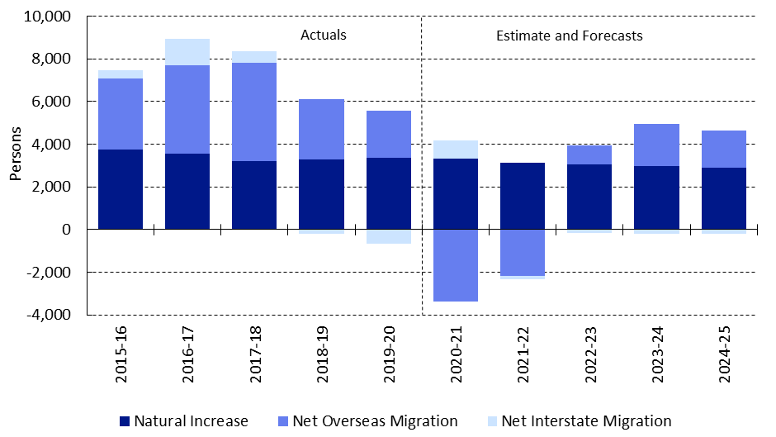

**Sources:** ABS National, State and Territory Populations and CMTEDD estimates.

As migration policy rests with the Commonwealth Government, any change to settings has the potential to substantially affect the population forecasts, which would also have flow on impacts for GSP and employment.

### Wage Price Index

Wage Price Index (WPI) grew by 1.7 per cent in 2020-21, which is 0.2 percentage points higher than the 2020‑21 Budget estimate, but broadly in line with the upside scenario estimated at the time. **This largely reflects stronger than expected wage growth in the private sector, while wage growth in the public sector continues to be moderate due to the six-month deferral of wage increases in the Australian Public Service.**

Wage growth is expected to remain moderate at 1¾ per cent in 2021-22. The current international border closures have resulted in a significant reduction in skilled migrant workers, triggering skill shortages in the Territory and across Australia. This is expected to put some upward pressure on wages in the near term.

The WPI is forecast to grow further by 2 per cent in 2022-23 and by 2¼ per cent in 2023-24, slightly stronger than expected at the time of the 2020-21 Budget. This largely reflects a faster than expected improvement in wages in the private sector over these two years, as the lower population growth leads to a tighter labour market and wage pressures.

WPI growth is estimated to increase to 2½ per cent in 2024-25, as the labour market continues to strengthen.

### Consumer Price Index

The headline Consumer Price Index (CPI) grew by 4.8 per cent in 2020-21, 1.8 percentage points higher than the estimate in the 2020-21 Budget. This largely reflects an increase in childcare fees following the unwinding of free childcare in July 2020, as well as stronger than expected increases in prices for automotive fuel and domestic holiday travel and accommodation. It also reflects broad declines across CPI components in the final quarter of 2019-20. However, this inflationary spike is expected to be temporary, given underlying inflation, which excludes those pandemic driven inflationary pressures, remains low nationally.

Growth in the CPI is estimated to be 1¾ per cent in 2021-22, ½ of a percentage point higher than expected at the time of the 2020-21 Budget. This is largely driven by expected strong growth in prices for new dwelling purchases as a result of the robust residential property market. Food prices are also anticipated to rise strongly in 2021-22, due to the ongoing food supply chain disruptions and labour shortages on farms.

CPI growth is expected to remain moderate at 1¾ per cent in 2022-23, before rising to 2 per cent to 2023-24 and to 2¼ per cent in 2024-25 on the back of a tighter labour market placing upward pressure on wages.

### Alternative Scenarios and Risks

As the economic impacts of the COVID-19 pandemic remain uncertain, the estimates presented in this Budget reflect a baseline scenario consistent with the assumptions outlined in Box 2.1.1. Uncertainty regarding the evolution of the pandemic, particularly as restrictions are eased and the virus continues to circulate in the community, makes it difficult to provide a definitive quantitative assessment of the balance of risks around the baseline forecast described above. However, in line with the approach taken in the August 2020 Economic and Fiscal Update and 2020-21 Budget, a range within which possible scenarios may fall on the upside and downside are presented in Table 2.2.2.

The shaded areas in Figures 2.2.9, 2.2.10 and 2.2.11 show the range of possible outcomes under the upside and downside scenarios for GSP, employment, and population, relative to the baseline scenario. The actual outcome will depend on how risks evolve and how our assumptions align with events that impact the key drivers of growth. In particular, the assumptions for migration and population growth will be affected by the effectiveness of the current efforts to contain the Delta outbreaks supported by high vaccination rates in the ACT and across Australia. This range does not represent the full possibility of outcomes; however, it does demonstrate the impact of changes in key assumptions on three important economic metrics, providing further information in a time of uncertainty.

Table 2.2.2 Gross State Product (GSP), employment and population scenarios, percentage change

|  |  |  |  |  |  |
| --- | --- | --- | --- | --- | --- |
|  | 2020-21 Estimate | 2021-22  Budget | 2022-23 Forecast | 2023-24 Projection | 2024-25 Projection |
| Gross State Product |  |  |  |  |  |
| Downside Scenario | 3 | 1¼ | 2¾ | 2¾ | 2¾ |
| **Baseline Scenario** | **3** | 2½ | **3¼** | **3** | **3** |
| Upside Scenario | 3 | 3½ | 3½ | 3¼ | 3¼ |
| **2020-21 Budget** | **2** | 2¾ | **2¾** | **3** | **3** |
| **2019-20 Budget Review** | **3** | 3 | **3½** | **3½** | **3½** |
| Employment |  |  |  |  |  |
| Downside Scenario | 1.8 | -½ | ¾ | ¾ | 1 |
| **Baseline Scenario** | **1.8** | ½ | **1** | **1¼** | **1¼** |
| Upside Scenario | 1.8 | ¾ | 1½ | 1½ | 1¾ |
| **2020-21 Budget** | **4** | ½ | **1** | **1¼** | **1¼** |
| **2019-20 Budget Review** | **1½** | 1½ | **1¾** | **1¾** | **1¾** |
| Population |  |  |  |  |  |
| Downside Scenario | ¼ | 0 | ½ | ¾ | ¾ |
| **Baseline Scenario** | **¼** | ¼ | **1** | **1** | **1** |
| Upside Scenario | ¼ | ½ | 1¼ | 1½ | 1¼ |
| **2020-21 Budget** | **¼** | ¼ | **¾** | **1** | **1** |
| **2019-20 Budget Review** | **1¾** | 1¾ | **1¾** | **1¾** | **1¾** |

**Sources:** ABS Australian National Accounts; Australian National Accounts: State Account; Labour Force, Australia; National, State and Territory Populations; and CMTEDD estimates.

Notes: Forecasts and projections are rounded to a ¼ of a percentage point. GSP is in real terms, employment and population is growth over the year.

#### Upside Scenario

The upside scenario assumes that the current Delta outbreaks are contained quickly with minimal lockdowns and high vaccination rate across Australia reduce the pressure on hospital capacity as restrictions are eased. This would also be accompanied by better cooperation on vaccines globally, reflected in increased vaccination rates in developing economies which would prevent renewed waves of infections and the emergence of new variants of COVID-19, ending the global health crisis sooner.

High vaccination rates reducing the pressure on hospital capacity, with less likelihood for new waves of infections, would allow faster normalisation of activity and provide greater certainty, restoring consumer and business confidence. In turn, this would encourage households to spend from their savings and accumulated housing wealth. With more certainty around demand there would be stronger private business investment and services exports. This could also see a stronger net inflow of overseas migration to the ACT than assumed in the baseline scenario following the reopening of Australia’s border from mid‑2022. With a high level of job vacancies expected to continue in this scenario, skilled migration would be attracted to the ACT from both overseas and interstate.

This would improve population growth over the period 2021-22 to 2024-25 to be ¼ to ½ of a percentage point higher than the baseline scenario. As a result, the ACT economy could expand at a faster rate than assumed under the baseline scenario, with GSP growth to stabilise at 3¼ per cent in 2024-25. Employment growth would also improve to around 1¾ per cent by the end of the forward estimates.

#### Downside Scenario

The downside scenario assumes that despite high vaccination rates, the spread of the virus puts pressure on hospital capacity and, consistent with the national plan, some jurisdictions are required to impose strict health restrictions to limit the spread of the virus through to the end of 2021. This affects activity into early 2022 and results in some economic scarring. There would remain challenges to vaccine access and efficacy globally with global vaccination rates remaining low. This would allow new variants to spread, with possibly higher risks of breakthrough infections among vaccinated populations.

This would see heightened uncertainty on both the health and economic fronts, with consumer and business confidence continuing to fall over the second half of 2021. Fewer opportunities for discretionary spending and concerns over employment prospects and income security would see households continue to increase saving and reduce their aggregate spending.

Businesses would keep employees on reduced hours, as well as delay hiring new staff and their investment plans for an extended period beyond that assumed under the baseline. The reopening of Australia’s international borders would be delayed until the end of 2022, further delaying the return of international students to the ACT. As a result, under the downside scenario, private final demand would remain subdued while government support may not be sufficient to offset weakness in the private sector. This would delay and hamper the recovery, with economic growth and employment remaining well below long run growth rates over the entire forecast period, leaving some scarring effects on the ACT economy and elevated unemployment.

Figure 2.2.9: Gross State Product (GSP), ACT – forecast scenarios, 2018-19 = 100

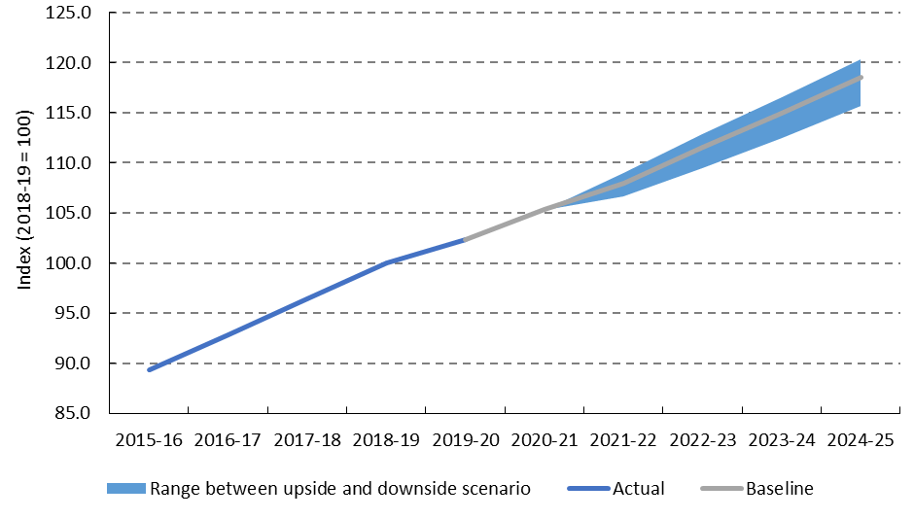

**Sources:** ABS Australian National Accounts, State Accounts and CMTEDD estimates.

Figure 2.2.10: Employment, ACT – forecast scenarios, December 2019 = 100

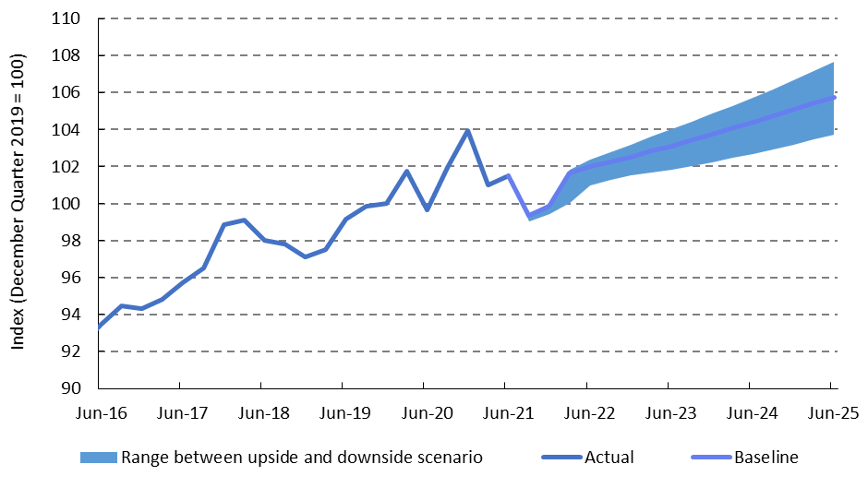

**Sources:** ABS Labour Force Australia and CMTEDD estimates.

Figure 2.2.11: Population, ACT – forecast scenarios, December 2019 = 100

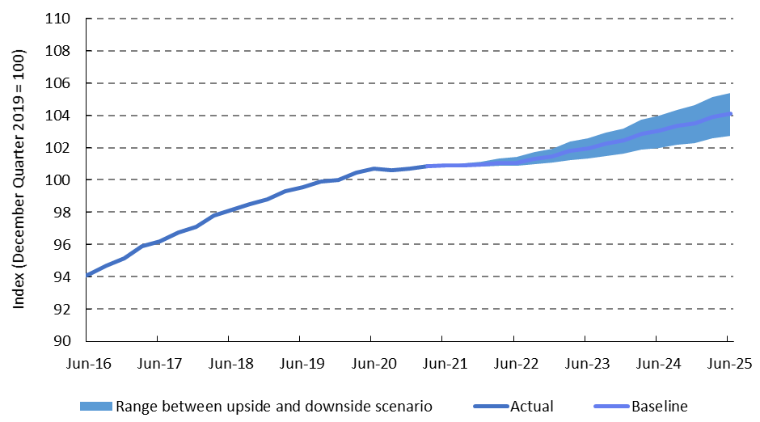

**Sources:** ABS National, State and Territory Populations and CMTEDD estimates.

#### Other risks and uncertainties

There remains significant uncertainty surrounding the ACT economic outlook, the national economy, and other economies across the globe as economic development continues to be driven by the evolution of the COVID-19 pandemic, particularly the emergence of more infectious strains such as the Delta variant. Possible longer lasting effects from the pandemic, including damage to supply chains and prolonged skills-mismatches, are unclear.

The risks to the ACT economy in the near term reflect increased uncertainty stemming from the Delta variant of coronavirus and the potential emergence of other strains that could reduce the effectiveness of vaccines.

The baseline economic outlook assumes that the fiscal supports and monetary policy measures limit the adverse economic impact of lockdowns over the September quarter 2021 and provide support for a stronger private sector recovery. As stimulus measures are withdrawn progressively, the gradual reopening of Australia’s domestic and international borders from December 2021 will support improved confidence and economic activity.

If inflation is higher than expected and leads to a need for the RBA to begin interest rate increases earlier than anticipated, this could adversely affect growth and the ACT housing market. Australian households are carrying significant debt and any rise in interest rates could see households decide to consolidate their balance sheets.

In addition, the Council of Financial Regulators has indicated there are some potential medium-term risks to the economy if credit growth materially outpaces growth in household income for an extended period. APRA is currently preparing an information paper on possible macroprudential measures to curb lending. Any such measures would impact on demand for credit and the housing market.

A prolonged period of heightened uncertainty and low demand could dampen scope for business investment to recover. This could delay capital replacement or lead to an unwillingness to undertake the risks associated with beginning a major project or business venture, despite the historically low cash rate.

On the upside, if the high vaccination rates in Australia and the ACT are effective in reducing the impact of the spread of the virus on the hospital system allowing restrictions to be eased more quickly than anticipated, accompanied by a faster rollout of vaccines in emerging market and developing economies, this could accelerate and strengthen the ACT economic recovery.

The Commonwealth decentralisation agenda outlined in the 2019-20 Commonwealth Budget to relocate more public sector jobs outside the ACT, including some from the Department of the Prime Minister and Cabinet, Indigenous Business Australia and Australian Financial Security Authority, remains a looming downside risk to the ACT’s economic outlook in the medium term.

In addition, any increase in the efficiency dividend for the Australian Public Service as the Commonwealth seeks to repair its fiscal position is a key medium-term downside risk to the ACT economy as 38.2 per cent of the Australian Public Service is in the Territory[1].

## Australian Economic Outlook

The national economic outlook continues to be driven by the evolution of the COVID-19 pandemic and the necessary public health responses across the country. The arrival of the Delta variant in Australia in June 2021 and the resulting lockdown measures in most jurisdictions, although of differing stringency and length, have halted the stronger than expected economic recovery that was underway.

Australian GDP grew at its fastest pace on record over the latter half of 2020 after a significant contraction of 7.0 per cent in the June quarter 2020. This was followed by further increases in GDP in the March quarter 2021 (1.9 per cent) and the June quarter 2021 (0.7 per cent) driven by increased household spending and public investment.

Prior to the Delta outbreak, the level of GDP in the June quarter 2021 was 1.6 per cent above the December quarter 2019 pre-pandemic levels. Overall, Australian GDP expanded by 1.4 per cent in 2020-21, slightly higher than the 1¼ per cent growth forecast in the 2021‑22 Commonwealth Budget.

Furthermore, unemployment fell to the lowest rate in a decade of 4.9 per cent in June 2021, while the employment-to-population ratio reached a record high of 63.0 per cent and employment was 1.3 per cent above the March 2020 pre-pandemic levels. This was accompanied by strong labour demand with job vacancies across Australia reaching a record high in May 2021 and skills shortages emerging in a number of occupations.

The Delta outbreak, however, has interrupted the momentum as the spread of COVID‑19 in New South Wales, Victoria and the ACT, along with the associated restrictions, has set back the economic recovery. GDP is now expected to contract significantly in the September quarter 2021 and any further improvement in the labour market will be delayed.

The RBA expects GDP is likely to contract by at least 2 per cent in the September quarter 2021, and possibly more due to lower household consumption, disruptions to the construction sector and delays in investment plans[2]. However, it expects the Delta outbreak to only temporarily delay the recovery, with the Australian economy to return to positive growth from the December quarter 2021 and into 2022 as vaccination rates increase and restrictions are eased.

The Australian labour market saw employment fall by 1.1 per cent or 146,300 people in August 2021, reflecting decreases in employment across Australia except in Victoria, Western Australia, and Northern Territory. Hours worked, which is proving to be a more accurate and useful measure of employment activity, nationally declined by 3.7 per cent or by 66.0 million hours between July and August 2021. The hours worked reduction in August 2021 followed falls of 1.8 per cent and 0.2 per cent in June and July respectively, driven by the lockdowns and other restrictions introduced during this period. Weekly Payroll Jobs and Wages have also seen declines nationally, driven mostly by the states and territories that are in lockdowns. As restrictions begin to ease in October across NSW, the ACT and Victoria, it is expected that employment and hours worked will begin to recover. As people return to work there is also likely to be an increase in the participation rate.

The significant supports provided by the Australian and State and Territory Governments in response to the outbreak are expected to boost the household saving rate in the near term, which will boost consumption as restrictions are gradually eased. In addition, a lift in household net wealth as a result of higher house prices and higher Australian equity prices, to above pre-pandemic levels, may also increase the potential for stronger household spending as restrictions are eased. Business investment is also expected to resume its pre‑Delta recovery trajectory.

The labour market is expected to improve following the expected bounce back in economic activity.

There are uncertainties surrounding the expected recovery of the national economy, including the possibility of significant community transmission of the virus putting pressure on hospital capacity and requiring the reimposition of public health social measures that restrict activity. There is also potential upside that once every eligible Australian has had an opportunity to get vaccinated there is lower community transmission facilitating greater freedom of domestic and international movement.

## International Economic Outlook

More than a year since the COVID-19 outbreak was declared a global pandemic, the situation has worsened in some parts of the world due to the emergence of more infectious strains of the virus. This has led to divergence in the economic recovery path globally, with vaccination rates and the size of fiscal supports being key determinants.

In its July 2021 World Economic Outlook (WEO), the International Monetary Fund (IMF) forecasts the global economy to grow by 6.0 per cent in 2021, following a 3.2 per cent contraction in 2020. Although the 2021 forecast is unchanged from the April 2021 WEO, an improvement in the outlook for advanced economies has been offset by a deterioration in emerging market and developing economies reflecting differences in pandemic developments and policy responses. Advanced economies are expected to recover further in the second half of 2021 as vaccine rollouts proceed, and additional fiscal supports are provided.

The outlook for global economic growth in 2022 is more positive, and growth has been upgraded to 4.9 per cent from the previous forecast of 4.4 per cent. This upgrade reflects expected additional fiscal support in the United States, which will flow through into the global economy.

The Organisation for Economic Co-operation and Development (OECD) in its September 2021 update was slightly more pessimistic than the IMF July 2021 update, projecting global GDP to grow by 5.7 per cent in 2021 and by a further 4.5 per cent in 2022.

The economic prospects of Australia’s major trading partners remain solid, underpinned by a robust outlook for China’s economy, which is expected to grow faster than the global average.

Both the IMF and the OECD emphasise that the uncertainty surrounding their baseline projections remains high primarily due to the outlook for emerging market and developing economies, with risks tilted to the downside in the near term. In particular, any further delays in the rollout of vaccines in emerging market and developing economies, along with further COVID-19 outbreaks, could lead to weaker growth. In advanced economies, concerns about employment prospects and income security, and tighter financial conditions could affect spending.

There is, however, some upside potential from better global cooperation toward overcoming logistical hurdles to vaccine deployment, which would allow for faster normalisation of activity, particularly among emerging markets and developing economies, and a stronger pick up in consumptions and business investment in advanced economies.

Table 2.4.1 Forecasts of global economic growth, percentage change

|  |  |  |  |  |
| --- | --- | --- | --- | --- |
|  | 2019 Actual | 2020  Actual | 2021 Projection | 2022  Projection |
| International Monetary Fund | 2.8 | -3.2 (-3.3) | 6.0 (6.0) | 4.9 (4.4) |
| Organisation for Economic Co-operation and Development | 2.7 | -3.4 (-3.5) | 5.7 (5.8) | 4.5 (4.4) |

**Sources:** World Economic Outlook (WOE), IMF, April 2021 and July 2021; and the OECD Economic Outlook Forecasts, OECD, May 2021 and September 2021 (Interim).

**Notes:** Numbers in brackets and the OECD’s estimate for 2019 were published in the previous release.

1. APS Commission, APS employment data, 31 December 2020 Release.
2. P. Lowe, 2021, *Delta, the Economy and Monetary Policy,* Address to the Anika Foundation on 14 September 2021. https://www.rba.gov.au/speeches/2021/sp-gov-2021-09-14.html