RENEWAL OF CANBERRA CBD AND SUBURBS
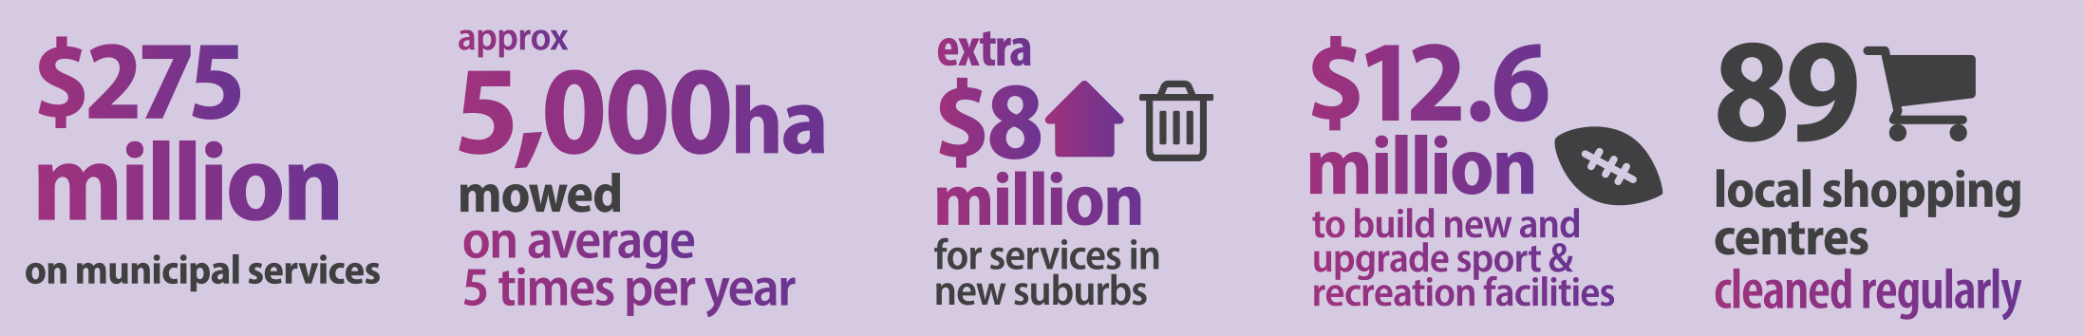
Canberra is the world’s most liveable city. To ensure our suburbs and town centres look and feel great, this budget provides more funding for suburban renewal.
This includes revitalising our shopping centres, playground maintenance, mowing our suburbs and cleaning our lakes.
New initiatives in the 2015-16 Budget form part of $275.5 million spent every year on municipal services across the city.

More mowing and suburban maintenance
The 2015-16 ACT Budget delivers extra funding for our suburbs, with more mowing, cleaning, weeding and other maintenance, including:
- $8 million over four years for more frequent mowing across Canberra’s 4500 hectares of urban open space, weed control on major thoroughfares and maintenance of trees and shrubs, lake and pond maintenance and graffiti prevention measures;
- $8.1 million over four years for municipal service delivery in our new suburbs such as waste collection, street lighting and the maintenance of public places; and
- $200,000 towards minor safety upgrades at playgrounds across Canberra.

Revamps around south Canberra shops
The 2015-16 ACT Budget will deliver $2.1 million to upgrade public spaces around shopping centres in south Canberra, including:
- $1.7 million to revamp the Erindale and Weston Group Centres. The revamps will include pedestrian paths and landscaping to improve safety and amenity;
- $430,000 to upgrade the street trees, landscaping and lighting along Anketell Street (north) in Tuggeranong;
- $250,000 for feasibility studies to improve walking and cycling access around Tuggeranong Town Centre and Kingston Group Centre; and
- $50,000 to develop detailed designs for an upgrade of the Kambah Group Centre.

Better sporting venues
This budget delivers more than $12 million over four years to build, upgrade and maintain sport and recreation facilities for Canberra, including:
- $6.7 million over three years for a new sports facility at Melrose High School. The Melrose Football Precinct will have a new FIFA-accredited synthetic football field, a new natural turf grass field, a new sports pavilion, lighting, a car park and multi-use hard courts;
- $4.6 million over two years to upgrade Phillip Oval. The upgrade, in partnership with AFL NSW/ACT and Cricket ACT, will include new community facilities, administration buildings, storage, and lighting. Under the partnership, the sporting codes will inject a further $1.6 million in this project;
- $871,000 in extra funding to maintain the quality of our neighbourhood ovals used by local sporting groups; and
- $400,000 in extra funding for the Sport and Recreation Grants Program to support community sporting organisations undertaking repairs and maintenance to their facilities.

Caring for the environment
The ACT leads the country in sustainable energy policy and actions and waste management and recycling. This year’s budget provides:
- $6.3 million over three years from the Energy Efficiency Improvement Scheme used to fund ActSmart programs for households, businesses and schools. These programs support reduced energy usage and cut energy costs;
- $1.9 million over four years for the Upper Murrumbidgee Waterwatch Program to continue water quality monitoring at 200 sites across the region, engaging more than 160 volunteers;
- $9.2 million to implement Strategic Bushfire Management Plan version 3 and implement fire management strategies in the Lower Cotter Catchment;
- $2.7 million over four years to help protect the ACT’s water quality, and manage an additional 20,000 hectares of land in the Cotter water catchment after construction of the enlarged Cotter Dam. This funding will go towards weed, pest and erosion control, as well as managing anti-social behaviour and vandalism;
- $500,000 over two years for Canberra Urban and Regional Futures (CURF) for its collaborative work in the research, business and community sectors to promote a sustainable future for cities and regions;
- $2.8 million for a feasibility study on long-term options for sustainably managing and treating waste in the ACT, $400,000 to continue the Bulky Waste Collection Scheme and $200,000 to continue street level recycling in the City; and
- A further $1 million for continuing waste management services at the Mugga Lane Resource Management Centre, and $20.9 million over two years to expand the centre to ensure landfill capacity until 2020.

Boost for inner city
The budget delivers:
- $4.1 million to upgrade Canberra’s premier performing arts venue, the Canberra Theatre Centre; and
- $1.5 million over two years for lighting and footpath improvements in Haig Park and Mort and Lonsdale Streets in Braddon.

More funding for animal welfare
- $740,000 in additional funding over four years for animal welfare and domestic animal services, including inspectorate services and management of domestic animals.
- $256,000 in additional funding for the RSPCA, supporting its care for stray, seized, neglected and other vulnerable animals.
- $242,000 to design and develop a new incident management system for Domestic Animal Services.

