

Briefing Note

Insert project name

Prepared for The Industry Panel of the Treasury of the ACT Government
23 March 2015

Document Information
Prepared for The Industry Panel of the Treasury of the ACT Government
Project Name Insert project name
File Reference Cardno - Response to Icon Water Comments v6.docx
Job Reference 3604-67
Date 23 March 2015

Contact Information
Cardno (QLD) Pty Ltd
ABN 57 051 074 992

Level 11, Green Square North Tower
515 St Paul’s Terrace
Locked Bag 4006
Fortitude Valley Qld 4006

Telephone: 07 3369 9822
Facsimile: 07 3369 9722
International: +61 7 3369 9822

www.cardno.com.au

Document Control
Version | Date | Author | Author Initials | Reviewer | Reviewer Initials
1 | 2 February 2015 | Alexander Nash |  | Stephen Walker | 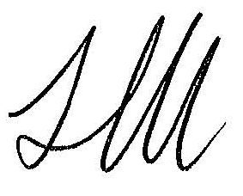
3 | 18 February 2015 | Alexander Nash |  | Stephen Walker
7 | 23 March 2015 | Alexander Nash |  | Patrick Lavery | 
© Cardno 2015. Copyright in the whole and every part of this document belongs to Cardno and may not be used, sold, transferred, copied or reproduced in whole or in part in any manner or form or in or on any media to any person other than by agreement with Cardno.
This document is produced by Cardno solely for the benefit and use by the client in accordance with the terms of the engagement. Cardno does not and shall not assume any responsibility or liability whatsoever to any third party arising out of any use or reliance by any third party on the content of this document.

Table of Contents
1 Introduction 1
2 Demand Risk 1
2.1 Approach to demand modelling 1
2.2 Specific criticisms 5
2.2.1 Restrictions variable 5
2.2.2 Note on Tier 1 Tier 2 Split 9
2.2.3 Sensitivity of Tier 1 / Tier 2 to changes in demand 10
2.2.4 Water aware variable 13
2.2.5 Out of sample testing 14
2.3 Perspectives about the future 14
3 Treatment of Water Security Projects 19
3.1 Comments on Theoretical Economic Benefits 19
3.2 Comments on evidence of climate change 19
3.3 Comments on Scaling of willingness to pay survey 19
Figures
Figure 2-1 Icon total Dam releases data (a proxy for total demand) 2
Figure 2-2 Rate of Change in Demand – 2006-07 to 2012-13 3
Figure 2-3 Cardno original (unweighted restrictions) model and Icon Water original forecasts 4
Figure 2-4 Actual vs modelled total volumes of water sold 6
Figure 2-5 Effect of various weightings on total demand forecast 7
Figure 2-6 Cardno updated demand forecast using optimised restriction weightings (central estimates) 8
Figure 2-7 Optimised restriction weighting effect on per capita consumption projections 9
Figure 2-8 Tier 1 and Tier 2 volumes (central, 20%ile and 80% volumes, all populations “central”) 10
Figure 2-9 T1% as a function of PCC – polynomial and exponential lines of best fit 11
Figure 2-10 Tier 1 and Tier 2 volumes at the upper and lower total demand boundaries (20% / 80%) 13
Figure 2-11 Figure ES2 from Icon Water’s “Future Water Options Review” showing increasing demand 15
Figure 2-12 Water efficient appliance penetration 16
Figure 2-13 Updated model using weighted restriction values – per capita consumption forecasts (Cardno and Icon Water) showing evaporation and restrictions levels assumed. 17
Figure 2-14 Sydney and Brisbane per capita consumption – post restriction trends 17
Figure 2-15 Per capita consumption – major Australian utilities 18

Appendices
Appendix A Bureau of meterology charts

Introduction
This briefing note contains Cardno’s response to Icon Water’s comments on the demand forecast developed by Cardno and adopted by The Industry Panel of the ACT Government for the purposes of price setting over the 2015-18 period. Icon Water’s comments were issued on 23 January 2015 in a letter to the Industry Panel.
Cardno received this feedback on 27 January 2015. We were asked to prepare a short response to the Industry Panel.

Demand Risk

Approach to demand modelling
Icon Water asserts that its demand model approach is reasonable. We agree that Icon Water has built a very detailed and comprehensive model for predicting short term demand. We noted in our report that it was less suitable for longer-term demand, as the model effectively predicts the same consumption every year, based on average historic weather conditions. We noted that our approach was to follow the guidelines in the National Water Commission paper “Integrated resource planning for urban water”. These guidelines offer three primary methods for best practice demand forecasting, all of which involve projected population growth as a variable.
Icon Water also noted that its model was not suitable for long term demand predictions. In its demand modelling report, Icon Water wrote: “…population growth would likely be an important factor for long-term forecasting and water-security planning” and cautioned that their model should be updated very frequently (“at least annually as new behavioural data become available”).
The question is, therefore, does a five year price period consitute a sufficiently “long term” to warrant the inclusion of population data ?
Icon Water’s response to the Industry Panel’s finding suggests that it does not. Icon Water noted that winter demand has not changed significanty over 30 years, despite increasing population growth (Figure 3 of its response).
Icon Water also (correctly) notes that their model does not ignore popultion growth, rather it ignores it as an explicit factor. Population growth is implicitly assumed to be offset by efficiency savings. If population growth is expected to continue, their model also implicitly assumes that efficiency measures will also continue.
In their response Icon Water makes this clear, but states “If the effects of population growth are to be explicitly modelled, then the effects of efficiency savings must also be explicitly modelled. However, there is little useful data available to create variables that would reliably capture these effects.”
In any case, Icon Water’s modelling shows that the net effects of these “residual” factors averages out to be zero in the time period used to construct their model. Icon Water’s approach was therefore to combine population and efficiency measures into the model residuals (i.e. the differences between observed consumption and theoretical - modelled - consumption), rather than attempt to model their effects.
Our approach was different. We essentially followed a more “typical” approach to demand modelling and included population and attempted to account for efficiency by conducting a detailed analysis of billing data. Indeed our effort was primarily concentrated on the analysis of the effects of efficiency measures and population forecasting accuracy, which we felt would be more “predictable”, and less concentrated on things we could not predict (weather). We do, of course, understand that a good model should also be able to account for water restrictions so as to be able to isolate or quantify their effects in the forecasts.
We took this approach because in the medium to long term, population and housing and industry effects will define demand – not weather. We accept that four to five years is somewhere “in between” short and long term, which means that there is some merit to both approaches.
The issue is whether Icon Water’s “implicit” analysis of the medium term effects of population and housing (and water efficiency measures) gives a more reasonable forecast than an “explicit” analysis which accounts for them.
Icon Water’s implicit approach suggests that per capita consumption will decline over the period. Historically, per captia consumption has indeed declined.
Icon Water described its approach as “to make what it sees as a neutral assumption that the future effects of ‘other factors’ would be zero, such that total consumption would no longer decrease, but would stabilise”.
Icon Water commented that “Cardno makes the assumption that after falling for more than 25 years, total consumption will now begin to increase. This assumption requires reconsideration”.
When Icon Water states that demand has been falling for more than 25 years, this suggests that a demand increase is unreasonable. We note that although total consumption today is lower than it was 25 years ago, over the past 27 years there have been periods when demand has fallen, and periods when it has risen (see Figure 2-1).
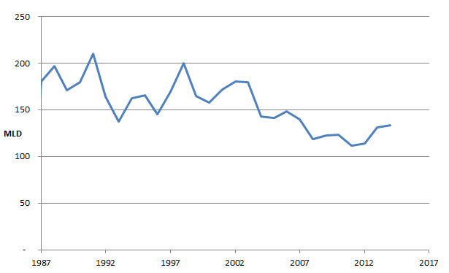
Figure 2-1 Icon total Dam releases data (a proxy for total demand)
In recent years (post drought), both total and per capita demand has increased. Icon Water’s analysis shows that it expects this recent trend to reverse and for a decline in per capita consumption to resume.
Our analysis shows that we expect a slight decline in per capita consumption (based on housing stock changes) over the forecast period 2014 to 2018, but we have essentially assumed that apart from per capita consumption declines that we can explain (based on our analysis of billing data), we are “neutral” about other changes to per capita consumption.
The question then is: “is this reasonable”? Icon Water states that it is unreasonable not to assume futher declines in per capita consumption – because historically, on average – such declines have been observed. Icon Water asserts that its implict assumption is that that increases in population will be offset by decreases in usage.
This can only be true up until a point. It is clearly not reasonable to assume that per capita consumption will fall to zero, regardless of what it has done over the past 25 years.
Indeed, Icon Water’s own analysis recognises that total demand will not fall continuously. Icon Water itself projects a total demand increase over the longer term, in their future water options review (see charts on pages 23 and 25 of their letter). Increased total demand and the associated economic benefits forms a key justification for the contruction of the Enlarged Cotter Dam.
Given that in the last few years, per capita consumption has “bounced back” after the restriction period, we considered that our projections of static to slightly falling per capita consumption are in fact “reasonable”. It is possible that per capita consumption will continue to rise, and it is also possible that it will change direction and fall.
This “bounce back” is not confined to Icon Water (which attributes the change to weather driven variance). Rather, the rate of change of per capita consumption has gone from negative to positive for all of the major Australian utilities, with the exception of Water Corp (where permanent water restritions are in place, and where per capita consumption is much higher than in the rest of the country).
Figure 2-2 shows a strong trend away from declining consumption to stable and even increasing consumption.
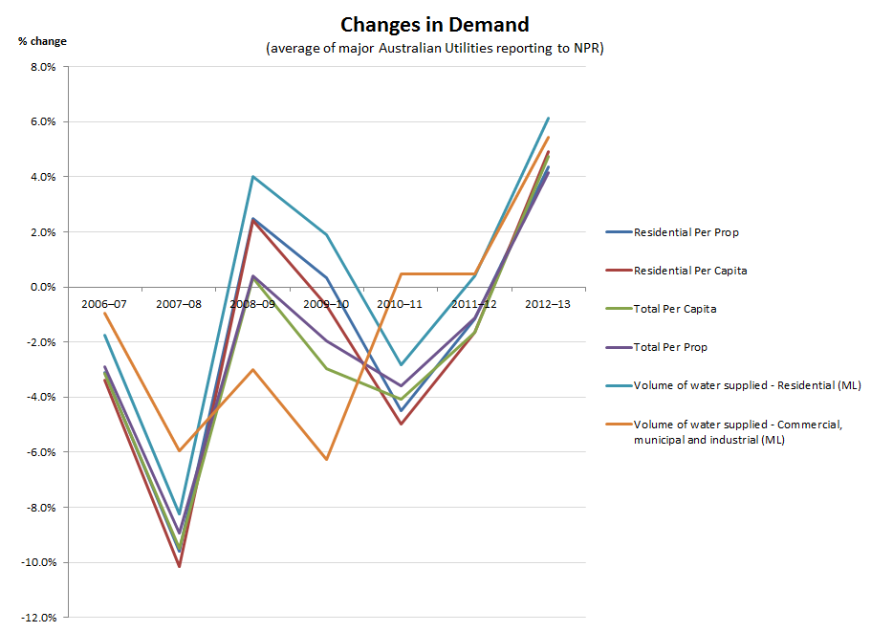
Figure 2-2 Rate of Change in Demand – 2006-07 to 2012-13
Source: National Performance Reports, National Water Commission
Given this finding of a strongly postive “second derivative”, it is reasonable to at least take a neutral view on per capita consumption over the next 5 years.
Our approach was therefore to try to account for the changes in per captia consumption that we could expect due to relatively certain changes in housing, but not assume anything about continued behavioural change in the uncertainty “post restrictions”.
Icon Water’s approach – at least for the purpose of the demand forecast used to set the price of water over the next five years – is to assume that the behavioural changes which have taken place over the past 15 years (due to drought and restrictions) will continue.
This may be the case. However it is not clear that this approach is more “reasonable” than assuming behaviour change will not continue indefinately. Icon Water itself assumes that at some point, total demand will increase. The assumption that total demand will increase (at some point) is presumably, therefore, not “unreasonable”.
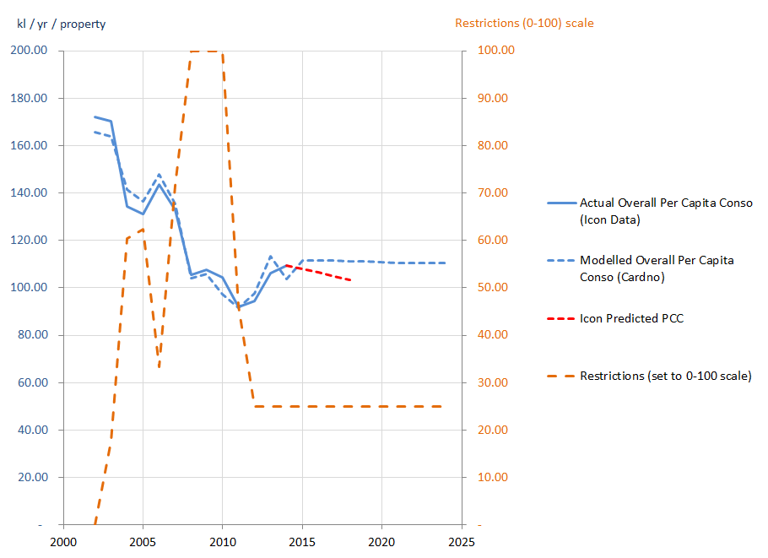
Figure 2-3 Cardno original (unweighted restrictions) model and Icon Water original forecasts
We also note that the long-term declines in per capita consumption witnessed in cities such as Brisbane and Sydney did not mean that declines in per capita consumption resumed after the end of drought restrictions. Rather, per capita consumption in these cities appears to have stayed relatively constant or increased slightly (in Brisbane).

Specific criticisms

Restrictions variable
Icon Water criticises the use of a simple integer restrictions variable in our annual regression model, noting that our model “imposes the constraint that the incremental effect on consumption of moving from one level of restrictions to the next must be equal.”
This is a fair criticism. In the limited time available, a large part of our efforts were concentrated on an analysis of housing consumption patterns, with a relatively simple regression model built to account for weather and restrictions. As previously mentioned, our focus was to account for the variability imposed by weather, and then to take a “typical” approach to demand forecasting involving demographic and housing projections.
Icon Water’s approach was to set up a number of variables representing restrictions. These were stage_0, stage_2, and stage_3. Icon also included specific variables to model the effect of restrictions during summer; stage0_s. These variables were generated from a column “Restriction Level” which included numbers from 0 to 4.
As we were modelling consumption at an annual average level (rather than daily), we did not need a variable to account for summer or winter. Because our model had relatively few points (2002 to 2014, as billed volume data broken down by consumer component was only available for this time period), we sought to limit the number of explanatory variables. This meant using the “Restriction level 0 to 4” parameter as one column, rather than a separate column (with 1 or 0 values in each year) for each level of restrictions.
Icon Water’s criticism that this is overly simplistic is reasonable and our approach will have contributed to poorer fit than a detailed analysis of the weighted effects of each level of restrictions would have. Indeed, we estimated our model accuracy to be ±4.5% based solely on the inherent errors from our modelling process. Following Icon Water’s comments on the Draft Report and analysis regarding the relative weights of the restriction levels, we have adjusted the model to account for the relative impact of restrictions by using a “weighted restrictions” variable.
Icon Water provides four sets of weights; for billed quantities or for releases, and for winter or summer (giving 4 combinations). The weights relative to “Stage 3” (i.e. level 4) provided by Icon Water and the relative weights used by Cardno are shown in the table below.

Residential billed (proportion of stage3 effect) |  |  | Releases (proportion of stage3 effect) |  |  | Cardno relative weights used in Draft Report
 | Winter | Summer | Winter | Summer
None | 0 | 0 | 0 | 0 |  | 0
stage0 | 0.77 | 0.65 | 0.72 | 0.56 |  | 0.25
stage1 | 0.77 | 0.65 | 0.72 | 0.56 |  | 0.5
stage2 | 1.00 | 0.76 | 1.00 | 0.77 |  | 0.75
stage3 | 1.00 | 1.00 | 1.00 | 1.00 |  | 1.00

Source: Icon Water file “Figure 5 Modelled effects of various stages of restrictions relative to Stage 3.xls”
These relative weights are derived from the regression model coefficients.
We note that Icon Water’s model treats Level 1 and Level 2 restrictions as the same thing (described above as Stage0 and Stage1). However our model does allow for an impact due to Level 2 restrictions.
We included both the summer and winter weightings in our model to examine the impact of using Icon Water’s weightings as calculated from its daily model. The results are shown in Figure 2-4.

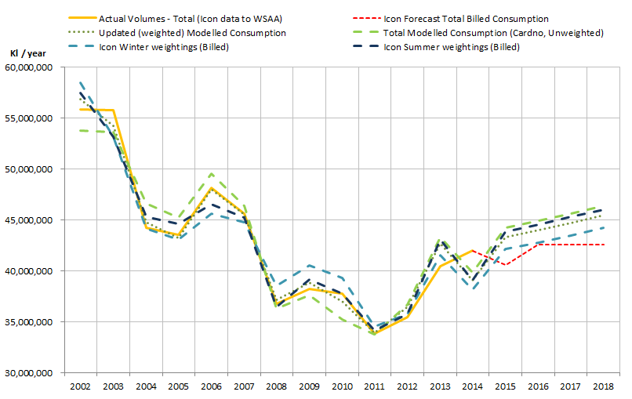
Figure 2-4 Actual vs modelled total volumes of water sold
Figure 2-4 shows a number of important results:
- The use of the weightings does improve the historical fit of the model
- The forecasts are very sensitive to the weighting allocated to Stage0 / Level 1 restrictions, because all future demand is assumed to take place at this level of restrictions (PWCM).
The question is, what weightings should be used ?
There are three possible approaches:
1) Use an average of the Icon Water weightings (average of summer and winter) as an approximation
The impact of the restriction variables in Icon Water’s model is influenced by the seasonal variable Stage0_s, which has a greater effect in summer and only applies when stage0 (Level 1) restrictions are in force.
Given that Icon determined the relative weight of its restriction variables from a daily model, and in the presence of a summer variable, it is difficult to apply them directly to our annual model.
We applied an average of weightings and the results are shown below in Figure 2-5.
2) Use the weightings developed by Icon Water in the annual average regression in the spreadsheet “Figure 4 The net effects of other factors.xls”
In the spreadsheet “Figure 4 The net effects of other factors.xls” Icon Water performed a basic regression on annual data, similar to our approach.
However, instead of using the Restriciton Level integers, Icon Water used the three “stage” parameters (three columns of binary data). This is an alternative way of demonstrating the weight of the “stage” parameters without the complications of being in a daily model or using the summer variable. The weightings are as follows:
Restriction variable | Coefficients | Total Impact | Relative Weight of Parameter when value = 1 | Restriction :Level Equivalent
None | 0 | 0 | 0 | 0
Stage_0 | -33,624 | -33,624 | 0.54446619 | 1 or 2
Stage_2 | -13,578 | -47,201 | 0.764330865 | 3
Stage_3 | -14,554 | -61,755 | 1 | 4
Source: Icon Water Spreadsheet “Figure 4 The net effects of other factors.xls”
Using the weightings above gives a forecast very similar to the unweighted forecast developed by Cardno for the Draft Report, but does give a better historical fit to the data. The result in show in Figure 2-5.
3) Optimise the restriction level weightings such that the Cardno model best fits the historical annual data
We used Excel to optimise the weightings of the 4 restriction levels such that the model errors were minimised over the 2002-2014 period. This resulted in the following weightings for restrictions:
Level 1: 50%
Level 2: 68%
Level 3: 100%
Level 4: 100%
The results of all three methods are show in Figure 2-5 below.
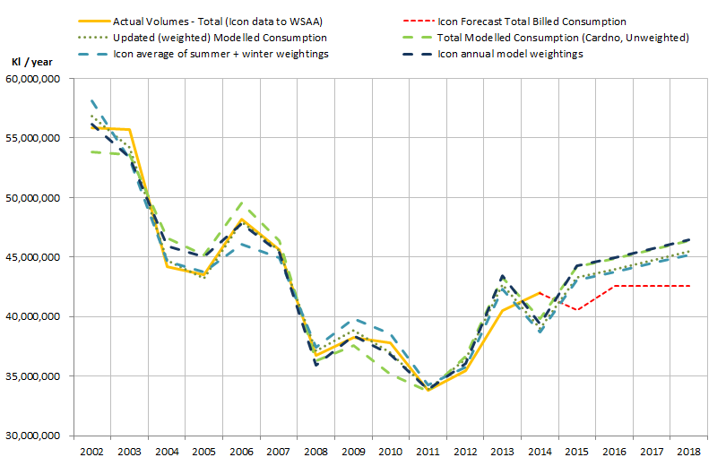
Figure 2-5 Effect of various weightings on total demand forecast

Figure 2-5 shows that the minimised error model gives a very good historical fit (indeed, it is optimised to do this), and gives approximately the same forecast values as the average of the Icon Water daily model weightings.
The use of the optimised weightings gives the following demand forecast (when housing impacts are included).
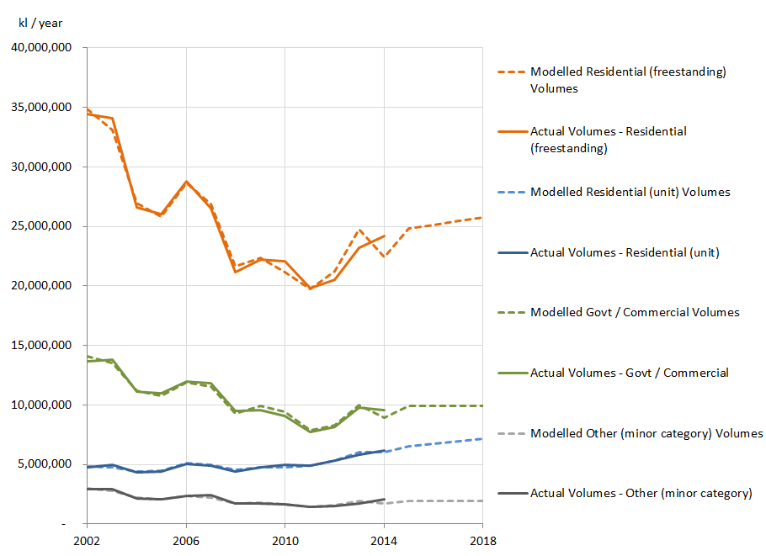
Figure 2-6 Cardno updated demand forecast using optimised restriction weightings (central estimates)

Year | 2015 | 2016 | 2017 | 2018
Total Demand | 43,146,339 | 43,668,110 | 44,204,654 | 44,756,513
Tier 1 | 24,527,730 | 25,313,508 | 26,042,589 | 26,720,228
Tier 2 | 18,618,609 | 18,354,602 | 18,162,065 | 18,036,285

We note that the difference between these forecasts and the previous forecasts is about 2% lower than previous forecasts.
This is within what we estimated the “model error” to be for the original model (±4.5%). By using the weighted restriction values, we have improved the regression fit, and therefore reduced the model error (to ± 3%).
The resulting per capita consumption trends and the new, weighted restriction values are show below:
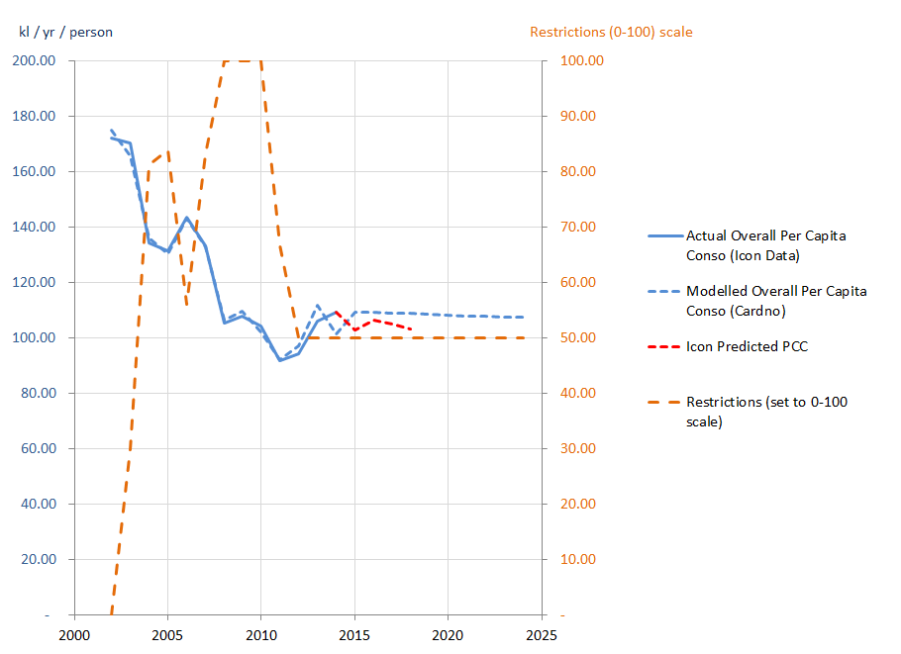
Figure 2-7 Optimised restriction weighting effect on per capita consumption projections

Note on Tier 1 Tier 2 Split
Icon Water suggest that we should not use a polynomial to forecast Tier 1 and Tier 2, as this may give spurious results when used outside the range for which it was calculated. We are aware of the risk of spurious results and note that the formula has not been used outside the range of 226 to 265 kl for the central estimates, all of which lie in the valid range. Our demand model generates the following consumptions per supply charge:
Year | 2015 | 2016 | 2017 | 2018
Volume per supply charge | 257.30 | 254.02 | 250.77 | 247.56
Tier 1 % (Cardno Polynomial) | 56.85% | 57.97% | 58.91% | 59.70%
Tier 1 % (Icon exponential equation applied to Cardno values) | 56.28% | 57.03% | 57.74% | 58.42%
Icon forecast consumption per supply charge | 243.00 | 248.65 | 242.59 | 236.70
Tier 1 % (Icon exponential equation applied to Icon value) | 59.33% | 58.19% | 59.41% | 60.52%

Sensitivity of Tier 1 / Tier 2 to changes in demand
We were asked by the Panel’s technical team to consider the upper and lower bounds for Tier 1 and Tier 2 splits within the variability included in the model.
Determining the upper and lower bounds of Tier 1 and Tier 2 is not straightforward. The main reason is that the Tier 1 % is determined from the per capita consumption (PCC), and the PCC is a function of several “moving parts”. The variability which goes into PCC includes uncertainty around demographic growth, model errors and weather.
When we refer to upper and lower bounds for demand forecast, we have been referring to the total volume consumed (the 20%ile and 80%ile values for any given year).
If we take these volumes, and divide by the “expected number of supply charges” (i.e. the central forecast), we can calculated a PCC, T1% and therefore a T1 volume. The results are below:
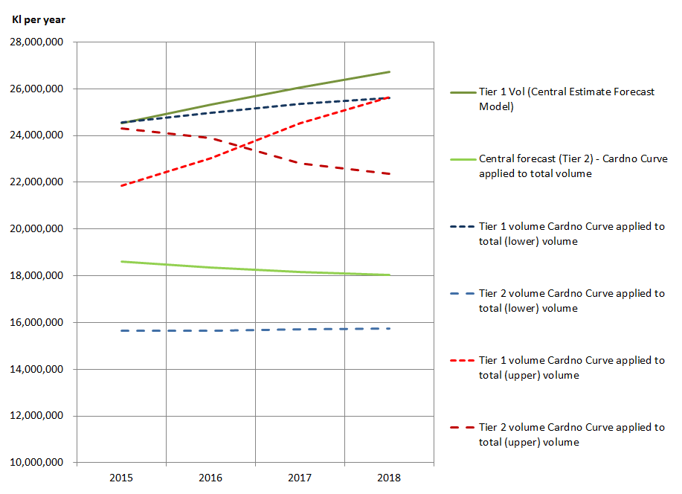
Figure 2-8 Tier 1 and Tier 2 volumes (central, 20%ile and 80% volumes, all populations “central”)
The results are counter intuitive – at the “upper volume” level, Tier 1 sales are below the “central” forecast, because so much of the volume is actually being sold in Tier 2. A high volume = a high PCC = a relatively small amount sold in Tier 1. The effect we see is that the T1 % drops off faster than the total volume increases, and so at high volumes, Tier 1 volumes are actually lower than for the central forecast.

An example of the effect is shown here using both formulae.
Per capital consumption (kl / account / year) | Population | Total Volume (kl) | Tier 1 % (Cardno) | Tier 1 Volume (Cardno) (kl) | Tier 1 % (Icon) | Tier 1 Volume (Icon) (kl)
250 | 167,689 | 41,922,259 | 59.11% | 24,564,816 | 57.91% | 24,275,925
260 | 167,689 | 43,599,150 | 55.80% | 24,326,283 | 55.64% | 24,260,444
A higher total volume results in a lower absolute Tier 1 volume.
The problem occurs for the higher per capita consumption values (when the T1% curve starts to drop off quickly – see Figure 2-9). As a result, this problem really affects the “upper bound” estimates (high PCC).
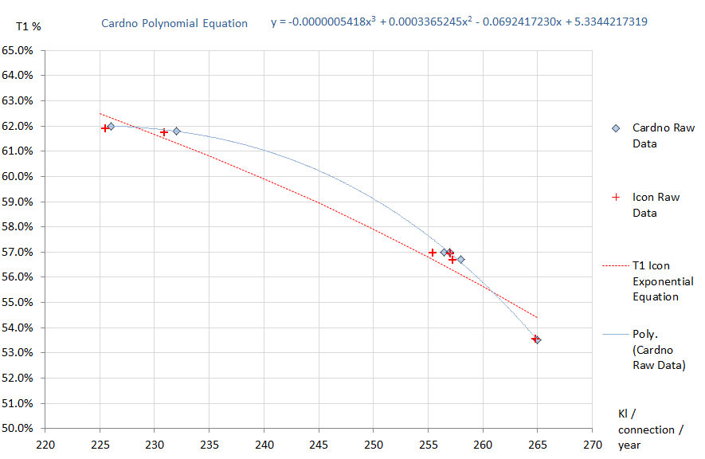
Figure 2-9 T1% as a function of PCC – polynomial and exponential lines of best fit
In practice, we do not expect increases in total volumes sold (or per capita consumption) to result in decreases in absolute Tier 1 consumption. The effect is a result of the approximation formulae we are using. At a minimum, if no new customers connected to the network and all demand growth was due to increases in per capita consumption, we would expect Tier 1 volumes to remain static (and all growth would be in Tier 2).
To get around this problem we took the following approach:
1) Use Icon’s formulae to determine the T1% as the exponential formula works better at the extremes the PCC ranges (in particular, the slope is not so steep for the high PCCs).
2) Use the upper and lower volumes as set points. In other words, consider that the “upper bound” T1 volume we will use is the one which occurs when there is an “upper bound” total volume (and the converse for the lower bound).
3) Find the %ile value for both PCC and population which satisfy the volume boundaries. This can be done using the “PERCENTILE” formula in excel, where both PCC values and numbers of customers are looked up for the same %ile value. A worked example is below:
- Step 1: Upper bound volume in 2015 is 46,165,909 kl (80%ile value from the Monte Carlo with all sources of variability turned “on”).
- Step 2: Find the 80%ile values for PCC and customer accounts using the PERCENTILE formula. The values are 275.4 kl / account and 169,651 connections.
- Step 3: determine the total volume for the combination found in Step 2 ( = 46,726,095 kl). This value is too high.
- Step 4: Adjust the %ile figure until the volume in Step 3 equals the volume in Step 1 (result: the 75.25th %ile)
- Step 5: use the PCC from this %ile (272.55 kl) to calculate the T1 % using Icon’s formula (result: 52.38%)
- Step 6: multiply the total volume 46,165,909 by 52.38% = 24,182,786 kl.
The results are shown in Figure 2-10 below.
Figure 2-10 shows what we intuitively expect to be true, which is that T1 volumes are actually relatively insensitive to changes in demand driven by weather and population. When demand is high, almost all of the increase above the “normal” is in the second tier. There is some increase in Tier 1 due to higher than expected population growth and some “low” users who increase their Tier 1 consumption. But almost all “high” demand occurs in Tier 2.
The converse is true for low demand, although Tier 1 is more sensitive to lower demand (as some customers who consume in Tier 2 presumably drop below the threshold, and even their Tier 1 consumption starts to take effect).
The “unidirectional” sensitivity makes sense because Tier 1 consumption effectively has a “ceiling” – it can only expand through relatively invariable population growth. Above the T1 ceiling, almost all demand increases go into Tier 2. However T1 demand has no “floor”; below the ceiling, a large part of demand reductions affect Tier 1.
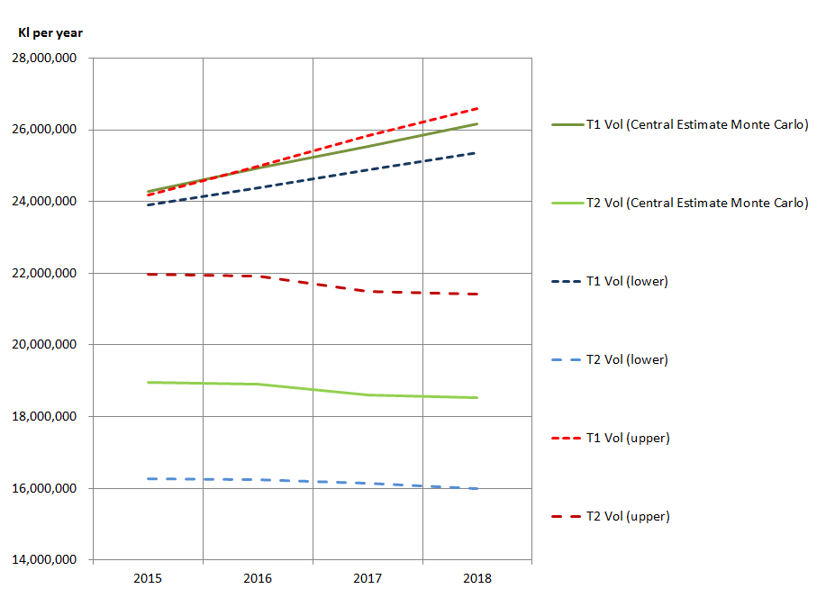
Figure 2-10 Tier 1 and Tier 2 volumes at the upper and lower total demand boundaries (20% / 80%)

(All figures kl/yr) | 2015 | 2016 | 2017 | 2018
Upper 80%ile total volume | 46,165,909 | 46,911,076 | 47,328,463 | 47,997,274
Tier 1 | 24,182,786 | 24,990,795 | 25,838,654 | 26,579,476
Tier 2 | 21,983,123 | 21,920,281 | 21,489,809 | 21,417,798
Central Estimate | 43,146,339 | 43,668,110 | 44,204,654 | 44,756,513
Tier 1 | 24,527,730 | 25,313,508 | 26,042,589 | 26,720,228
Tier 2 | 18,618,609 | 18,354,602 | 18,162,065 | 18,036,285
Lower 20%ile total volume | 40,186,912 | 40,628,194 | 41,043,654 | 41,351,679
Tier 1 | 23,910,330 | 24,385,693 | 24,892,026 | 25,354,373
Tier 2 | 16,276,582 | 16,242,501 | 16,151,629 | 15,997,307

Water aware variable
Icon Water raise a number of criticisms about the choice and nature of the “water aware” variable. These are:
- The lack of evidence of Cardno testing alternative specifications of this variable
- That the variable will cease to increase from 2014 onwards. Cardno notes in its report that this assumption is subjective. Icon Water contends that this assumption is also unreasonable.
- By holding it constant, the definition of the variable has been changed between the historical and forecast periods.
Within the limited time available to develop an alternative model, we did test a number of increasing variables (e.g. population, housing effect, account numbers). Of these, the choice of the cumulative sum of the restrictions value was selected because it was better able to explain the historical demand, but also because it represented a “ratcheting” up of behavioural change and installation of water efficient appliances in response to increasing levels of restrictions.
Icon Water raises the point that the future values of water awareness are inconsistent with the historical values. This is true, and is a subjective decision as described in our report.
The reason for this is that we accounted for some of the future water efficiency measures captured in “water aware” separately through our analysis of changes in the housing stock and changes in consumption patterns by housing type.
If we were to project “water aware” going forward as well as the housing analysis, we would be double counting to some extent.
We noted that the effect of continuing the “water aware” variable as it was greater than the effect of housing changes estimated from our analysis.
The “housing effect” which we explicitly account for has the following demand impact (in GL):

Year | 2015 | 2016 | 2017 | 2018
Housing effect (GL) | -0.164 | -0.332 | -0.507 | -0.687
Housing effect (% of total) | -0.38% | -0.76% | -1.13% | -1.51%

The effect of keeping the “water aware” variable as a cumulative behavioural change variable would be to lower demand by -1.79% in 2015 up to -7.14% by 2018 (3.2 GL).
We outlined our reasons for keeping water aware constant on page 73 of our report. Further evidence that behavioural change and in-house appliances may have reahed saturation point is provided in Figure 2-2.

Out of sample testing
Our regression model made use of 13 data points (for 13 years). This meant that there was not much data which could be included or excluded. However, when tested, excluding one year of data (i.e. one point) had a relatively minor effect on the model coefficients and predicted value (i.e. within ±4.5%, which is the model error).

Perspectives about the future
At the heart of the differences of approach in demand forecasting lie two different perspectives about the medium-term future.
Icon Water has taken the approach that the future will be identical to the past, with population growth offset by changes in water use.
Icon Water states that its approach is consistent with ACT Government policy to restrict demand to a constant value in absolute terms, which results in a continously declining per capita consumption.
At the same time, Icon Water justified the construction of the enlarged Cotter Dam partly on the basis of security of supply and the need to meet future demand, which is projected to grow in absolute terms. Constant demand and growing population results in inexorably decreasing per capita consumption. If the ACT Government policy is really one of falling demand in absolute terms (“demand reduction initiatives that reduce per capita use and overall consumption, will continue to be pursued”), we note that Icon Water’s future water options document does not show constant or falling demand in the long term. The projection – used to justify a series of water security projects – is therefore not consistent with the stated policy.
We also note that it is a departure from the “last 25 years’ experience” of falling absolute demand. Icon Water considers our departure from this trend to be “unreasonable”, but it has itself planned on this trend reversing at some point in the medium term future (in fact, from 2007 according to Figure ES2 of their document “Future Water Options Review”, below).
Figure 2-11 Figure ES2 from Icon Water’s “Future Water Options Review” showing increasing demand

The question is, at what point will efficiency measures and behavioural change “bottom out”?
We consider that Figure 2-2 shows that there is some evidence that in Australia, on average, per capita consumption has “bottomed out”, stopped falling (and even started rising). In addition to this, ABS data show that water efficiency appliances which have generated part of the reductions in per capita consumption are reaching saturation point (see Figure 2-12 below). Icon Water is effectively assuming that these devices are either not at saturation point, or will be replaced by other devices which continually use less and less water.
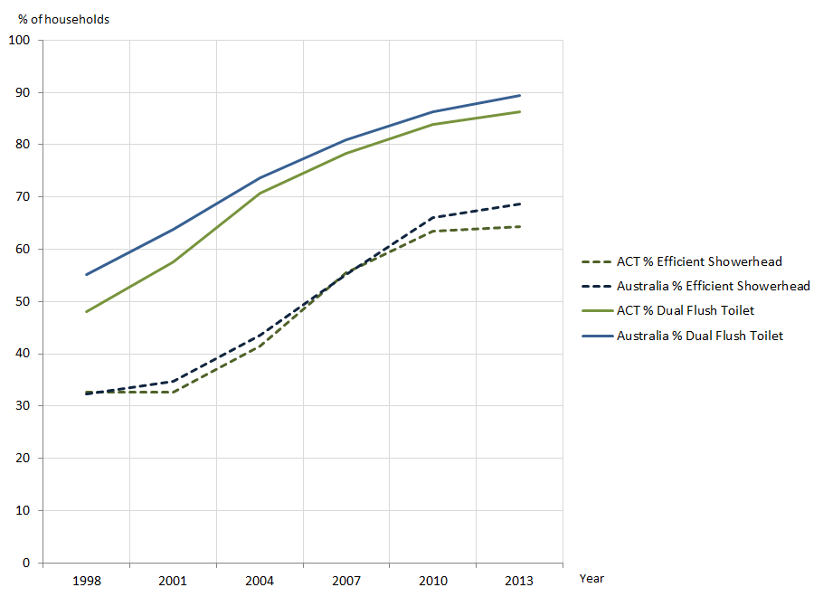
Figure 2-12 Water efficient appliance penetration
Source: ABS Series 4602.0.55.003
In medium to long term water supply planning, the general approach is to assume that population growth will occur, and that there are limits to how low per capita consumption will fall. This is the approach recommended by the National Water Commission. Sydney and Brisbane’s post drought experience has not been a resumption of declines in per capita consumption. Arguably, despite whatever has happened over the past 25 years, it would not be reasonable for Canberra to resume drought like consumption conditions in the absence of any restrictions. For this reason, our model assumes a “neutral” approach to per capita consumption (holding it approximately constant).
Figure 2-13 below shows an updated per capita consumption forecast, and the difference between Icon Water’s forecast and the updated Cardno demand model using weighted restriction values (and continuing to hold “water aware” constant in future). We have included the assumed levels of restrictions and evaporation, as these are the major drivers of the “baseline” demand, before the effects of population growth are taken into account. The assumption of “average” levels of evaporation (the green line “cumevap”) is the main driver for the increase in consumption between 2013-14 and 2014-15.
Figure 2-14 shows Sydney and Brisbane per capita consumption following the end of restrictions.
Figure 2-15 shows the per capita consumption in major Australian cities, a declining trend which has bottomed out and started rising.
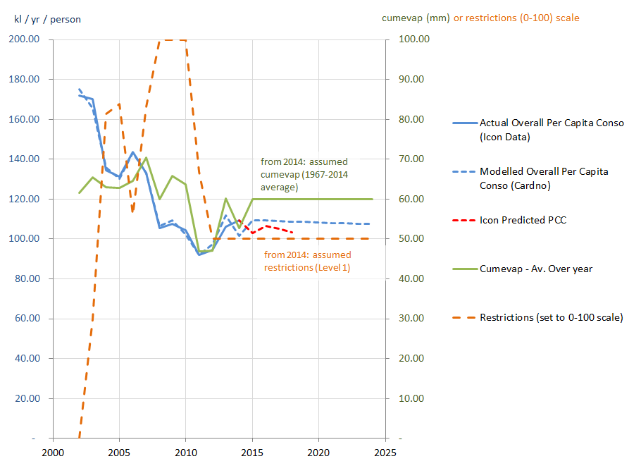
Figure 2-13 Updated model using weighted restriction values – per capita consumption forecasts (Cardno and Icon Water) showing evaporation and restrictions levels assumed.

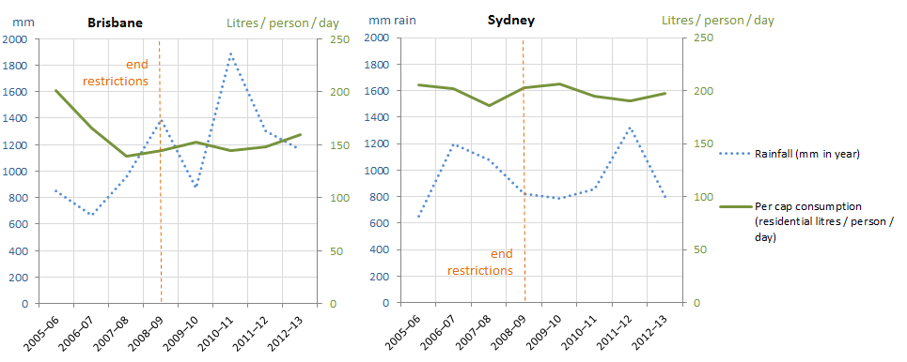
Figure 2-14 Sydney and Brisbane per capita consumption – post restriction trends
Source: National Water Commission and Bureau of Metrology Websites
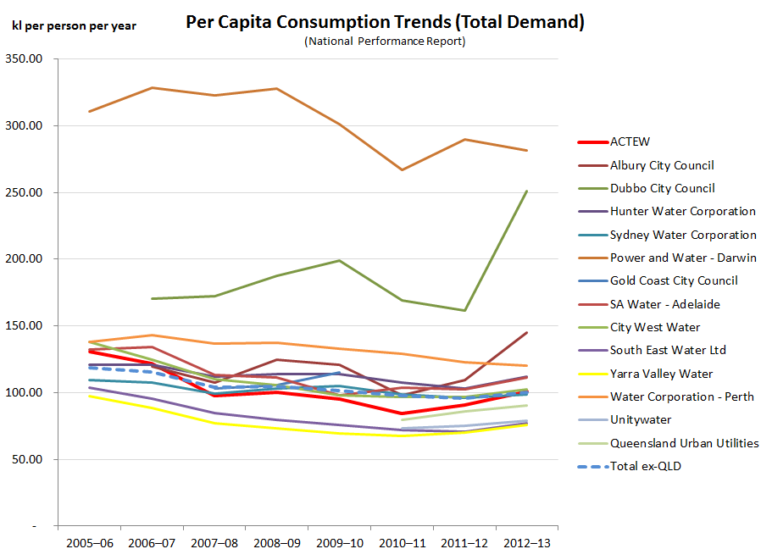
Figure 2-15 Per capita consumption – major Australian utilities
Source: National Water Commission (National Performance Reports)
In our model, we have recognised that some reductions in per capita consumption will continue to be driven by the changes in housing stock (more apartments), but have assumed no future changes due to behaviour and appliances (i.e. no specific increases or decreases in per capita consumption). We believe this approach is reasonable in the light of the following.
- According to the National Water Commission Performance Report; 6 out of 11 of Australia’s largest utilities experienced rises in per-property consumption in both 2012 and 2013, and 10 out of 11 had a rise in one of those two years. Indeed the only utility with recent falling per capita consumption is Water Corporation.
- Recent post-drought demand forecasts made by other utilities which assume constant per capita consumption.
- Recent post-drought demand forecasts made by other state regulators which assume increasing per capita consumption.
- The findings in Figure 2-2, Figure 2-12, Figure 2-14 and Figure 2-15.
- We also note that Icon Water’s assertion that per capita consumption in the ACT has “returned to its long-term decline” in the past two years is based on using its forecast model with average weather for 2013 and 2014, instead of using observed data and adjusting for a “weather effect”. Using the latter approach shows a rising per capita consumption, even after weather effects are taken into account.

Treatment of Water Security Projects

Comments on Theoretical Economic Benefits
We note that we are not suggesting that “benefit cost analysis should not rely on non-financial benefits”, merely noting that different approaches to cost benefit analysis can give different results, which are sometimes inconsistent.
The example given was that theoretical benefits (e.g. from estimated time saved) can be inconsistent with results from willingness to pay surveys.
Icon Water notes that their studies used willingness to pay surveys to quantify benefits.

Comments on evidence of climate change
The difference in findings between Icon Water and Cardno regarding rainfall patterns is due to the fact that Icon Water used calendar years and we used finanical years to total the rainfall.
The analysis methods were otherwise the identical. We used financial year rainfall data simply because this was the set of data we were using for our regression model (water volumes billed was supplied to WSAA by financial year).

Comments on Scaling of willingness to pay survey
We note that Icon Water subsequently supported their initial estimate of the impact of Level 4 restrictions with the result of two willingness to pay studies. The point was simply that at the time of writing ““Water Security for the ACT and Region”, (July 2007), the scaling factor of 3 was an “estimate” which was not referenced to any supporting studies in the report.



- BBureau of meterology charts

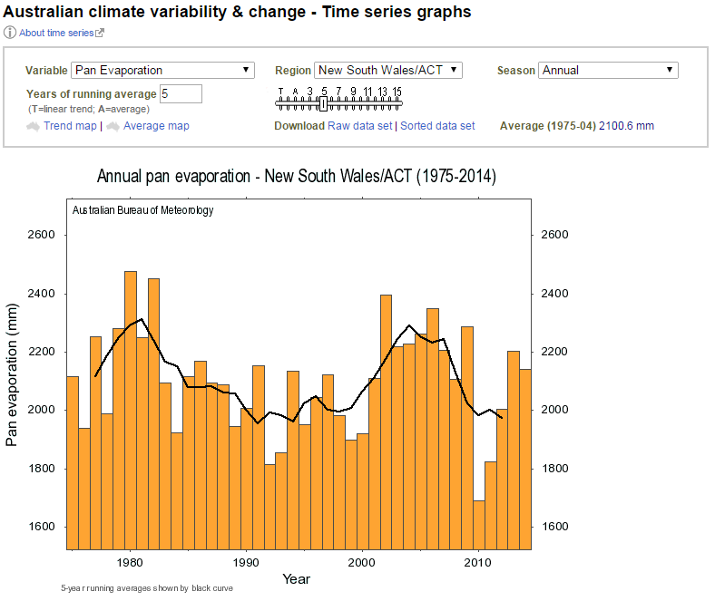
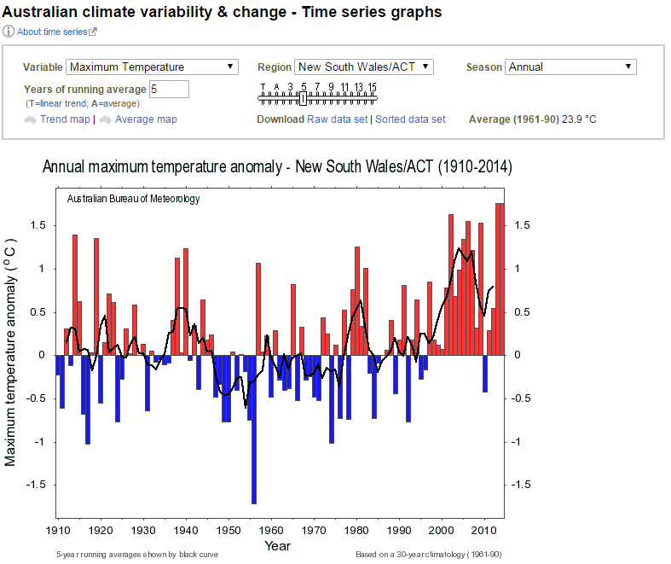
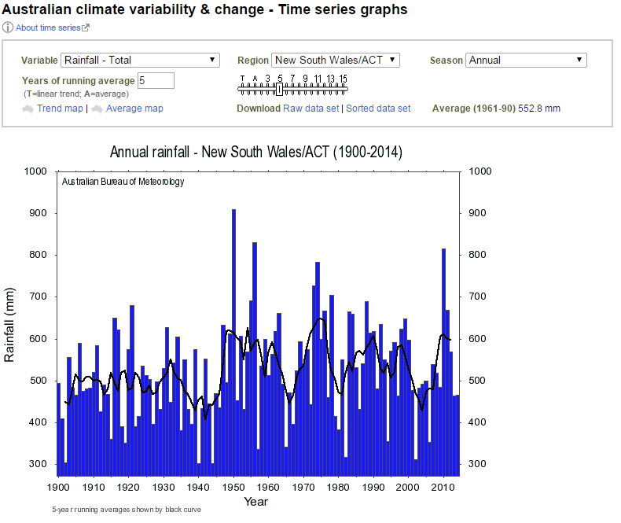

Institute for Sustainable Futures Waterlines Report Series No. 41, March 2011
i.e. behavioural changes or changes related to further retrofitting of increasingly water efficient appliances
Using the separate restrictions variables stage_0, stage_2 and stage_3 also raises difficulties in our per capita annual average model, as the stage_3 variable obtained a positive coefficient – suggesting that Level 4 restrictions increase consumption. This is clearly unlikely to be true and the spurious result was reflected in the low significance value for that coefficient. When Icon developed an example annual per capita model using separate restrictions variables as part of their responses to the Panel, they also obtained a positive coefficient (for stage_2).
Note that we would expect the %ile determined to always be lower (i.e. more frequent) than the total volume. The total volume is the result of a number of sources of variability which to some extent “cancel out other out” as they are combined and so it has a tighter distribution curve than the individual elements from which it is made. To “recreate” the 80th %ile volume record we only need the 75th %ile PCC and population records, as these parameters are more widely distributed than volume.
Note that the Tier 1 central estimate for 2015 is actually slightly higher than this at 24,527,730 kl. However a PCC of 272 is outside the range for which both formulae were developed.

